AI ASSISTED CODING

ASSIGNMENT 8.3

M.SWAPNA

2403A51260

BATCH-11

# Task Description#1

Use AI to generate test cases for is_valid_email(email) and then implement the validator function.

# Requirements:

* Must contain @ and . characters.
* Must not start or end with special characters.
* Should not allow multiple @.

Task-0

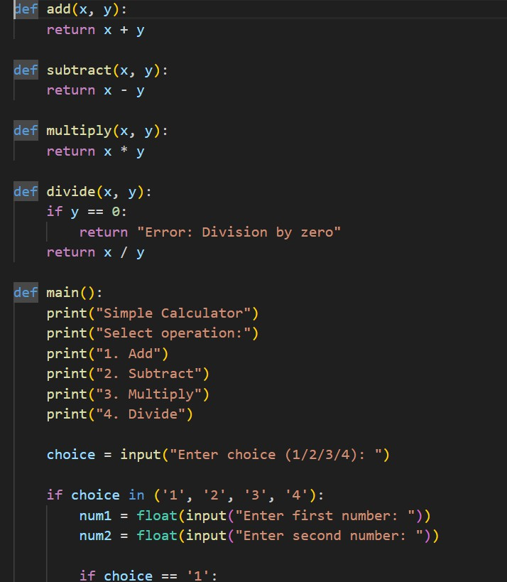

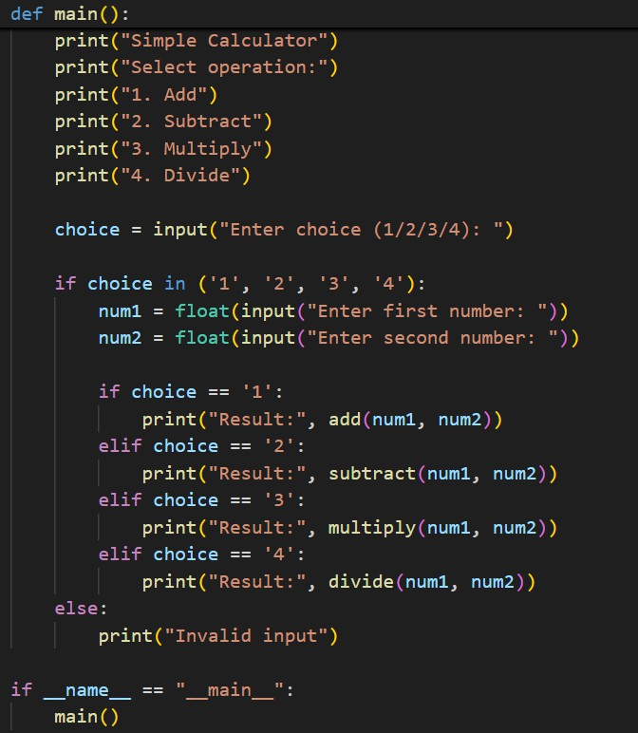

OUTPUT:

