**AI ASSISTED CODING**

**LAB-EXAM 2**

**2403A51260**

**M.SWAPNA**

**BATCH-11**

**H.1 — [S18H1] Extract hashtags and mentions**

**Context:**

Moderation in real estate listings platform needs # and @ extraction.

**Your Task:**

Regex extract mentions/hashtags, lowercase lists.

Data & Edge Cases:

Ignore punctuation around tags.

AI Assistance Expectation:

Ask AI for regex and tests.

Constraints & Notes:

Return two lists.

**Sample Input**

Hello @alice check #AI and #Python with @Bob

**Sample Output**

mentions=['alice','bob'], hashtags=['ai','python']

Acceptance Criteria: Normalized lowercase; ignores punctuation

**PROMPT:** Write a Python function that extracts @mentions and #hashtags from text using regex.

Return two lowercase lists (mentions, hashtags).

Ignore punctuation and skip emails.

Add test cases.

**CODE:**

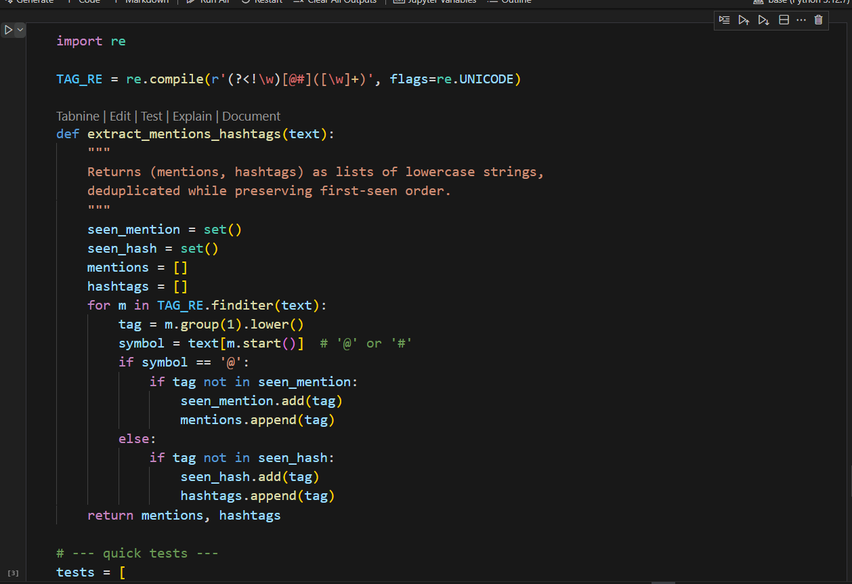

**OUTPUT**:

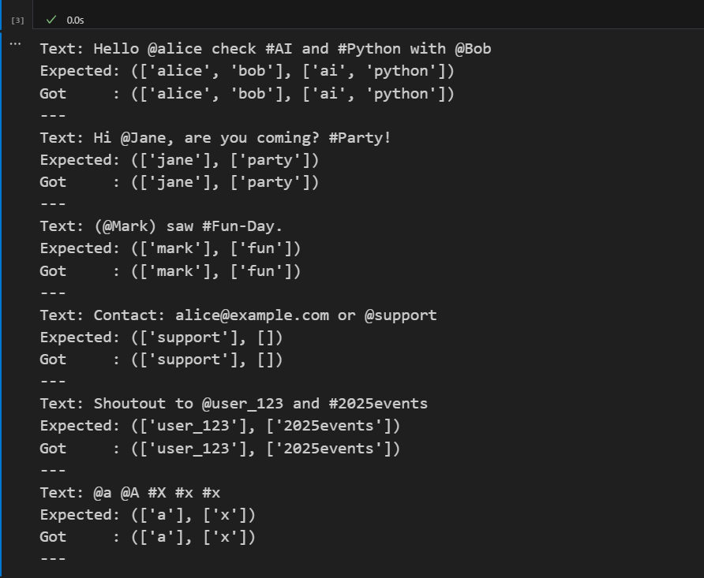

**H.2 — [S18H2] Shortest path on weighted graph (Dijkstra)**

**Context:**

Routing in real estate listings platform needs shortest paths.

Your Task:

Dijkstra from 'A' using heapq.

Data & Edge Cases:

Positive weights adjacency dict.

AI Assistance Expectation:

Use AI to outline relaxations.

Constraints & Notes:

Return distances dict.

**Sample Input**

{'A':{'B':1,'C':4},'B':{'C':2,'D':5},'C':{'D':1},'D':{}}

**Sample Output**

{'A':0,'B':1,'C':3,'D':4}

Acceptance Criteria: Correct distances

**PROMPT:** Python Dijkstra using heapq from 'A' on adjacency dict.  
Return shortest distance dict.  
Test with {'A':{'B':1,'C':4},'B':{'C':2,'D':5},'C':{'D':1},'D':{}} → {'A':0,'B':1,'C':3,'D':4}.  
and skip emails.  
Add test cases

**CODE & OUTPUT:**

