**AI ASSISTED CODING**

ASSIGNMENT-5.4

2403A51260

M.SWAPNA

BATCH-11

**Task-1:**

**Prompt:** Generate a Python script that collects user data (e.g., name, age,email). Then,add comments on how to anonymize or protect this data

**Response:**

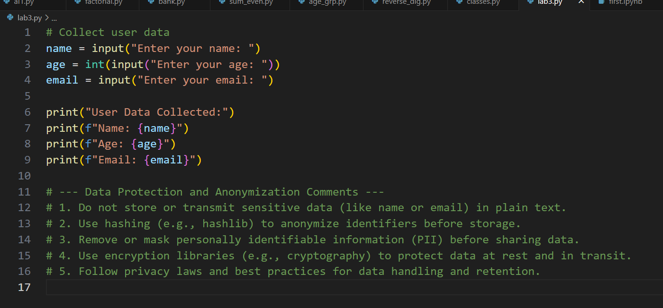

**Output:**

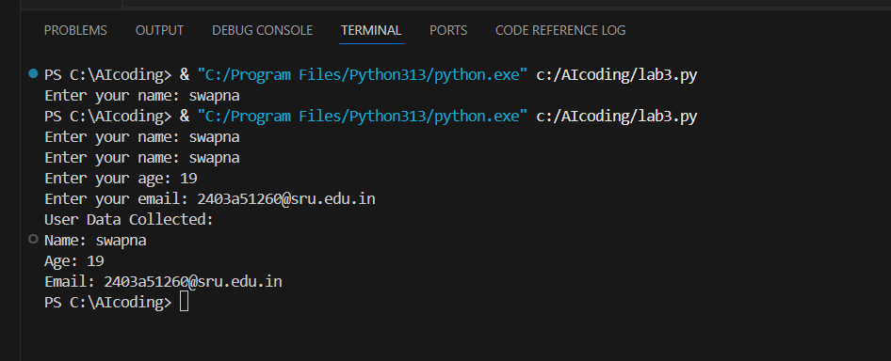

**Task-2:**

Prompt: Generate a Python function for sentiment analysis then identify and handle potential biases in the data.

**Response:**

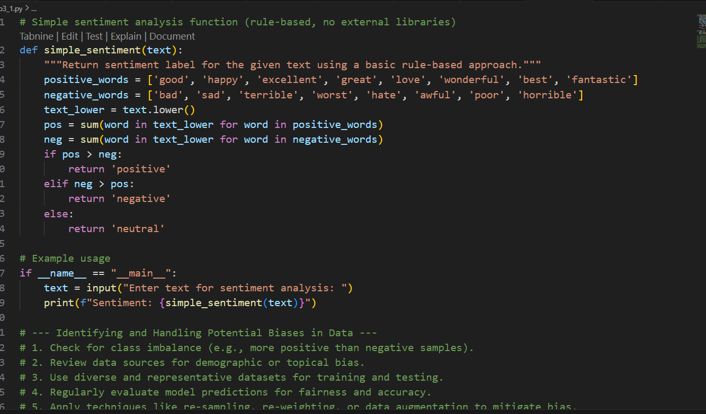

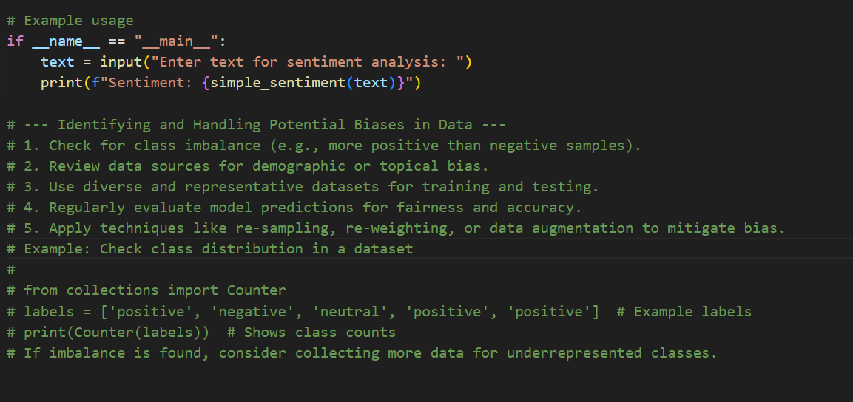

**Output:**

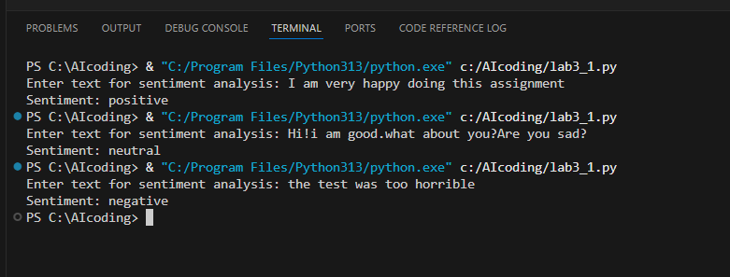

**Task-3:**

**Prompt:** write a Python program that recommends products based on user history and follow ethical guidelines like transparency and fairness include explanations, fairness checks (e.g., avoiding favoritism), and user feedback options in the code.

**Response:**

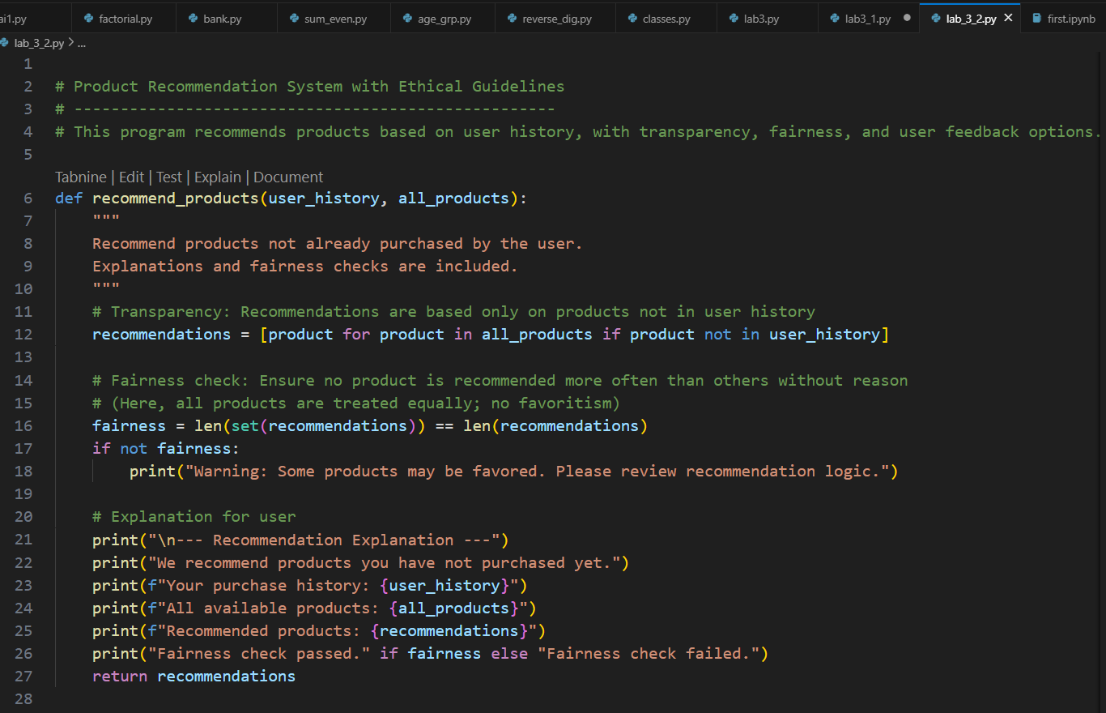

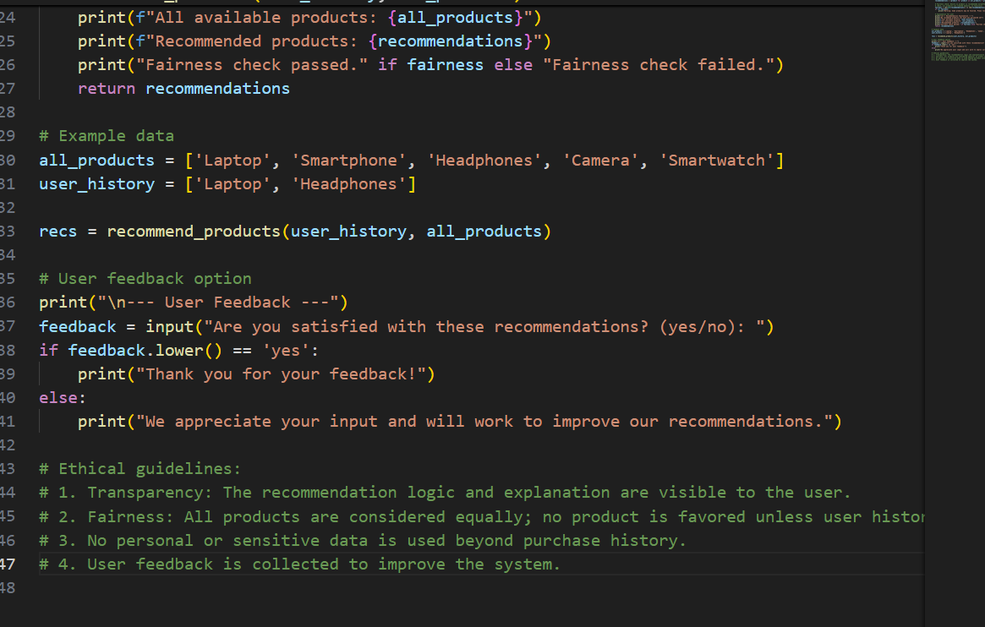

**Output:**

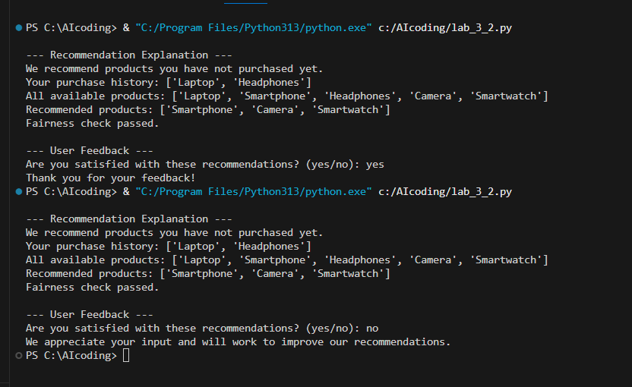

**Task-4:**

**Prompt:** Generate logging functionality in a Python web application.ensure the logs do not record sensitive information. generate Logging code that avoids saving personal identifiers (e.g., passwords, emails), and includes comments about ethical logging practices.

**Response:**

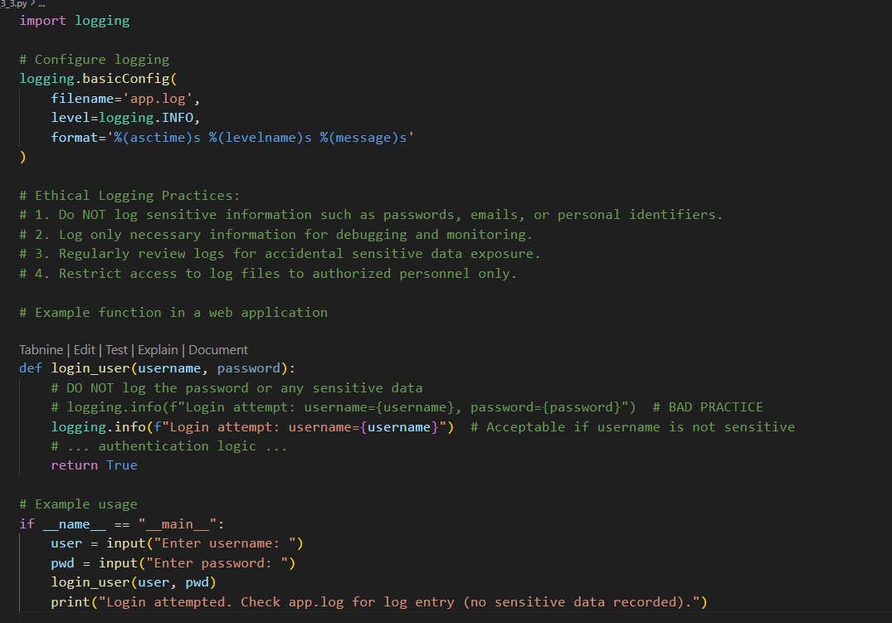

**Output:**

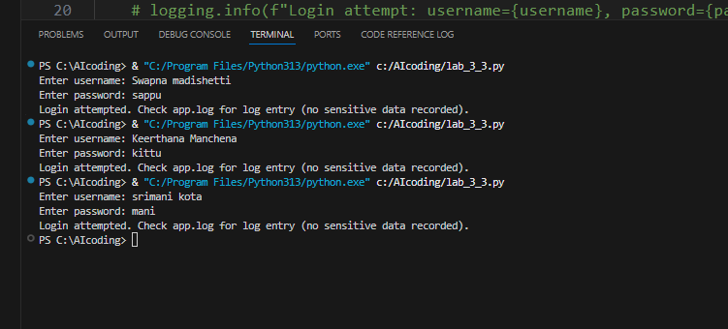

**App.log file:**

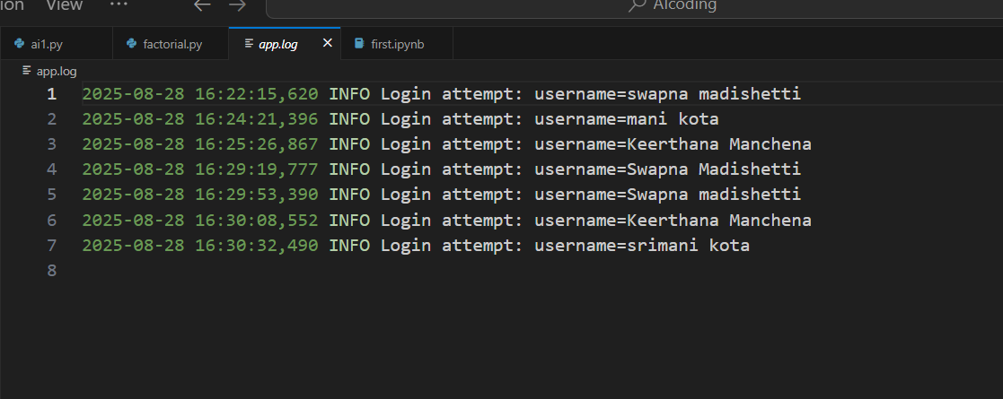

**Task-5:**

**Prompt:** generate a machine learning model.Add documentation on how to use the model responsibly (e.g., explainability, accuracy limits).Generated model code with a README or inline documentation suggesting responsible usage, limitations, and fairness consideration use copper.csv file.

**Response:**

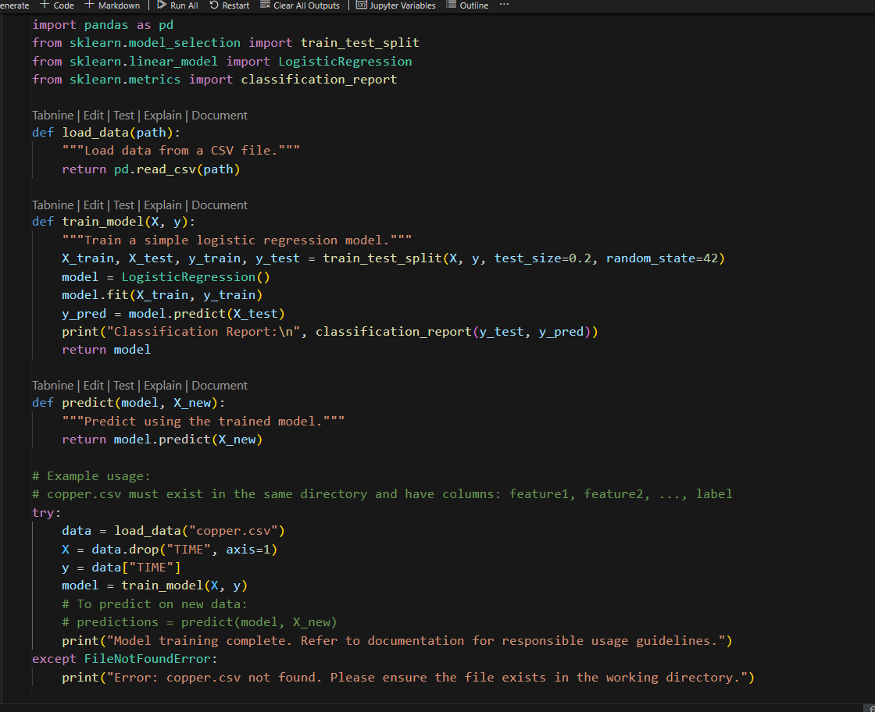

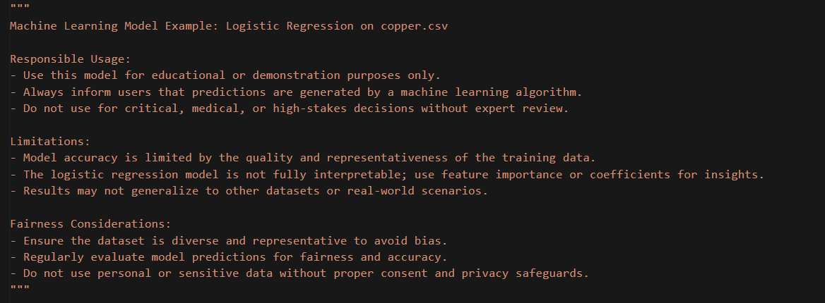

**Output:**

