**AI Assisted Coding**

**Assignment 4.4**

2403a51260

M.Swapna

Batch-11

**Task-1:**

**Prompt:** Auto-Complete a Python Class for Bank Account.Write a class definition comment and start the constructor for a class called BankAccount with account_holder and balance attributes auto-complete the rest of the class, including methods to deposit, withdraw, and display balance.  
  
**Code:**

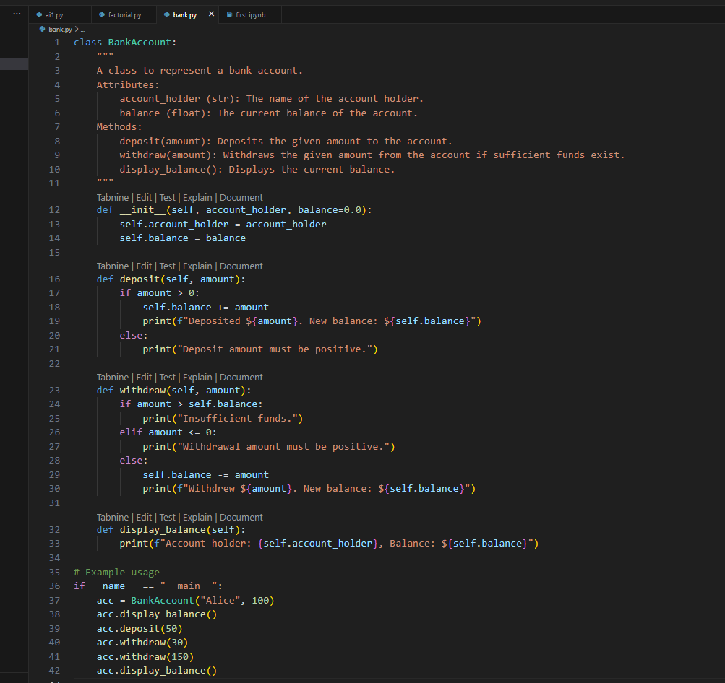

**Output:**

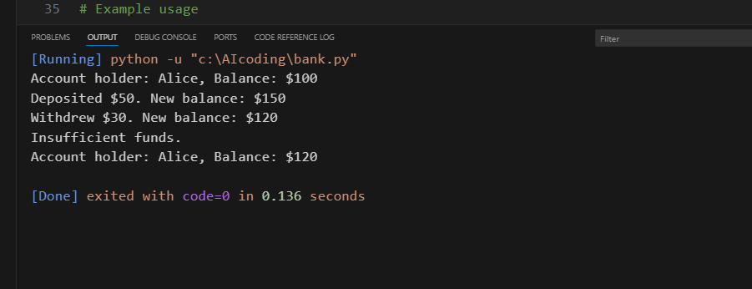

**Task-2:**

**Prompt:** Write a comment and the initial line of a loop to iterate over a list .complete the logic to sum all even numbers in the list.

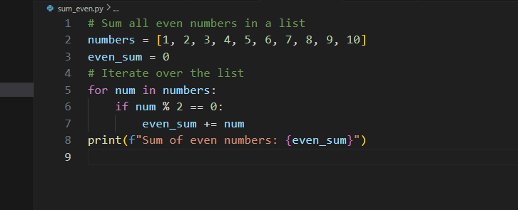

**Output:**

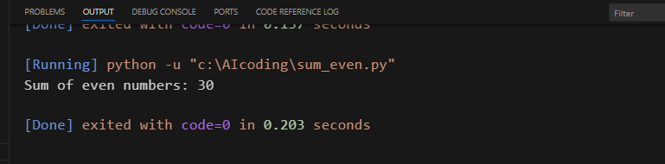

**Task-3:**

**Prompt:** Start a function that takes age as input and returns whether the person is a child, teenager,adult, or senior using if-elif-else.

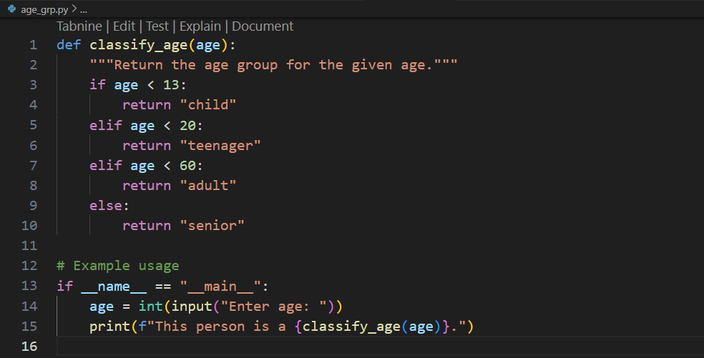

**Output:**

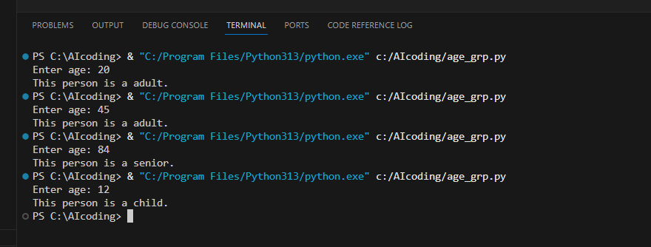

**Task-4:**

**Prompt:** Write a comment and start a while loop to reverse the digits of a number.

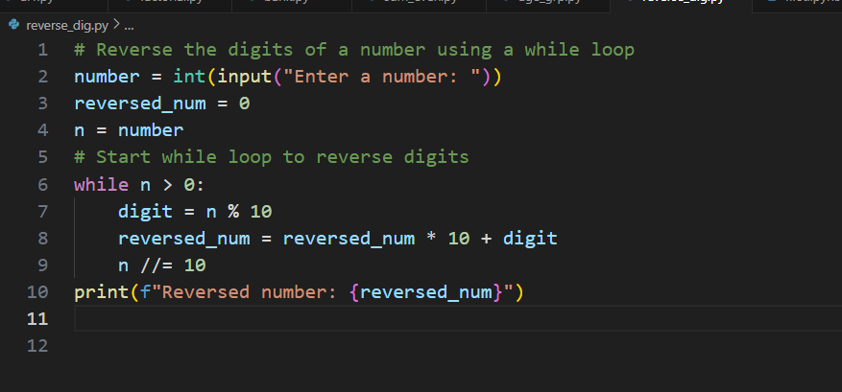

**Output:**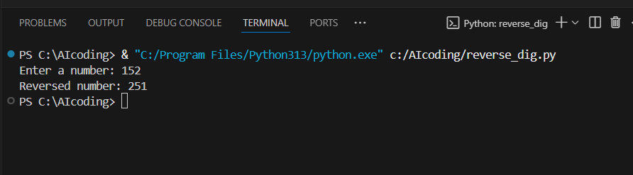

**Task-5:**

**Prompt:** Begin a class Employee with attributes name and salary. Then, start a derived class Manager that inherits from Employee and adds department. Complete the methods  
and constructor chaining.

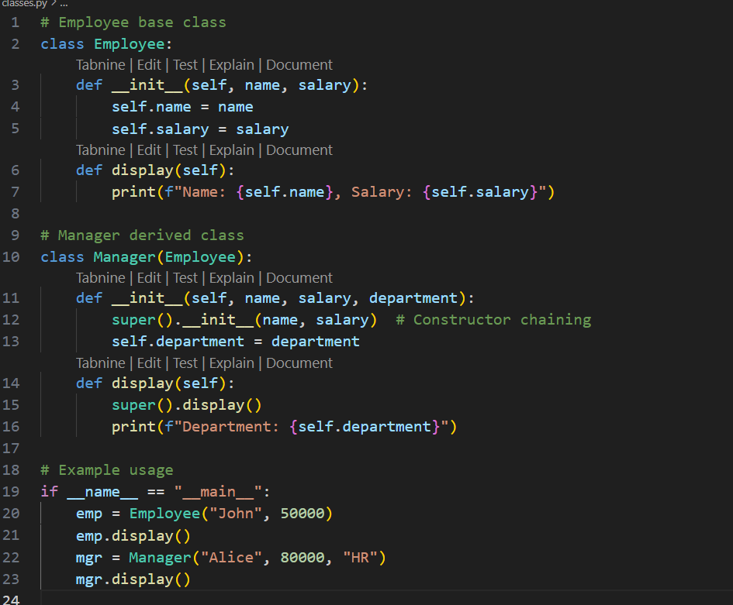

**Output:**

