**AI ASSISTED CODING**

**CLASS TEST-1**

**2403A51260**

**Madishetti Swapna**

**Batch-11**

**Question-1:** Write a python code to calculate the sum ofodd and even numbers in a given list using guithub copilot along with vscode.Use zero -shot prompting.

**Prompt:** Write a Python function to calculate the sum of even numbers and odd numbers in a list and print the results.

**Code:**

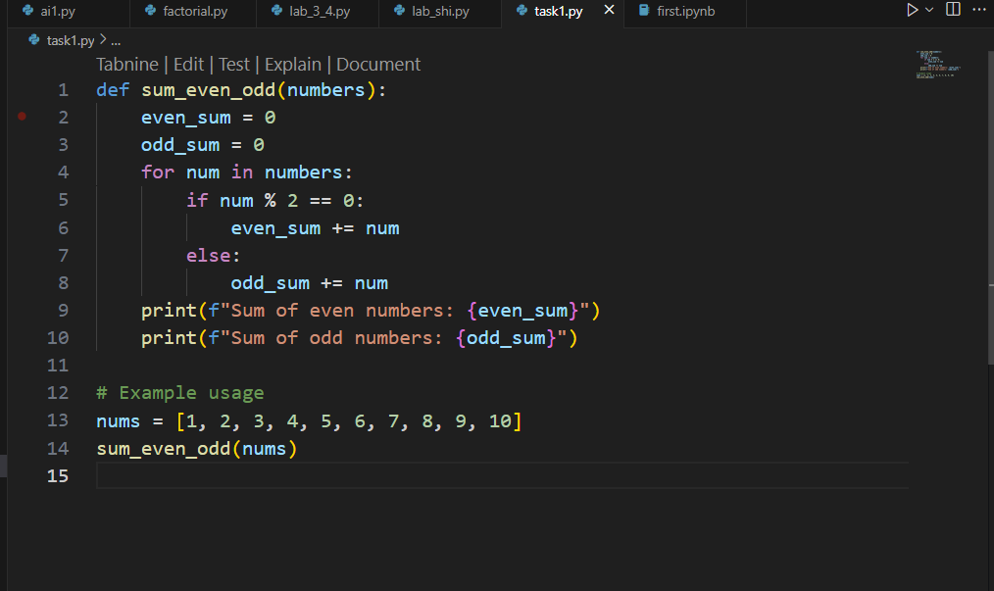

**Output:**

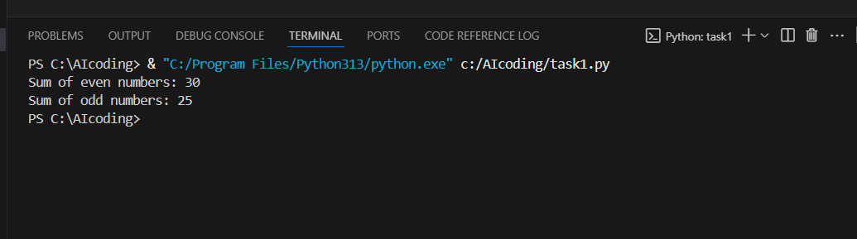

**Question-2:** Write a python code for given a list of integers,remove duplicates and print the sorted result.Github copilot along with vscode.Use one short prompting.

**Prompt:** Example: input [1,5,3,1,5]--> output [1,3,5]

Now Write a python code for given a list of integers,remove duplicates and print the sorted result.

**Code:**

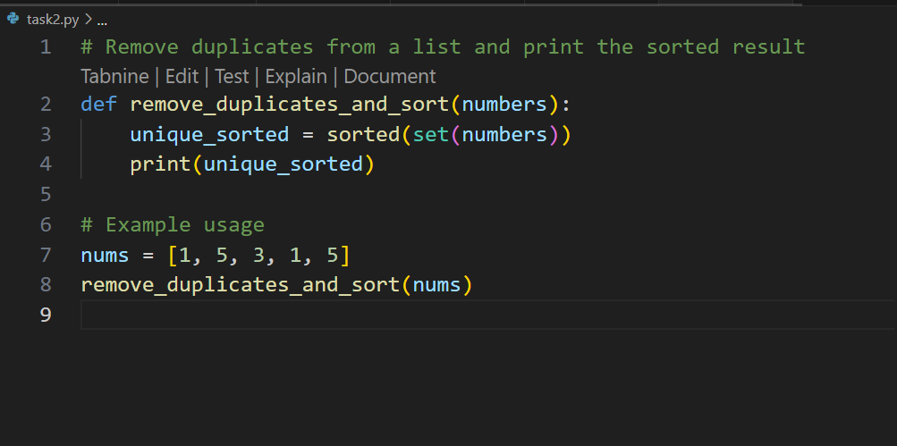

**Output:**

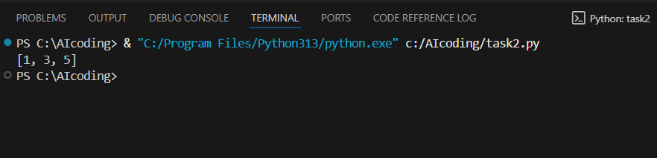

**Question-3:** Write a python function that converts temperature between Celsius,Fahrenheit and kelvin based on user choice.Use the cursor AI tool.Use few short prompting.

**Prompt:**

**E**xample 1: input: 100, from "celsius" to "fahrenheit" -> output: 212.0 Example 2: input: 0, from "celsius" to "kelvin" -> output: 273.15

Example 3: input: 212, from "fahrenheit" to "celsius" -> output: 100.0

Now Write a python function that converts temperature between Celsius,Fahrenheit and kelvin based on user choice**.**

**Code:**

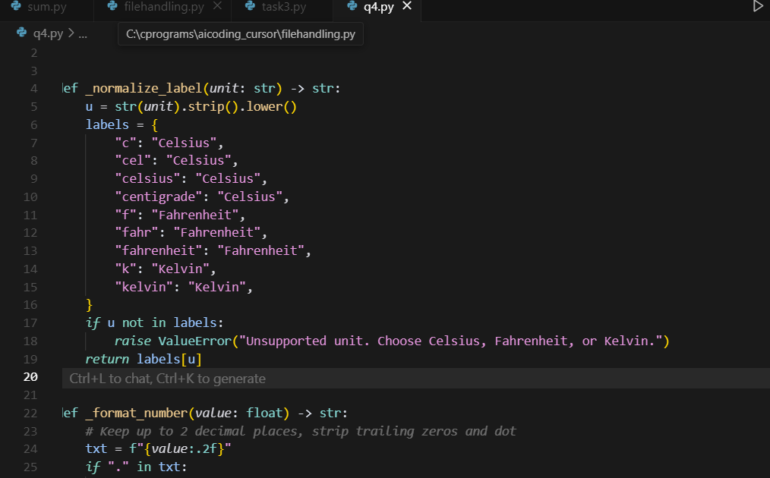

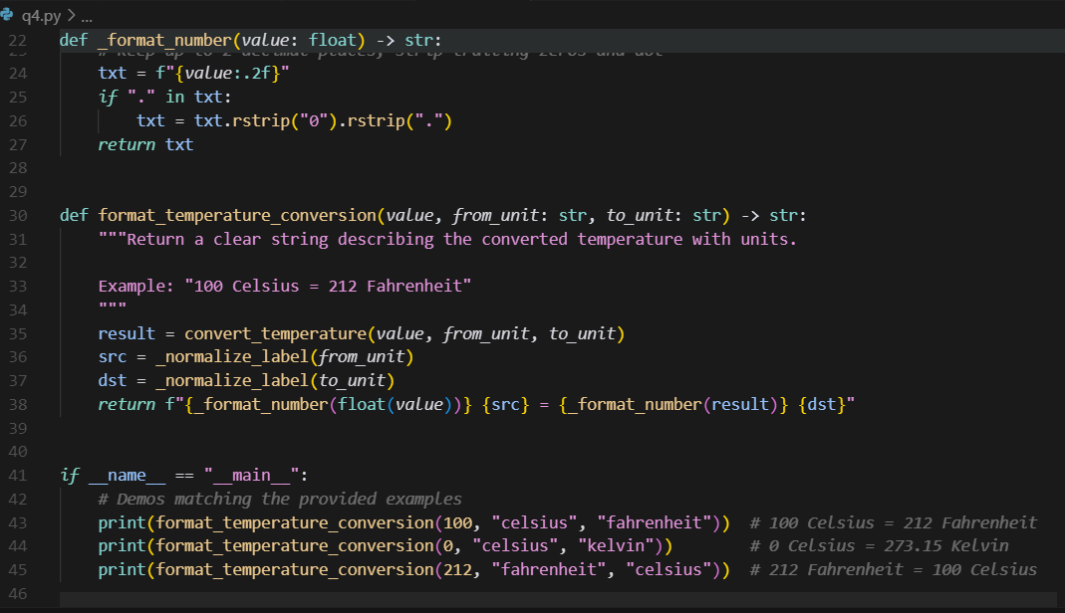

**Output:**

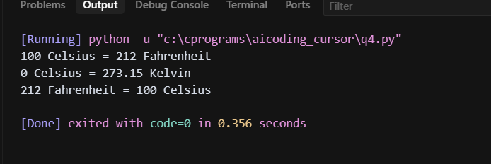

**Question 4:**

**Prompt:** write a python function to remove punctuation,convert to lowercase,and remove stopwords from a given text.

**Code:**

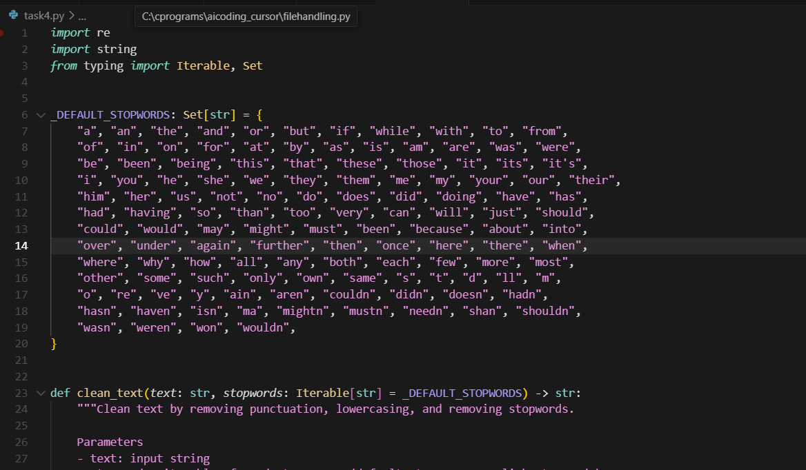

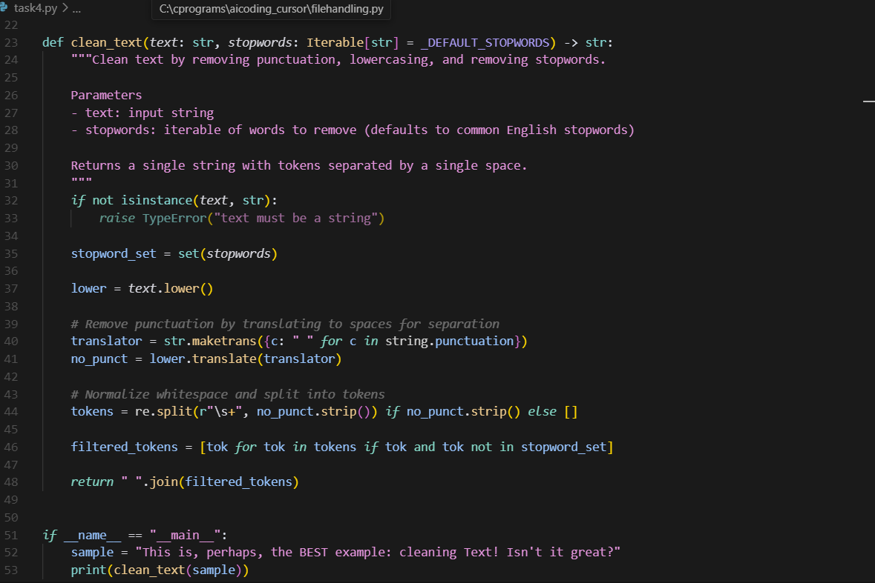

**Output:**

