# AI ASSITED CODING

## ASSIGNEMNT-9.4

Anjali Maripudi

2403A51272

BATCH-12

TASK 1-

Scenario: You have been given a Python function without comments. def calculate_discount(price, discount_rate): return price - (price * discount_rate / 100) • Use an AI tool (or manually simulate it) to generate line-by-line comments for the function. • Modify the function so that it includes a docstring in Google-style or NumPy-style format. • Compare the auto-generated comments with your manually written version.

PROMPT-

Add line-by-line comments to the function calculate_discount(price, discount_rate).  
Also write a docstring in Google-style or NumPy-style.  
Compare AI-generated comments with manual comments.

CODE-

ORIGINAL FUNCTION-

AI-Generated Comments (Simulated)-

Manual Comments-

Function with NumPy-Style Docstring

Comparison

AI comments: short and repeats code, little explanation.

Manual comments: detailed, explain parameters, calculation, and reasoning.

Docstring: structured, includes types, return value, and example usage.

TASK 2-

A team is building a Library Management System with  
multiple functions.  
def add_book(title, author, year):  
# code to add book  
pass  
def issue_book(book_id, user_id):  
# code to issue book  
Pass  
• Write a Python script that uses docstrings for each function (with  
input, output, and description)

PROMPT-

Write a Python script for a Library Management System with functions add_book(title, author, year) and issue_book(book_id, user_id).  
Add **docstrings** for each function describing input parameters, output, and function purpose.  
Include print() statements to show example usage.

CODE-

TASK 3-

Scenario: You are reviewing a colleague’s codebase containing long

functions.

def process_sensor_data(data):

cleaned = [x for x in data if x is not None]

avg = sum(cleaned)/len(cleaned)

anomalies = [x for x in cleaned if abs(x - avg) > 10]

return {"average": avg, "anomalies": anomalies}

• Generate a summary comment explaining the purpose of the

function in 2–3 lines.

• Create a flow-style comment (step-by-step explanation).

• Write a short paragraph of documentation describing possible use

cases of this function in real-world scenarios.

PROMPT-

Explain this function in 2–3 lines, add step-by-step comments, write a short real-life use case paragraph, add a Google-style docstring, and include print statements to show cleaned data, average, anomalies, and final result:

def process_sensor_data(data):

cleaned = [x for x in data if x is not None]

avg = sum(cleaned)/len(cleaned)

anomalies = [x for x in cleaned if abs(x - avg) > 10]

return {"average": avg, "anomalies": anomalies}

CODE-

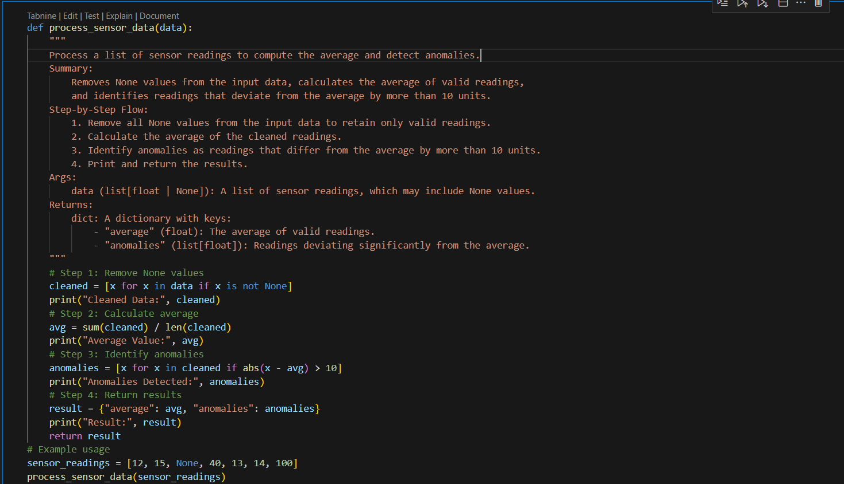

OUTPUT-

