AI ASSISTED CODING

**ASSIGNMENT-10.1**

**TASK 1**

**GIVEN CODE-**

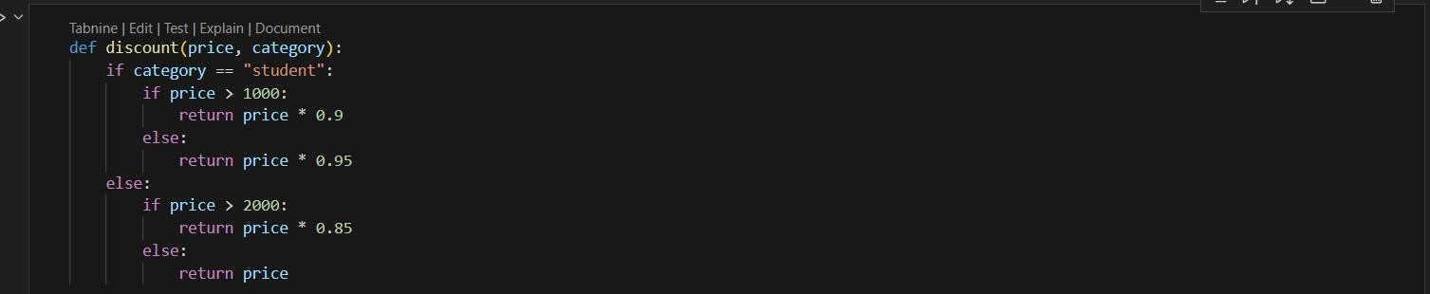

**PROMPT-**

Fortheabovecodesimplifyand refactor forreadability.

**AI GENERATED CODE-**

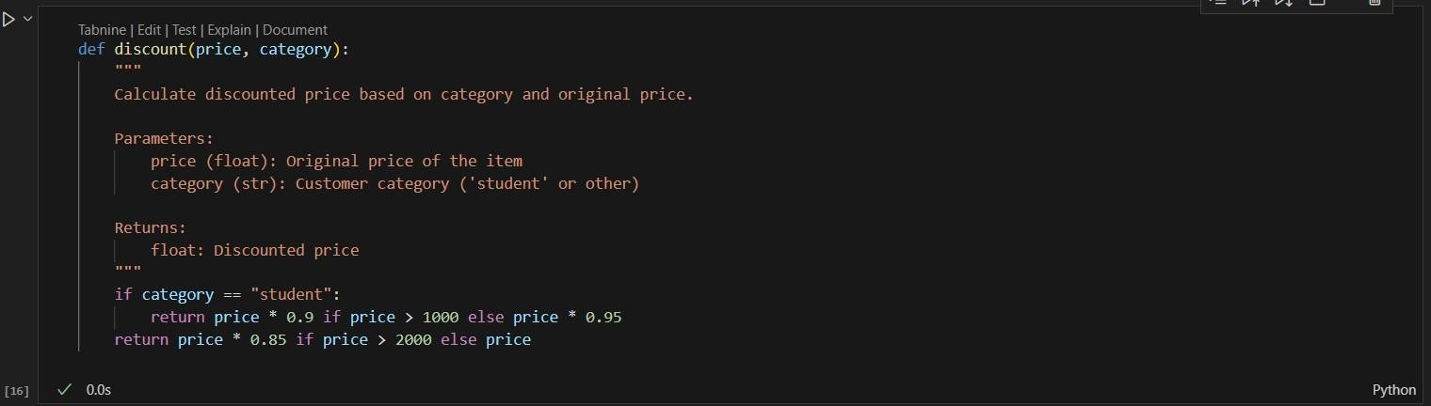

**TASK 2**

**GIVEN CODE-**

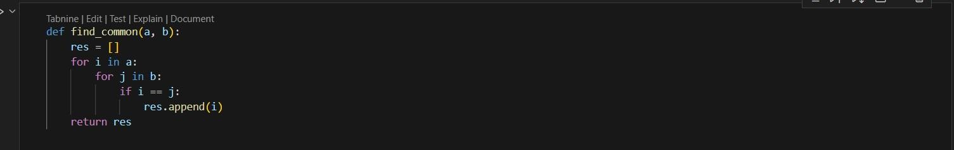

**PROMPT-**

Refactorand optimize theabovecode.

**AI GENERATED CODE-**

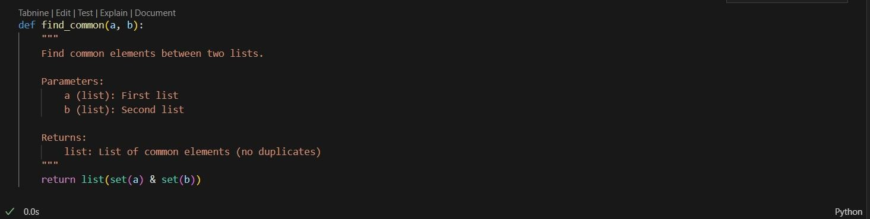

**TASK 3**

**GIVEN CODE-**

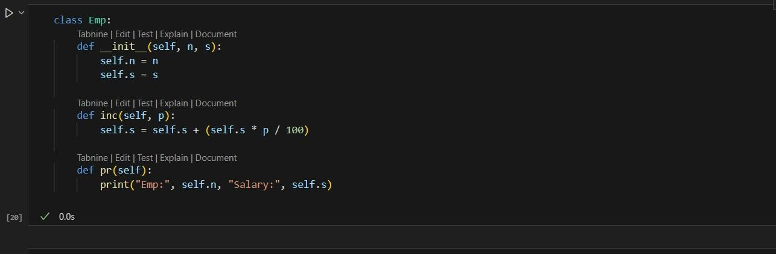

**PROMPT-**

For the above code improve Naming conventions, Encapsulation, Readability C maintainability.

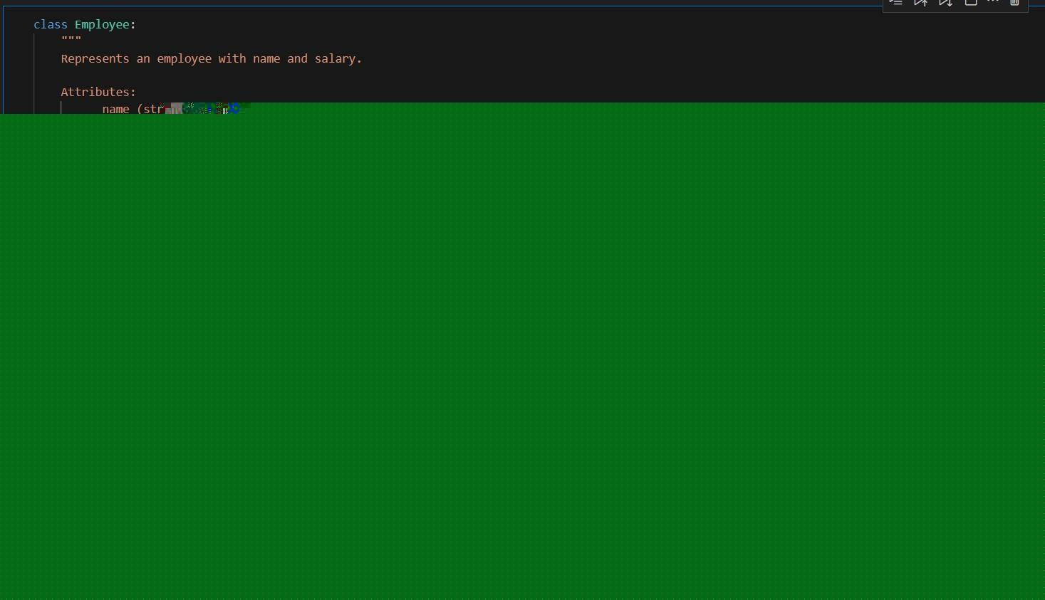

**TASK 4**

**GIVEN CODE-**

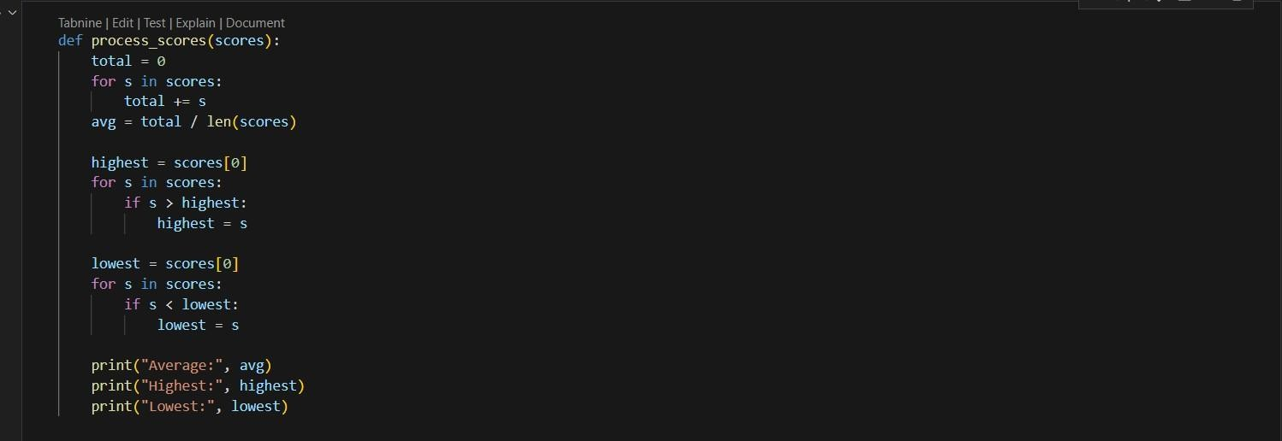

**PROMPT-**

Break the code into smaller helper functions.



**AI GENERATED CODE-**

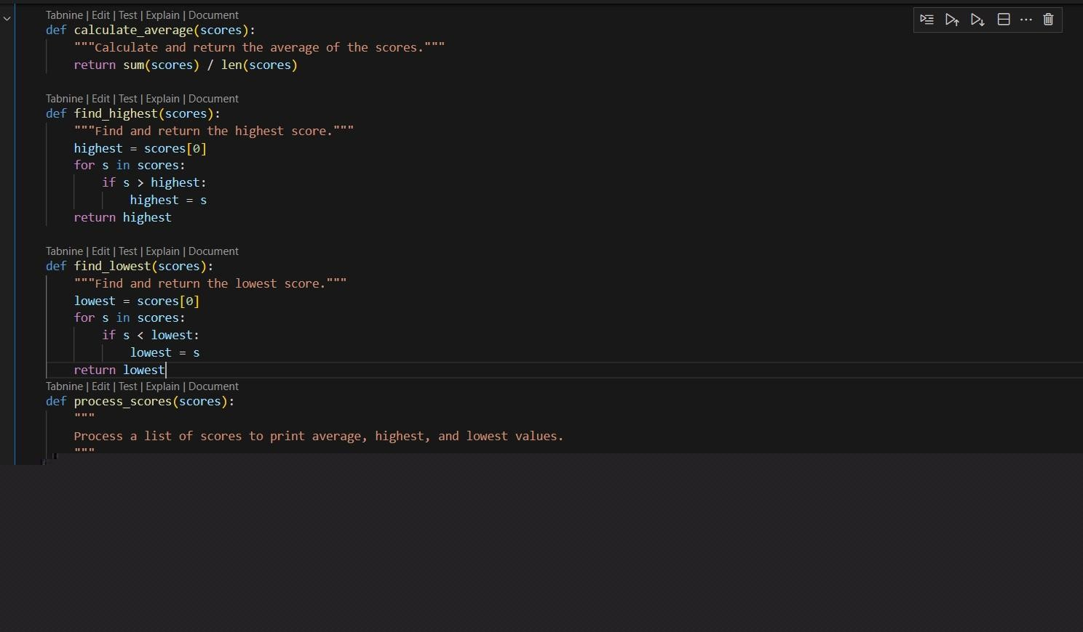

**OUTPUT-**



**TASK 5**

**GIVEN CODE-**



**PROMPT-**

Fortheabovecodeimprove errorhandling, naming, and readability.

**AI GENERATED CODE-**



**TASK 6**

**GIVEN CODE-**

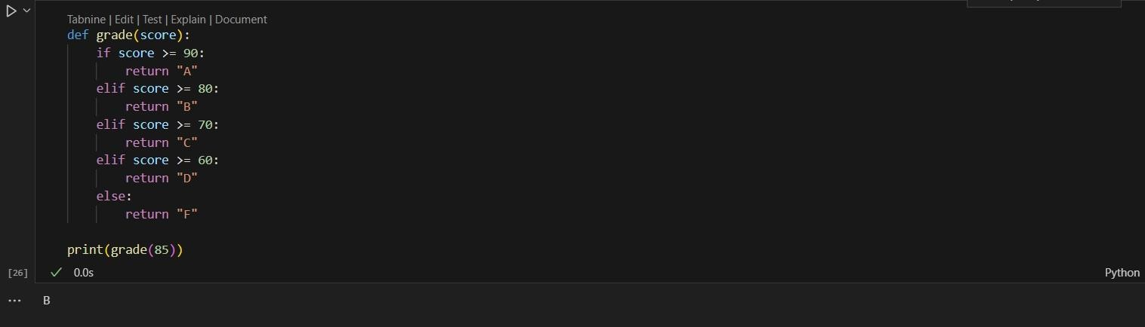

**PROMPT-**

Simplifyoverly complexlogic.

**AI GENERATED CODE-**

