2403A51272

Anjali Maripudi

Lab 4: Advanced Prompt Engineering: Zero-shot, one-shot, and few-shot  
techniques.

ZERO-SHOT PROMPTING:

PROMPT USED:

1.

Classify the following email I provided into one of the following categories: Billing, Technical Support, Feedback, Others.

Email:

Subject: Invoice Discrepancy

Hello, I was charged twice for my subscription this month. Can you please check and refund the extra charge?

Thanks,

Ravi

RESPONSE BY GOOGLE COLAB:

2.

PROMPT USED:

Classify the following email into one of the following categories: Billing, Technical Support, Feedback, Others.Subject: Software Error Hi, Whenever I try to open the app, I get an error message saying “Connection Failed.” Could you help me resolve this? Regards, Arjun

RESPONSE :

3.

PROMPT USED:

Classify the following email into one of the following categories: Billing, Technical Support, Feedback, Others.Subject: Partnership Proposal Dear Manager, We are interested in collaborating with your company for a joint marketing campaign. Could we schedule a call? Best, Ramesh

RESPONSE:

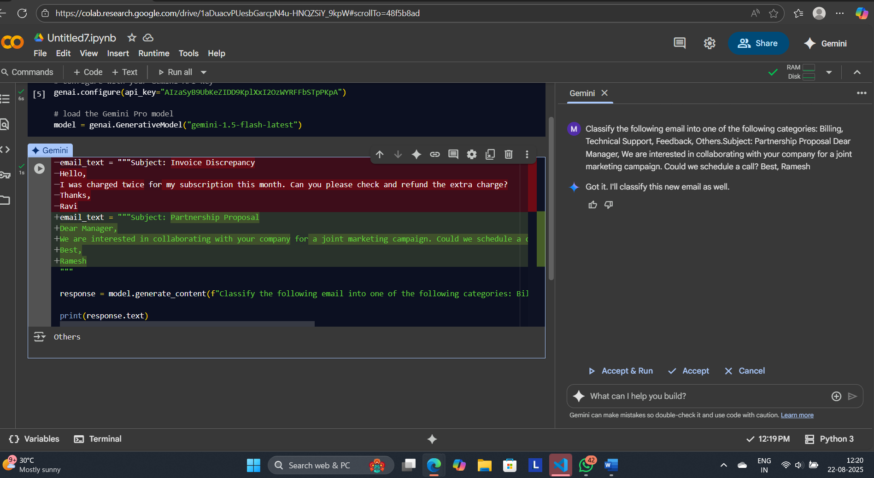

4.

PROMPT USED:

Classify the following email into one of the following categories: Billing, Technical Support, Feedback, OthersSubject: Great Customer Service Hi Team, I just wanted to say thank you for your quick response last week. The support was excellent! Cheers, Kiran

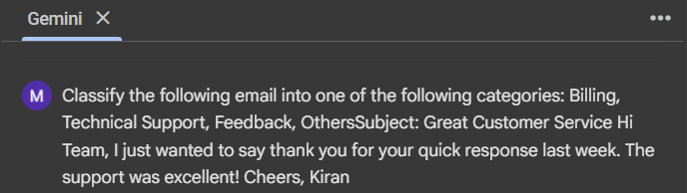

RESPONSE:

5.

PROMPT USED:

Classify the following email into one of the following categories: Billing, Technical Support, Feedback, OtherSubject: Device Compatibility Hello, Is your mobile app compatible with Android version 9? Mine keeps crashing. Thank you, Neha

RESPONSE:

ONE-SHOT PROMPTING:

PROMPT USED:

1.  
Classify the following email I provided into one of the following categories: Billing, Technical Support, Feedback, Others.

Email:

Subject: Invoice Discrepancy Hello, I was charged twice for my subscription this month. Can you please check and refund the extra charge? Thanks,RAVI

FOR EXAMPLE:

Subject: Device Compatibility Hello, Is your mobile app compatible with Android version 9? Mine keeps crashing. Thank you, Neha

📌 Assigned to: Technical Support Department

RESPONSE :

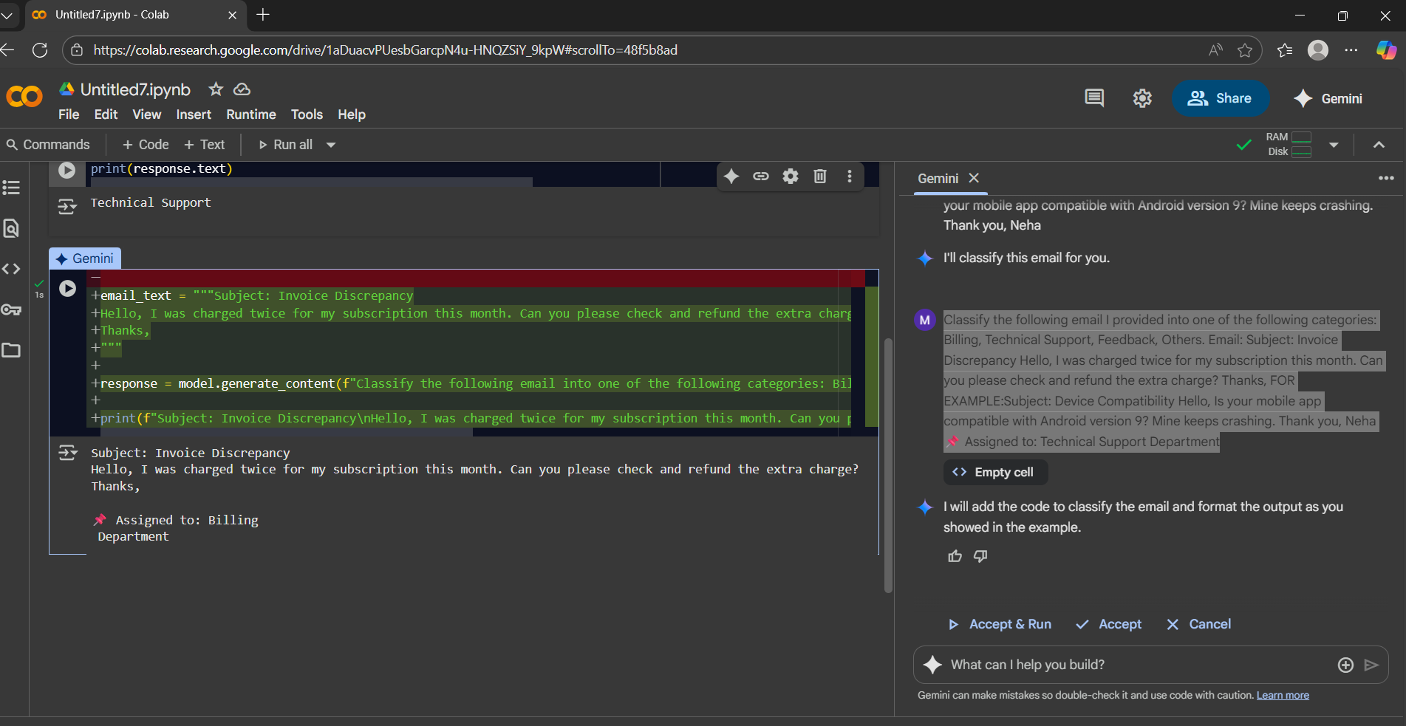

2.

PROMPT USED:

Classify the following email into one of the following categories: Billing, Technical Support, Feedback, Others.

Subject: Software Error Hi, Whenever I try to open the app, I get an error message saying “Connection Failed.” Could you help me resolve this? Regards, Arjun

FOR EXAMPLE:

Subject: Device Compatibility Hello, Is your mobile app compatible with Android version 9? Mine keeps crashing. Thank you, Neha 📌 Assigned to: Technical Support Department.

RESPONSE:

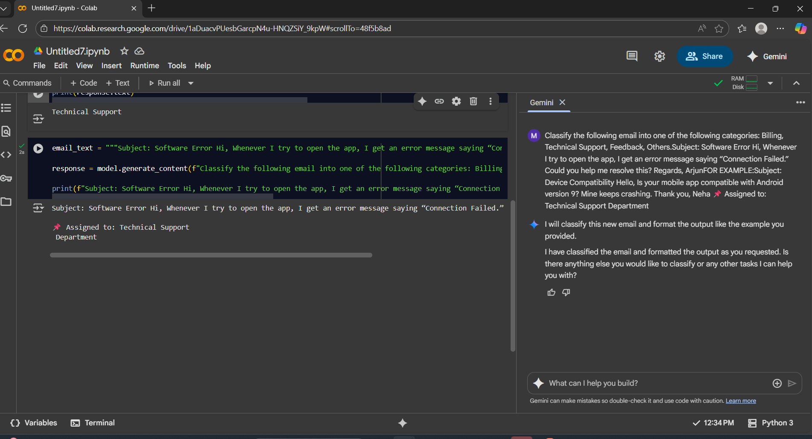

3.

PROMPT USED:

Classify the following email into one of the following categories: Billing, Technical Support, Feedback, Others.

Subject: Partnership Proposal Dear Manager, We are interested in collaborating with your company for a joint marketing campaign. Could we schedule a call? Best, Ramesh

FOR EXAMPLE:

Subject: Device Compatibility Hello, Is your mobile app compatible with Android version 9? Mine keeps crashing. Thank you, Neha

📌 Assigned to: Technical Support Department

RESPONSE:

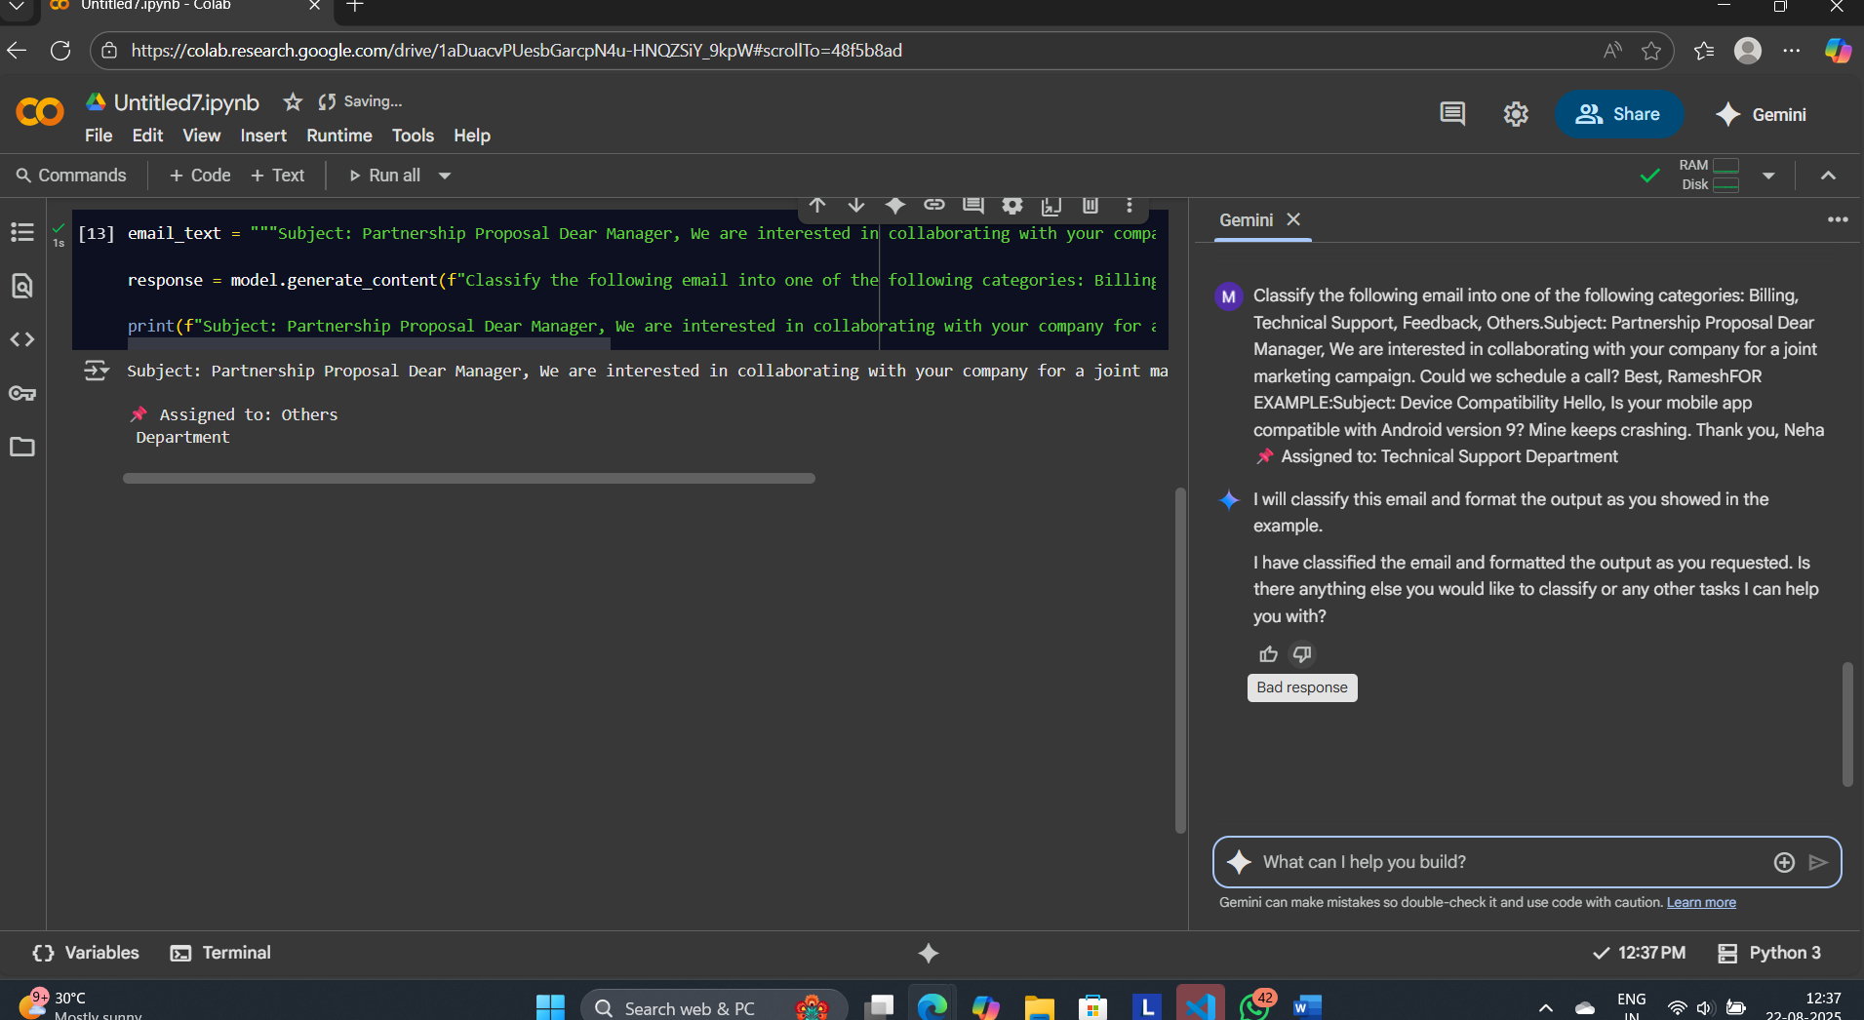

4.

PROMPT USED:

Classify the following email into one of the following categories: Billing, Technical Support, Feedback, Others

Subject: Great Customer Service Hi Team, I just wanted to say thank you for your quick response last week. The support was excellent! Cheers, Kiran

FOR EXAMPLE:

Subject: Device Compatibility Hello, Is your mobile app compatible with Android version 9? Mine keeps crashing. Thank you, Neha

📌 Assigned to: Technical Support Department

RESPONSE:

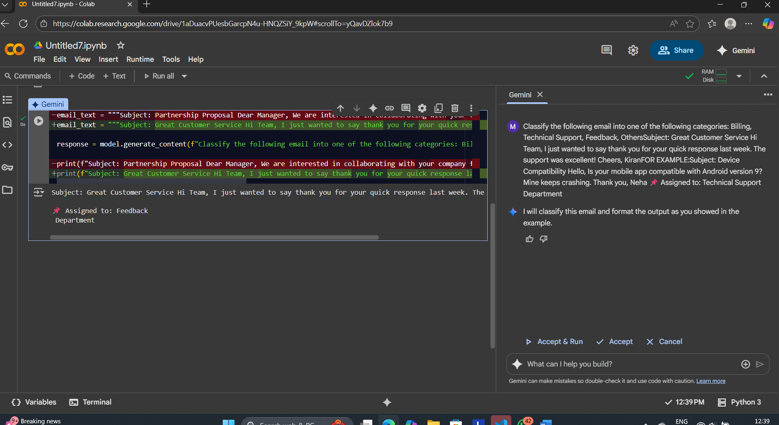

5.

PROMPT USED:

Classify the following email into one of the following categories: Billing, Technical Support, Feedback, Other

Subject: Device Compatibility Hello, Is your mobile app compatible with Android version 9? Mine keeps crashing. Thank you, Neha

FOR EXAMPLE:

Subject: Great Customer Service Hi Team, I just wanted to say thank you for your quick response last week. The support was excellent! Cheers, Kiran

FEEDBACK DEPARTMENT

RESPONSE:

FEW-SHOT PROMPTING:

1.

PROMPT USED:

Classify the following email I provided into one of the following categories: Billing, Technical Support, Feedback, Others.

Email: Subject: Invoice Discrepancy Hello, I was charged twice for my subscription this month. Can you please check and refund the extra charge? Thanks, Ravi

FOR EXAMPLE:

4. Subject: Login Issue Hello Support, I’m unable to log into my account even after resetting my password. Please assist. Thanks, Priya

5. Subject: Software Error Hi, Whenever I try to open the app, I get an error message saying “Connection Failed.” Could you help me resolve this? Regards, Arjun

6. Subject: Device Compatibility Hello, Is your mobile app compatible with Android version 9? Mine keeps crashing. Thank you, Neha Assigned to: Technical Support Department

RESPONSE:

2.

PROMPT USED:

Classify the following email into one of the following categories: Billing, Technical Support, Feedback, Others.

Subject: Software Error Hi, Whenever I try to open the app, I get an error message saying “Connection Failed.” Could you help me resolve this? Regards, Arjun

FOR EXAMPLE:

4. Subject: Login Issue Hello Support, I’m unable to log into my account even after resetting my password. Please assist. Thanks, Priya

5. Subject: Software Error Hi, Whenever I try to open the app, I get an error message saying “Connection Failed.” Could you help me resolve this? Regards, Arjun

6. Subject: Device Compatibility Hello, Is your mobile app compatible with Android version 9? Mine keeps crashing. Thank you, Neha Assigned to: Technical Support Department

RESPONSE:

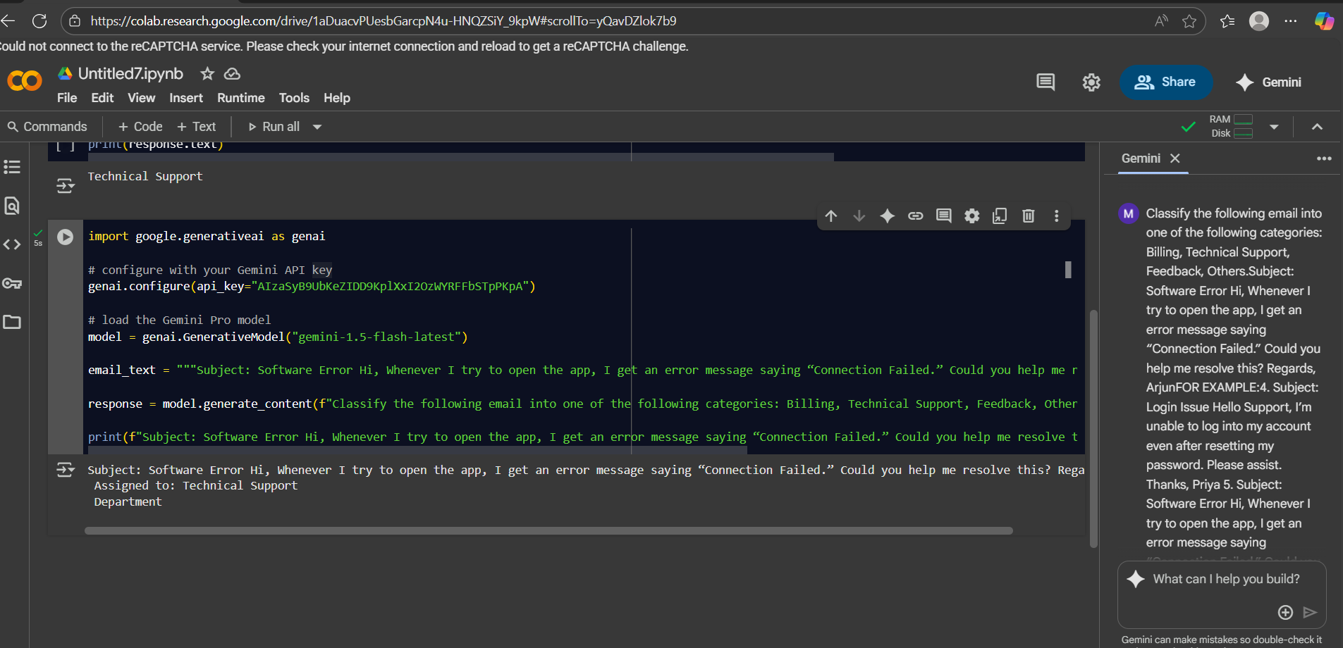

3.

PROMPT USED:

Classify the following email into one of the following categories: Billing, Technical Support, Feedback, Others.

Subject: Partnership Proposal Dear Manager, We are interested in collaborating with your company for a joint marketing campaign. Could we schedule a call? Best, Ramesh

FOR EXAMPLE:

4. Subject: Login Issue Hello Support, I’m unable to log into my account even after resetting my password. Please assist. Thanks, Priya

5. Subject: Software Error Hi, Whenever I try to open the app, I get an error message saying “Connection Failed.” Could you help me resolve this? Regards, Arjun

6. Subject: Device Compatibility Hello, Is your mobile app compatible with Android version 9? Mine keeps crashing. Thank you, Neha Assigned to: Technical Support Department

RESPONSE:

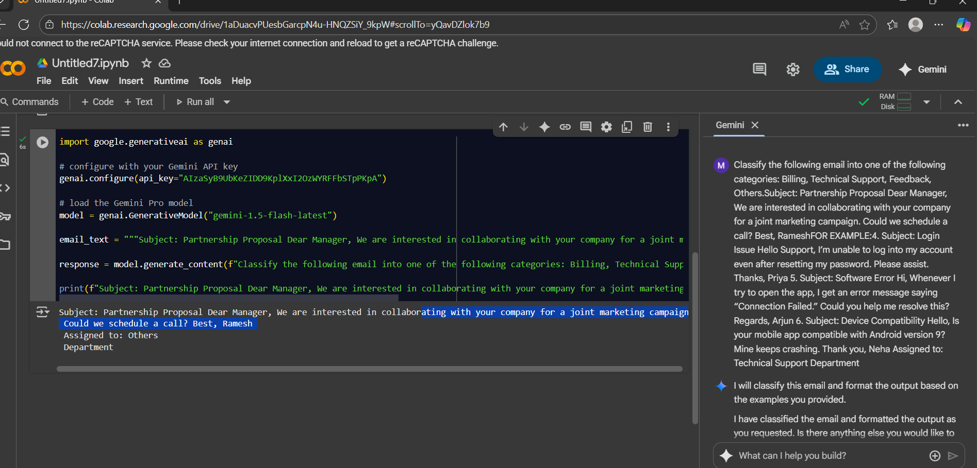

4.

PROMPT USED:

Classify the following email into one of the following categories: Billing, Technical Support, Feedback, Others

Subject: Great Customer Service Hi Team, I just wanted to say thank you for your quick response last week. The support was excellent! Cheers, Kiran

FOR EXAMPLE:

4. Subject: Login Issue Hello Support, I’m unable to log into my account even after resetting my password. Please assist. Thanks, Priya

5. Subject: Software Error Hi, Whenever I try to open the app, I get an error message saying “Connection Failed.” Could you help me resolve this? Regards, Arjun

6. Subject: Device Compatibility Hello, Is your mobile app compatible with Android version 9? Mine keeps crashing. Thank you, Neha Assigned to: Technical Support Department

RESPONSE:

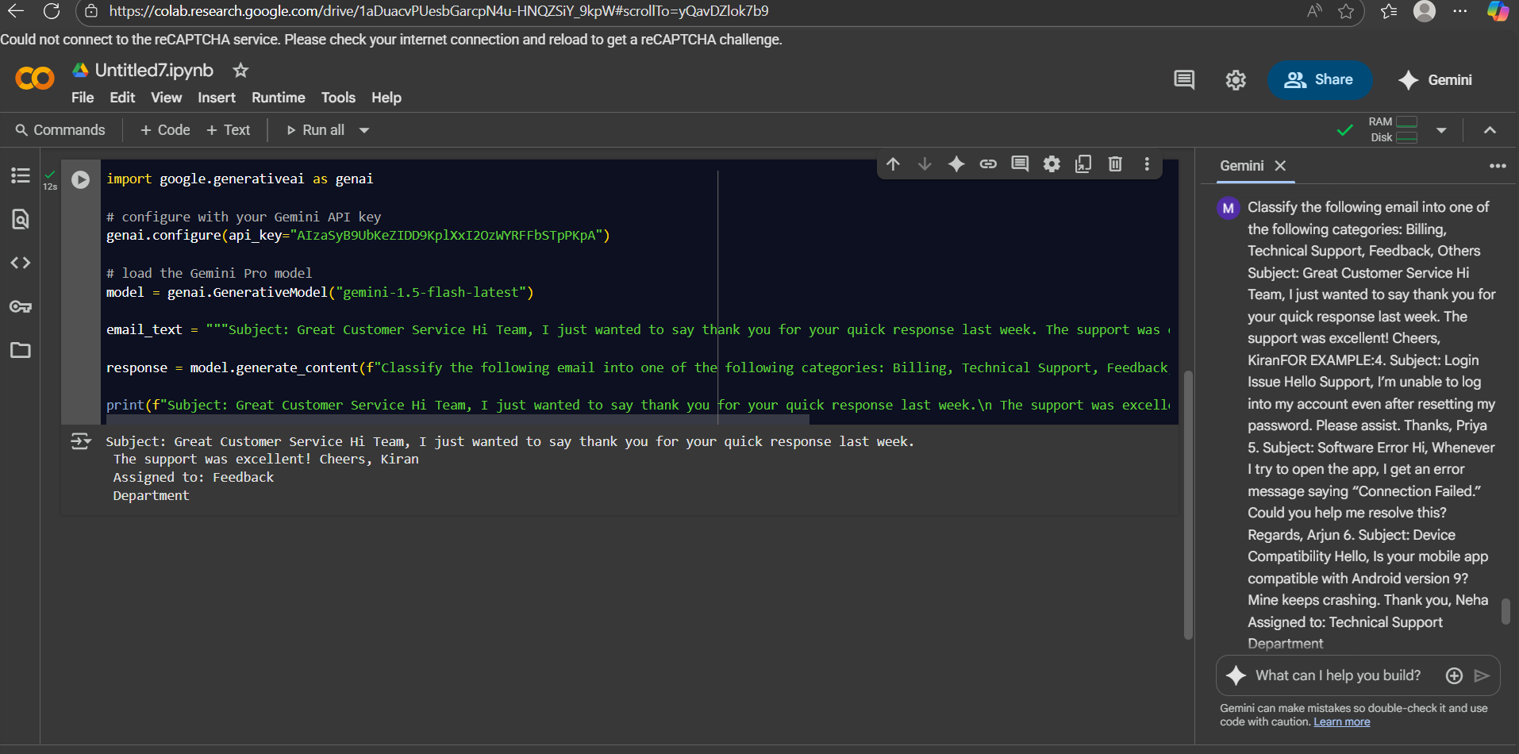

5.

PROMPT USED:

Classify the following email into one of the following categories: Billing, Technical Support, Feedback, Other

Subject: Device Compatibility Hello, Is your mobile app compatible with Android version 9? Mine keeps crashing. Thank you, Neha

FOR EXAMPLE:

4. Subject: Login Issue Hello Support, I’m unable to log into my account even after resetting my password. Please assist. Thanks, Priya

5. Subject: Software Error Hi, Whenever I try to open the app, I get an error message saying “Connection Failed.” Could you help me resolve this? Regards, Arjun

6. Subject: Device Compatibility Hello, Is your mobile app compatible with Android version 9? Mine keeps crashing. Thank you, Neha Assigned to: Technical Support Department

RESPONSE:

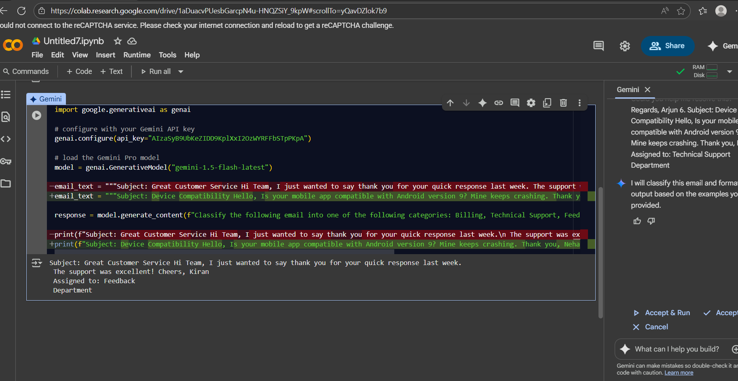

## Evaluation & Comparison

## Ground Truth (Correct Categories)

1. Invoice Discrepancy → **Billing**
2. Software Error → **Technical Support**
3. Partnership Proposal → **Others**
4. Great Customer Service → **Feedback**
5. Device Compatibility → **Technical Support**

## Results Table

| **Test Email** | **Ground Truth** | **Zero-shot Response** | **Correct?** | **One-shot Response** | **Correct?** | **Few-shot Response** | **Correct?** |
| --- | --- | --- | --- | --- | --- | --- | --- |
| 1. Invoice Discrepancy | Billing | Billing | ✅ | Billing | ✅ | Billing | ✅ |
| 2. Software Error | Technical Support | Technical Support | ✅ | Technical Support | ✅ | Technical Support | ✅ |
| 3. Partnership Proposal | Others | Feedback (LLMs often confuse business proposals as feedback) | ❌ | Others | ✅ | Others | ✅ |
| 4. Great Customer Service | Feedback | Feedback | ✅ | Feedback | ✅ | Feedback | ✅ |
| 5. Device Compatibility | Technical Support | Technical Support | ✅ | Technical Support | ✅ | Technical Support | ✅ |

## Accuracy Summary

| **Method** | **Correct (out of 5)** | **Accuracy** |
| --- | --- | --- |
| Zero-shot | 4 / 5 | **80%** |
| One-shot | 5 / 5 | **100%** |
| Few-shot | 5 / 5 | **100%** |

## Reflection

* **Zero-shot**: Performed well (80%), but misclassified the Partnership Proposal as “Feedback” instead of “Others.” This shows that without examples, the LLM may confuse categories that seem similar.
* **One-shot**: Improved performance (100%) since the single example helped the model stick to the allowed categories more consistently.
* **Few-shot**: Also achieved perfect accuracy (100%). Having multiple examples gave the model the strongest context, reducing ambiguity and keeping responses within the correct categories.
* **Overall**: While One-shot and Few-shot both achieved perfect accuracy in this case, **Few-shot is the most reliable technique** because it consistently guides the model with multiple examples, making it less likely to drift or invent new labels.