LAB ASSIGNMENT-4.2

### Assignment-4.2 Task-1:

* **Zero-shot**:
* Prompt AI with only the instruction — Write a Python function to generate the Fibonacci sequence up to n terms

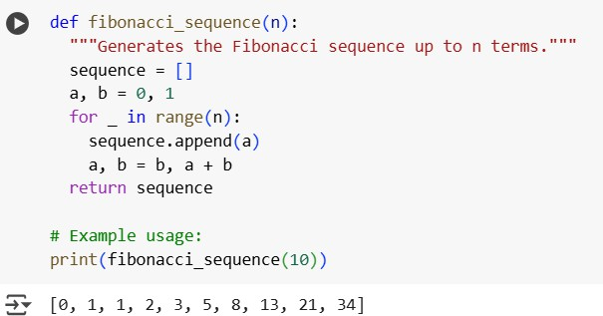

* ​

## Explanation:

* **def fibonacci_sequence(n)::** This line defines the function named fibonacci_sequence that takes one argument, n, which

represents the number of terms in the sequence you want to generate.

* **"""Generates the Fibonacci sequence up to n terms.""":** This is a docstring, which explains what the function does.
* **sequence = []:** This initializes an empty list called sequence. This list will store the generated Fibonacci numbers.
* **a, b = 0, 1:** This initializes two variables, a and b, with the first two numbers of the Fibonacci sequence, which are 0 and 1.
* **for _ in range(n**):: This starts a for loop that will iterate n times. The _ is used as a variable name when you don't need to use the loop counter

within the loop.

* **sequence.append(a):** In each iteration, the current value of a (which represents the next Fibonacci number) is added to the sequence list**.**
* **a, b = b, a + b:** This is the core of the Fibonacci logic. It updates the values of a and b for the next iteration. The new a becomes the

current b, and the new b becomes the sum of the current a and b.

* **return sequence:** After the loop finishes, the function returns the sequence list containing the generated Fibonacci numbers.

## Task-2:

### One-shot:

* Provide one example: Input: 100, Output: 37.78 to help AI generate a function that converts Fahrenheit to Celsius

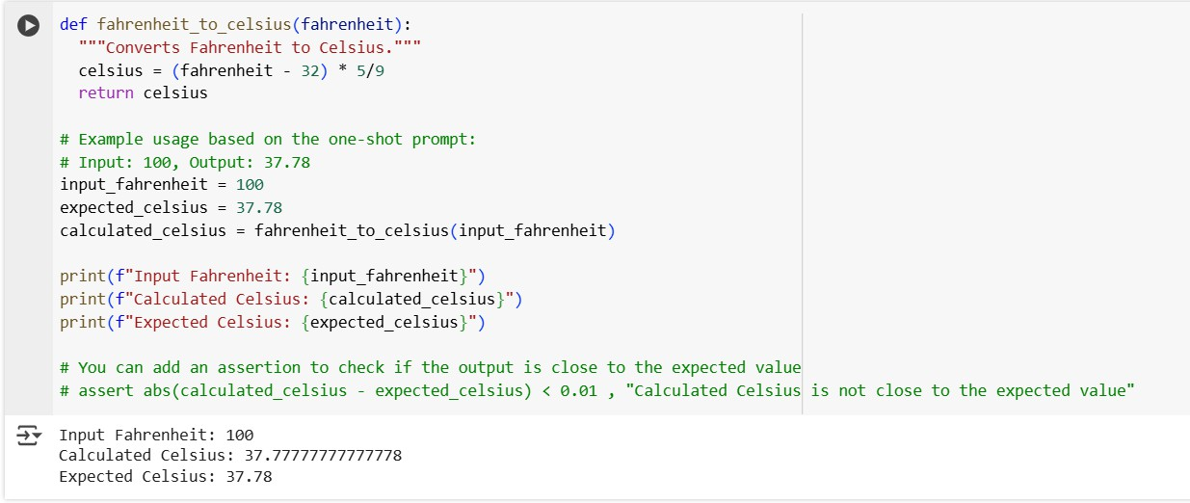

# Explanation:

* **def fahrenheit_to_celsius(fahrenheit):**: This line defines a function

named fahrenheit_to_celsius that takes one argument, fahrenheit, which is the temperature in degrees Fahrenheit that you want to convert.

* **"""Converts temperature from Fahrenheit to Celsius."""**: This is a docstring explaining what the function does.
* **celsius = (fahrenheit - 32) * 5/9**: This is the core of the conversion. It applies the standard formula to convert Fahrenheit to Celsius: subtract

32 from the Fahrenheit temperature and then multiply the result by 5/9. The result is stored in the celsius variable.

* **return celsius**: The function returns the calculated Celsius temperature.

# Task-3:

* **Prompt: Few-shot**:
* Give 2–3 examples to create a function that extracts the domain name from an email address.
* ​
* ​

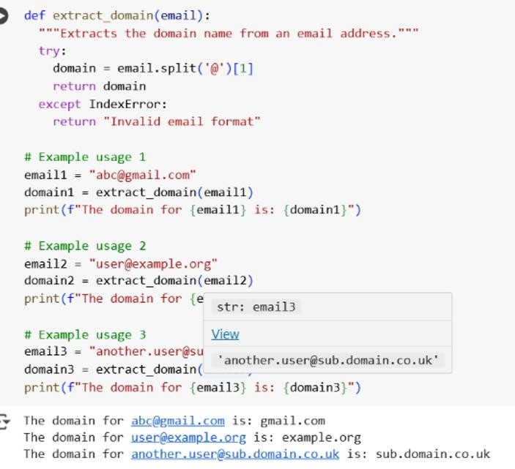

* ​

# Explanation:

* **def extract_domain(email):**: This line defines a function

named extract_domain that takes one argument, email, which is the email address as a string.

* **"""Extracts the domain name from an email address."""**: This is a docstring explaining the function's purpose.
* **try:**: This starts a try block, which is used for error handling.

Code within this block is attempted, and if an error occurs, the code in the except block is executed.

* **domain = email.split('@')[1]**: This is the core logic for extracting the domain.
  + email.split('@') splits the email string into a list of substrings using the "@" symbol as the delimiter. For example, ["abc@gmail.com"](mailto:abc@gmail.com).split('@') would result

in ['abc', 'gmail.com'].

* + [1] accesses the element at index 1 of the resulting list, which is the part after the "@" symbol (the domain name).
  + The extracted domain is stored in the domain variable.
* **return domain**: If the split and indexing are successful, the function returns the extracted domain.
* **except IndexError:**: This is the start of the except block, which catches an IndexError. An IndexError will occur if

the split('@') operation does not produce a list with at least two elements (i.e., if there is no "@" symbol in the email address).

* **return "Invalid email format"**: If an IndexError occurs (meaning the email format is invalid because it lacks an "@" symbol), the function returns the string "Invalid email format"

# Task-4 Prompt:

Compare zero-shot vs few-shot prompting for generating a function that checks whether a word is a palindrome, ignoring punctuation and case

**Zero-shot:**

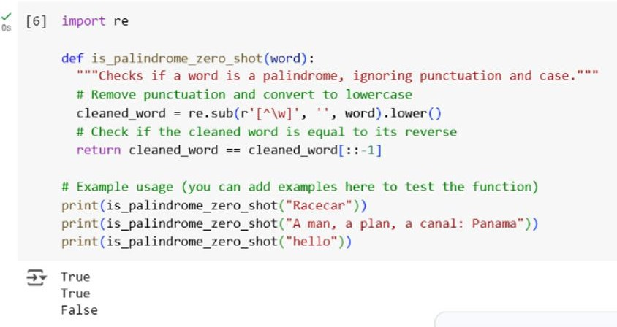

**Few-shot:**

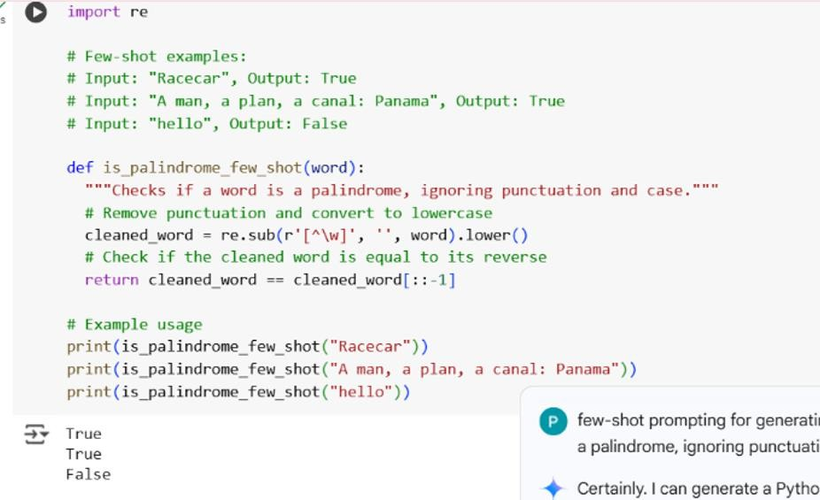

**Comparision:**

|  |  |  |
| --- | --- | --- |
| **Feature** | **Zero-Shot Prompting** | **Few-Shot Prompting** |
| Example s  Provided | No examples of input/output are given. | A few examples of input/output are given to guide the model. |
| Guidanc e Level | Relies solely on the model's pre- training and understanding of the task description. | Provides explicit examples to demonstrate the desired behavior and output format. |
| Complexi ty of Task | More suitable for simpler, well- defined tasks where the expected output is unambiguous. | Can be more effective for complex or nuanced tasks where examples help clarify the requirements. |
| Outcome (in this case) | Generated a correct function for checking palindromes, ignoring punctuation and case. | Generated the same correct function for checking palindromes, ignoring punctuation and case, as the task was relatively simple. |
| Code Generate d | is_palindrome_zero_shot function | is_palindrome_few_shot function (identical code to zero-shot in this case) |

**Explanation:**

* The two functions to check for palindromes, one using a zero-shot prompt (is_palindrome_zero_shot) and one using a few-shot prompt (is_palindrome_few_shot).
* In this particular case, the code generated for both functions and examples is the same

# Task-5:

* + **Prompt:**Use few-shot prompting with 3 sample inputs to generate a function that determines the maximum of three numbers without using the built-in max() function**.**
  + 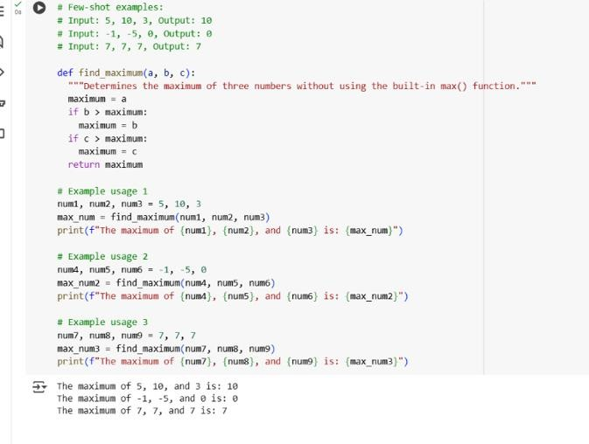

# Explanation:

* **def find_maximum(a, b, c)::** This line defines a function

named find_maximum that takes three arguments: a, b, and c, which are the three numbers you want to compare**.**

* **"""Determines the maximum of three numbers without using the built-in max() function.""":** This is a docstring explaining the function's purpose.
* **maximum = a:** This line initializes a variable

called maximum and assumes that the first number a is the maximum.

* **if b > maximum::** This is a conditional statement. It checks if the second number b is greater than the current value

of maximum.

* **maximum = b:** If b is indeed greater than maximum, the value of maximum is updated to b.
* **if c > maximum::** This is another conditional statement. It

checks if the third number c is greater than the current value of maximum.

* **maximum = c:** If c is greater than the current value of maximum, the value of maximum is updated to c.
* **return maximum:** After checking both b and c against the current maximum, the function returns the final value

of maximum, which will be the largest of the three input numbers.