TASK-1: CODE:

AI CODING

ASSIGNMENT-4.4

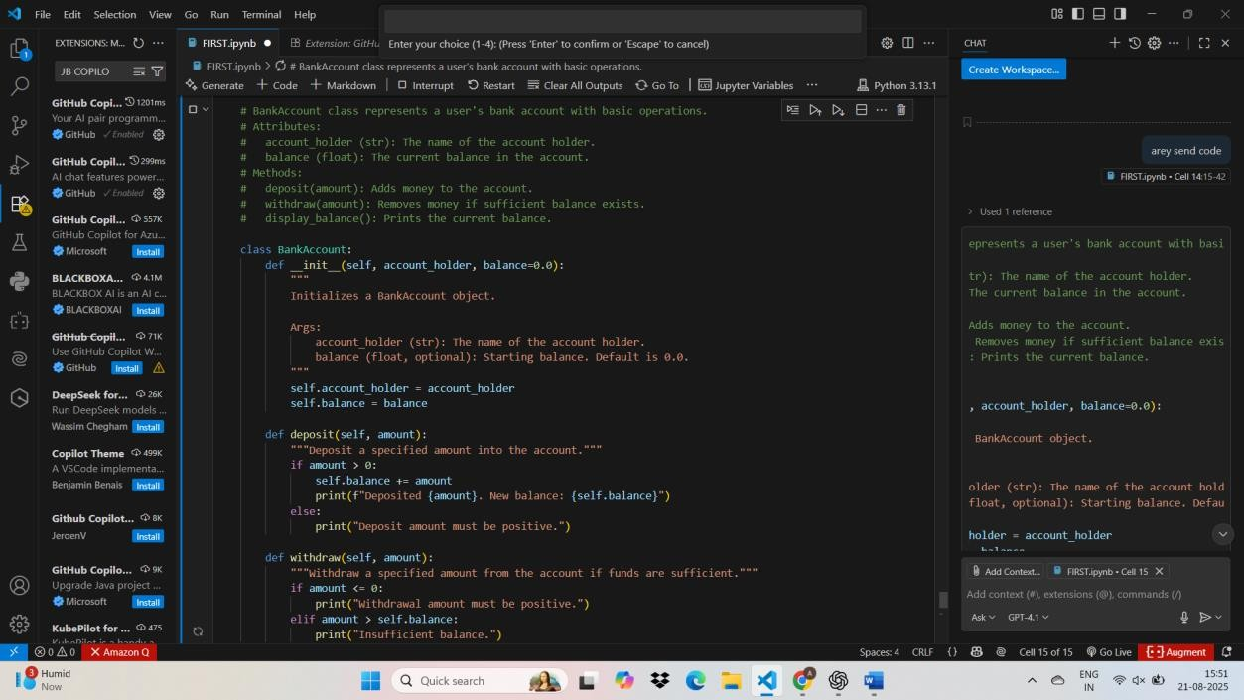

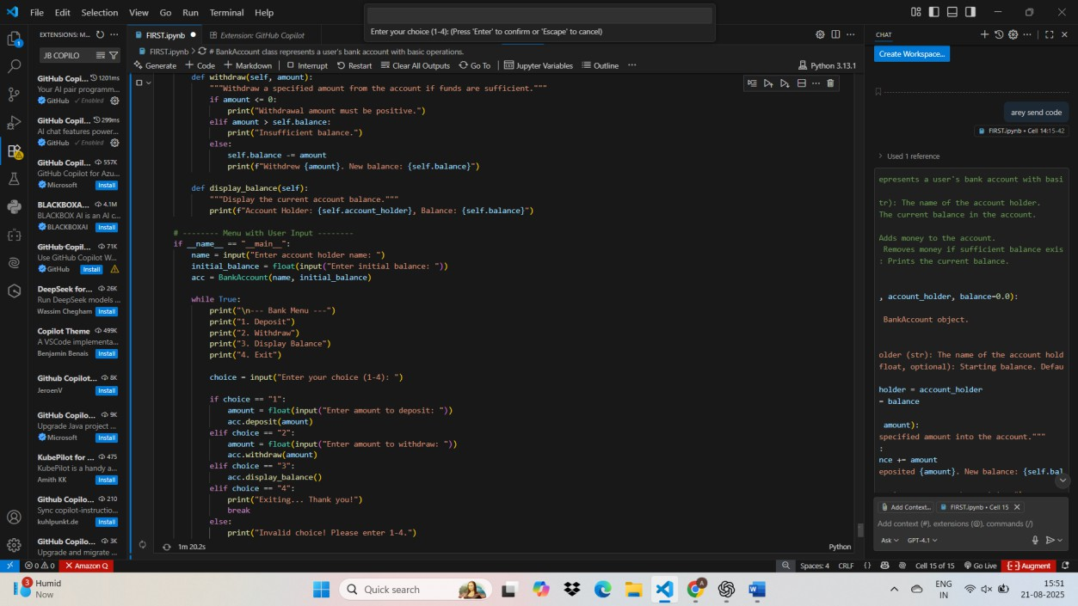

OUTPUT:

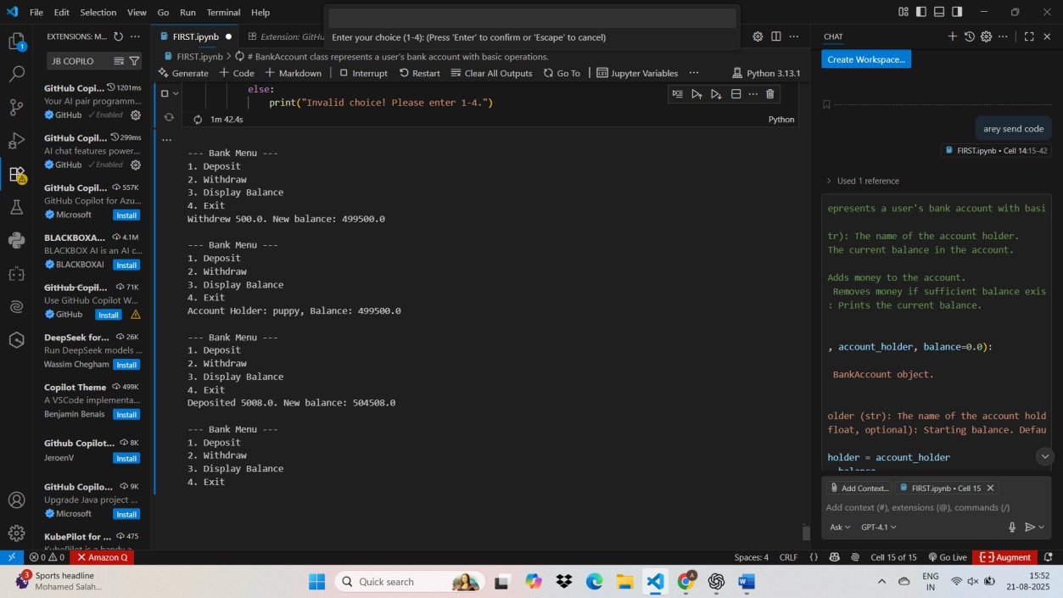

TASK-2

CODE WITH OUTPUT:

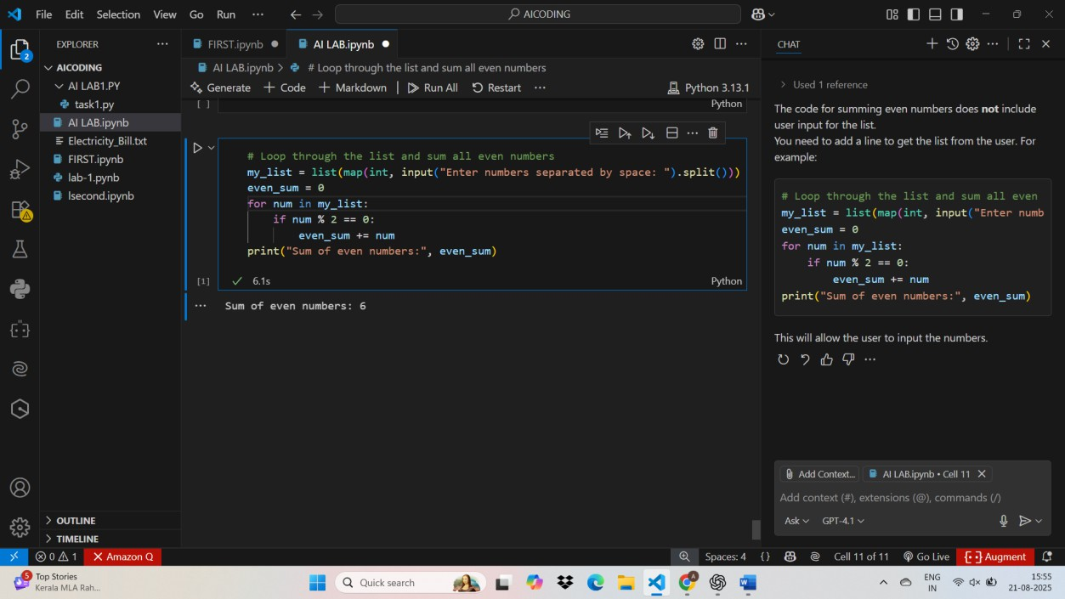

TASK3:

CODE WITH OUTPUT:

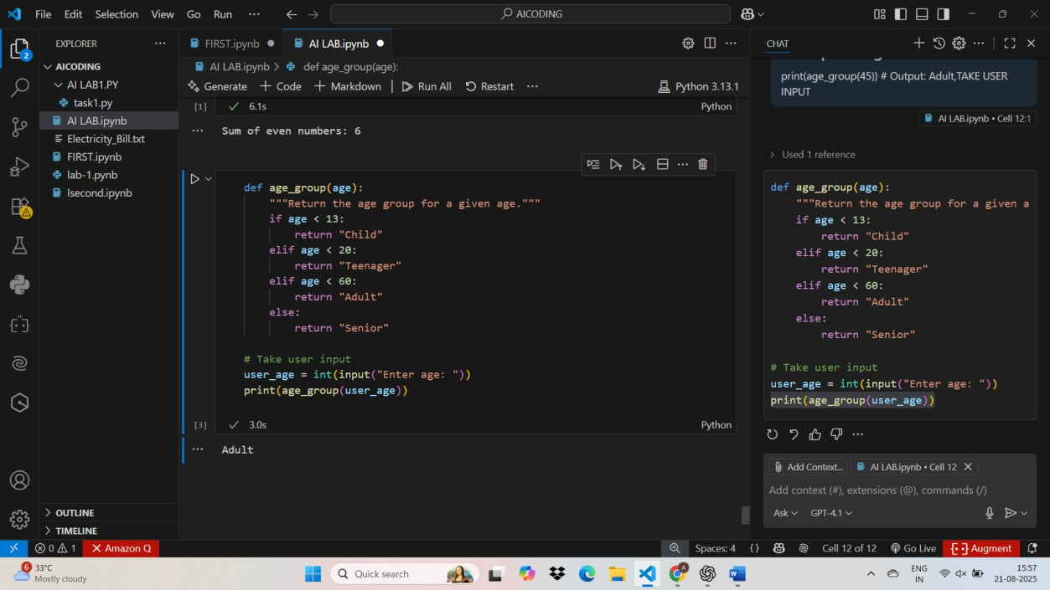

TASK-4:

CODE WITH OUTPUT

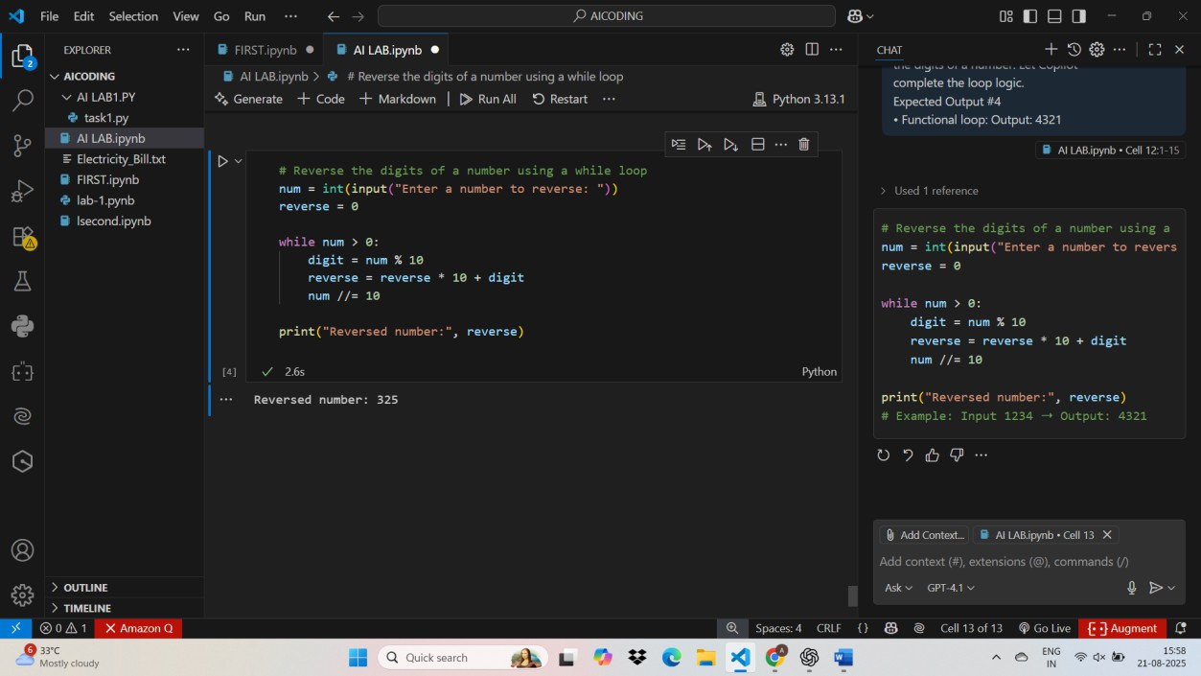

TASK 5:

Code with output:

