**ASSIGNMENT-8.3**

**Task Description#1**

Use AI to generate test cases for is_valid_email(email) and then implement the validator function.

**Requirements:**

* Must contain @ and . characters.
* Must not start or end with special characters.
* Should not allow multiple @.

Task-0

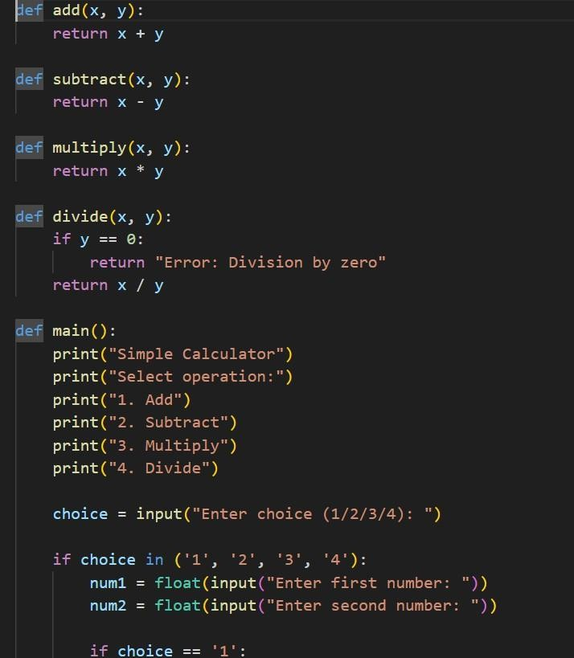

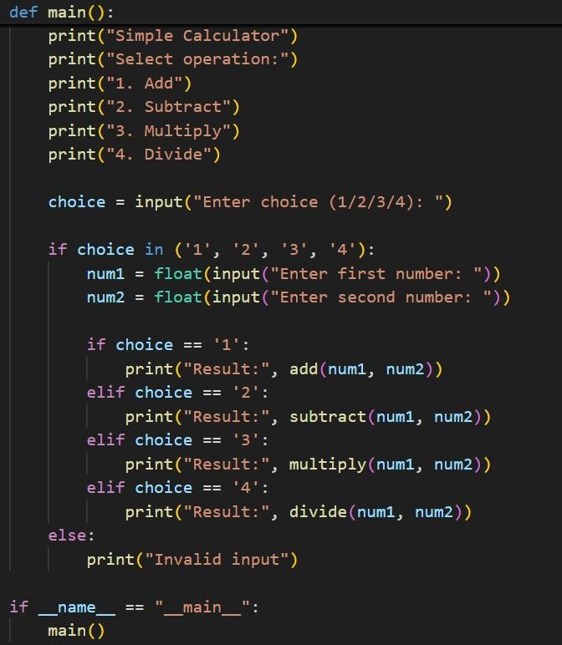

OUTPUT:

