AI ASSITED CODING

ASSIGNEMNT-9.4
G.Swamy
2403A51274
BATCH-12
TASK 1-
Scenario: You have been given a Python function without comments. def calculate_discount(price, discount_rate): return price - (price * discount_rate / 100) • Use an AI tool (or manually simulate it) to generate line-by-line comments for the function. • Modify the function so that it includes a docstring in Google-style or NumPy-style format. • Compare the auto-generated comments with your manually written version.
PROMPT-
Add line-by-line comments to the function calculate_discount(price, discount_rate).
Also write a docstring in Google-style or NumPy-style.
Compare AI-generated comments with manual comments.
CODE-
ORIGINAL FUNCTION-
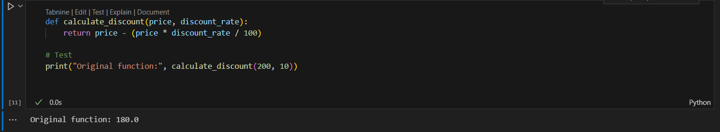
AI-Generated Comments (Simulated)-
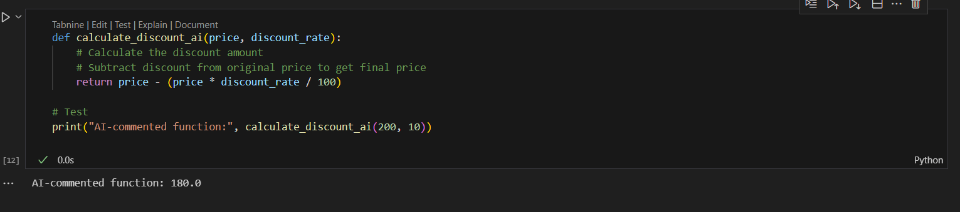
Manual Comments-
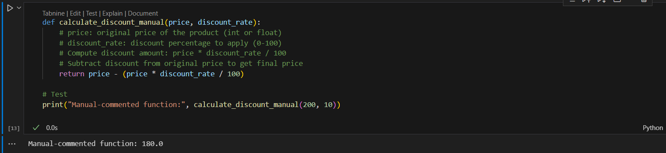
Function with NumPy-Style Docstring
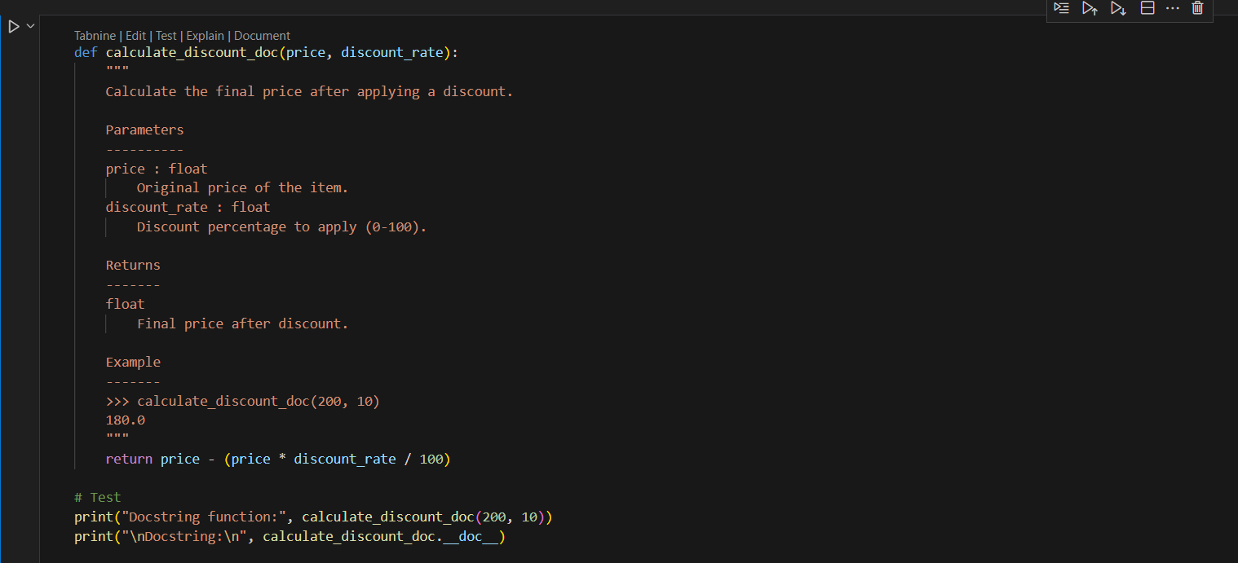
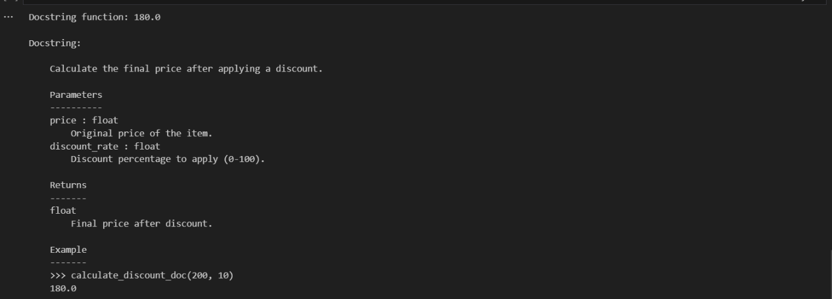
Comparison
AI comments: short and repeats code, little explanation.
Manual comments: detailed, explain parameters, calculation, and reasoning.
Docstring: structured, includes types, return value, and example usage.
TASK 2-
A team is building a Library Management System with
multiple functions.
def add_book(title, author, year):
# code to add book
pass
def issue_book(book_id, user_id):
# code to issue book
Pass
• Write a Python script that uses docstrings for each function (with
input, output, and description)
PROMPT-
Write a Python script for a Library Management System with functions add_book(title, author, year) and issue_book(book_id, user_id).
Add docstrings for each function describing input parameters, output, and function purpose.
Include print() statements to show example usage.
CODE-
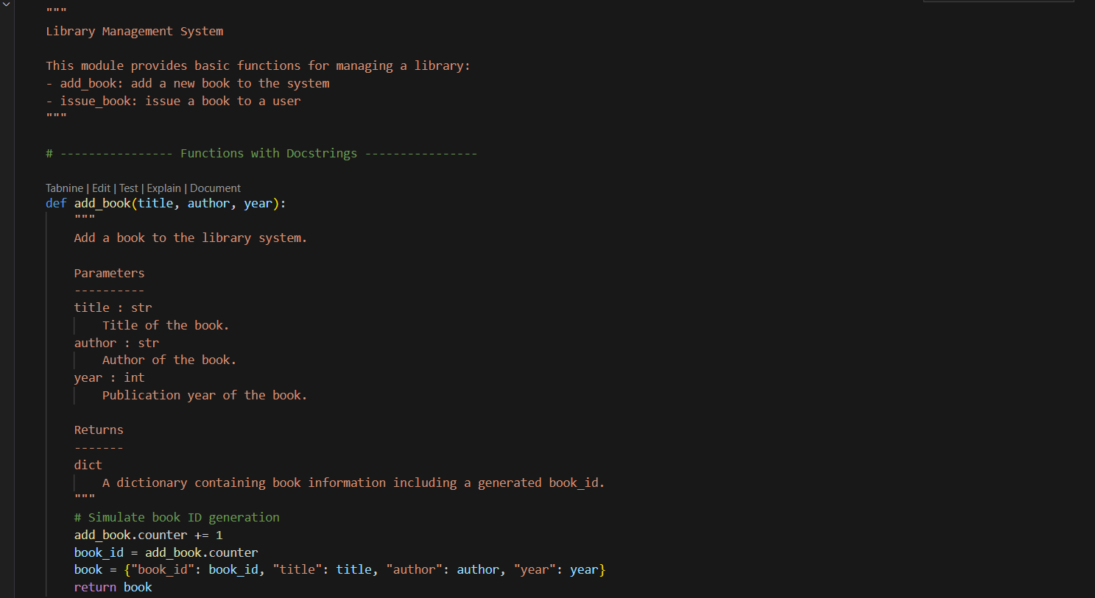
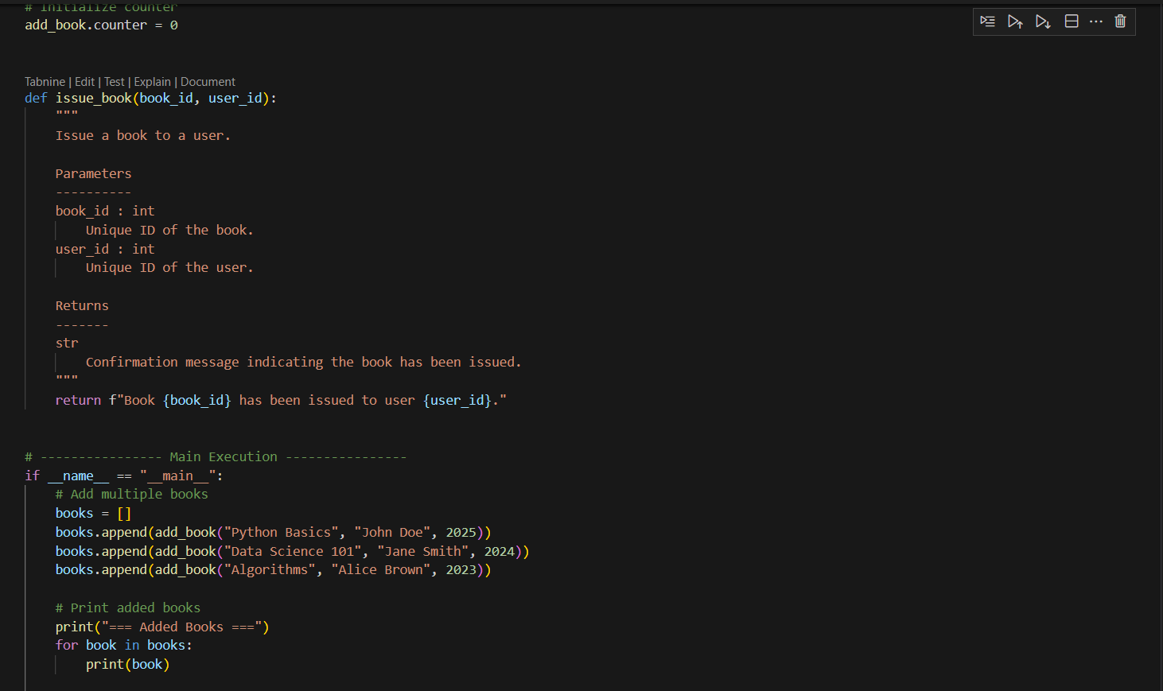
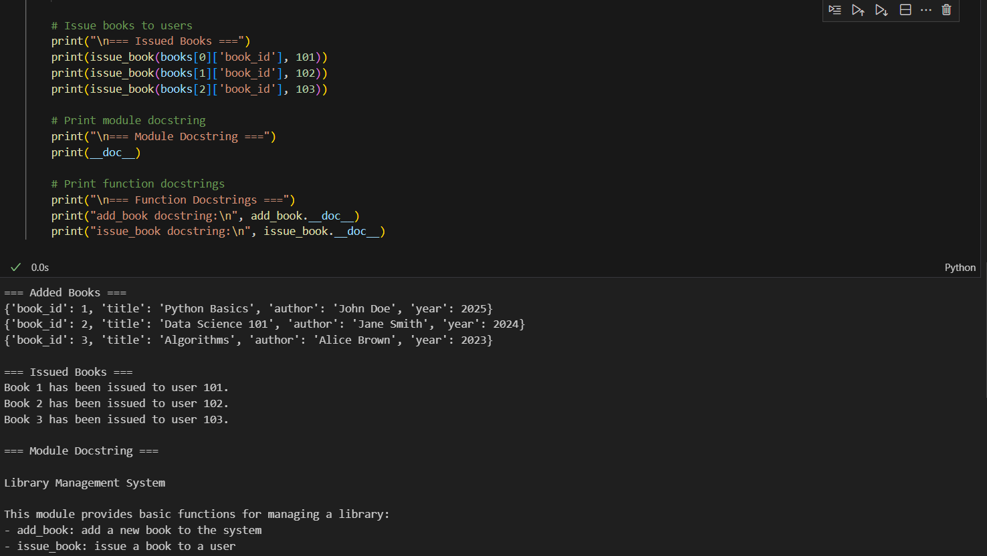
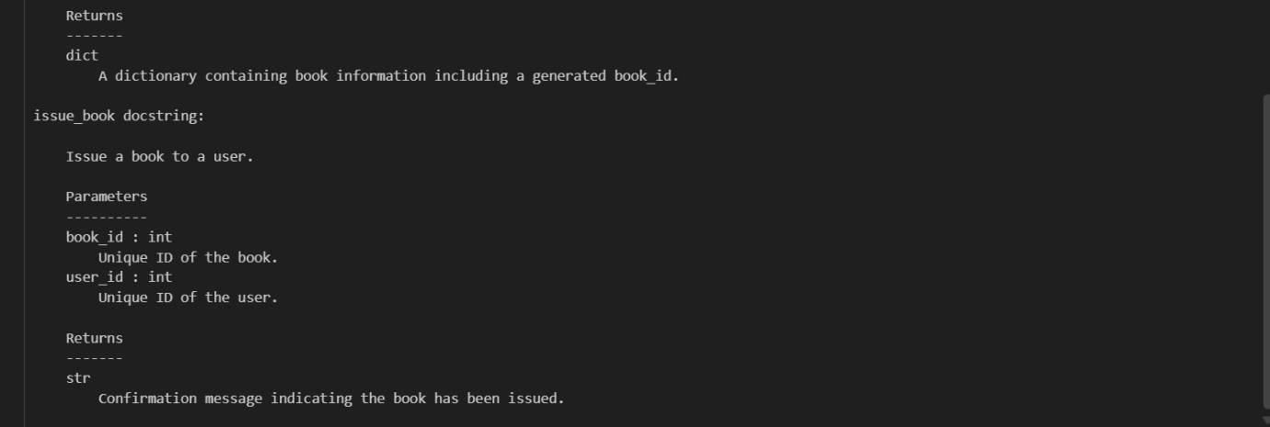
TASK 3-
Scenario: You are reviewing a colleague’s codebase containing long
functions.

def process_sensor_data(data):
cleaned = [x for x in data if x is not None]
avg = sum(cleaned)/len(cleaned)
anomalies = [x for x in cleaned if abs(x - avg) > 10]
return {"average": avg, "anomalies": anomalies}
• Generate a summary comment explaining the purpose of the
function in 2–3 lines.
• Create a flow-style comment (step-by-step explanation).
• Write a short paragraph of documentation describing possible use
cases of this function in real-world scenarios.

PROMPT-

Explain this function in 2–3 lines, add step-by-step comments, write a short real-life use case paragraph, add a Google-style docstring, and include print statements to show cleaned data, average, anomalies, and final result:

def process_sensor_data(data):
cleaned = [x for x in data if x is not None]
avg = sum(cleaned)/len(cleaned)
anomalies = [x for x in cleaned if abs(x - avg) > 10]
return {"average": avg, "anomalies": anomalies}

CODE-
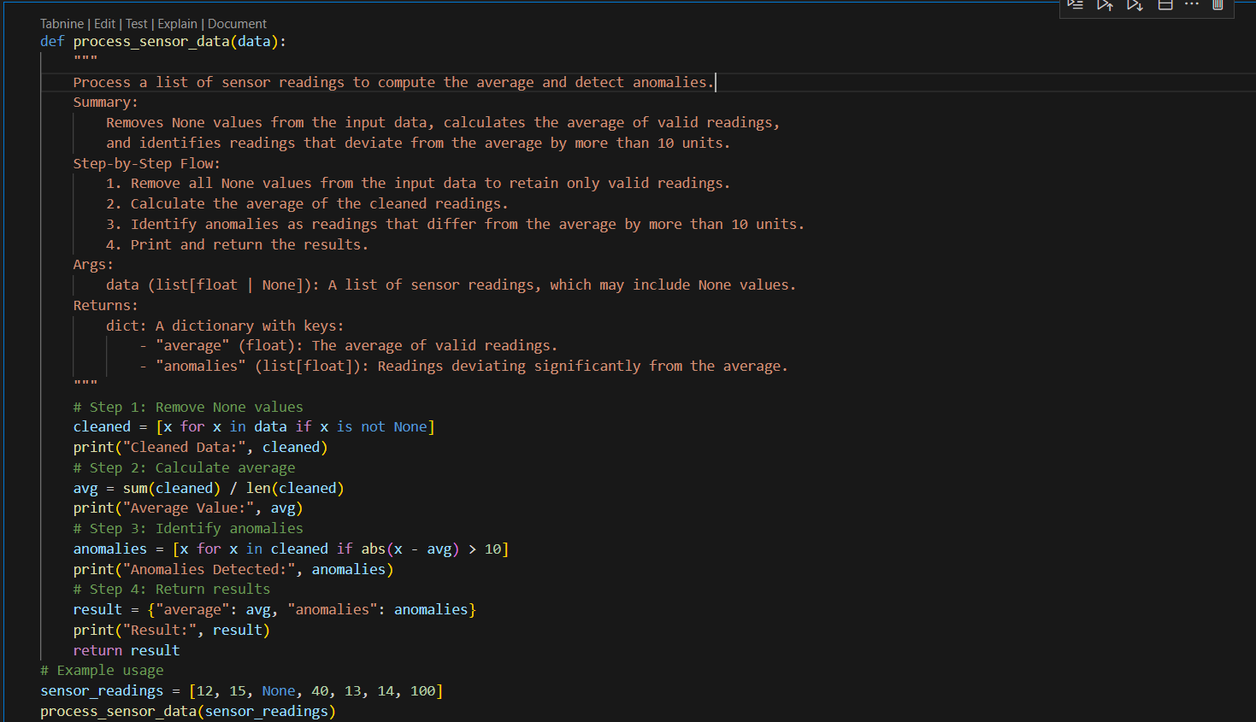
OUTPUT-
