AI ASSISTED CODING

ASSIGNMENT-9.3
G.Swamy
2403A51274
BATCH-12
TASK-1
Basic Docstring Generation
• Write python function to return sum of even and odd numbers in the given list
• Incorporate manual docstring in code with Google Style.
• Use an AI-assisted tool (e.g., Copilot, Cursor AI) to generate a docstring describing the function.
• Compare the AI-generated docstring with your manually written one
PROMPT-
Generate a Google-style docstring for the following Python function that calculates and returns the sum of even and odd numbers in a given list. The docstring should include a short description, parameters with type hints, and return values with type hints. Do not include input-output examples.
CODE-
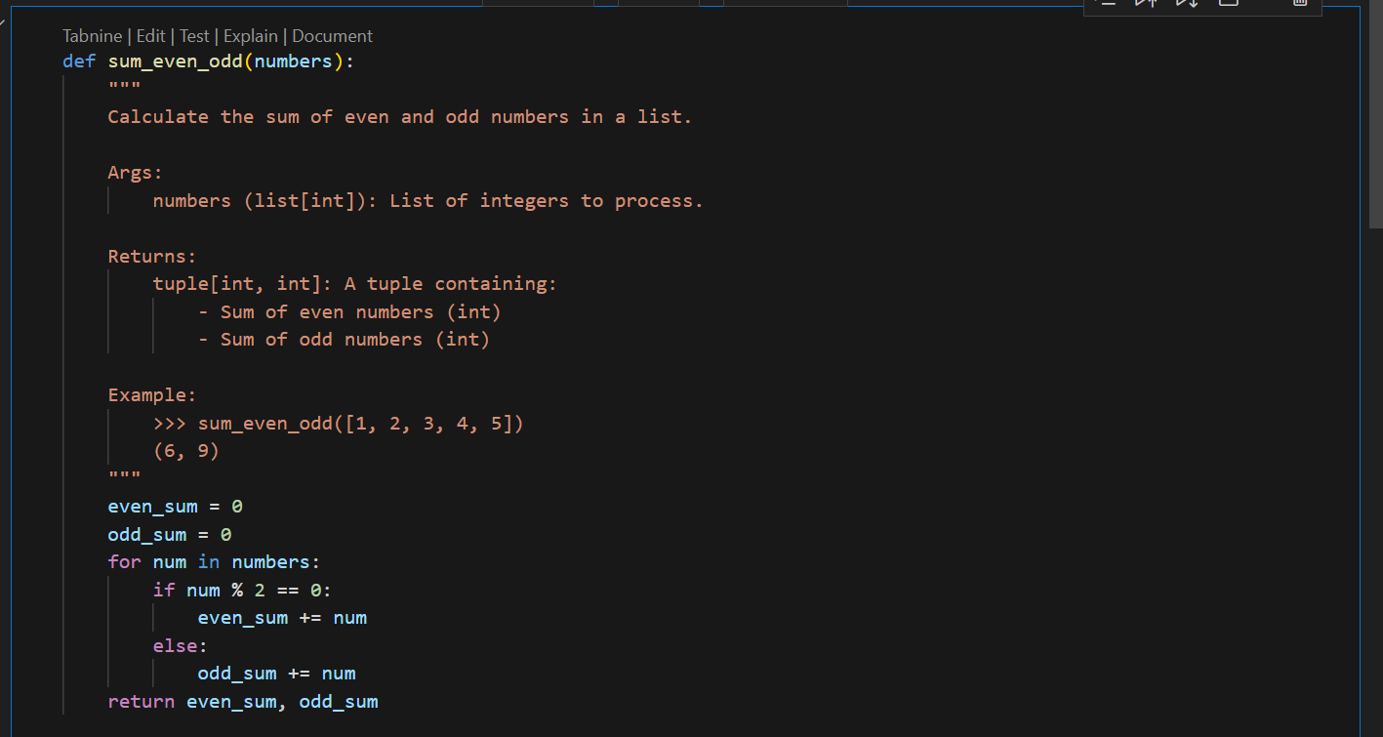
AI GENERATED DOCSTRING-
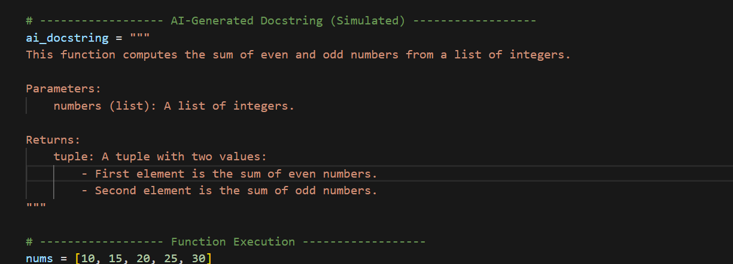
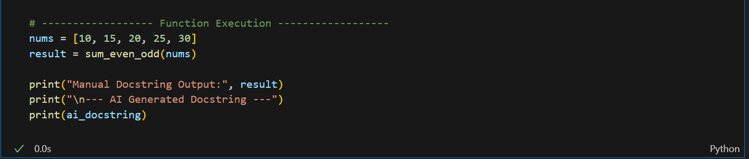
OUTPUT-
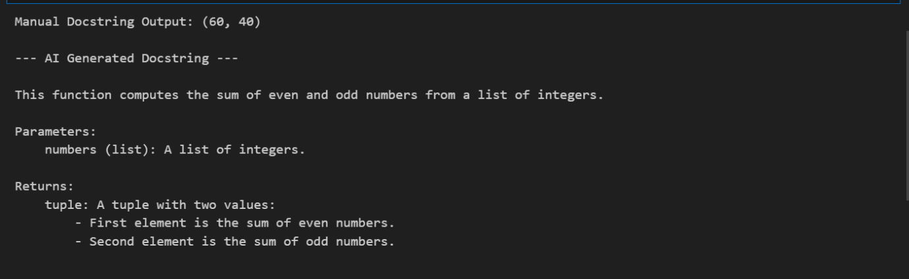
COMPARISON-
- Manual Docstring (Google Style)
  - More structured.
  - Includes type hints (list[int], tuple[int, int]).
  - Provides an Example for clarity.
- AI-Generated Docstring
  - Simpler, less detailed.
  - Doesn’t specify types precisely (just says list and tuple).
  - Lacks example usage.
👉 Conclusion: The manual version is more professional and precise, while the AI one is shorter and easier to write but misses some details

TASK 2-
Write python program for sru_student class with attributes like name, roll no.,
hostel_status and fee_update method and display_details method.
• Write comments manually for each line/code block
• Ask an AI tool to add inline comments explaining each line/step.
• Compare the AI-generated comments with your manually written one.
MANUAL COMMENTS-CODE-
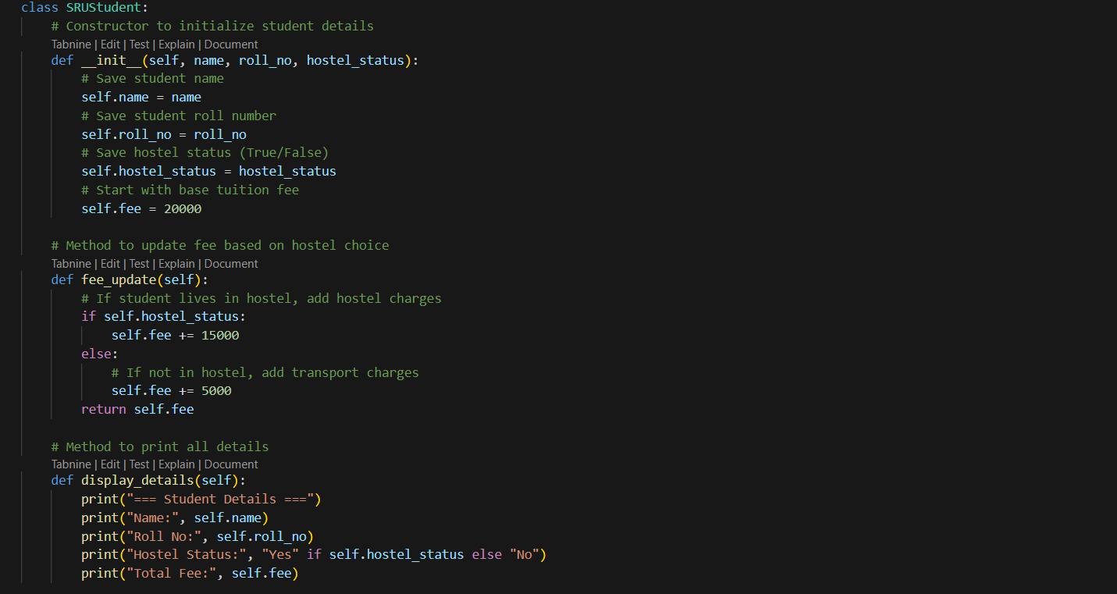
OUTPUT-
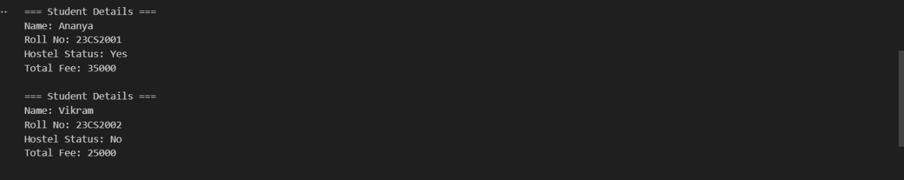

PROMPT-
Add inline comments to this Python class SRUStudent which has attributes like name, roll no., hostel_status, and methods fee_update and display_details. The comments should explain each line or step in simple terms
CODE-
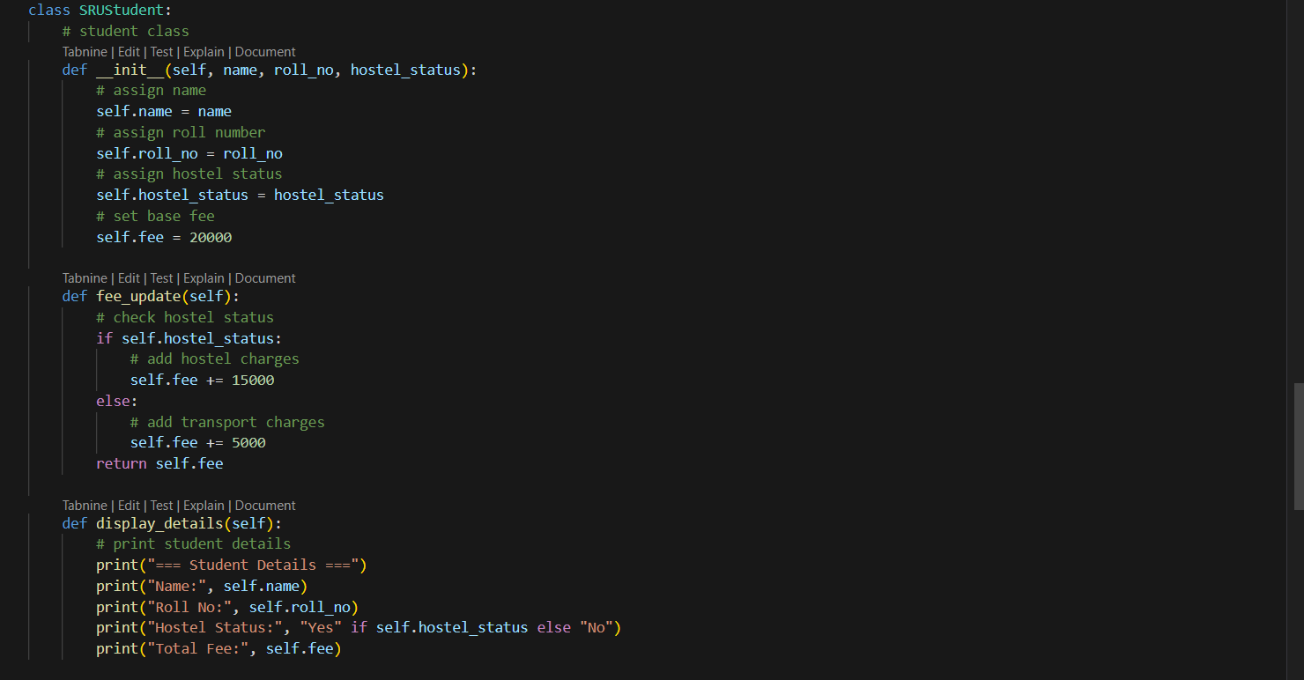
OUTPUT-
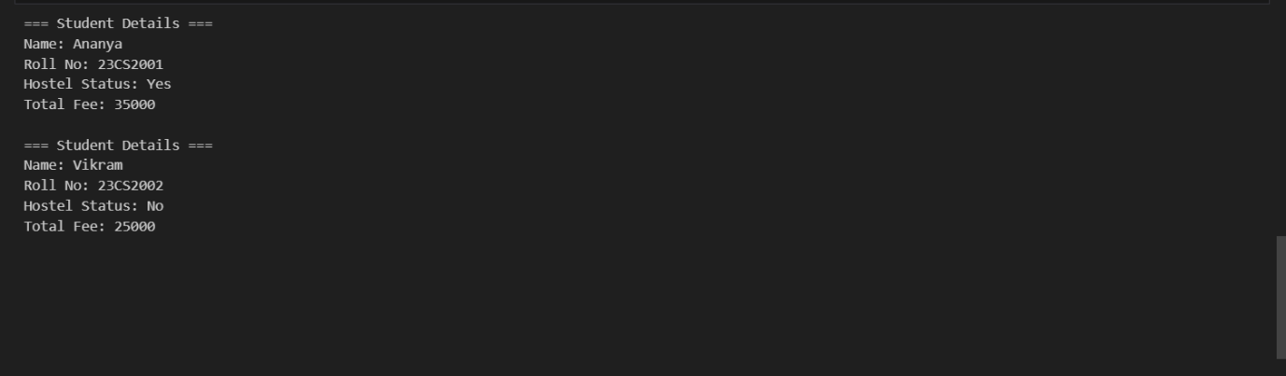
TASK 3-
Write a Python script with 3–4 functions (e.g., calculator: add, subtract, multiply,
divide).
• Incorporate manual docstring in code with NumPy Style
• Use AI assistance to generate a module-level docstring + individual function
docstrings.
• Compare the AI-generated docstring with your manually written one.
PROMPT-
Write a module-level and function-level docstring in NumPy style for a Python calculator with functions add, subtract, multiply, and divide. Include parameter types, return types, and error handling.
CODE-
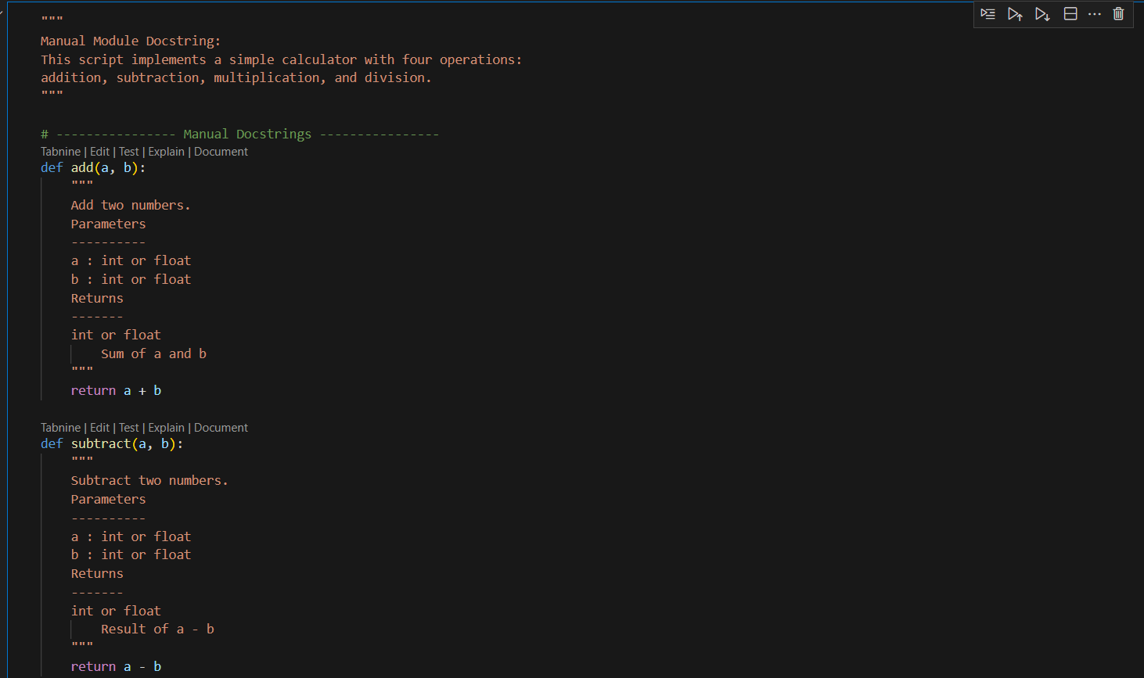
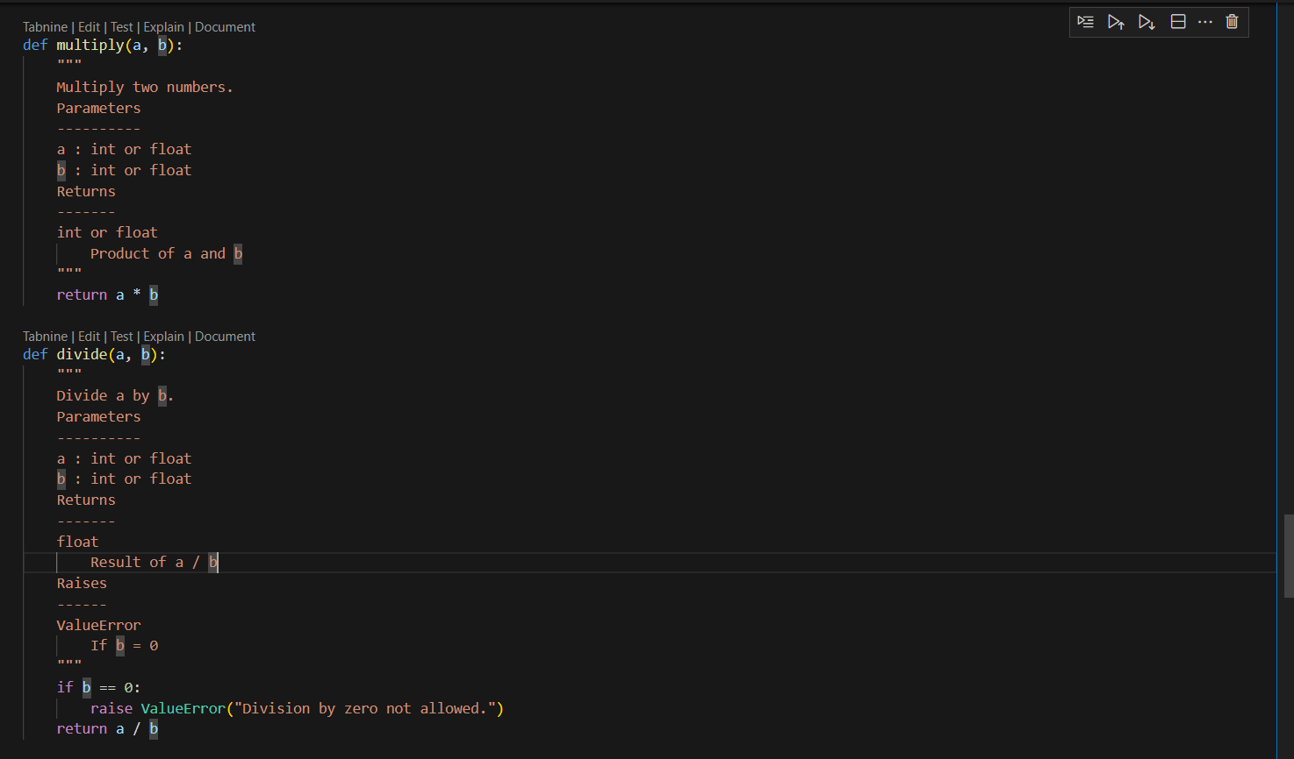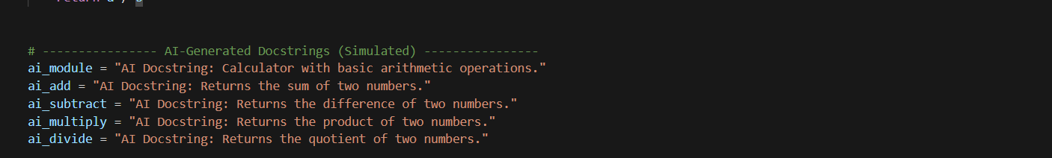
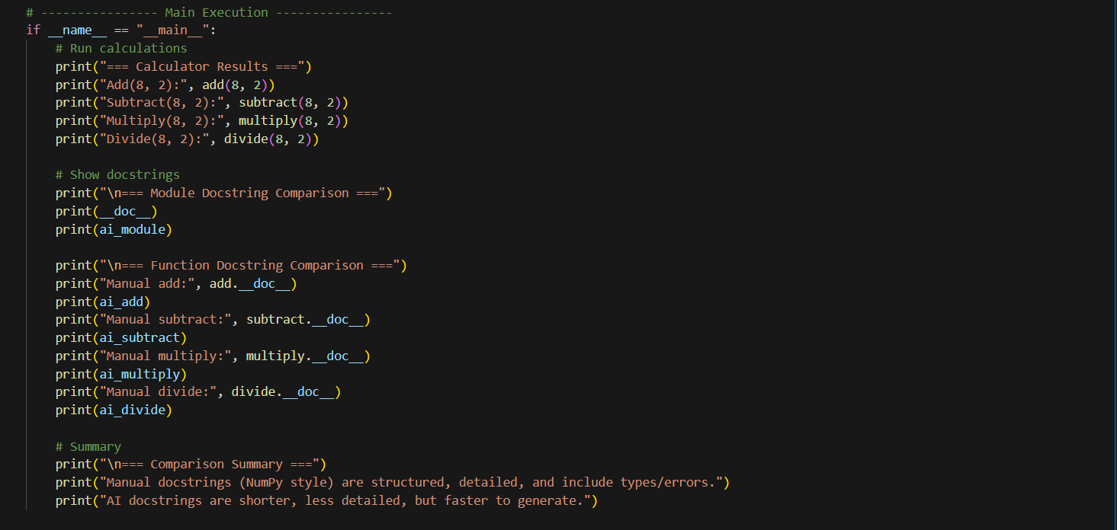
OUTPUT-
