AI Assisted Coding

Assignment-10.3

G.Swamy

2403A51274

Batch12
Task-1:
Prompt:
Refactor the following nested conditional Python code for better readability. Aim to simplify the logic using cleaner structures such as dictionaries, helper functions, or other Pythonic approaches:
def discount(price, category):
if category == "student":
if price > 1000:
return price * 0.9
else:
return price * 0.95
else:
if price > 2000:
return price * 0.85
else:
return price

Expected Output:
• Refactored code using cleaner logic, possibly a dictionary or separate
helper functions.

Code:
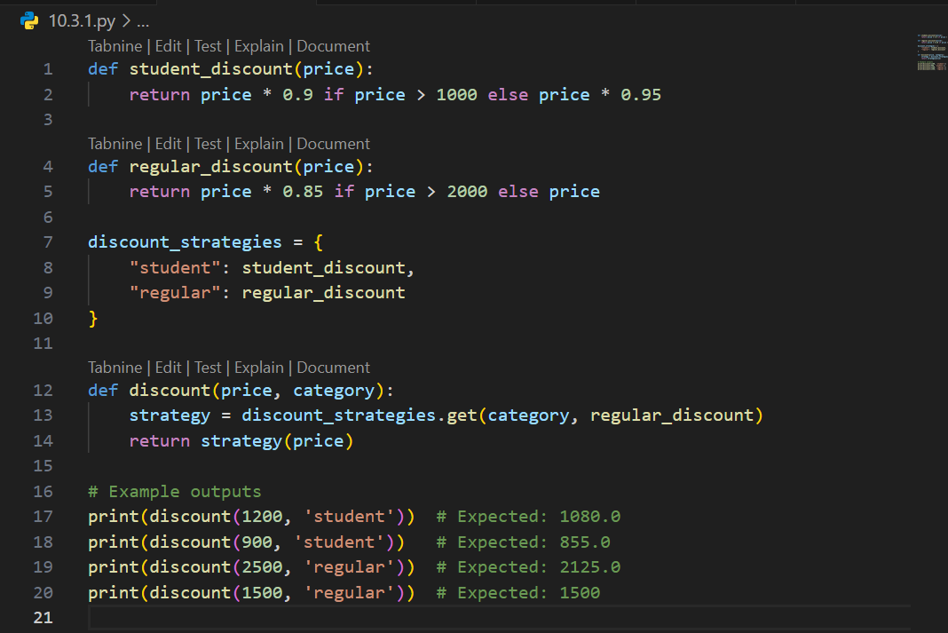
Output:
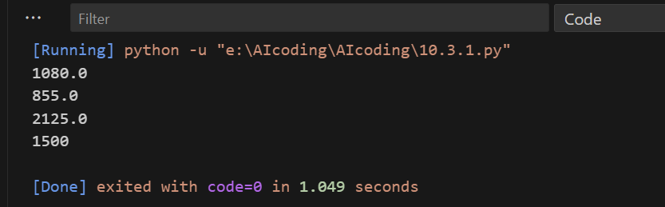

Task-2:

Prompt:
Refactor the following Python code to eliminate redundant nested loops. Optimize it using more efficient Python features such as sets:
def find_common(a, b):
res = []
for i in a:
for j in b:
if i == j:
res.append(i)
return res
Expected Output:
Cleaner version using Python sets (set(a) & set(b))

Code:

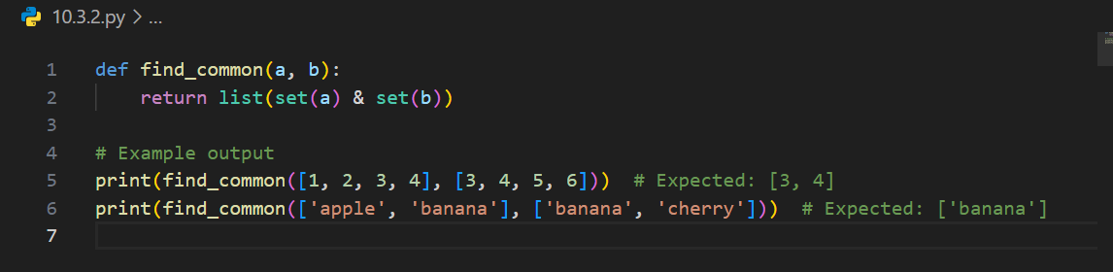

Output:
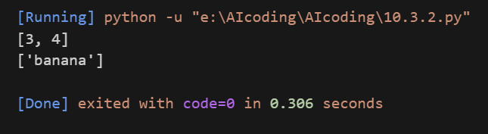
Task-3:

Prompt:
Refactor the following Python class to improve readability and maintainability. Apply proper naming conventions, encapsulation, and clear method responsibilities. Add docstrings for better understanding.
class emp:
def __init__(self,n,s):
self.n=n
self.s=s
def inc(self,p):
self.s=self.s+(self.s*p/100)
def pr(self):
print("emp:",self.n,"salary:",self.s)
Expected Output:
• Employee class with meaningful methods (increase_salary,
display_info), formatted output, and added docstrings.

Code:

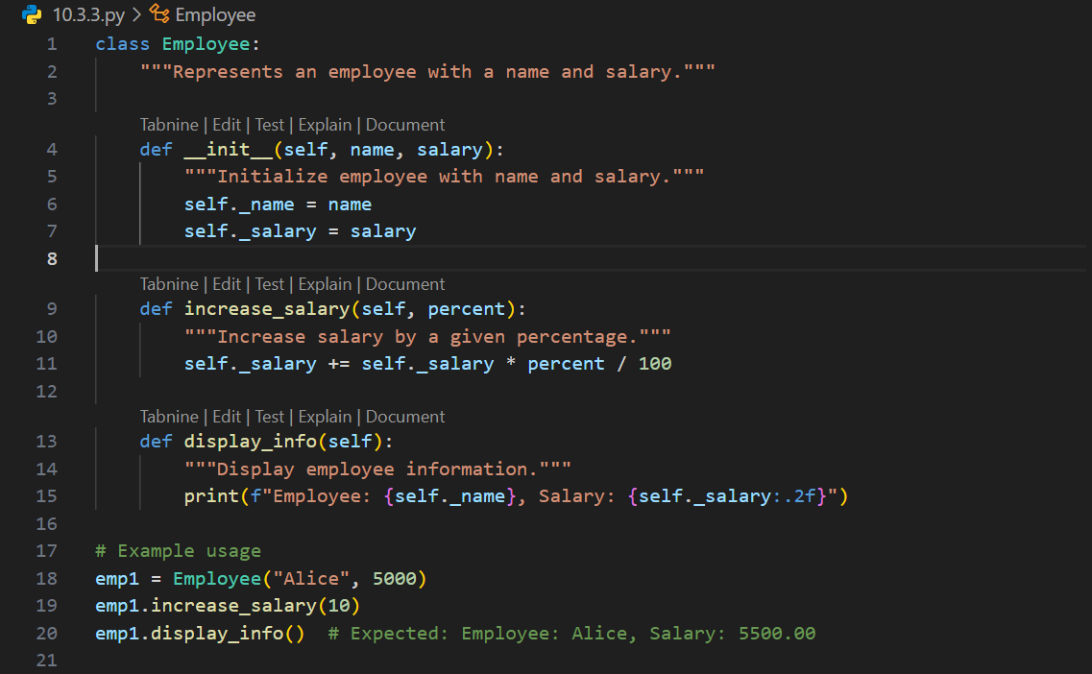
Output:
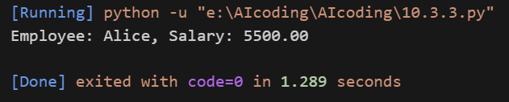

Task-4:

Prompt:
Refactor the following long, unstructured Python function by breaking it into smaller, reusable helper functions. Improve readability and maintainability by modularizing the logic.
def process_scores(scores):
total = 0
for s in scores:
total += s
avg = total / len(scores)
highest = scores[0]
for s in scores:
if s > highest:
highest = s
lowest = scores[0]
for s in scores:
if s < lowest:
lowest = s
print("Average:", avg)
print("Highest:", highest)
print("Lowest:", lowest)

Expected Output:
• Split into functions: calculate_average, find_highest, find_lowest.
• Clean main process_scores() using helper functions.

Code:
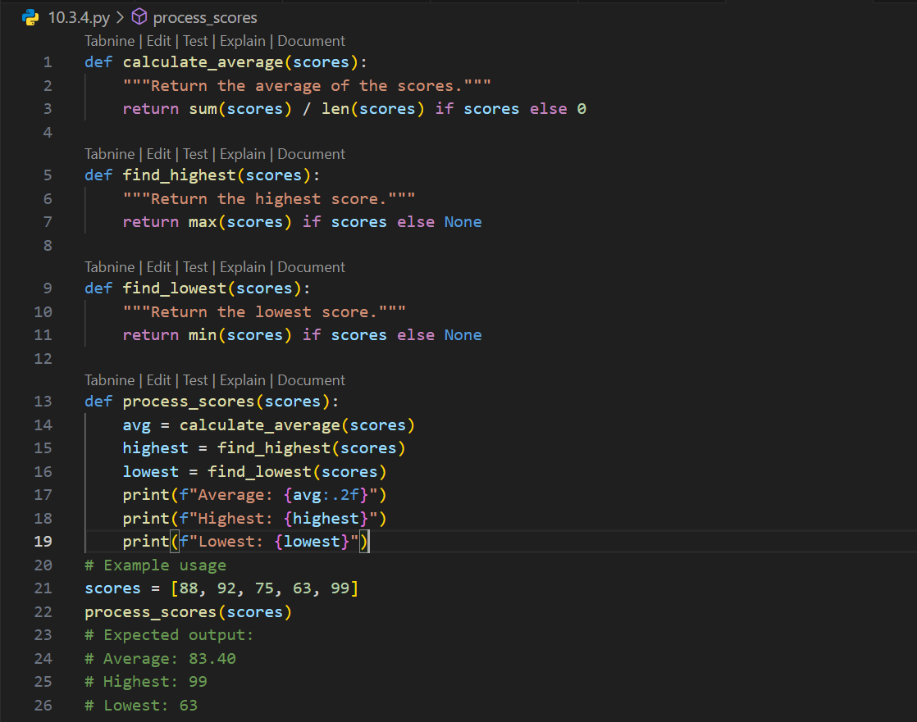
Output:
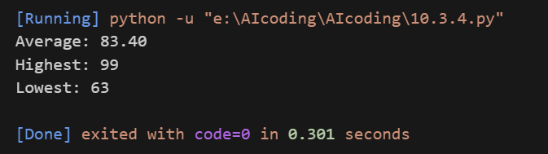

Task-5:

Prompt:
Review and refactor the following Python code to improve error handling, naming conventions, and readability. Add a docstring that explains the function and its error handling.
def div(a,b):
return a/b
print(div(10,0))
Expected Output:
• Function with proper error handling using try-except.
• Better naming (divide_numbers).
• AI-generated docstring explaining error handling.

Code:
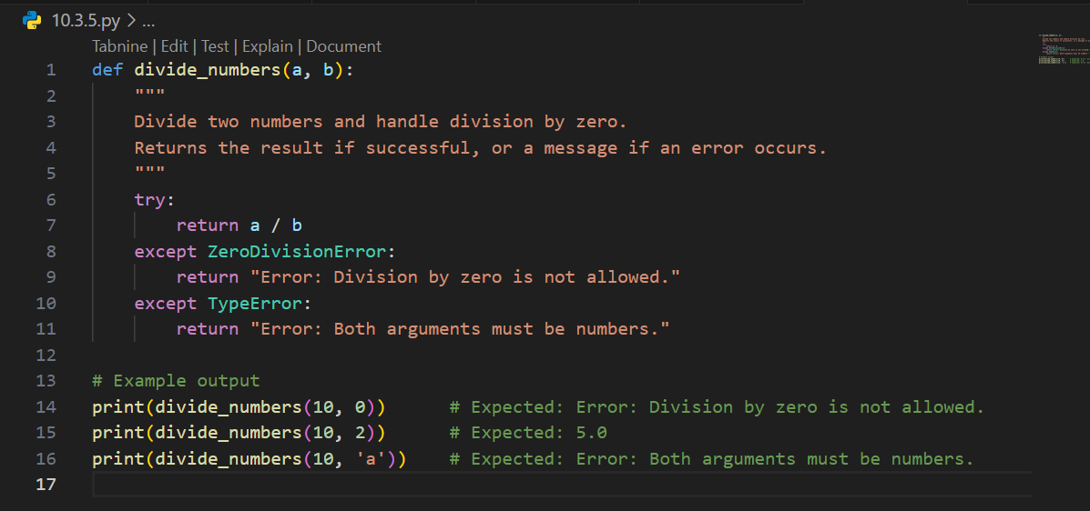

Output:
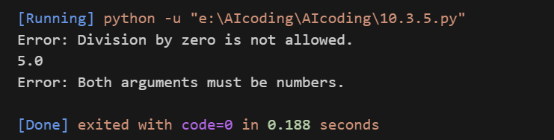
Task-6:

Prompt:
Simplify the following overly complex Python function that uses deeply nested conditionals. Refactor it into a cleaner version using elif statements or a dictionary mapping for better readability and maintainability.
def grade(score):
if score >= 90:
return "A"
else:
if score >= 80:
return "B"
else:
if score >= 70:
return "C"
else:
if score >= 60:
return "D"
else:
return "F"

Expected Output:
• Cleaner logic using elif or dictionary mapping.

Code:
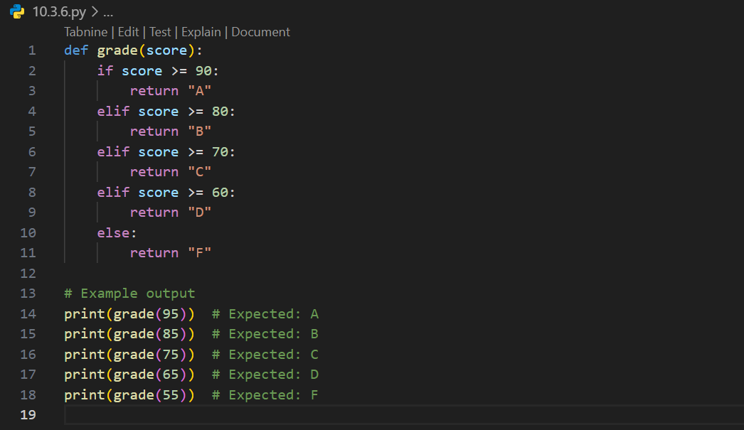

Output:
