AI ASSISTED CODING
LAB EXAM
Name-G.Swamy
Ht No-2403A51274
Batch-12

Subgroup O
O.1 — [S18O1] Point-in-polygon (ray cas ng) Context:
Geofencing checks in real estate lis ngs pla orm. Your Task:
Ray-cas ng point-in-polygon; edges inside. Data & Edge Cases:
Square example; return booleans.
AI Assistance Expectation:
Crossing-count logic.
Constraints & Notes:
Return list[bool]. Sample Input
poly=[(0,0),(4,0),(4,4),(0,4)], pts=[(2,2),(5,5)]
Sample Output
[True, False]
Acceptance Criteria: Edges inside

AI GENERATED CODE:
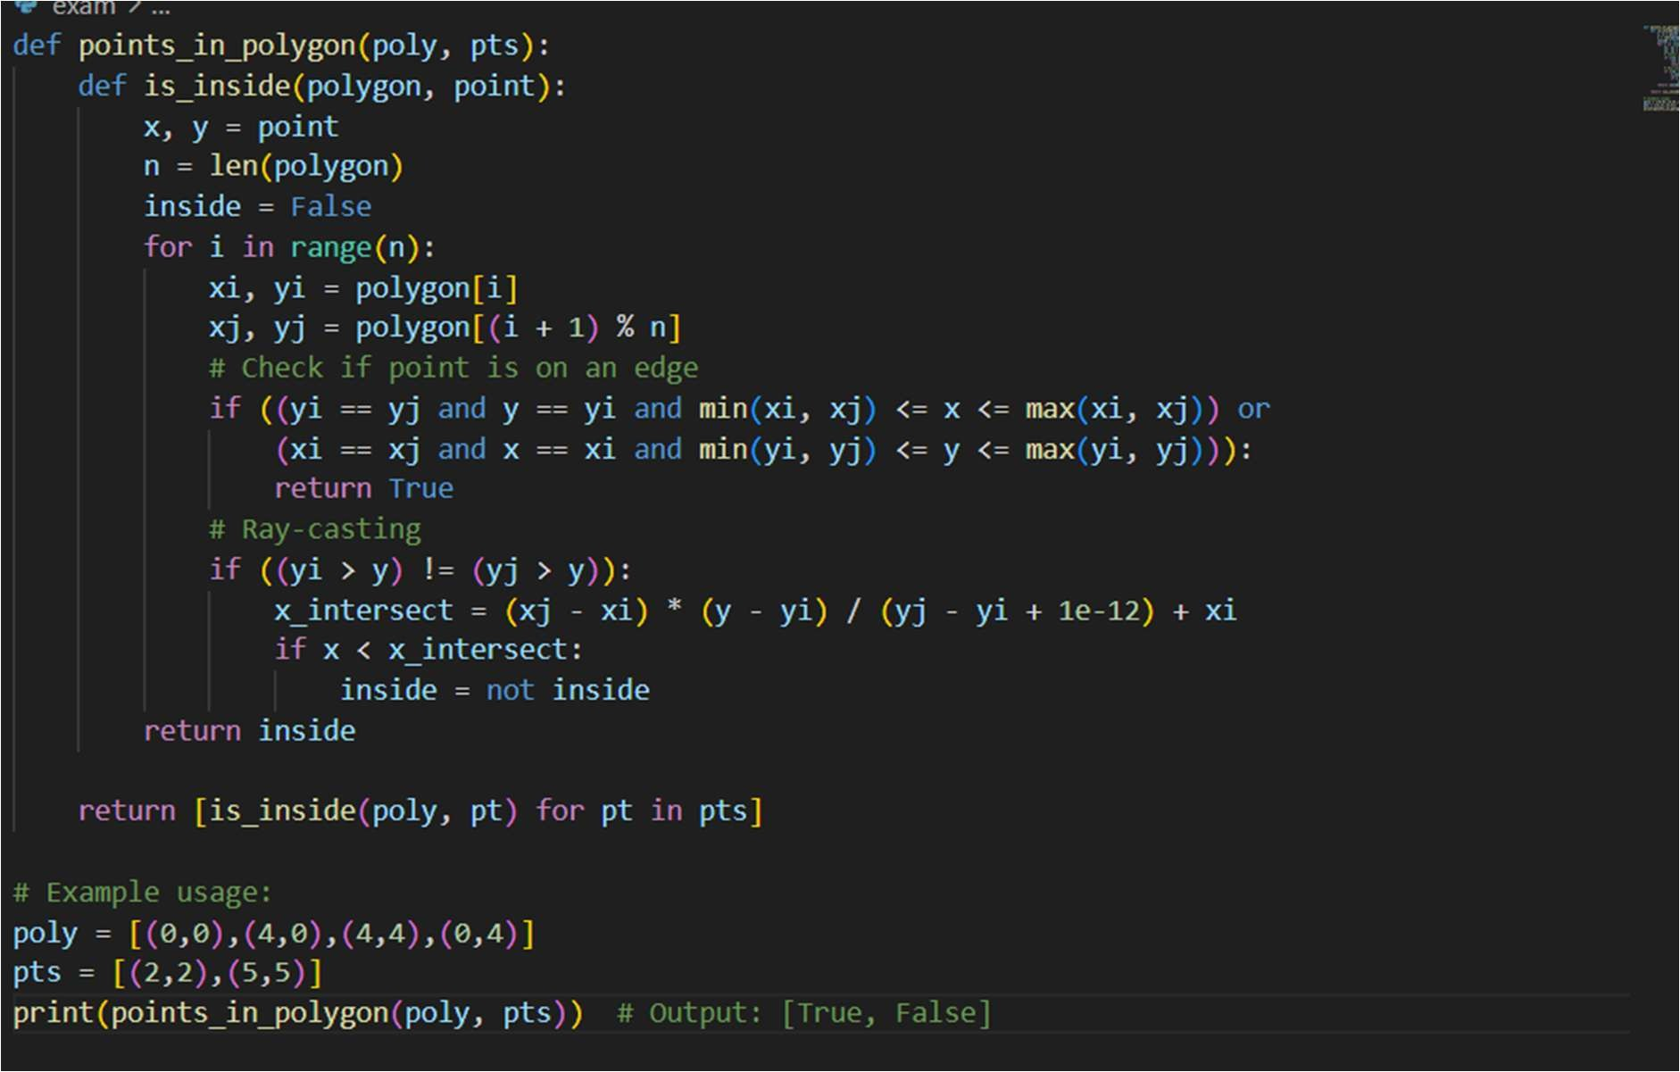
OUTPUT:

O.2 — [S18O2] Compute rolling median (w=3)
Context:
Rolling medians (w=3) for real estate lis ngs pla orm anomaly detec on.
Your Task:
Return median per sliding window; efficient approach.
Data & Edge Cases:
Example list provided; large-n acceptable.
AI Assistance Expectation:
AI to propose bisect/heaps and tests.
Constraints & Notes:
Include small edge tests.
Sample Input
[1, 3, 2, 5, 4]
Sample Output
[2, 3, 4]
Acceptance Criteria: Efficient and correct.

AI-GENERATED CODE: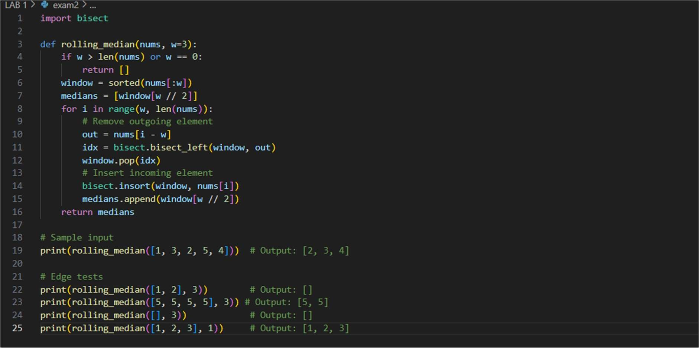
OUTPUT:
