AI Assisted coding

ASSIGNMENT 7.1 Name: [K.UMESH]

batch no: 12 hall ticket no:2403A51277

QUESTION:

Lab Objectives



tools.

-assisted debugging suggestions.



Task 1 – Syntax Error: Missing Parentheses in

Print Statement Buggy Code:

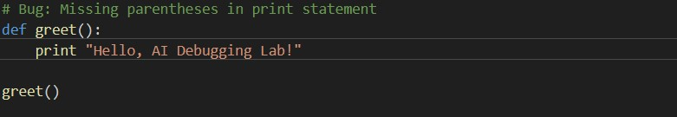

Explanation:

AI detects a SyntaxError due to the incorrect use of the print statement without parentheses. In

Python 3, print is a function and must be used with parentheses.

Corrected Code:

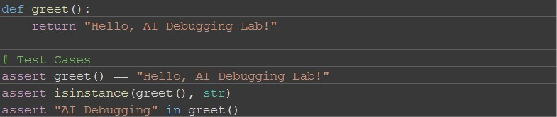

Output

Hello, AI Debugging Lab!

Task 2 – Logic Error: Using = Instead of == Buggy Code:

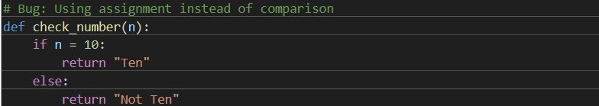

Explanation:

The code uses = (assignment operator) instead of == (comparison operator). In if conditions, == is required to check equality. Using = causes a SyntaxError

CORRECT CODE:

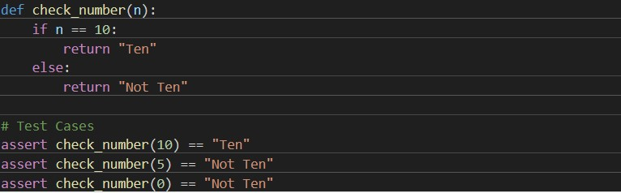

Output:

Ten

Not Ten

Not Ten

Task 3 – Runtime Error: File Not Found Buggy Code:

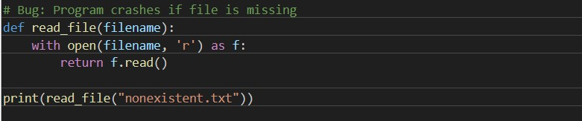

Explanation:

Attempting to open a non-existent file raises a FileNotFoundError. AI suggests using a try- except block to handle this gracefully.

Corrected Code:

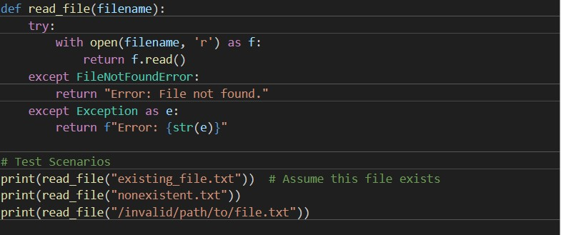

Output Examples

<file content if file exists>

Error: File not found.

Error: [Errno 2] No such file or directory: '/invalid/path/to/file.txt'

Task 4 – AttributeError: Calling Undefined

Method

Buggy Code:

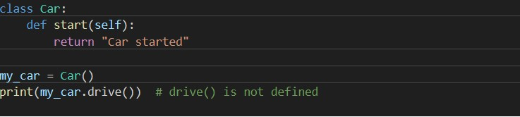

Explanation:

Calling a method drive() which is not defined in the Car class causes an AttributeError. AI suggests either defining the drive() method or correcting the method call if it was a typo. Corrected Code (Option 1: Define the method)

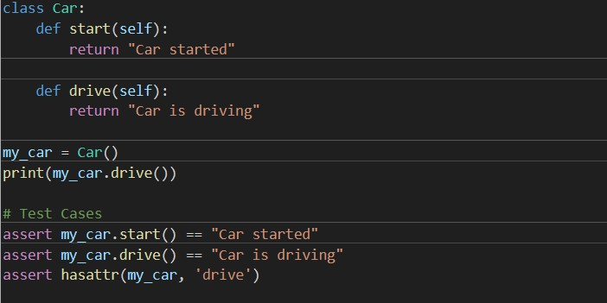

Output:

Car is driving

Task 5 – TypeError: Mixing Strings and

Integers

Buggy Code:

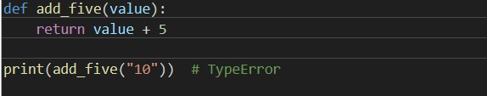

Explanation:

This causes a TypeError because a string ("10") and an integer (5) cannot be added directly. AI suggests two fixes:

1. Convert string to integer before adding.
2. Convert integer to string for concatenation.

Solution 1: Type Casting

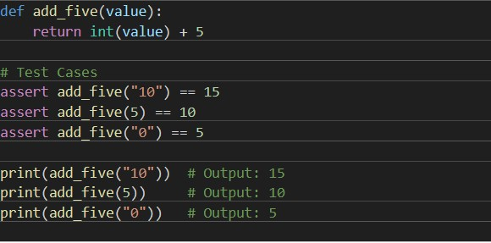

def add_five(value): return int(value) + 5 Output

15

10

5

Solution 2: String Concatenation

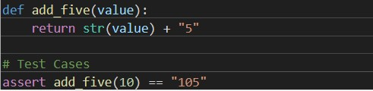

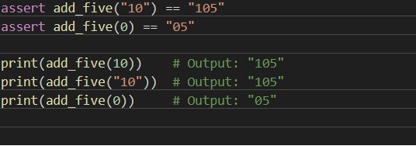

Output

105

105

05