LabTest-2

Roll NO: 2403A51294

Batch: 24BTCAICSB12 Date:19-09-2025

Question-1: (A)

A.1 — [S18A1] Compute per-probe average from logs (AI completion)

PROMPT:

Write a Python function compute_probe_averages(raw_text) that parses telemetry logs (id,timestamp,ppm) and returns (dict{id: avg}, overall_avg).

Requirements:

* Skip malformed lines or non-numeric ppm.
* O(n) pass, averages rounded to 2 decimals.
* overall_avg=None if no valid data.

Also provide unittest cases for:

1. Clean input
2. Malformed + non-numeric
3. Empty input

Show full runnable code with function + tests.

CODE:

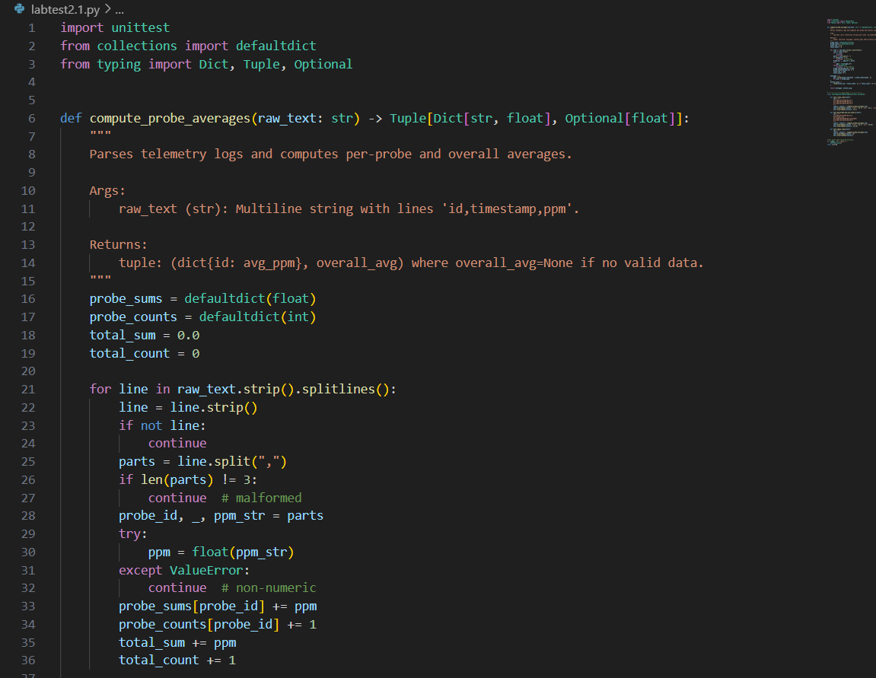

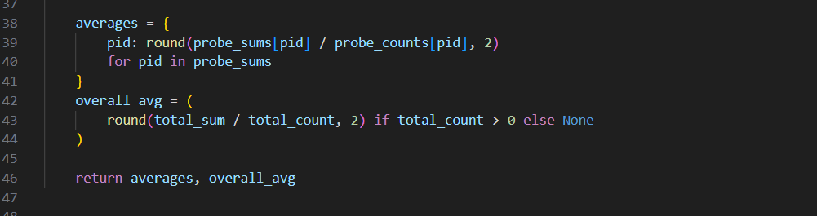

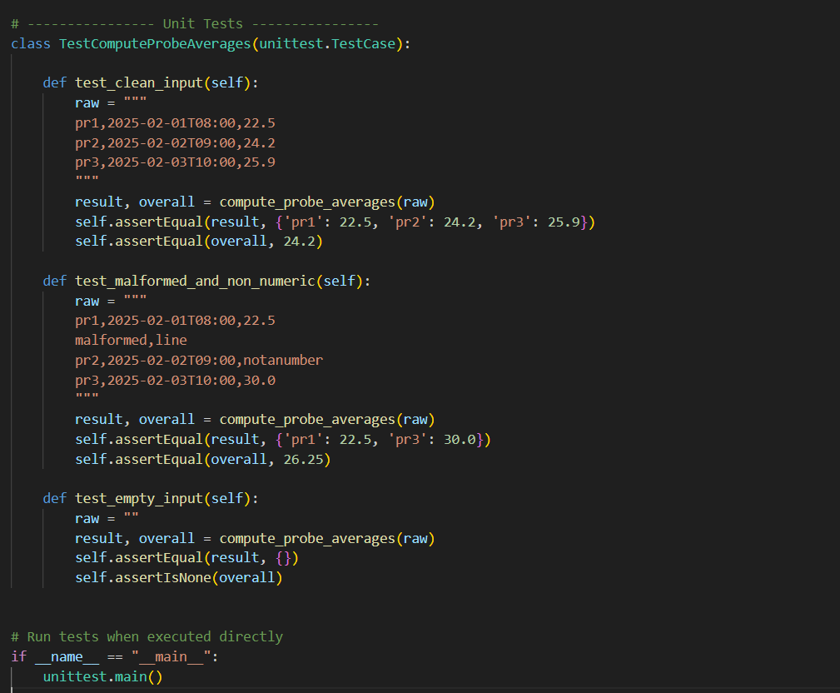

OUTPUT:



Question-2:

A.2 — [S18A2] Implement ListingWindow with add/remove/summary (AI completion)

PROMPT:

Write a Python class ListingWindow to track values keyed by unique IDs.

**Requirements:**

* The class should support three methods:
  1. add(id: str, value: float) → adds or updates a value for the ID (re-adding overwrites).
  2. remove(id: str) → removes the ID if present; safe if missing (no exception).
  3. summary() -> tuple[int, float|None] → returns (count, average).
* Store state in a dictionary (dict). All operations should be O(1).
* The average should be rounded to 2 decimals.
* If the store is empty, return (0, None) for the summary.

**Constraints:**

* Use type hints and docstrings.
* Provide an example usage block that runs the following operations:
* [{'op': 'add', 'id': 'a1', 'value': 12},
* {'op': 'add', 'id': 'b2', 'value': 17},
* {'op': 'remove', 'id': 'a1'},
* {'op': 'add', 'id': 'c3', 'value': 9}]
* The example should print:
* count=2, avg=12.5

CODE:

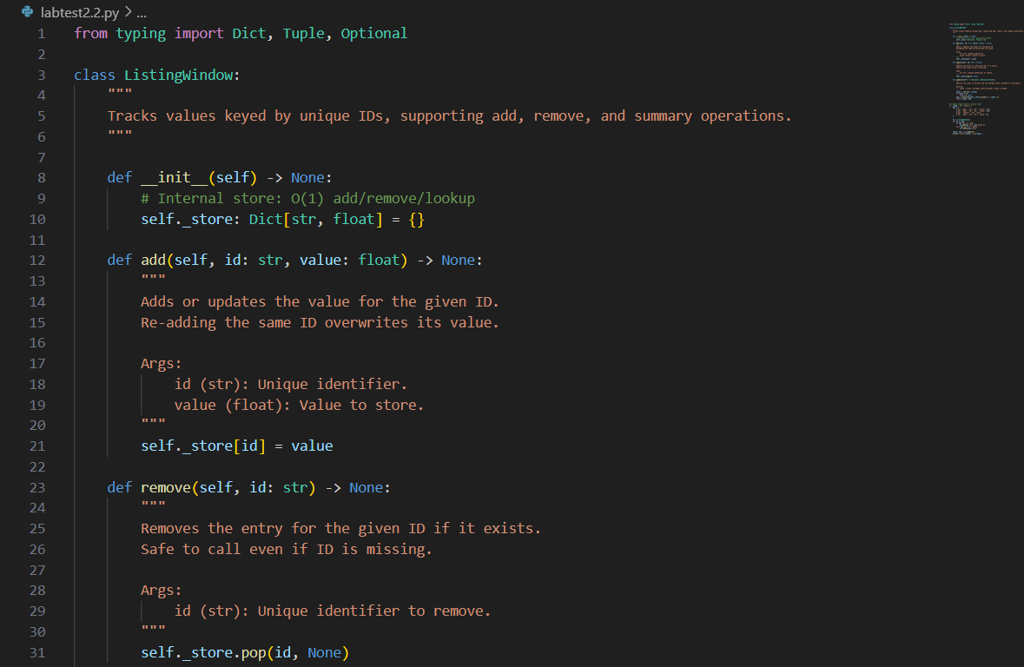

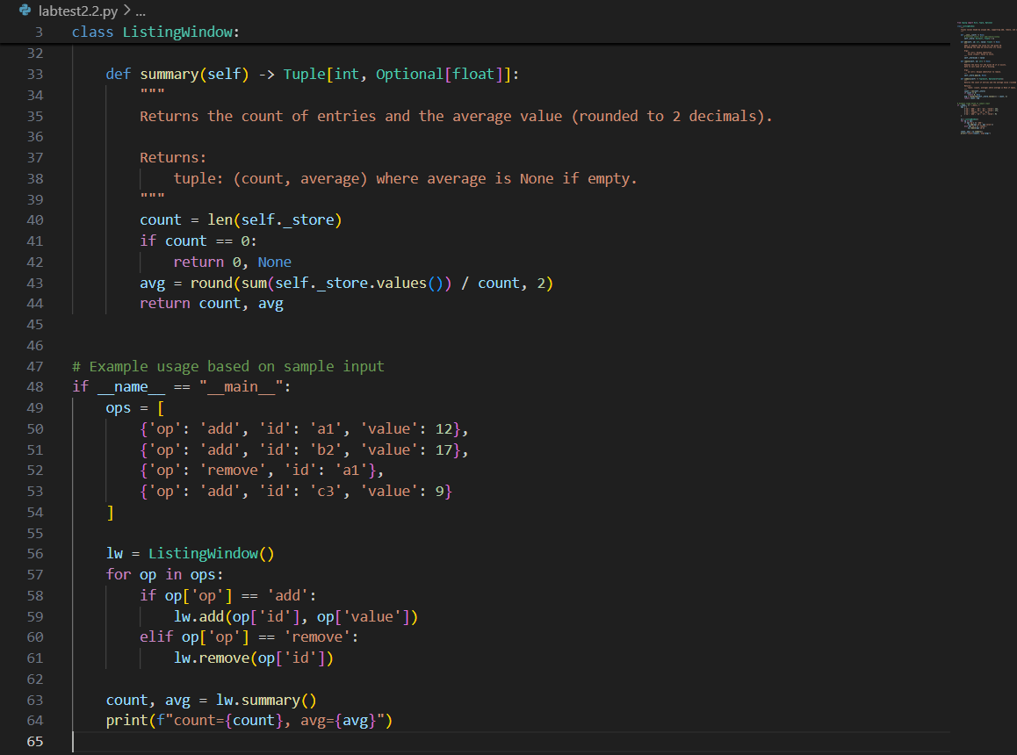

OUTPUT:

