Assignment-10.3

Lab 10 – Code Review and Quality: Using AI to Improve Code  
Quality and Readability

10.3.1:

CODE:

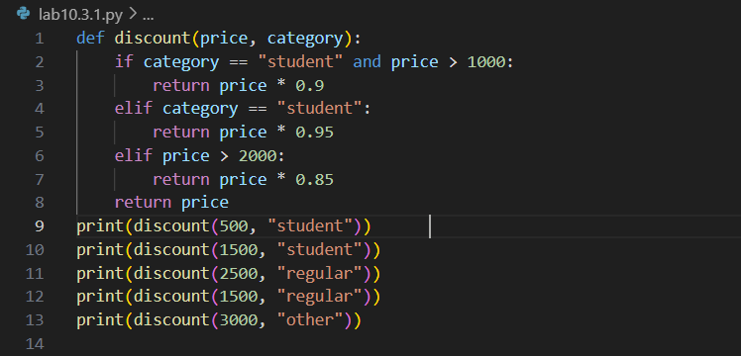

**Version 1: Flat Conditionals**

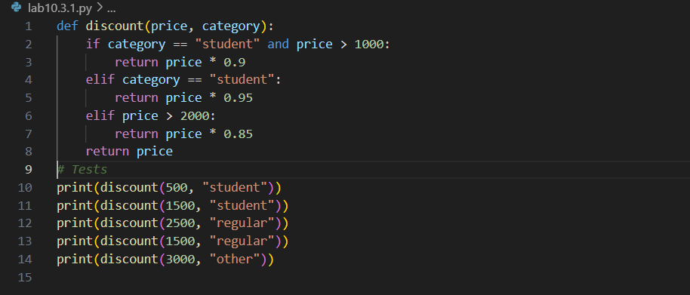

**Version 2: Helper Functions**

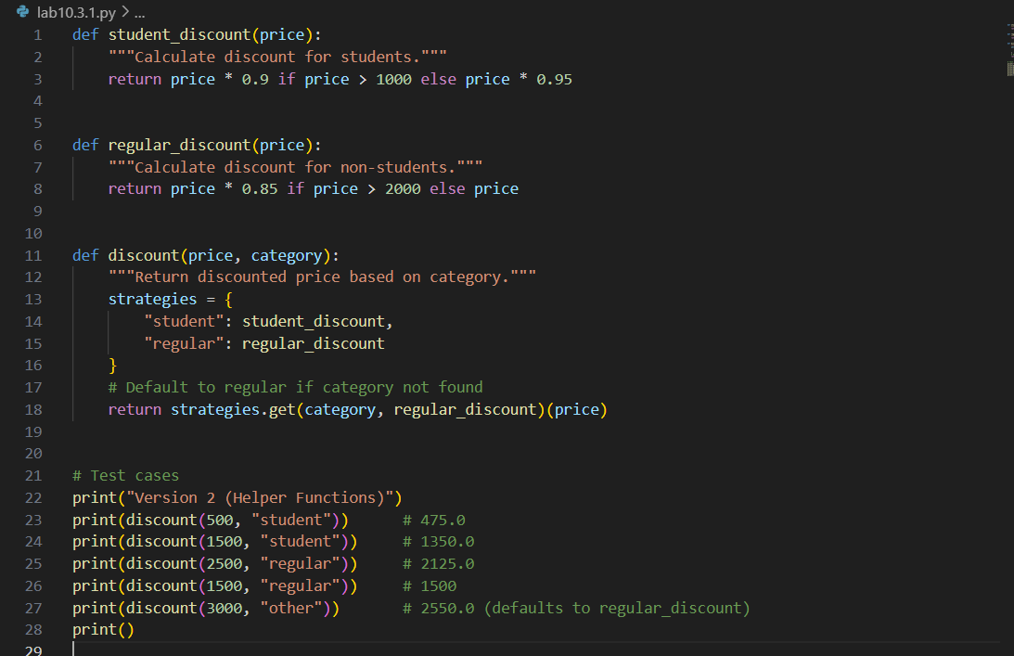

**Version 3: Dictionary + Lambdas**

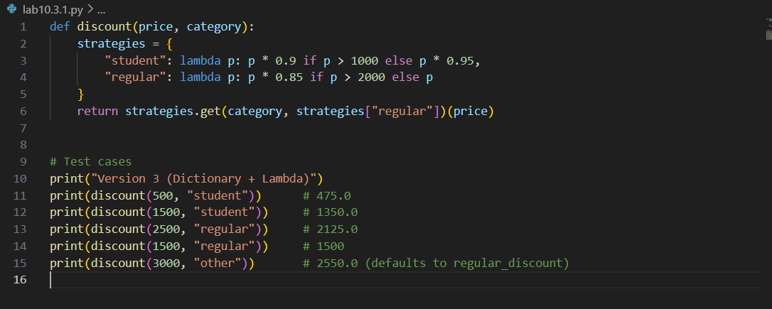

OUTPUT:

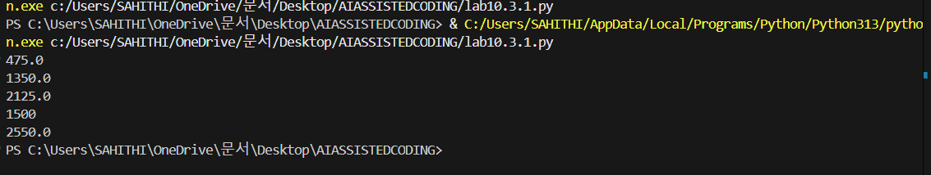

10.3.2:

CODE:

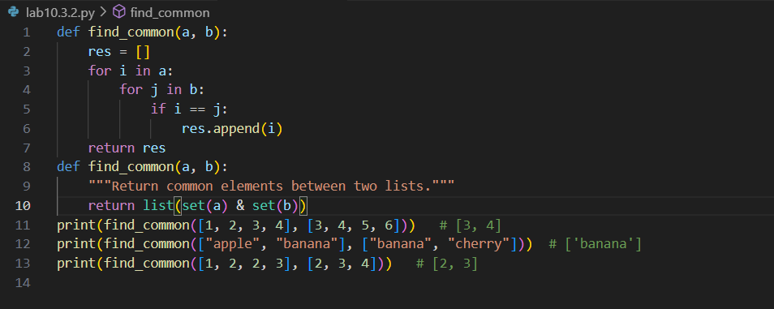

OUTPUT:



10.3.3:

CODE:

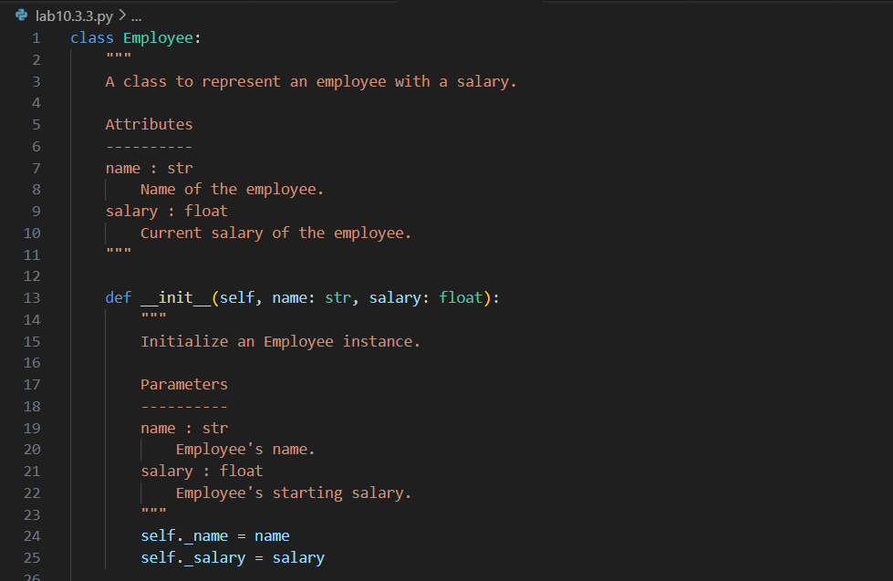

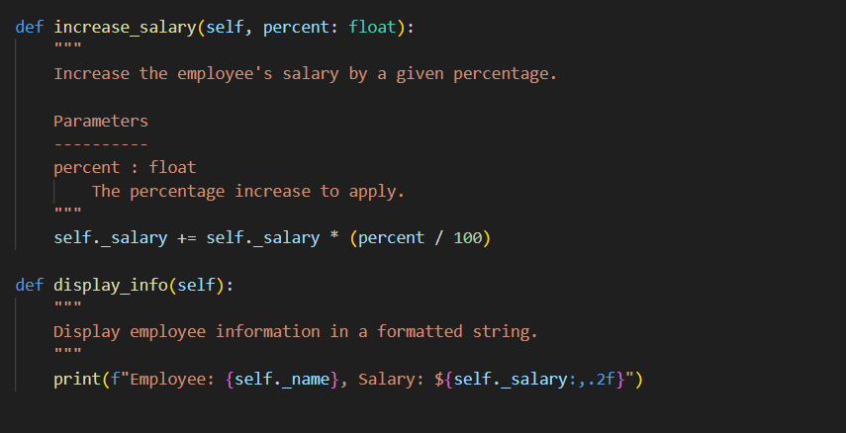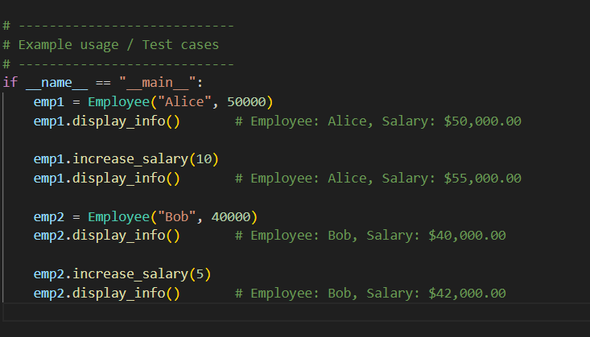

OUTPUT:

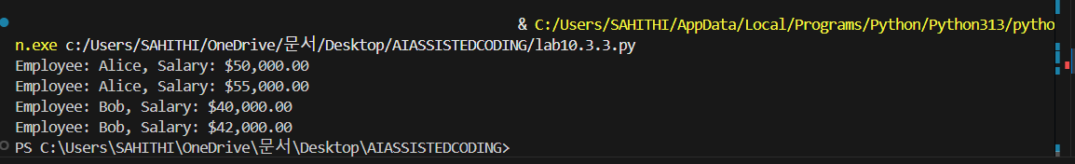

10.3.4:

CODE:

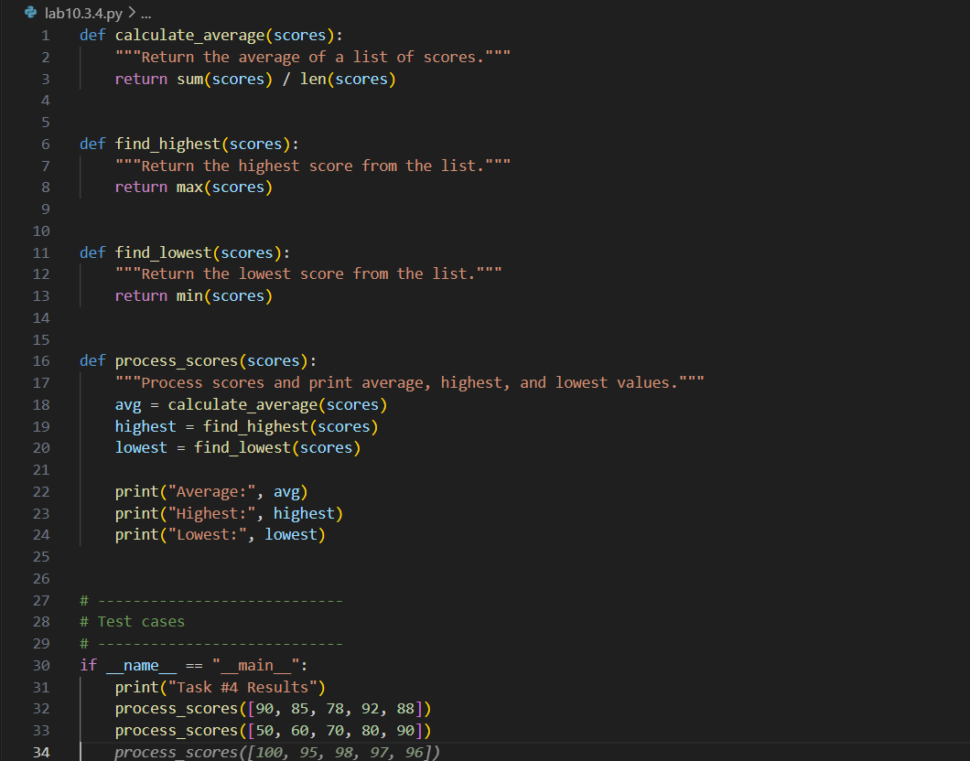

OUTPUT: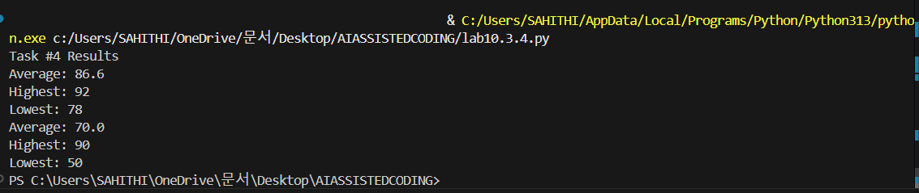

10.3.5:

CODE:

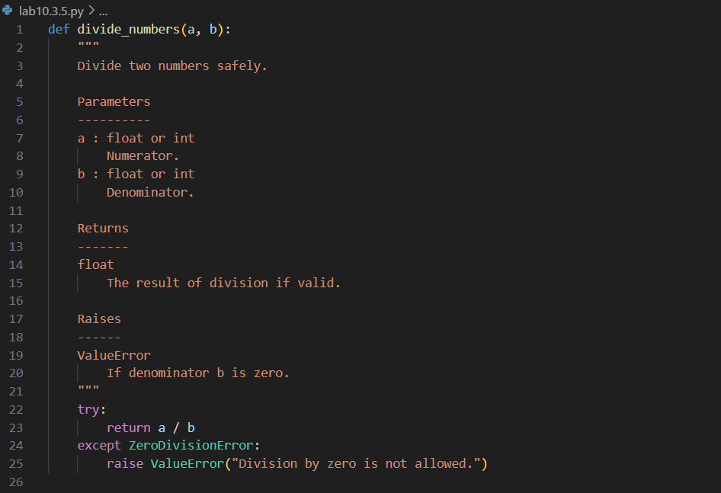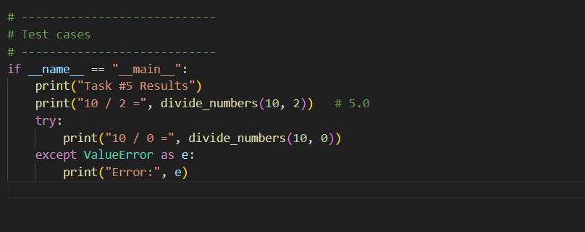

OUTPUT: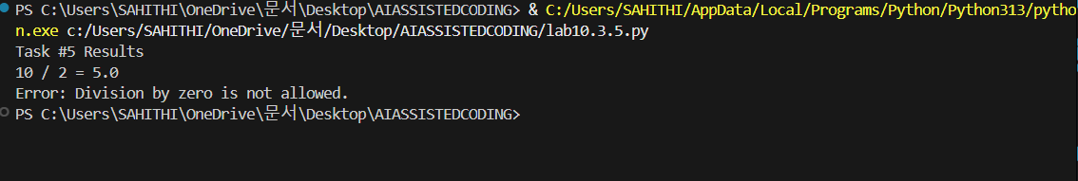

10.3.6:

CODE:

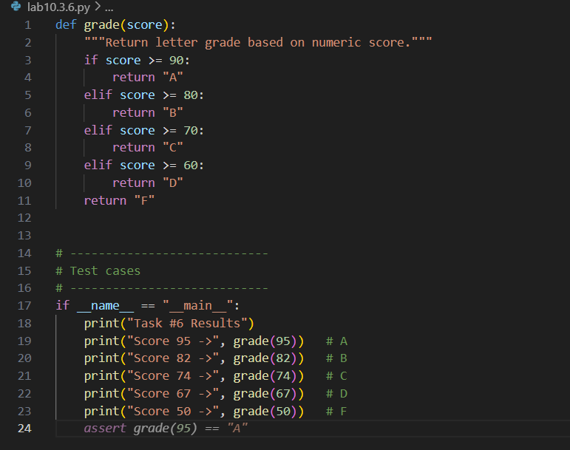

OUTPUT:

