ASSIGNMENT – 12

HT.NO: 2403A51294

BATCH: CSE12

Task-1

Prompt: write a python program which implements bubble sort. include inline comments explaining key logic and provide time complexity analysis.

Code:

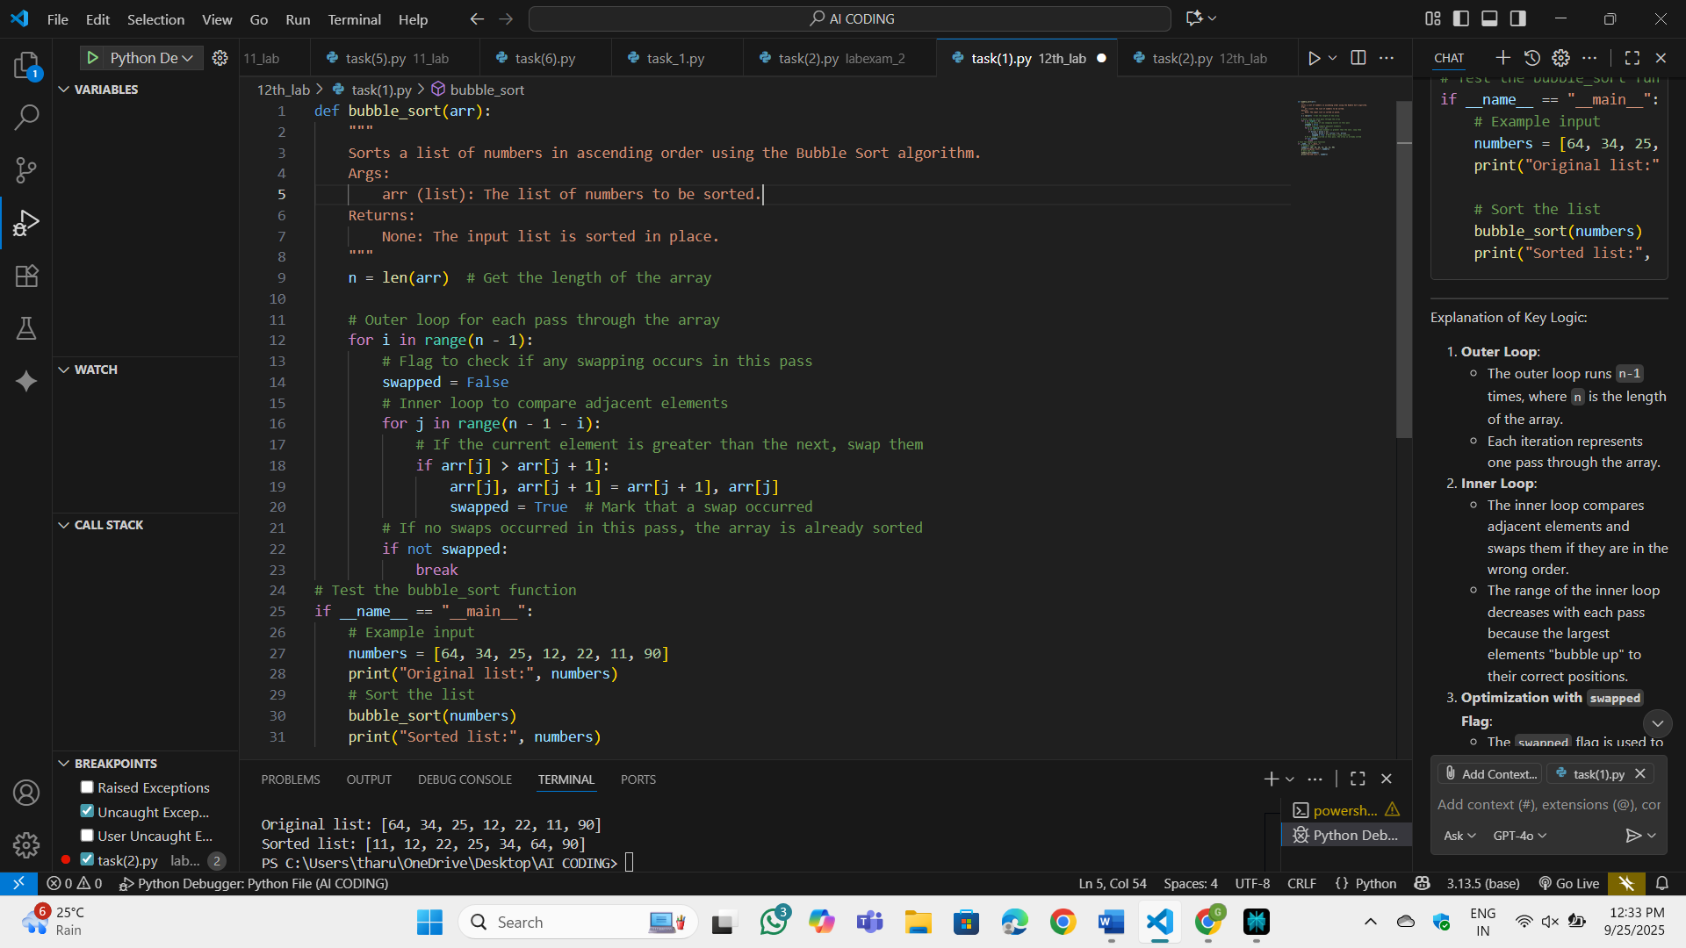

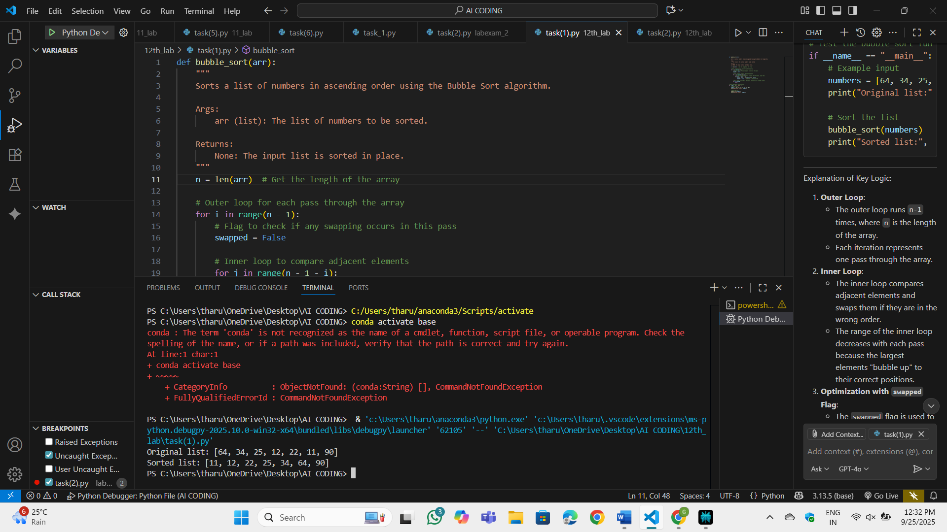

Task-2

Prompt: suggest a more efficient algorithm for partially sorted arrays

Code:

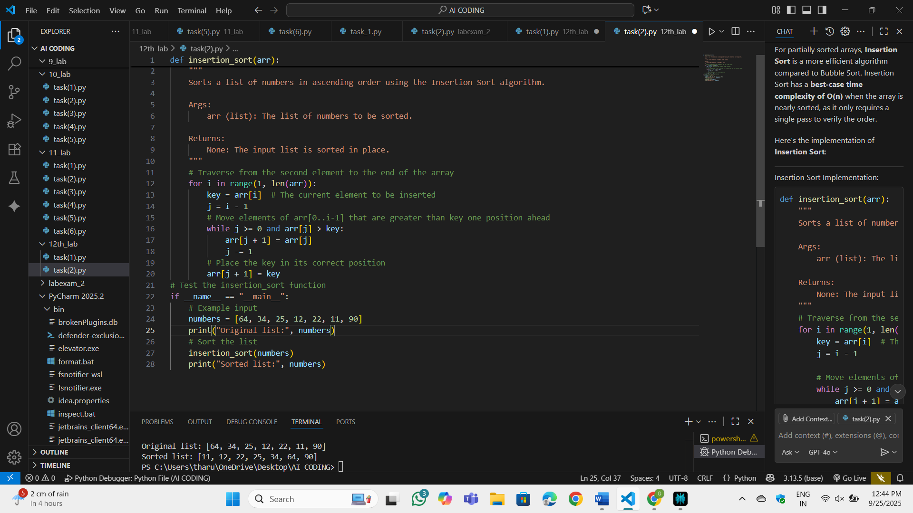

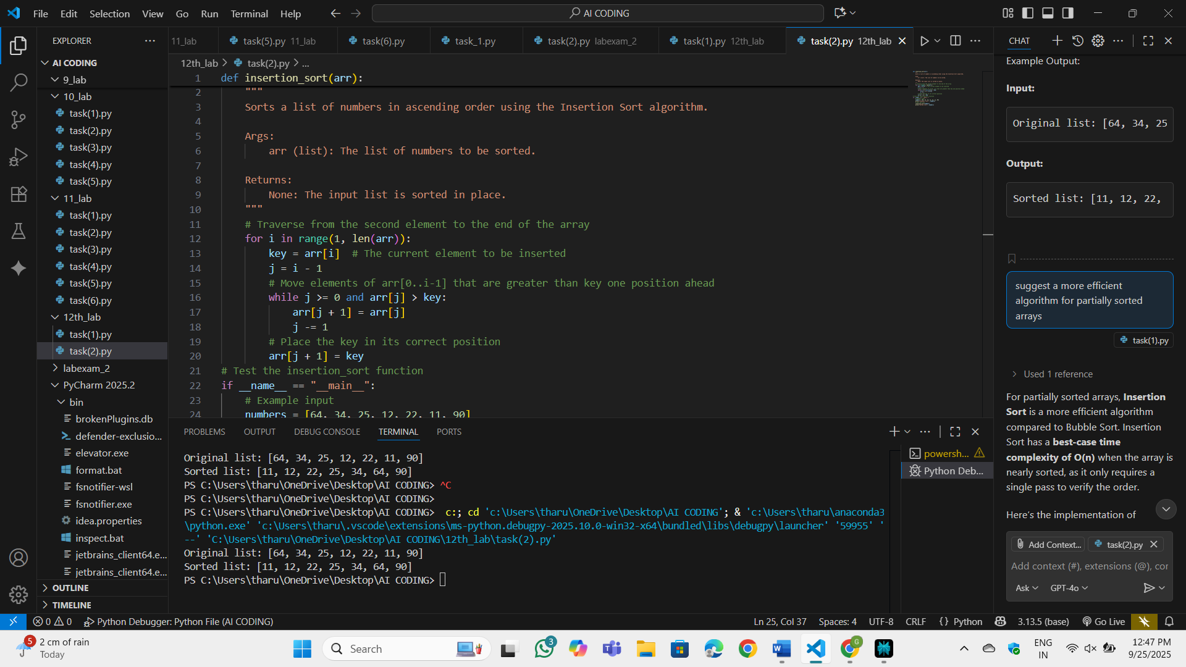

Task-3:

Prompt: Write a python code for linear search and binary search with docstrings and performance notes

Code:

Task-4:

Prompt: Write a python code for implementation of Quick sort and Merge sort using recursion and add docstrings. Explain average, best, and worst-case complexities. Compare both on random, sorted, and reverse-sorted lists.

Code:

