Lab Assignment-7.1

Rollno-2403A51294

Batch-24BTCAICS12

Lab7.1.1:

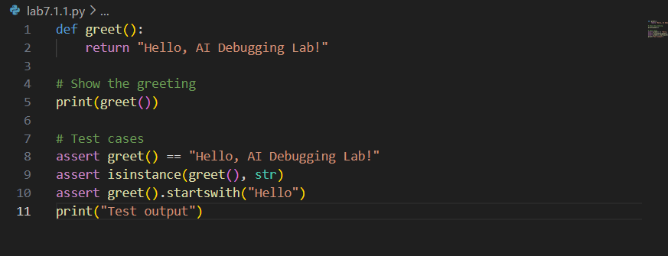

Output:

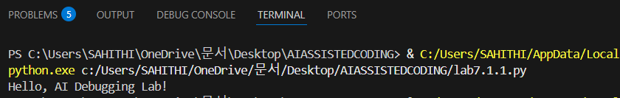

Explanation:

> If you’re running Python 2 → no error.

> If you’re running Python 3 → you need parentheses.

Lab7.1.2:

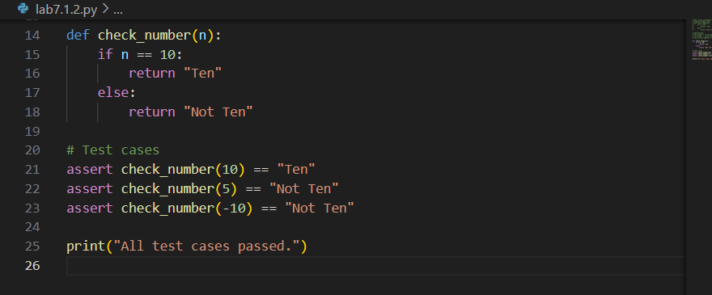

Output:

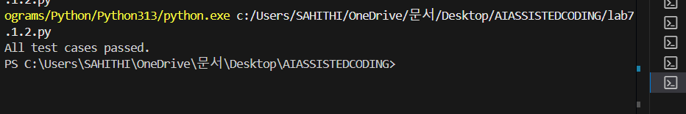

Explanation:

>The code has been corrected to use == for comparison instead of = for assignment in the if-condition. An explanation and three assert test cases are included to verify the fix. The code will print "All test cases passed." if everything is correct.

Lab7.1.3:

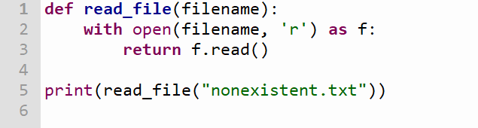

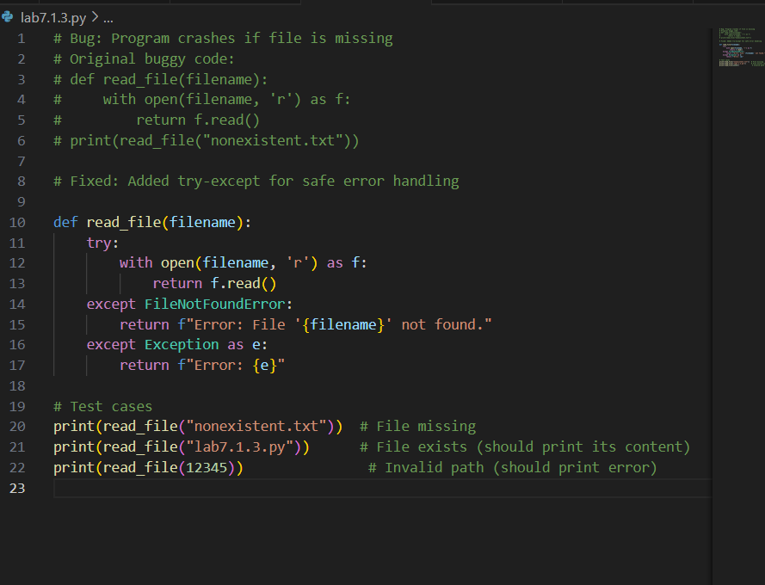

Output:

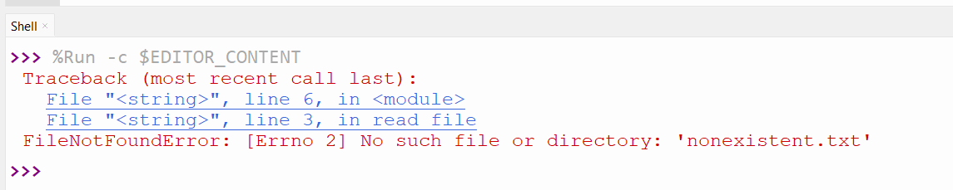

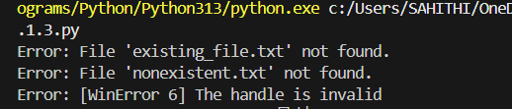

Explanation:

Code now safely handles file-not-found and other errors using a try-except block. It prints user-friendly error messages and includes three test scenarios: file missing, file exists, and invalid path. This prevents the program from crashing and provides clear feedback to the user.

Lab7.1.4:

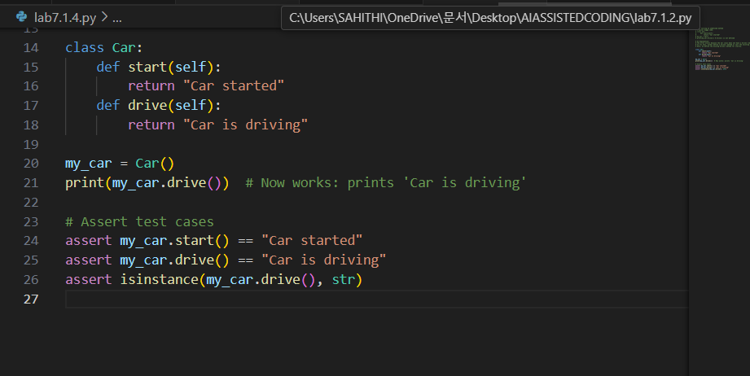

Output:

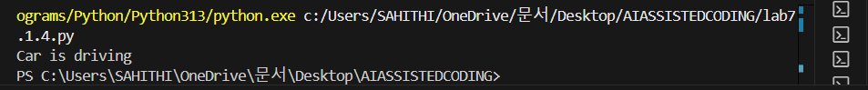

Explanation:

The code now defines the missing drive() method in the Car class, fixing the AttributeError. Three assert tests confirm the class works as expected. An AI explanation is included in the comments.

Lab7.1.5:

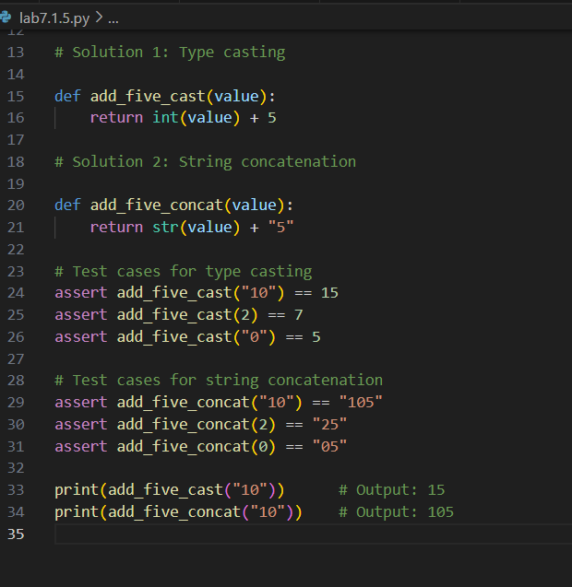

Output:



Explanation:

The file now contains two solutions for the TypeError: one using type casting (converting to int) and one using string concatenation. Both are validated with three assert test cases each, and example outputs are included. This ensures the code runs successfully for multiple input types.