Lab Assignment 8.1

Rollno-2403A51294

Batch-24BTCAICS12

Lab8.1.1:

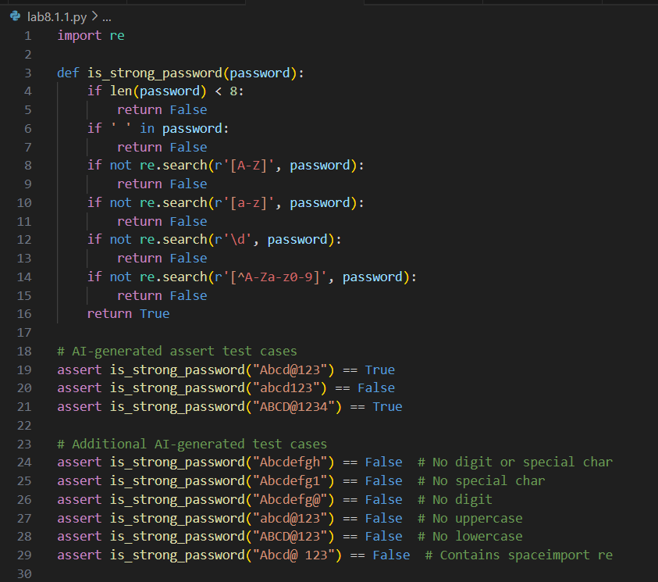

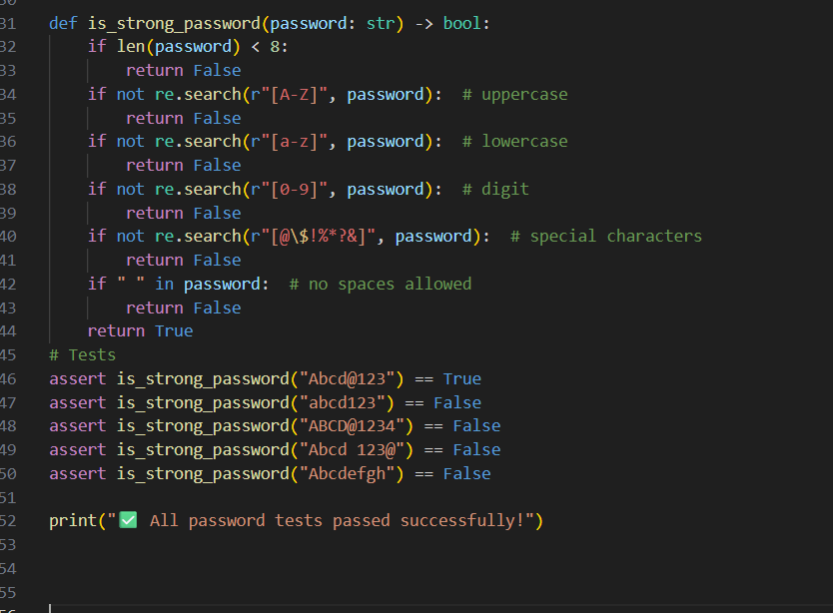

Output:

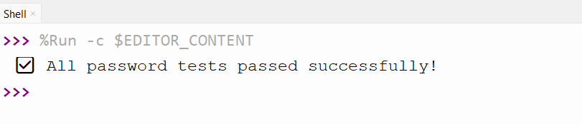

Explanation:

The is_strong_password function is now implemented in your file, meeting all requirements. It includes at least 3 assert test cases (plus extra) to validate password strength. The code will print "All password strength test cases passed." if everything is correct.

Lab8.1.2:

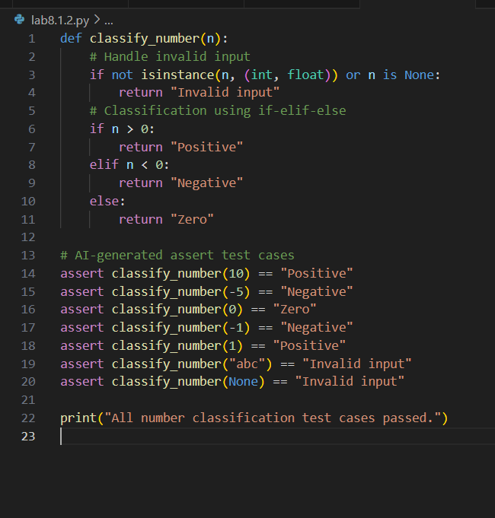

Output:

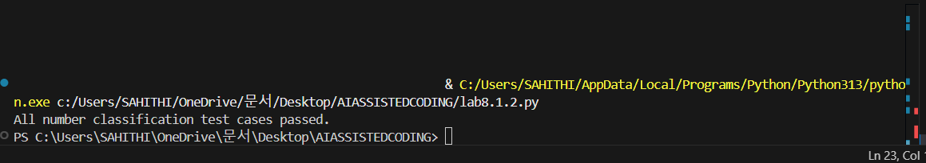

Explanation:

The classify_number function is now implemented with edge case handling for invalid inputs, and includes assert test cases for positive, negative, zero, and boundary conditions. The code will print "All number classification test cases passed." if everything is correct.

Lab8.1.3:

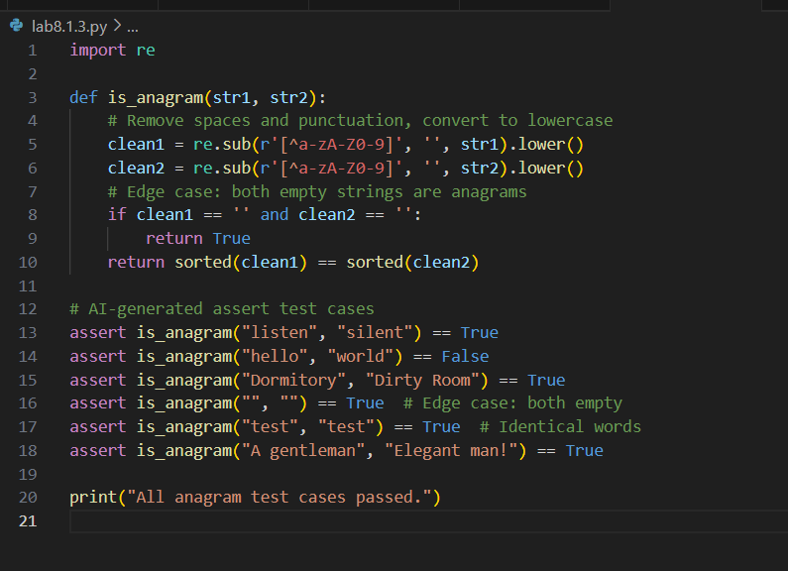

Output:



Explanation:

The is_anagram function is now implemented in your file. It ignores case, spaces, and punctuation, and handles edge cases like empty strings and identical words. Assert test cases are included to verify correctness. The code will print "All anagram test cases passed." if everything is correct.

Lab8.1.4:

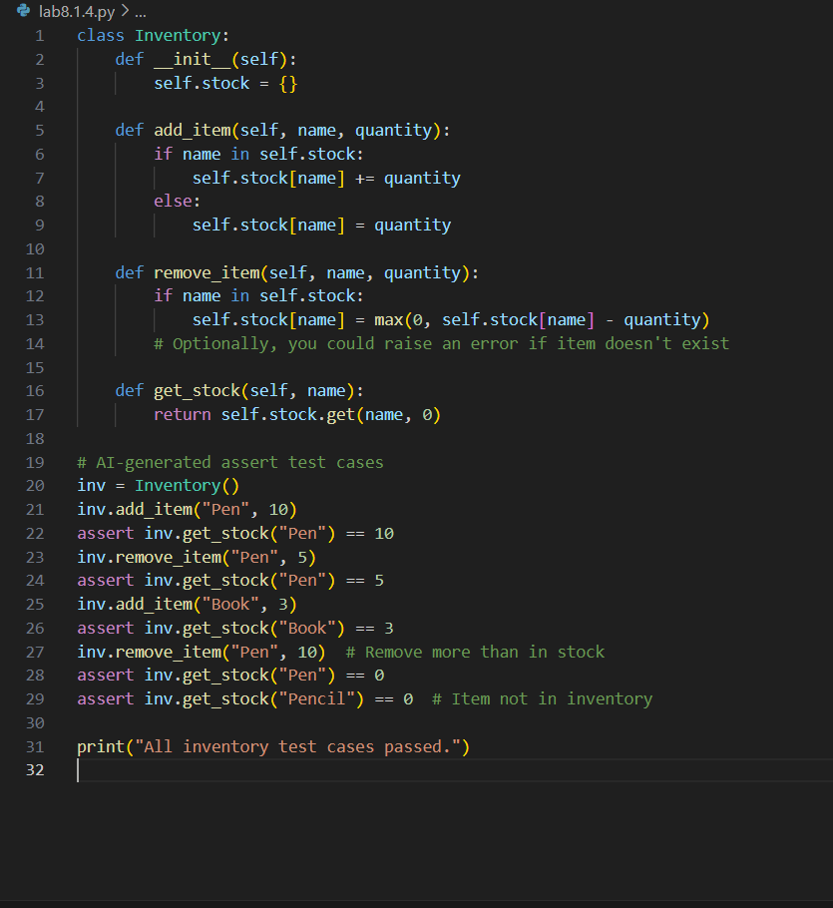

Output:

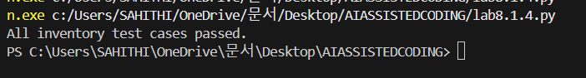

Explanation:

The Inventory class is now implemented in your file with methods for adding, removing, and checking stock. Assert-based tests are included to verify correct stock management and edge cases. The code will print "All inventory test cases passed." if everything works as expected.

Lab8.1.5:

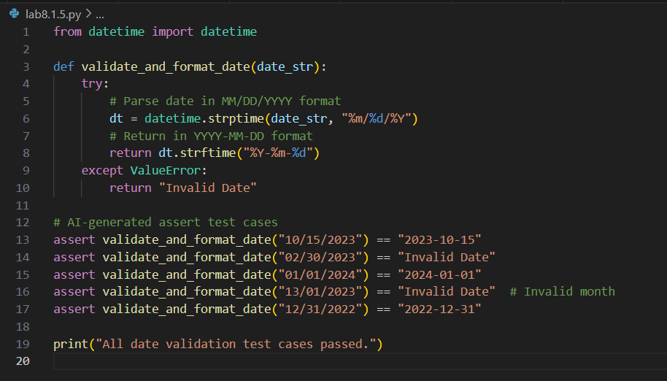

Output:



Explanation:

The validate_and_format_date function is now implemented in your file. It validates dates in "MM/DD/YYYY" format, handles invalid dates, and converts valid dates to "YYYY-MM-DD". Assert test cases are included for edge cases. The code will print "All date validation test cases passed." if everything is correct.