Assignment-9.2

RollNo-2403A51294

Batch-24BTCAICSB12 Date:12-09-2025

9.2.1

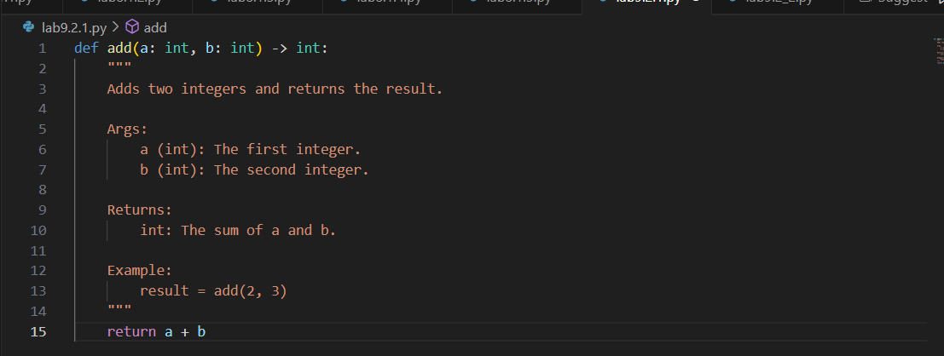

OUTPUT:

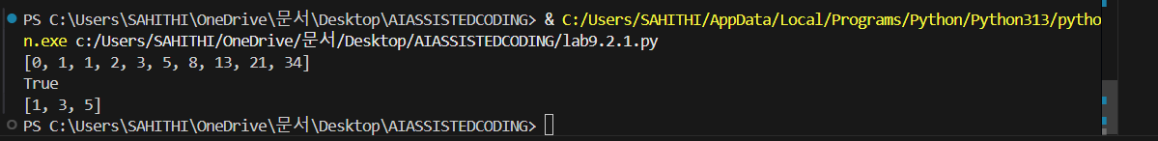

9.2.2

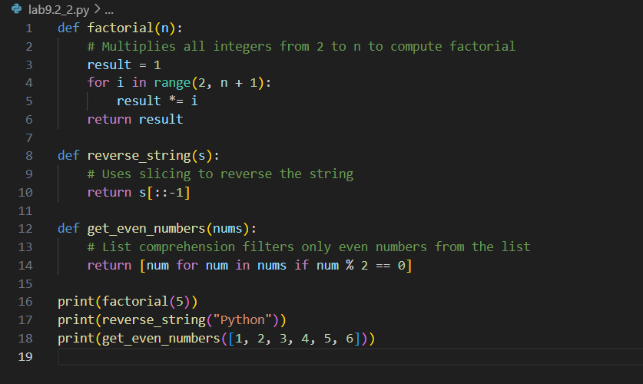

OUTPUT:



9.2.3

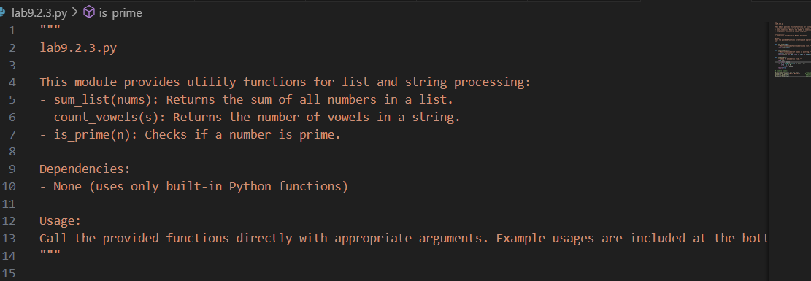

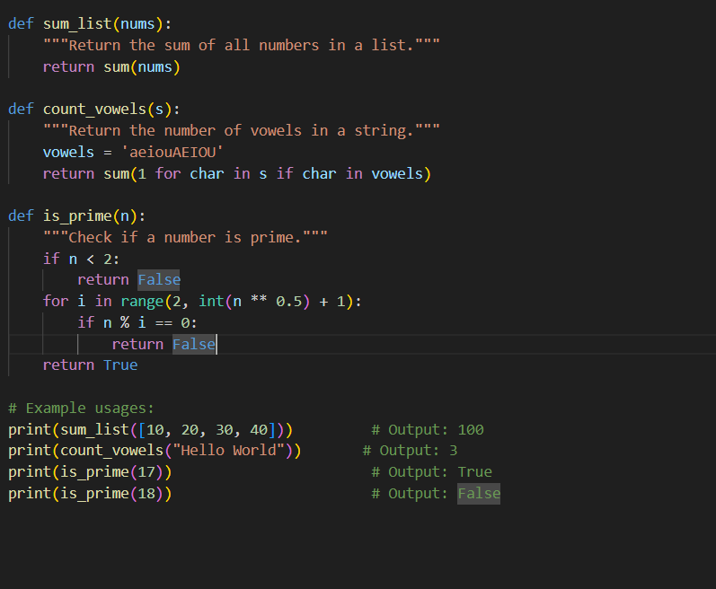

Output:

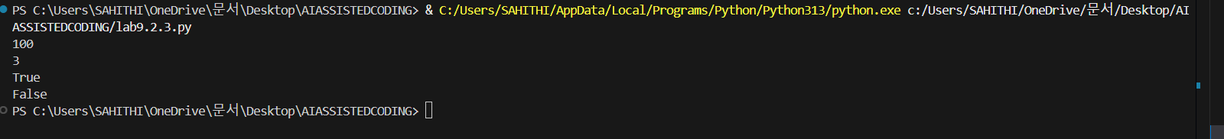

9.2.4

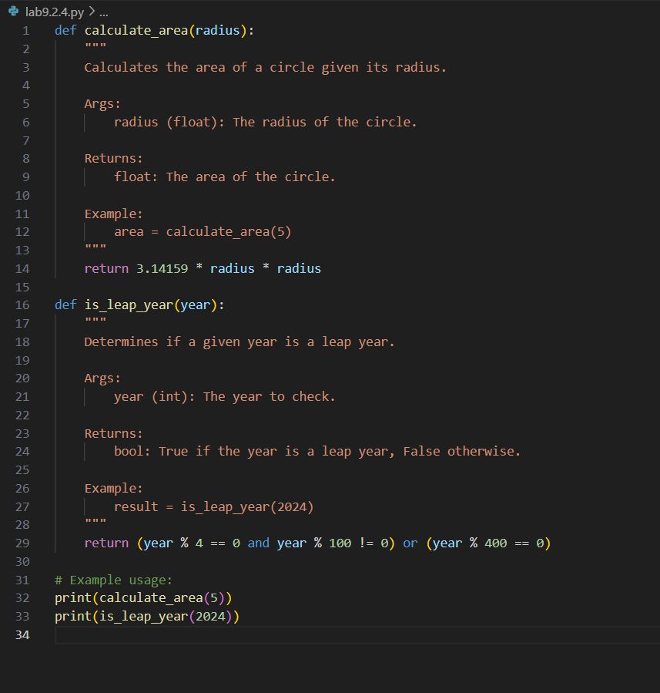

Output:

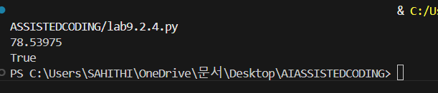

9.2.5

Before correcting:

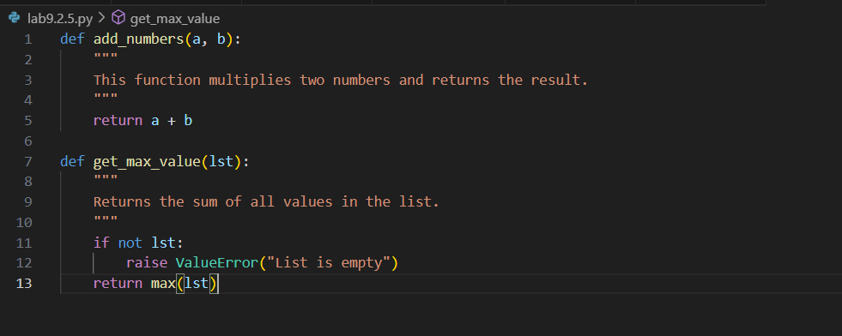

After correcting:

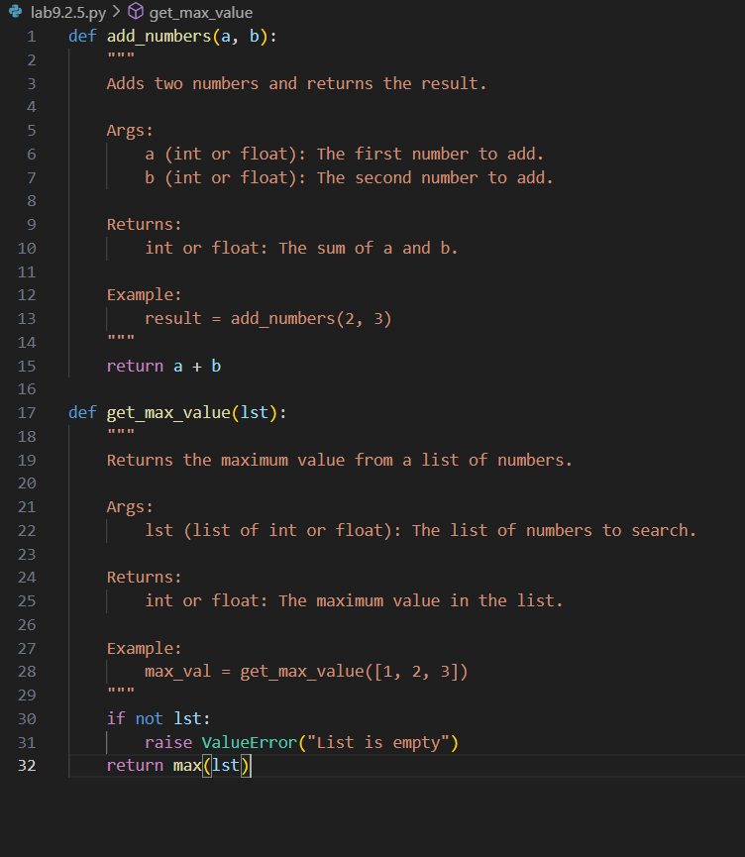

Output:

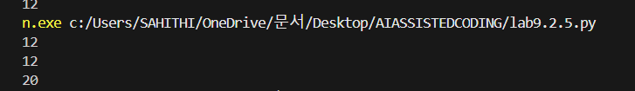

9.2.6

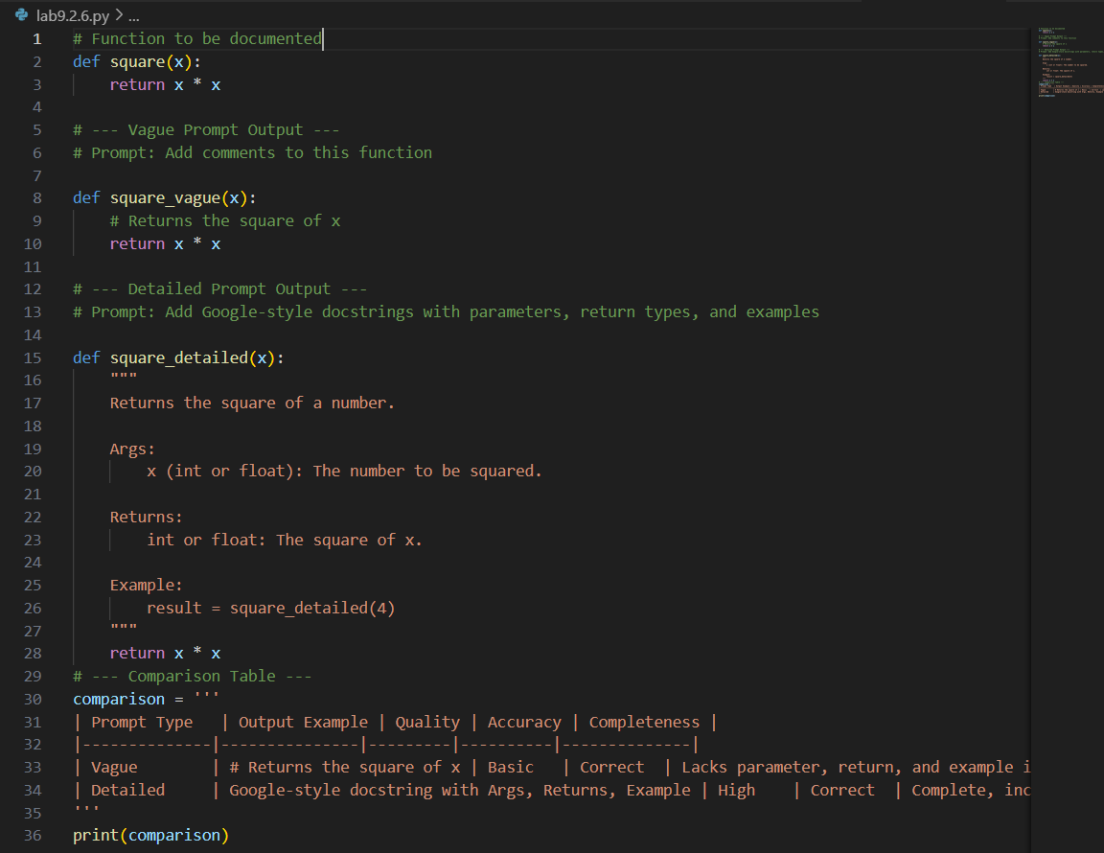

Output:

