ASSIGNMENT-11.4
Name: N. Shiva
Htno:2403A51298
Batch:24BTCAICSB12

Task 1: Implementing a Stack (LIFO)
PROMPT:
- Write a Python Stack class with push(), pop(), peek(), and is_empty(), using Google-style docstrings and inline comments. Show sample tests with data and suggest an optimized version using collections.deque
CODE: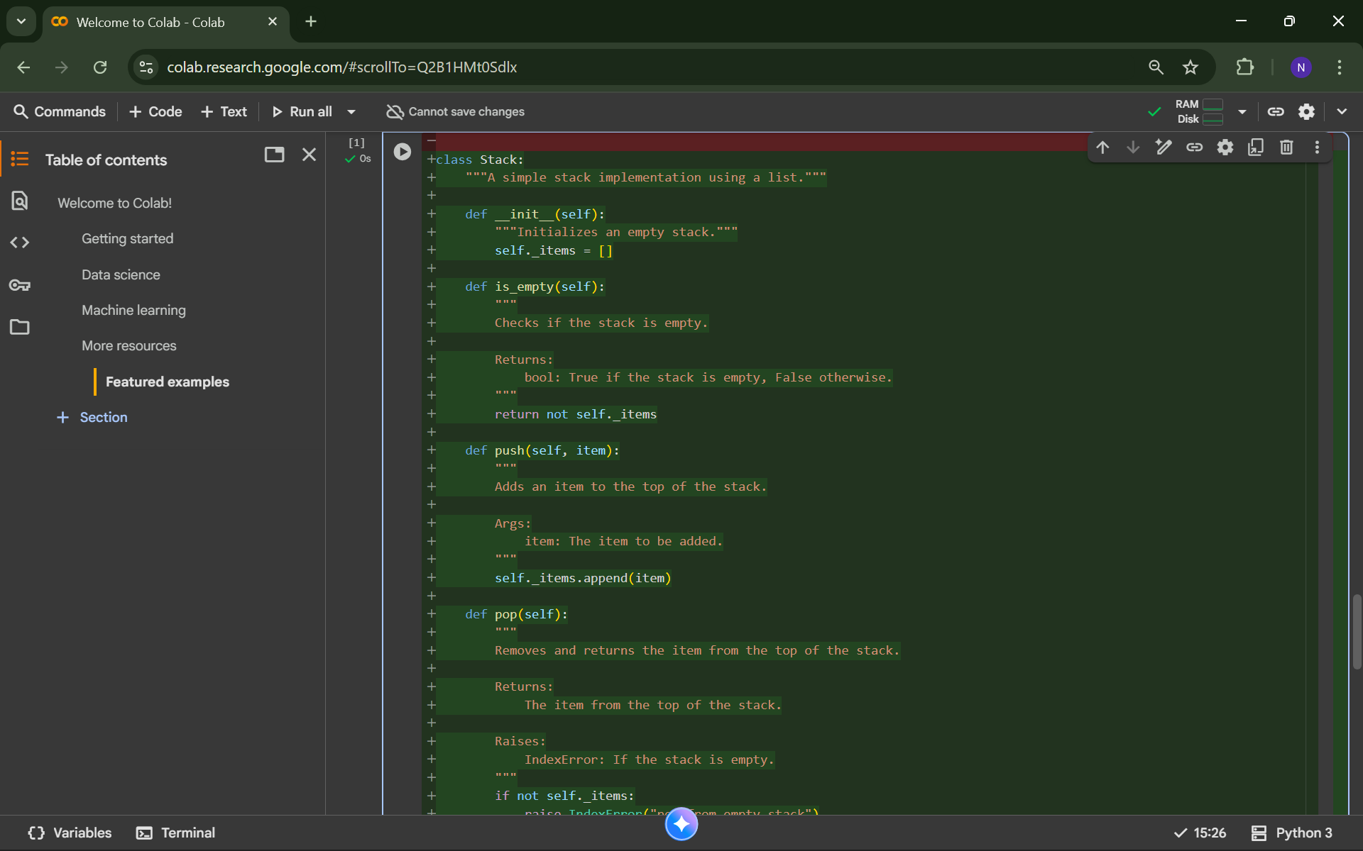
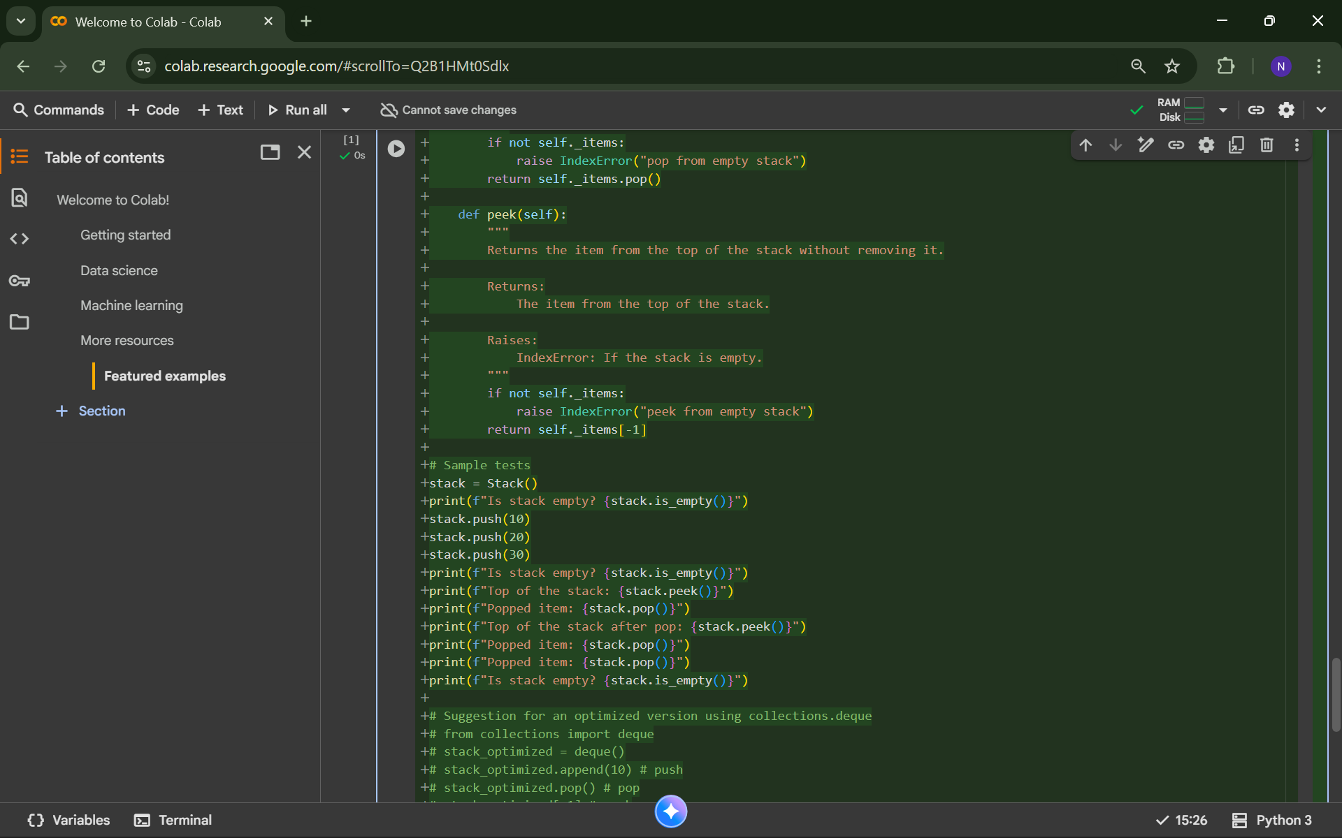
OUTPUT:
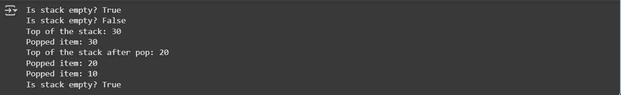
Task 2: Queue Implementation with Performance Review
PROMPT:
- Implement two versions of a Python Queue with enqueue(), dequeue(), and is_empty(): one with lists and one with collections.deque. Include docstrings, comments, and compare performance. Show sample enqueue and dequeue operations
CODE:
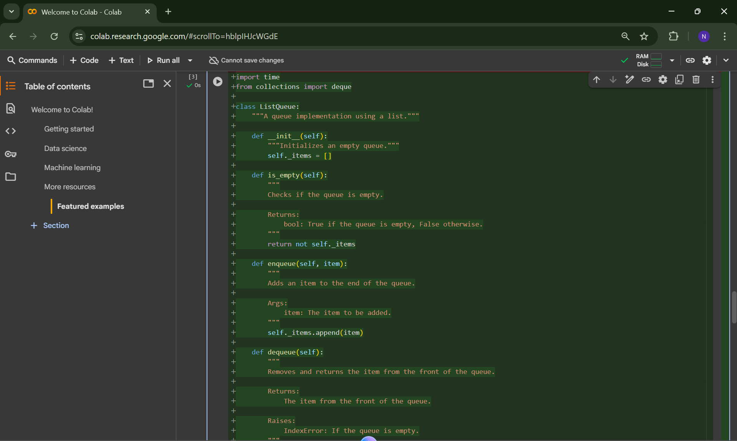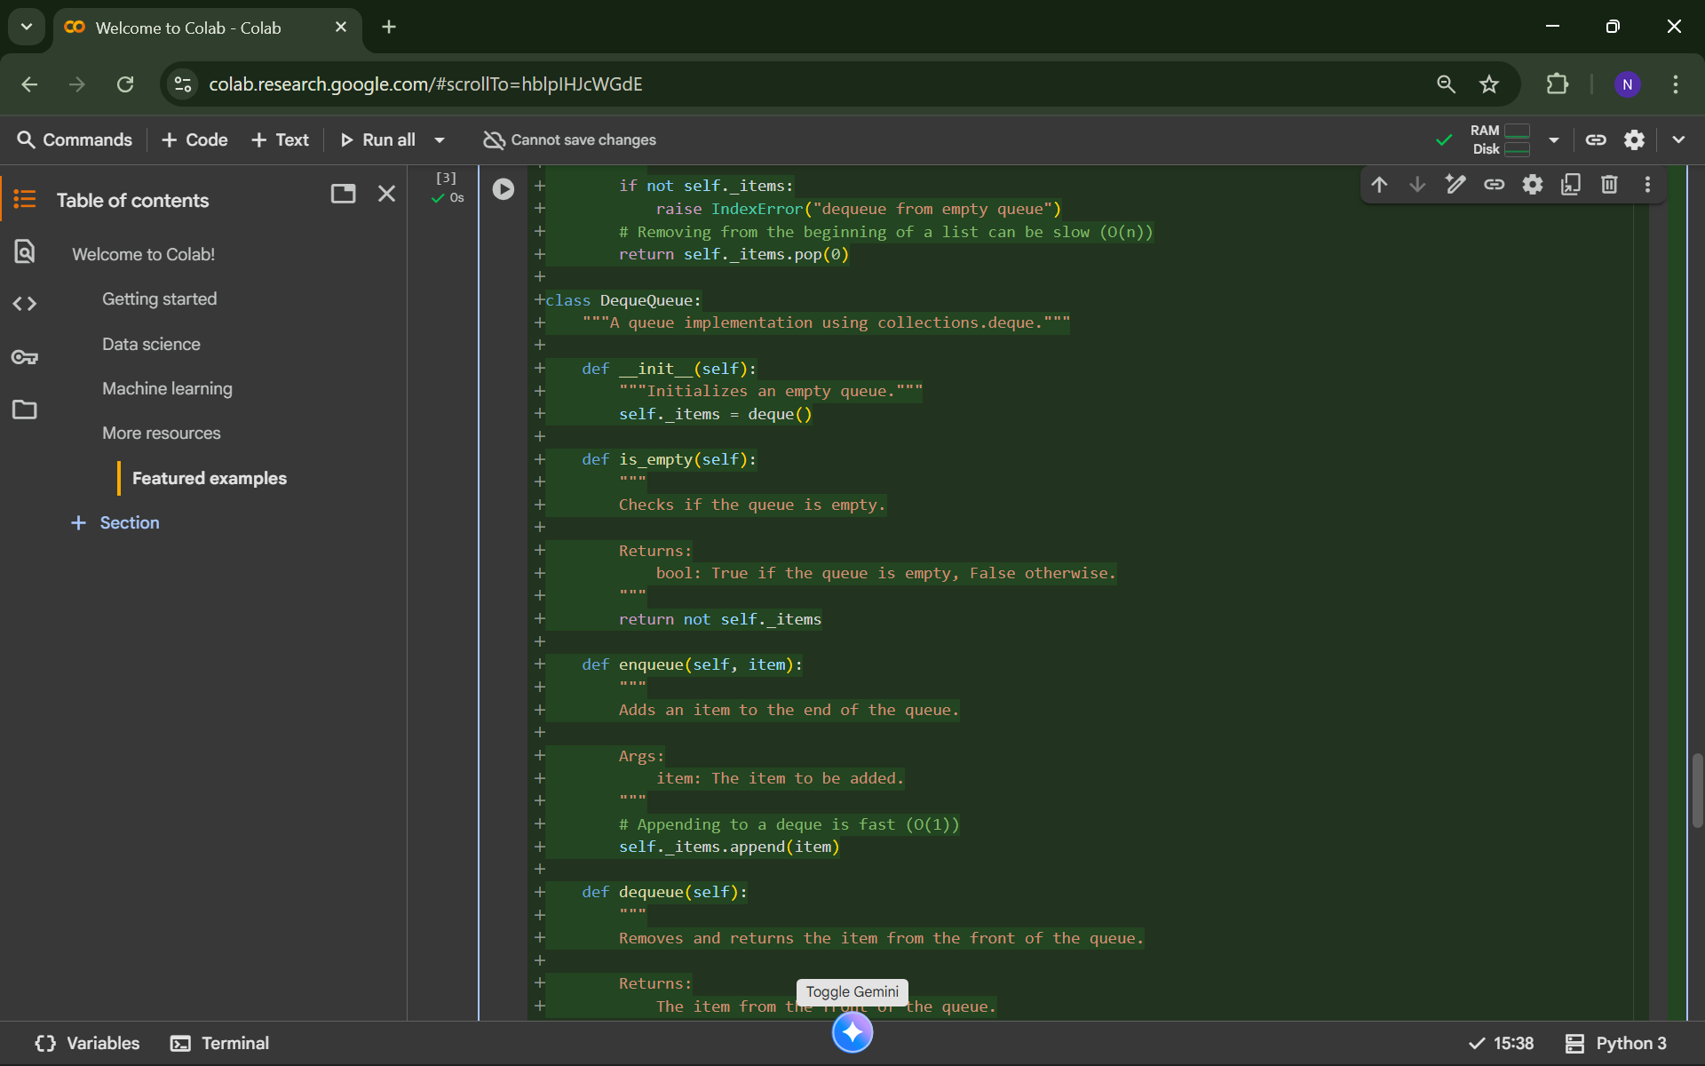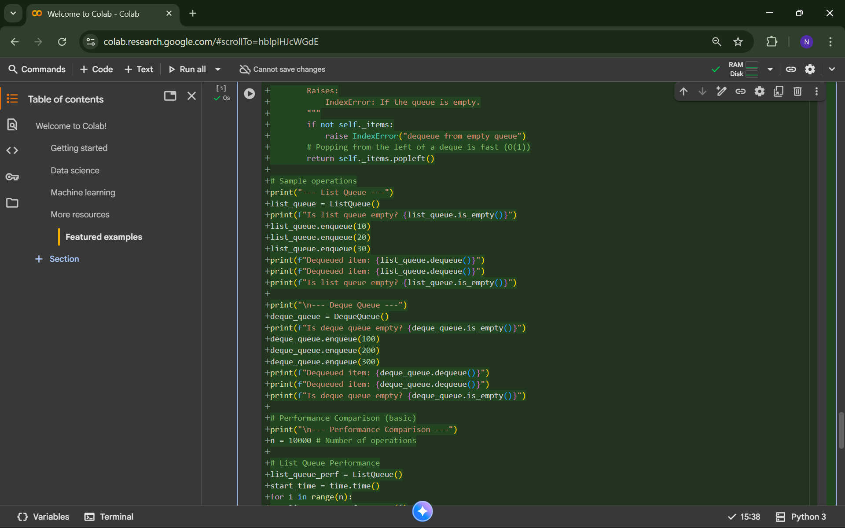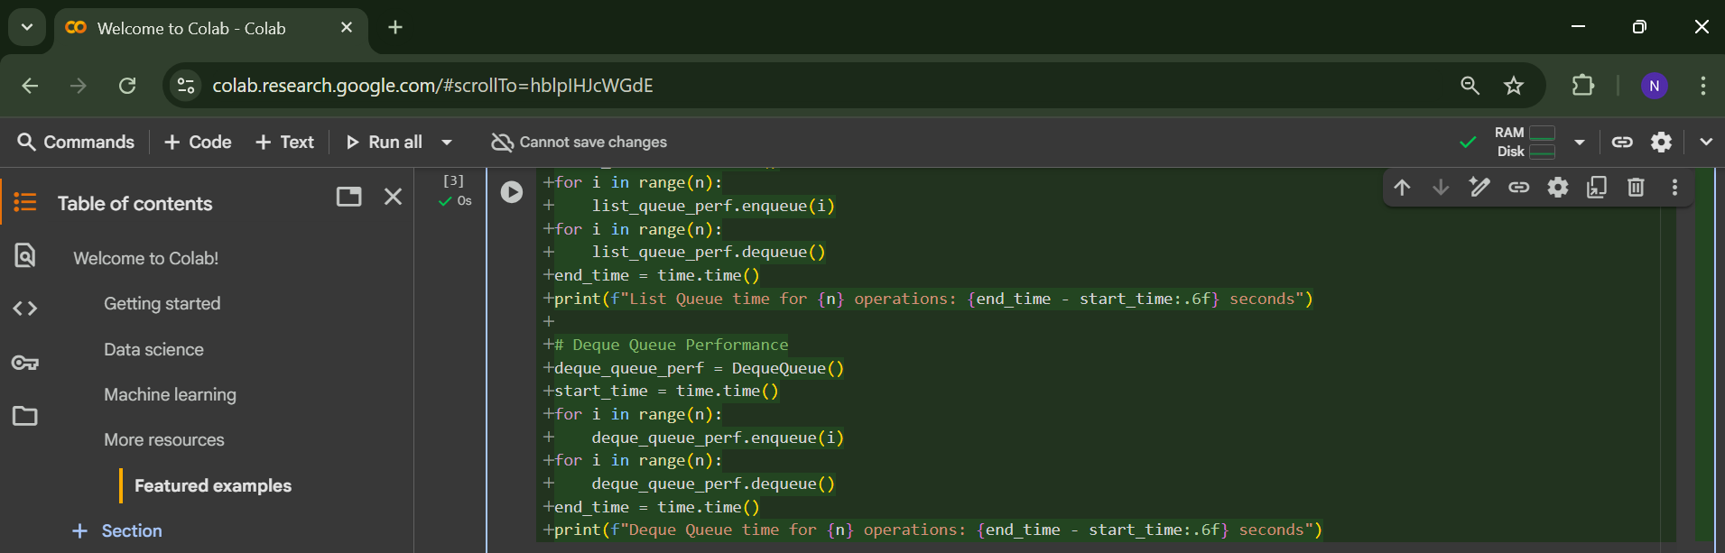
OUTPUT: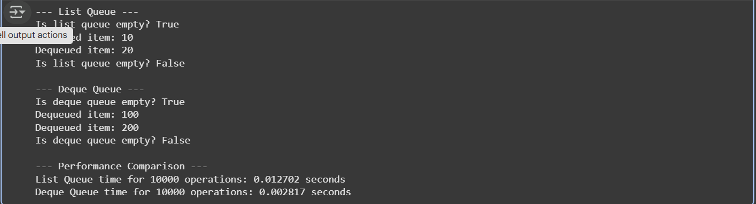
Task 3: Singly Linked List with Traversal
PROMPT:
- Create a Python Singly Linked List (Node and LinkedList) with insert_at_end(), delete_value(), and traverse(). Add comments explaining pointer changes, include docstrings, and suggest test cases covering edge cases
CODE:

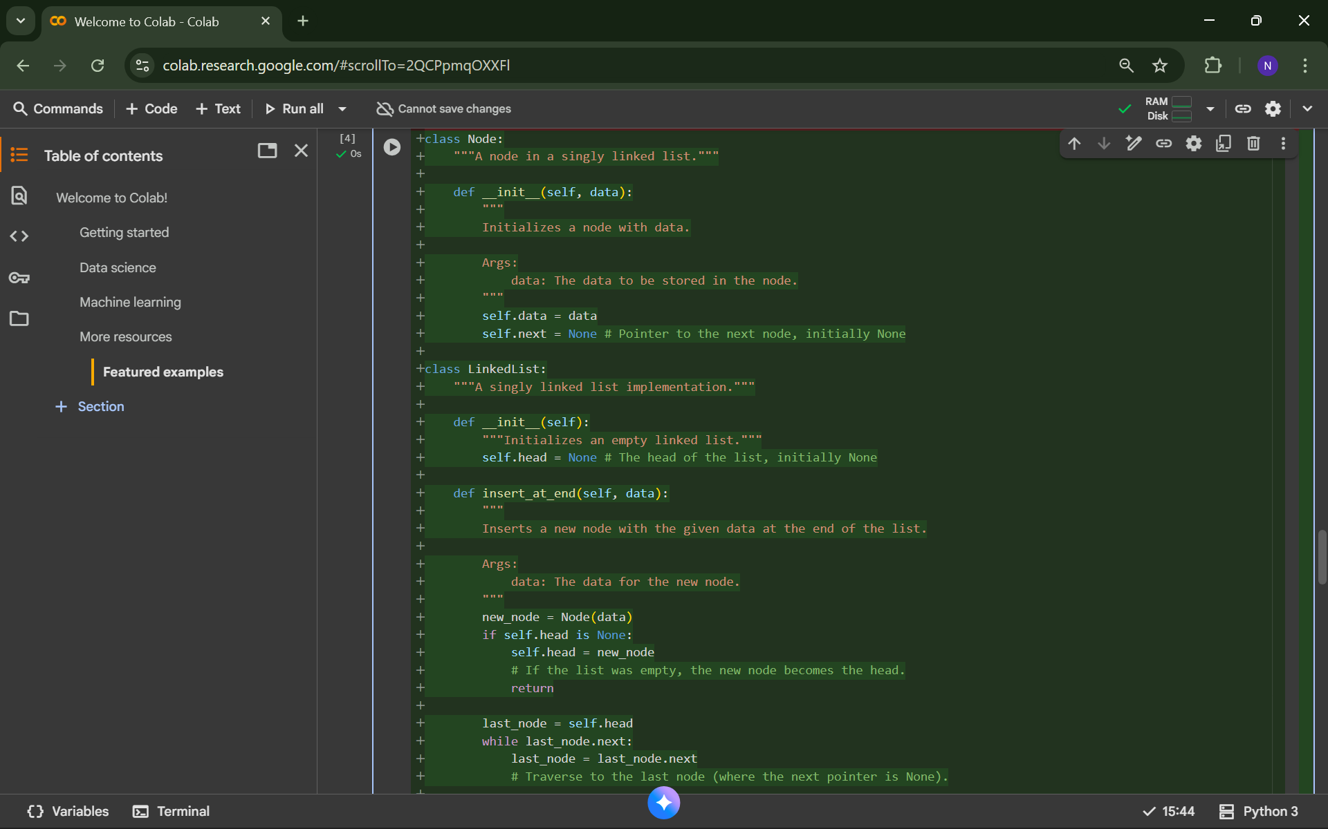
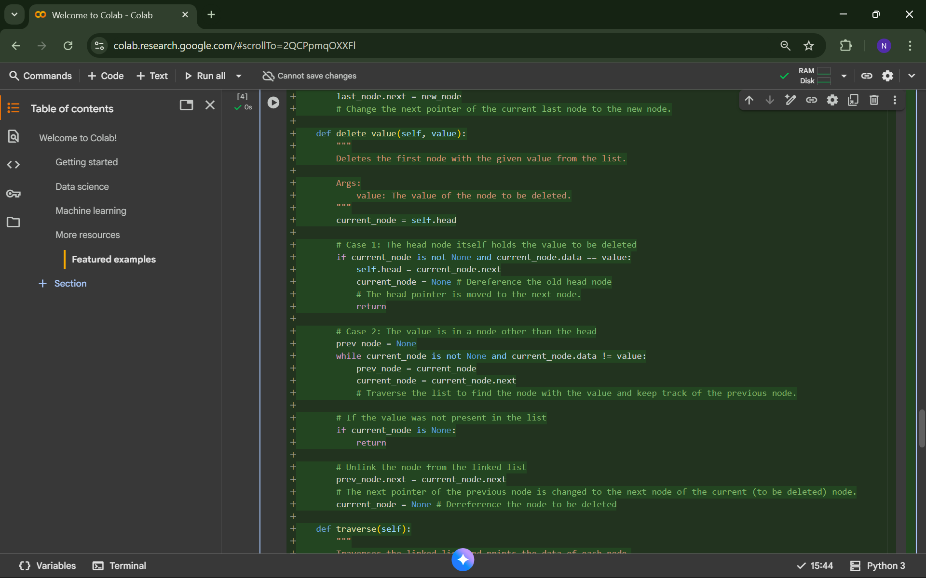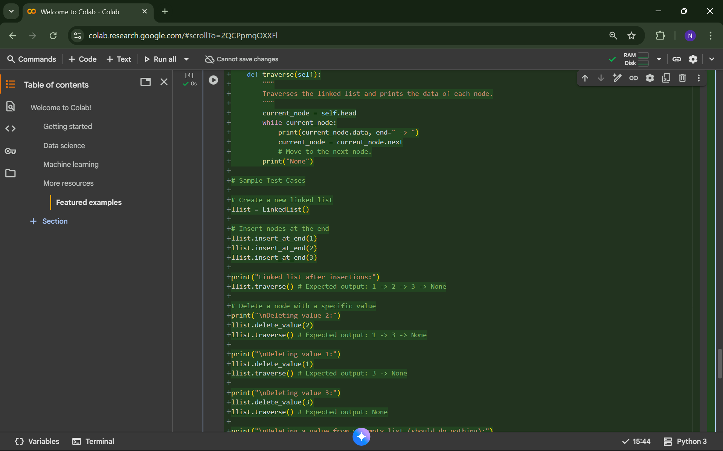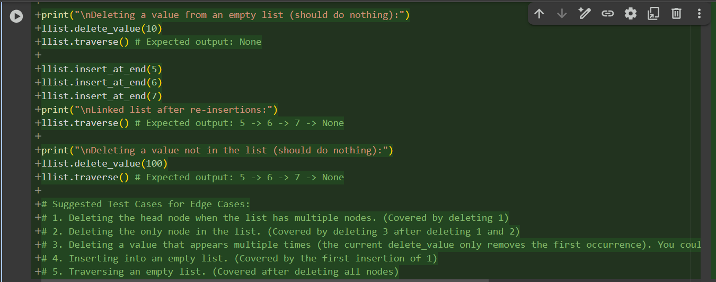
OUTPUT:
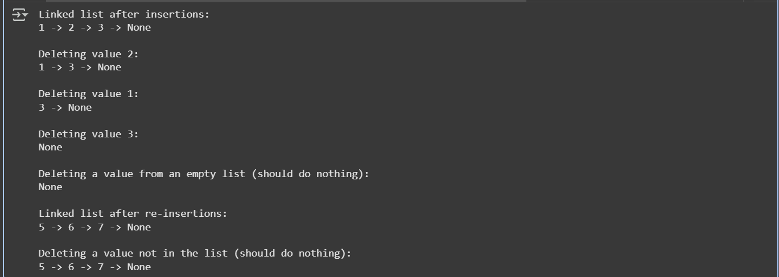
Task 4: Binary Search Tree (BST)
PROMPT:
- Complete a Binary Search Tree with insert(), search(), and inorder_traversal(), assuming a Node class already exists. Include docstrings, test with a list of integers, check search for present and absent values, and print an inorder traversal
CODE:
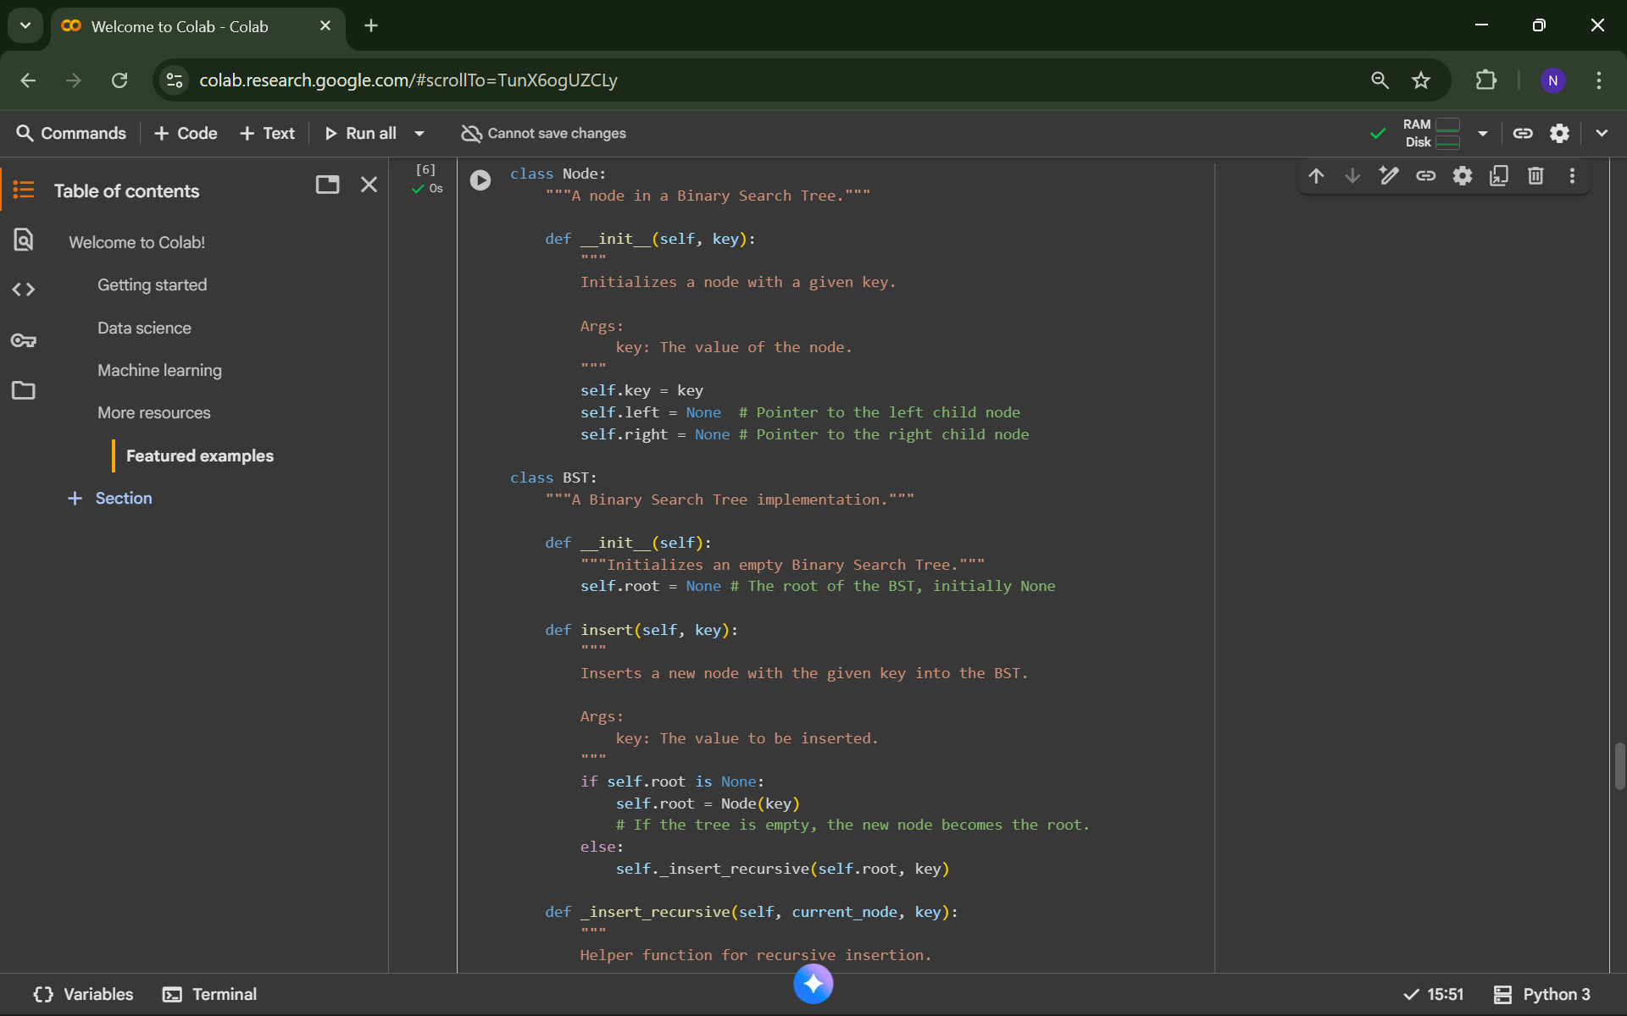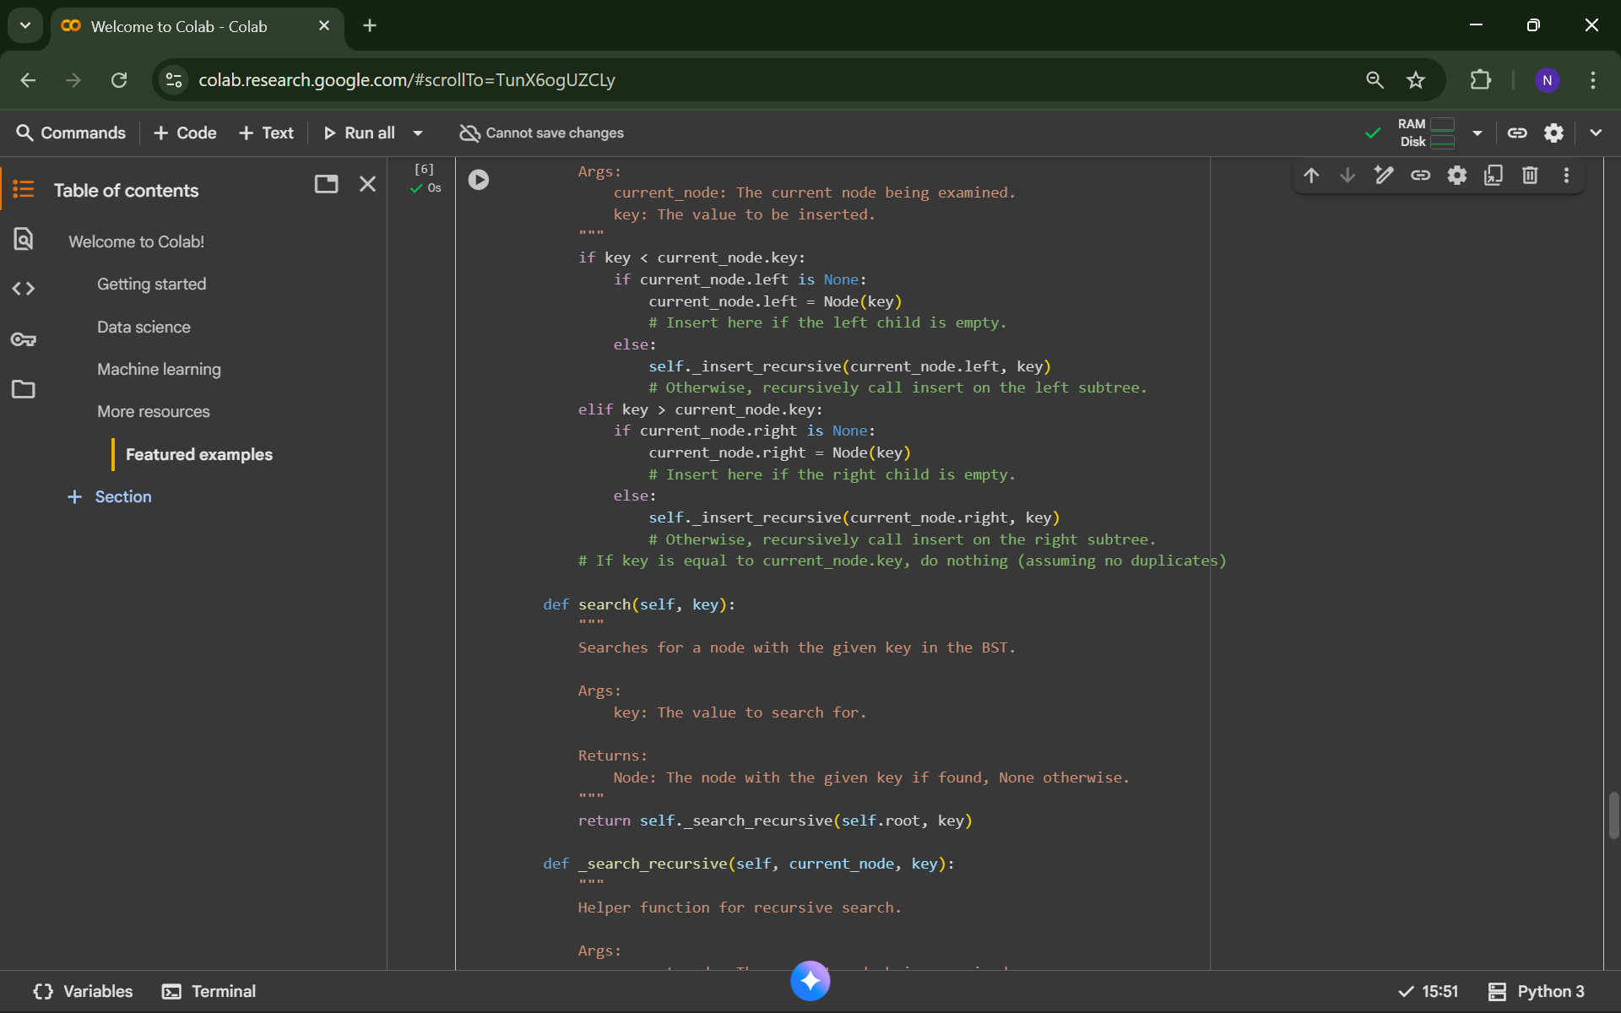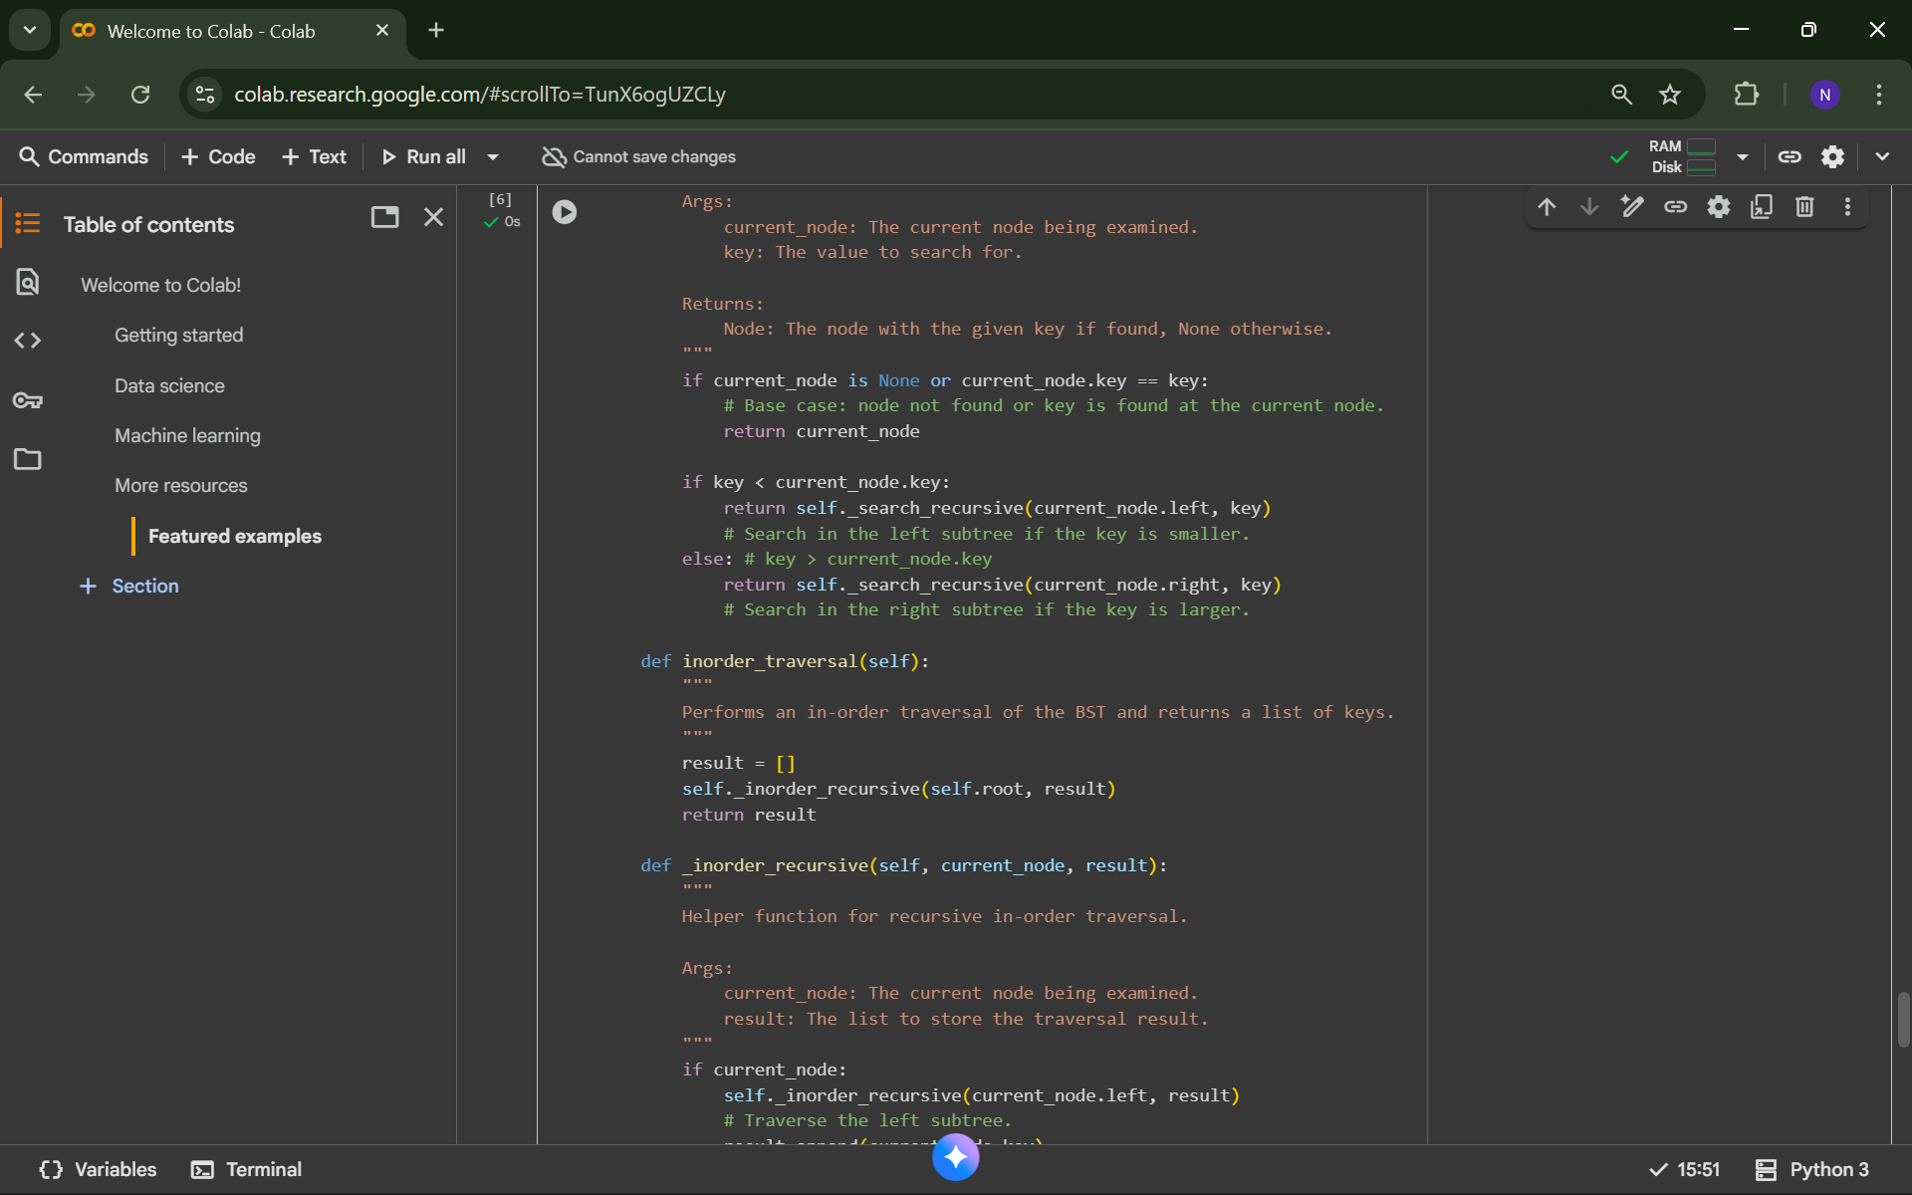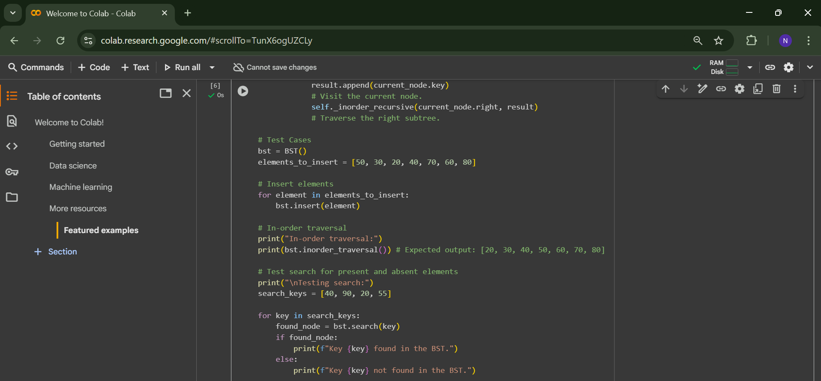
OUTPUT: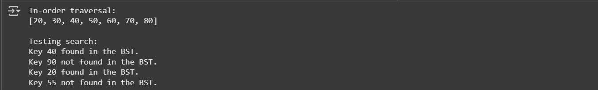
Task 5: Graph Representation and BFS/DFS Traversal
PROMPT:
- Implement a Graph using an adjacency list with BFS() and DFS(). Add docstrings and comments explaining each step, show both recursive and iterative DFS, and demonstrate BFS/DFS outputs on sample data
CODE:
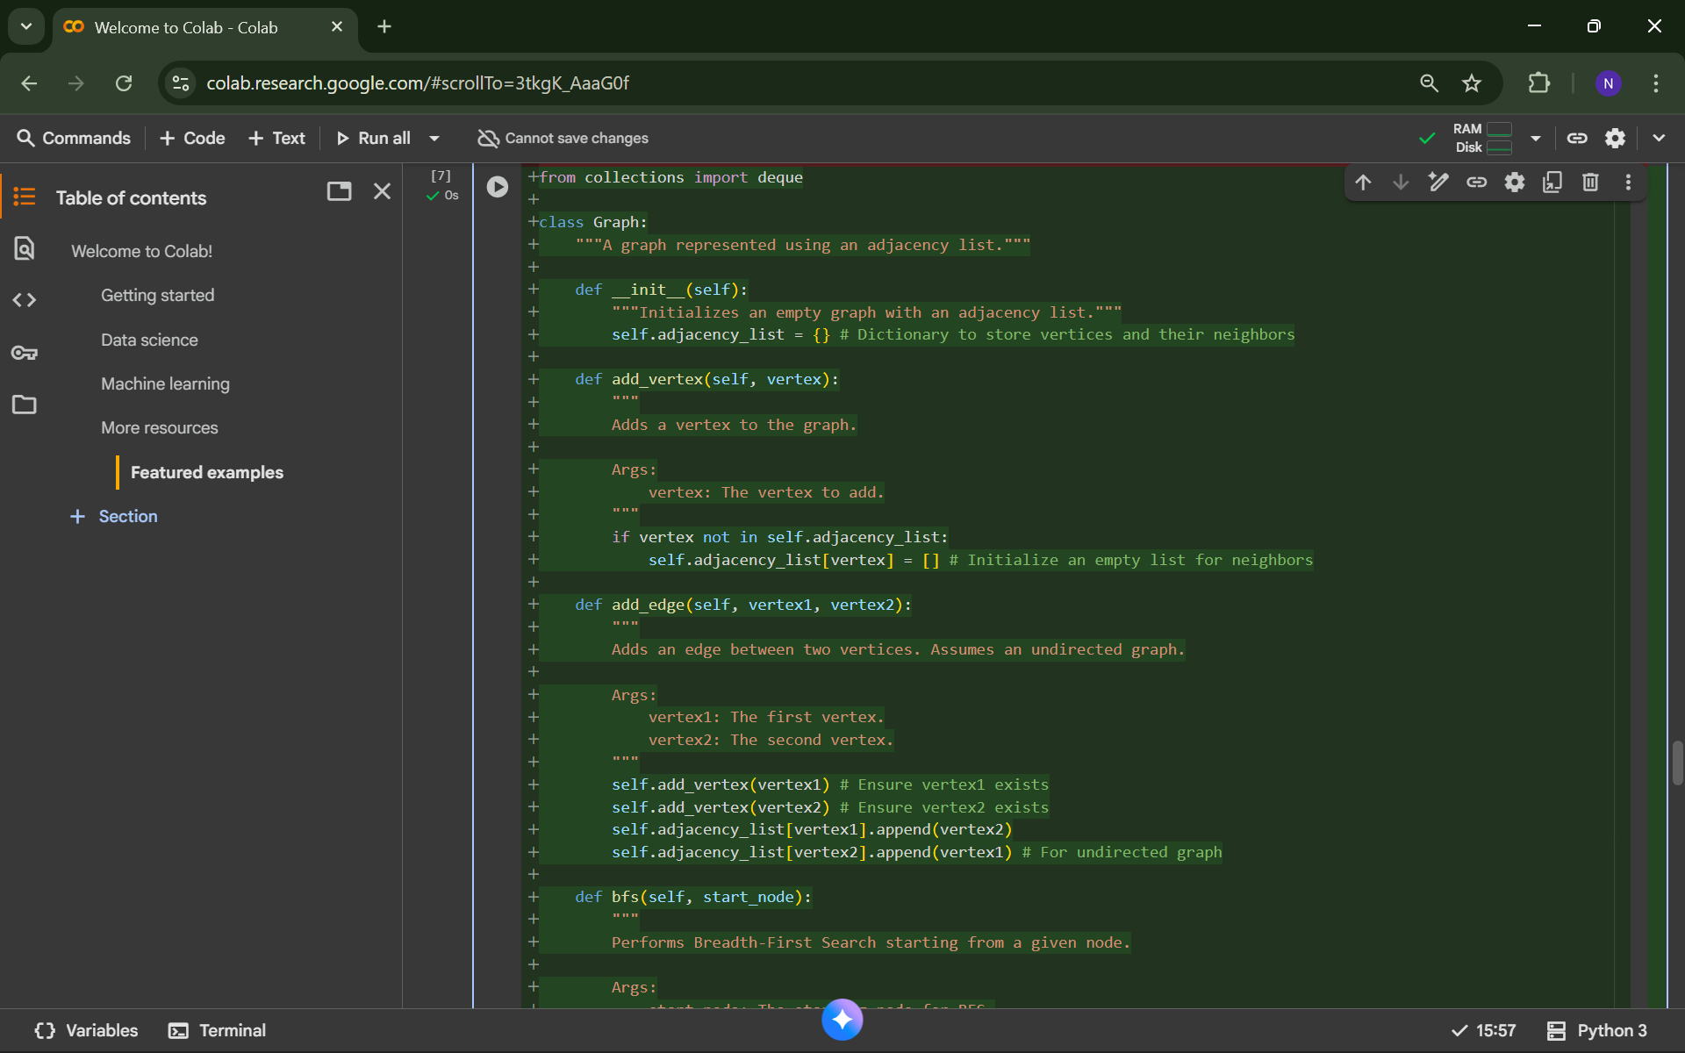
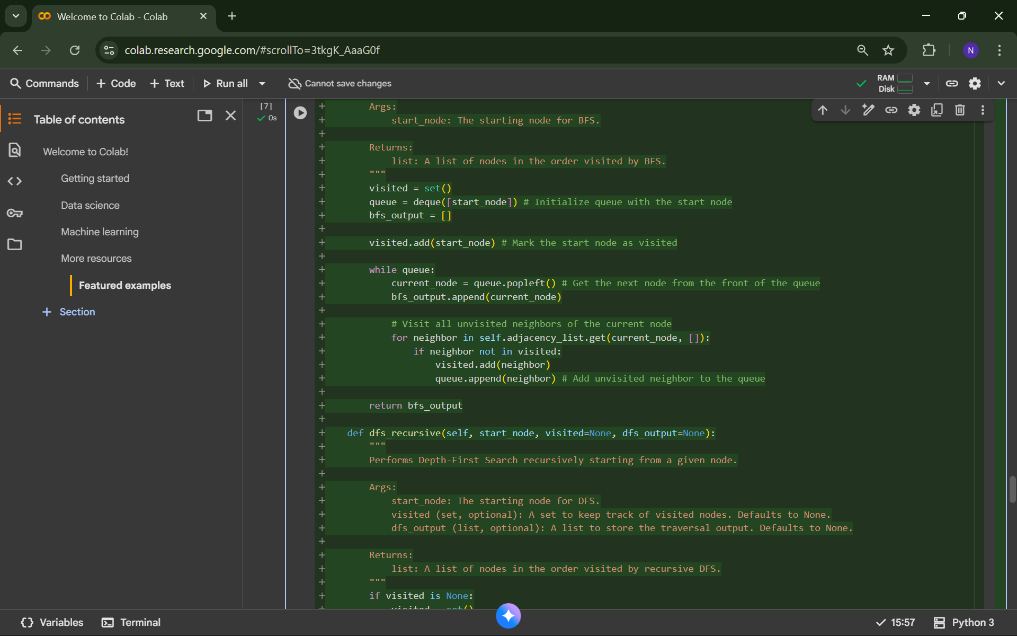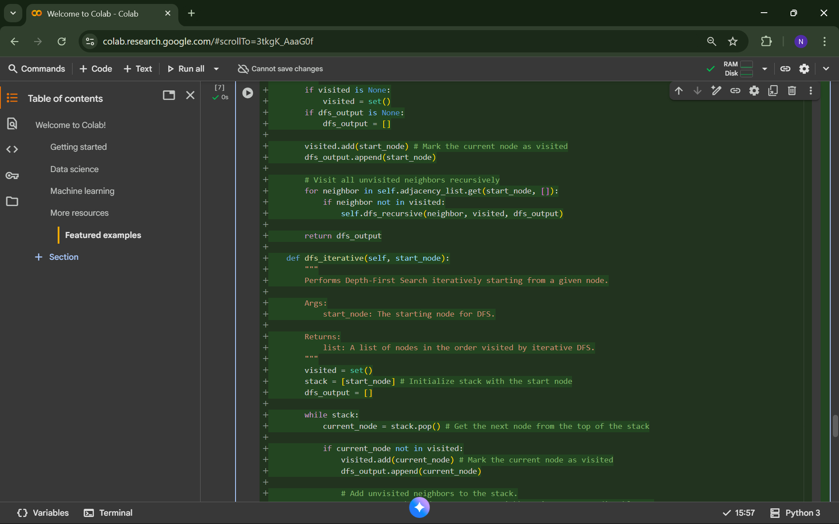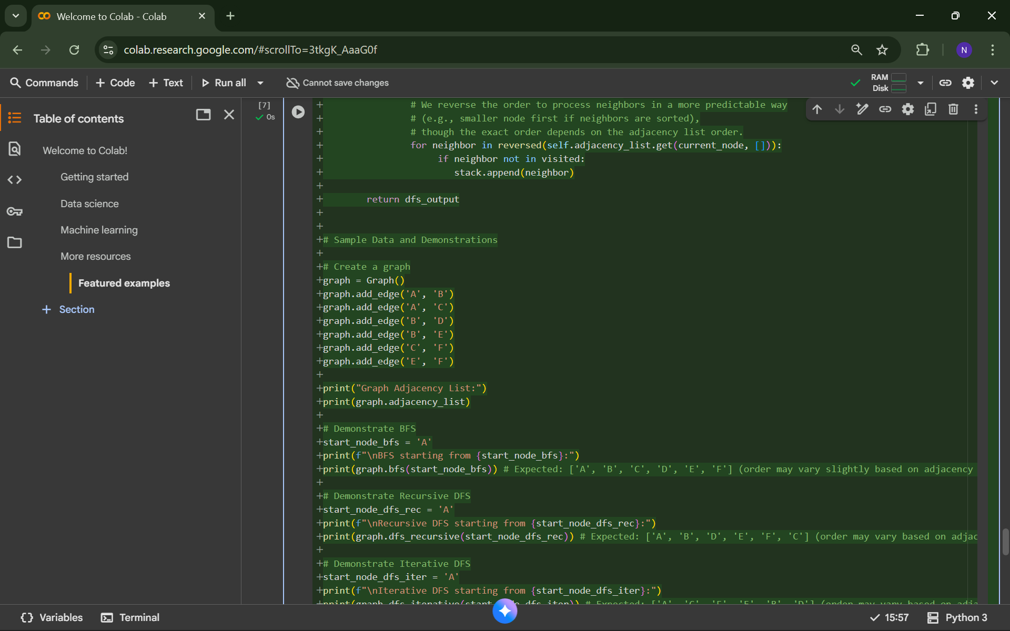
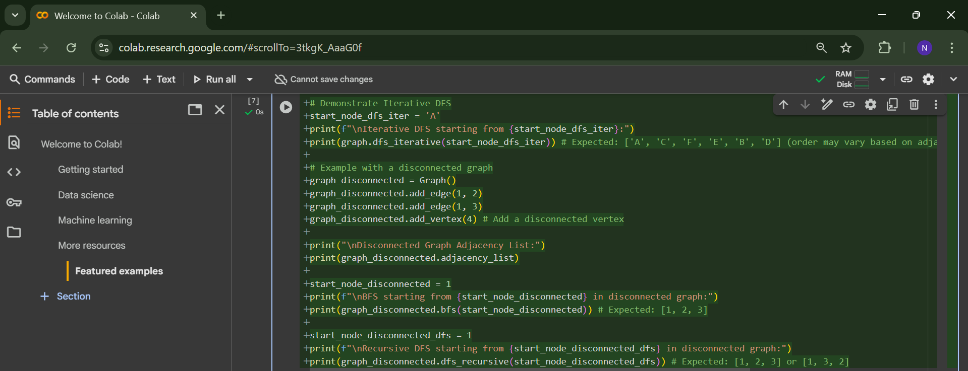
OUTPUT:
