ASSIGNMENT: 7.1
Name: N. shiva
Htno:2403A51298
Batch:24BTCAICS12
Task #1: Syntax Errors – Missing Parentheses in Print
Statement
Prompt:
Create a Python snippet with a missing parenthesis in a print statement, run it to observe the syntax error, then apply AI to fix it. Add at least three assert test cases verifying that the corrected code works correctly
Code: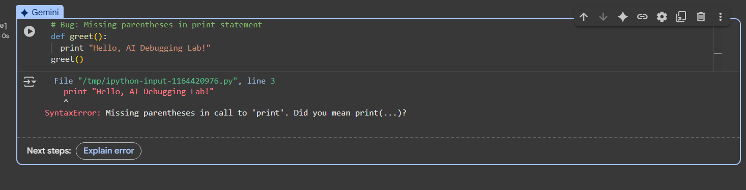
Corrected code:
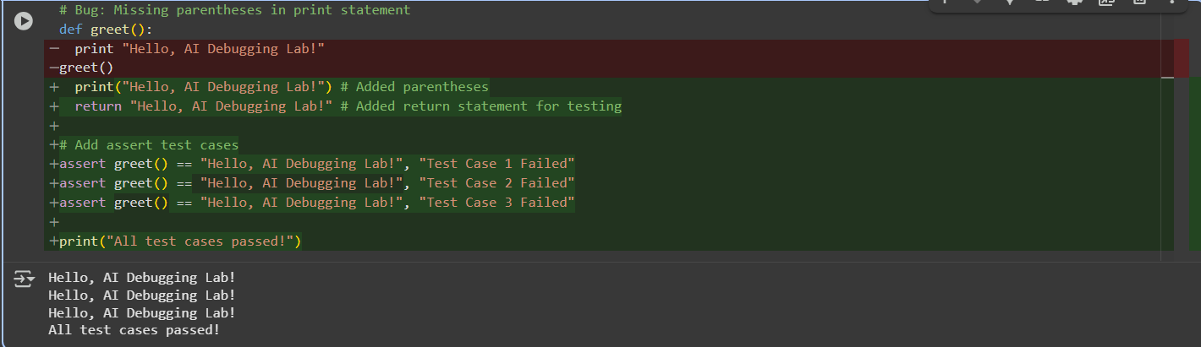
Task #2: Logic Error – Incorrect Condition in an If
Statement
Prompt:
Write a Python function with a bug where an if-condition incorrectly uses = instead of ==. Run it to see the error, then use AI to explain why it fails, correct the code, and verify correctness with three assert test cases.
Code:
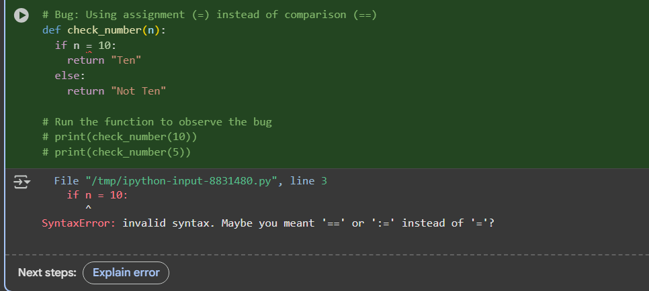
Corrected code:
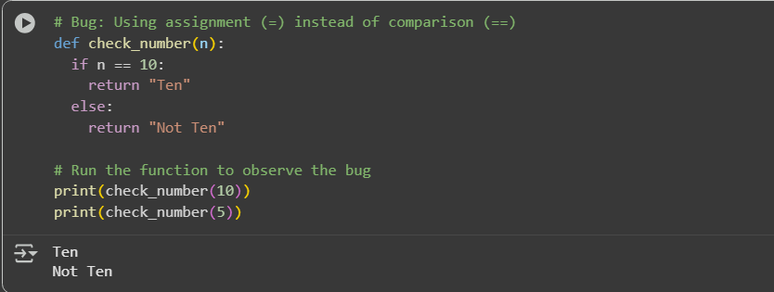
Task #3: Runtime Error – File Not Found
Prompt:
Write a Python function that tries to open a non-existent file and crashes. Run it to see the error, then use AI to add safe error handling with a try-except block, provide a user-friendly message, and test three scenarios: file exists, file missing, and invalid path.
Code:
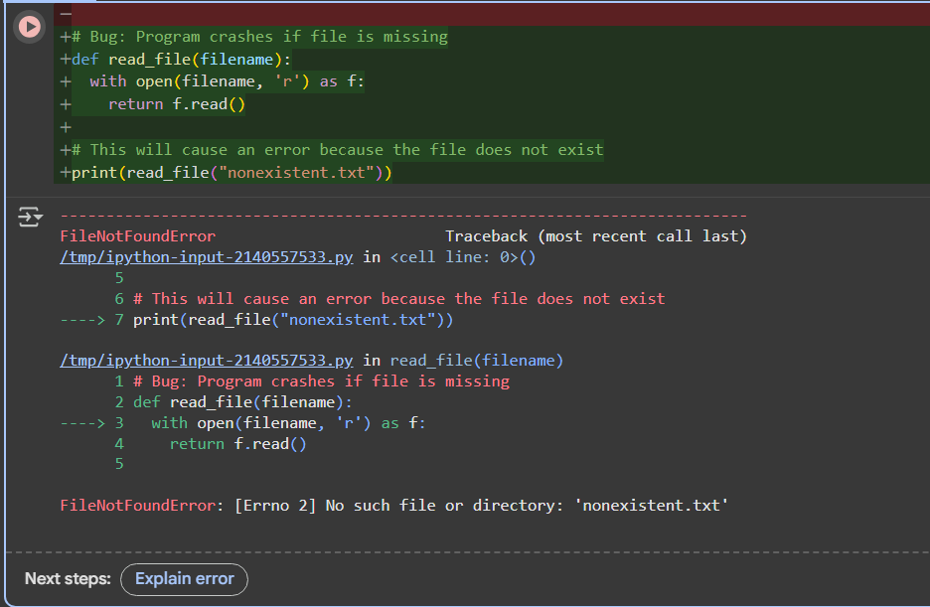
Corrected code:
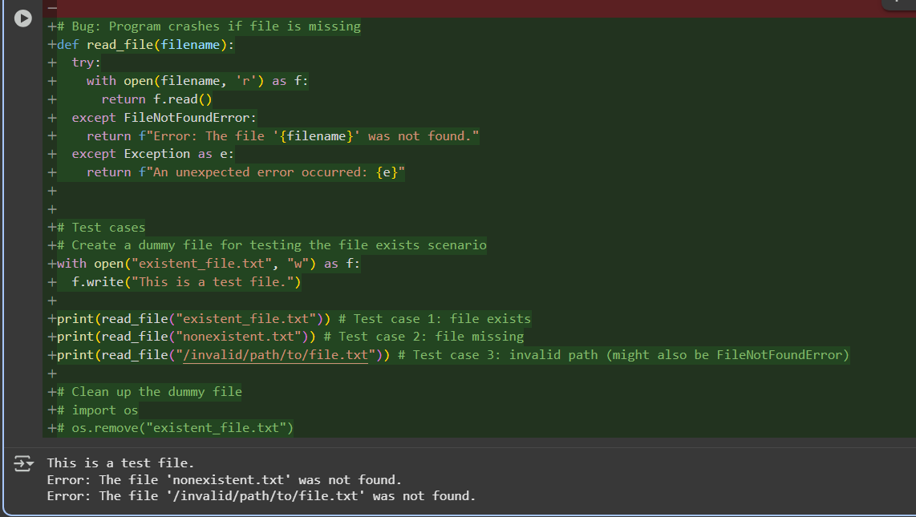
Task #4: Attribute Error – Calling a Non-Existent Method
Prompt:
Write a Python class where an object calls a non-existent method (e.g., obj. undefined_ method ()), causing an error. Run the code to observe the failure, then use AI to explain the issue, decide whether to define the missing method or correct the method call, and verify correctness with three assert test cases.
Code:
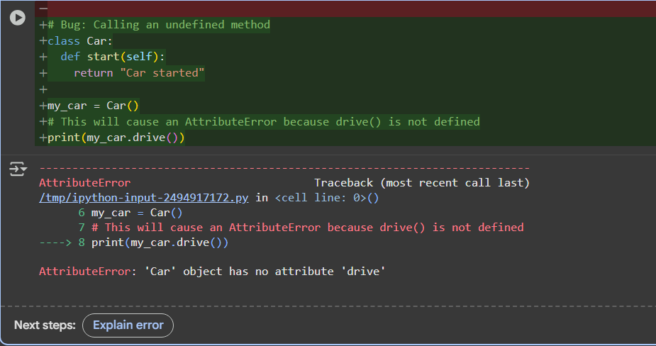
Corrected code:
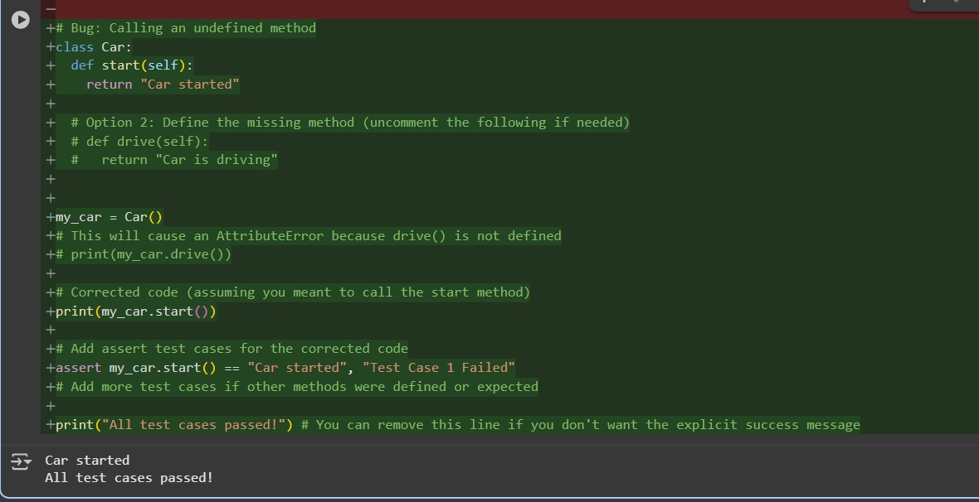
Task #5 Type Error – Mixing Strings and Integers in Addition
Prompt:
Write a Python function that adds an integer and a string (e.g., "5" + 2), causing a TypeError. Run to observe the error, then use AI to suggest fixes, such as type casting and string concatenation. Verify correctness with three assert test cases.
Code:
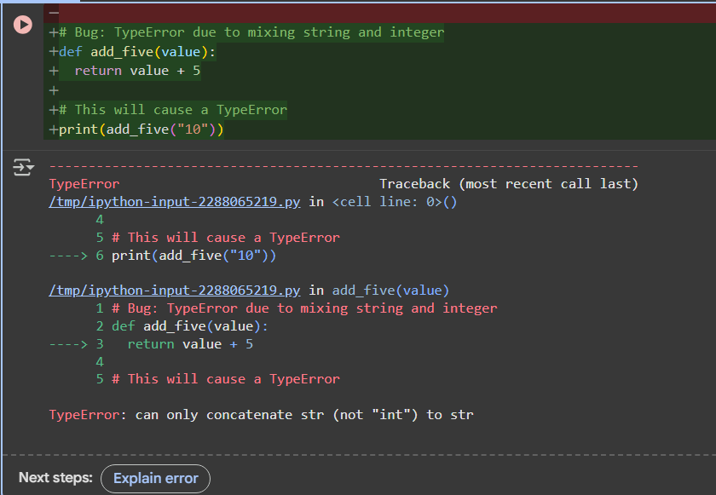
Corrected code:
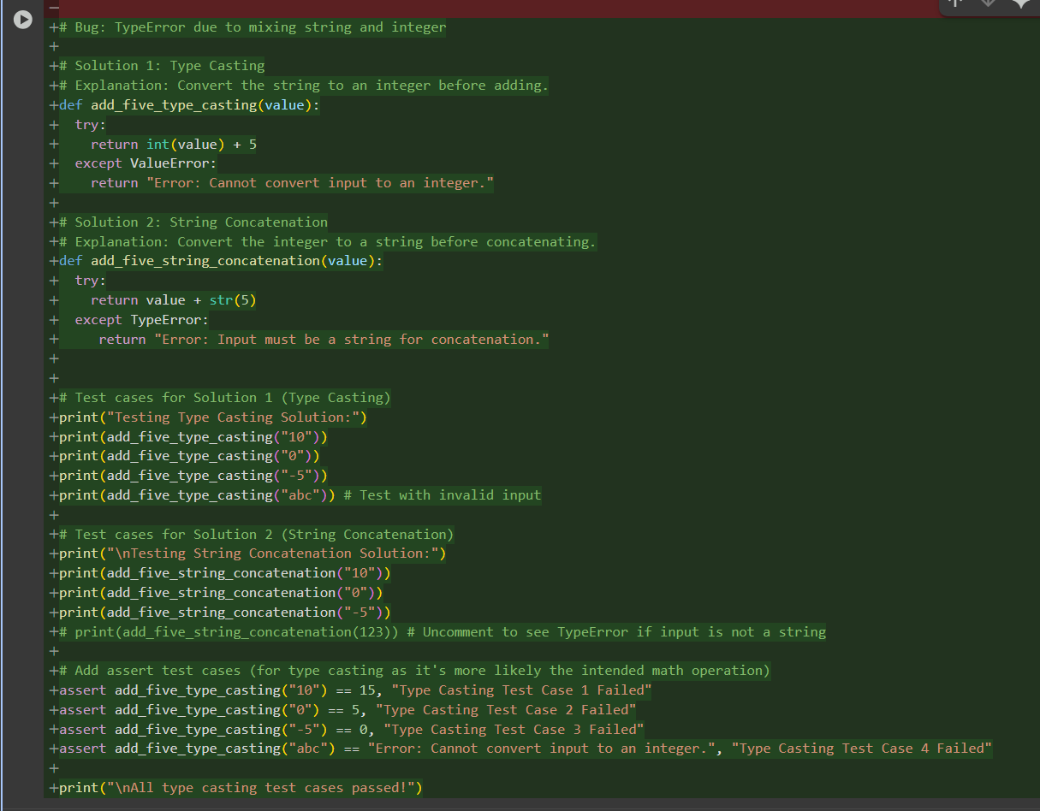
Output:
