Lab Exam-2
Name: N. Shiva
Htno:2403A51298
Batch:24BTCAICSB12
A.1 — [S18A1] Compute per-probe average from logs (AI completion)
Prompt:
Write a Python routine which can be used to input raw log text with lines such as id,timestamp,ppm. Other lines can be broken or contain invalid numbers, so they are ignored. Given each id, take the average of the ppm to the nearest 2 decimals and give a dictionary of all the id values and avg values and also give the average of all the values of the id. Include docstrings and maintain a clean and readable code.
Code:
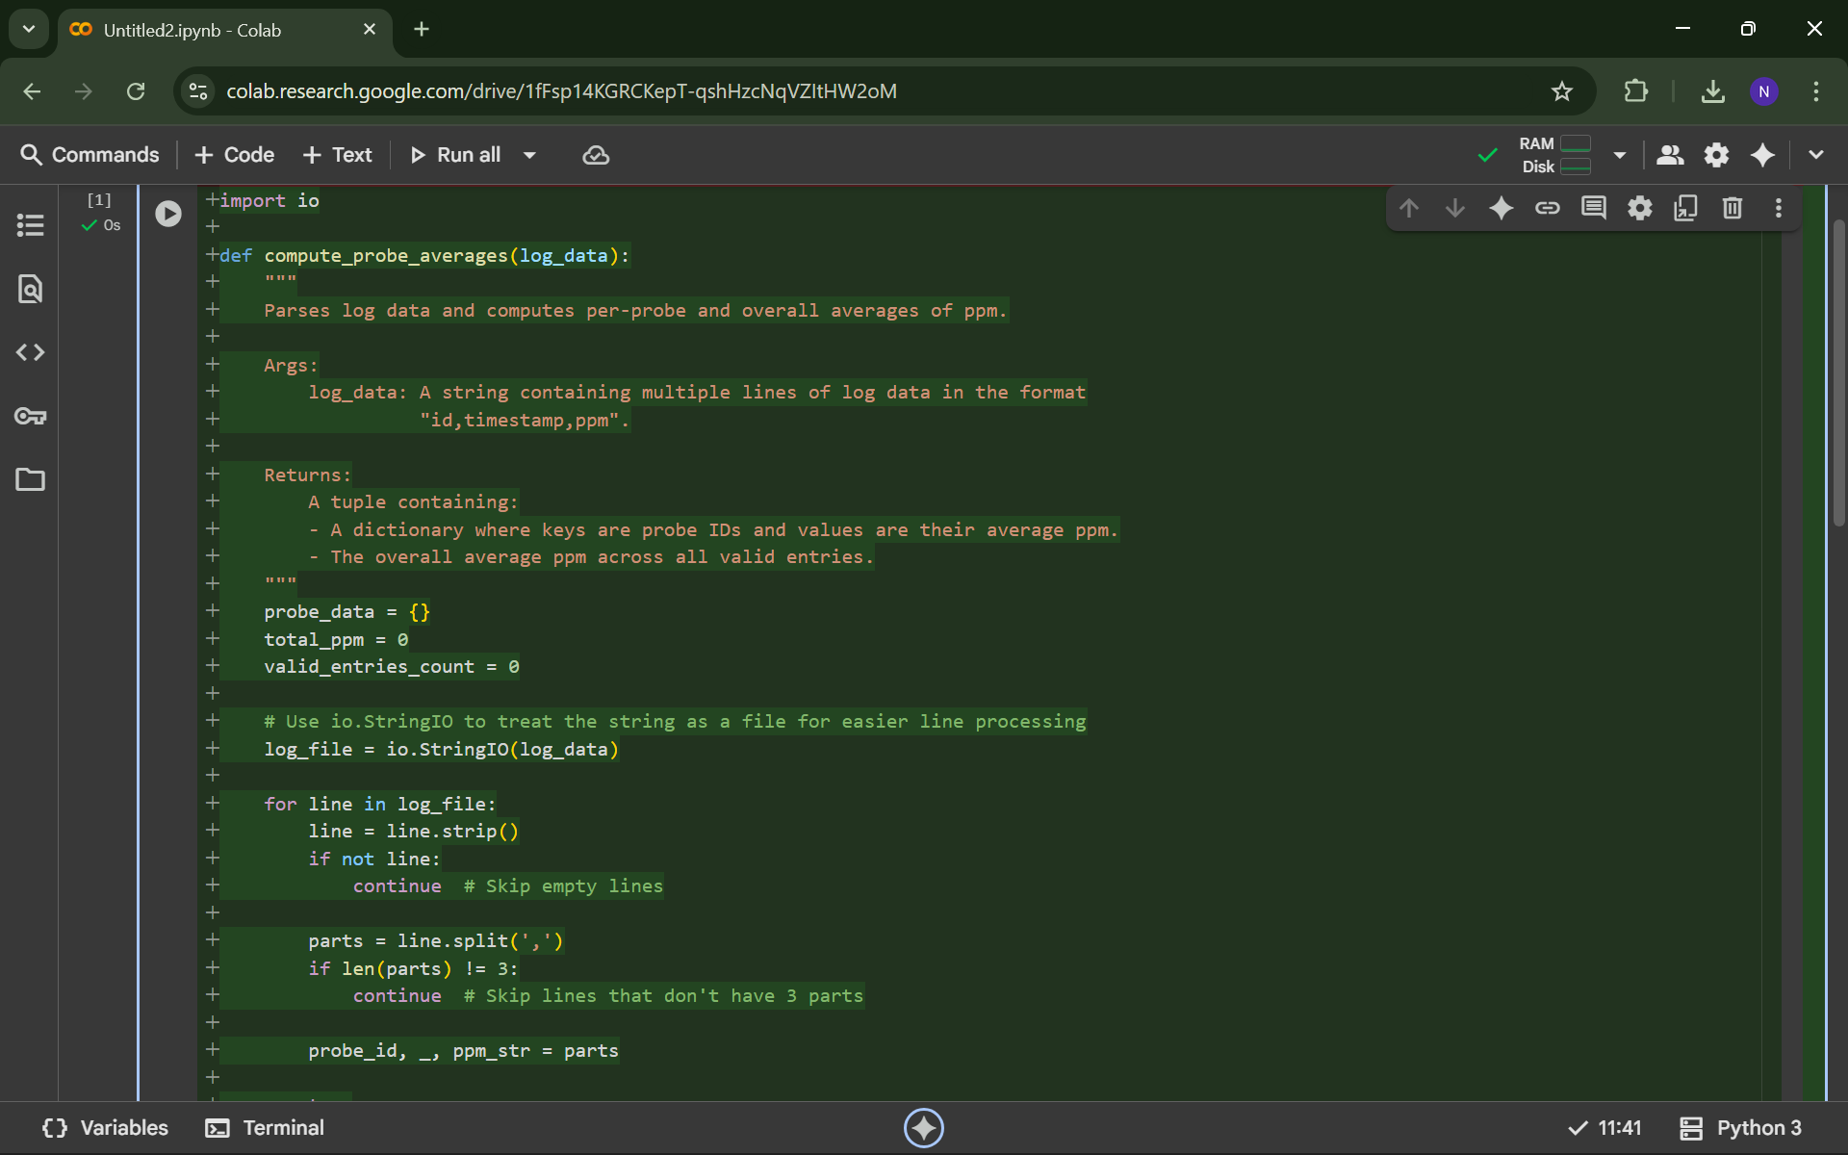
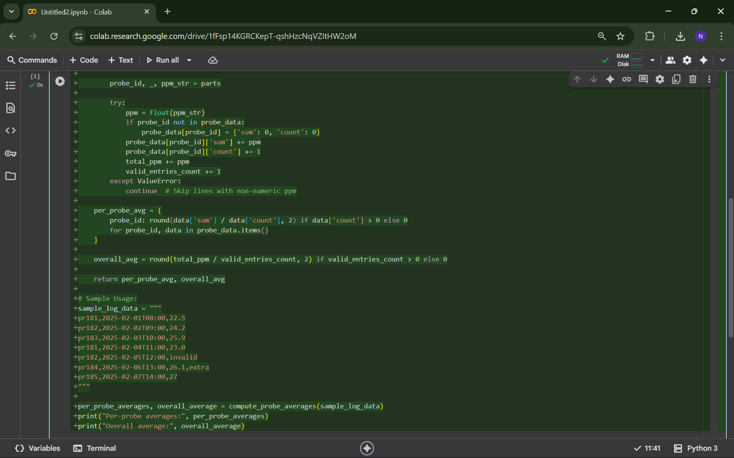
Output:

A.2 — [S18A2] Implement Listing Window with add/remove/summary (AI completion)
Prompt:
Create a Python object named Listing window, which will save values in a dictionary where id is the key. It should also contain add(id, value) to insert or update, remove(id) to safely delete when it exists, and summary() to give the number of items and the mean value should be under 2 decimals, or nothing to give none. Include some docstrings and a minimal usage example. To be clear and understandable, the code must be very simple.
Code:
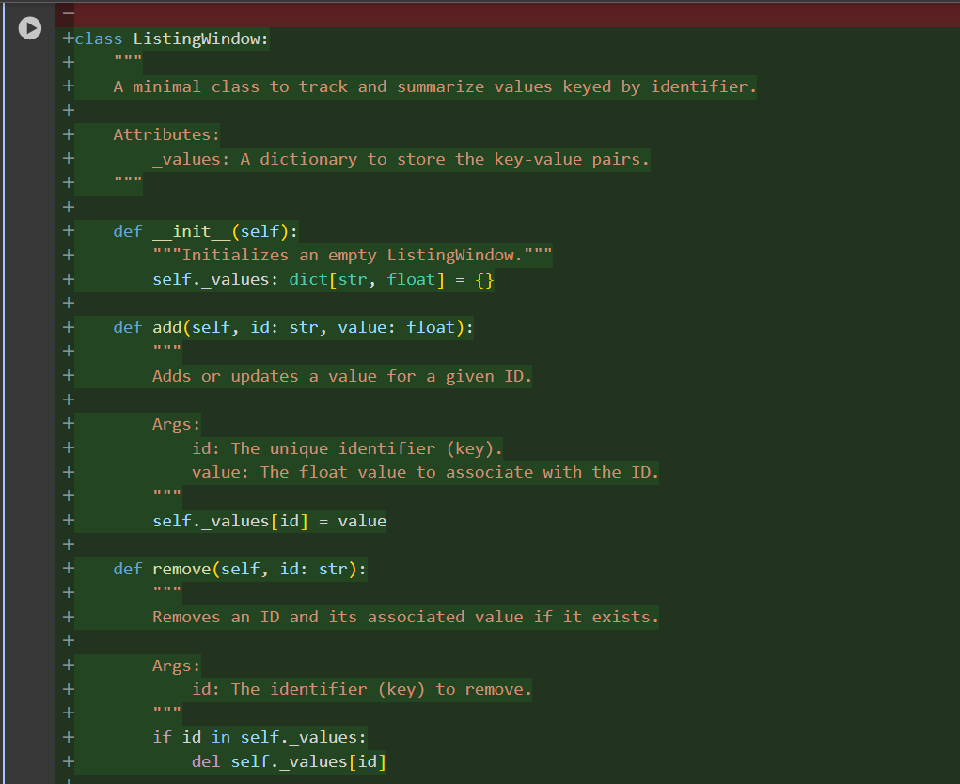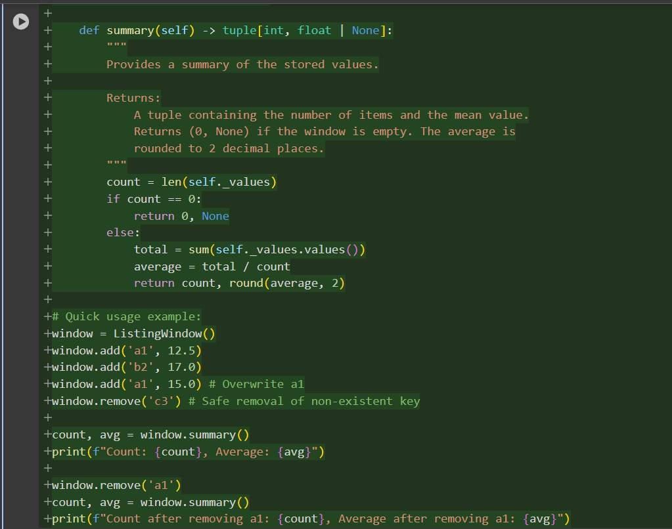
Output:

