ASSIGNMENT: 9.1
Name: N. Shiva
Htno:2403A51298
Batch: 24BTCAICSB12
Task #1: Documentation-Google-Style Docstrings for
Python Functions
PROMPT:
Add Google-style docstrings to all functions in this Python script.
Include: description, parameters with types, return type, and example usage (no I/O examples).
Preserve code logic, ensure proper indentation, and follow Google-style formatting strictly.
Code:
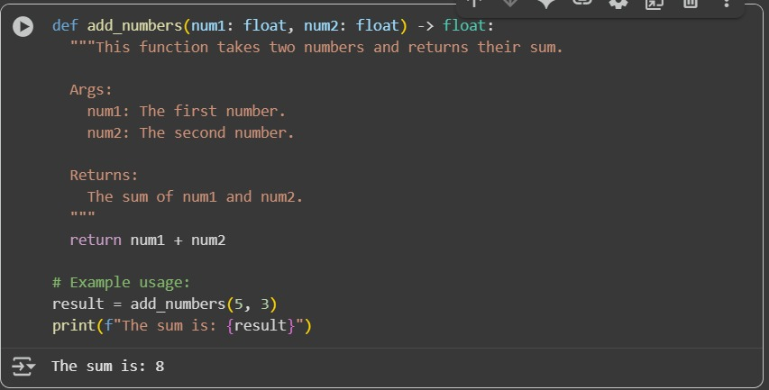

Task #2: Documentation – Inline Comments for Complex
Logic
Prompt:
Add inline comments only for complex or non-obvious logic in this Python script.
Skip obvious syntax. Keep comments concise and context-aware.
Do not change the code.
Code:
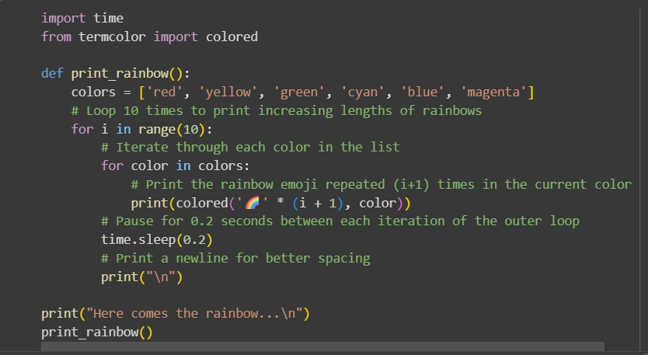
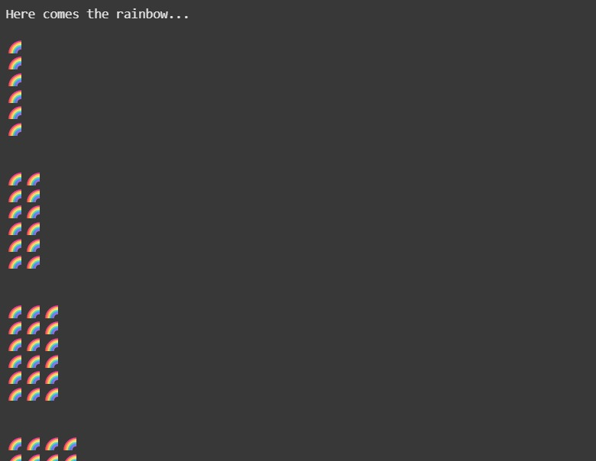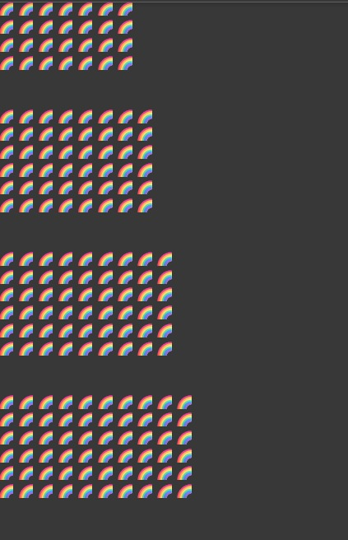

Task #3: Documentation – Module-Level Documentation
Prompt:
Add a module-level docstring at the top of this Python file.
Summarize purpose, dependencies, and main functions/classes.
Keep it concise, clear, and multi-line.
Do not alter the code.
Code:
Python file:

Docstring
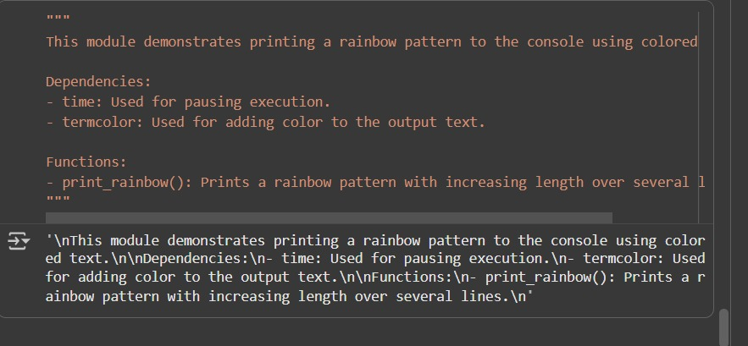

Task #4: Documentation – Convert Comments to Structured Docstrings
Prompt:
Convert inline comments in this Python code into structured Google-style docstrings.
Keep meaning intact, improve clarity, and remove the old comments.
Do not change code logic.
Code:
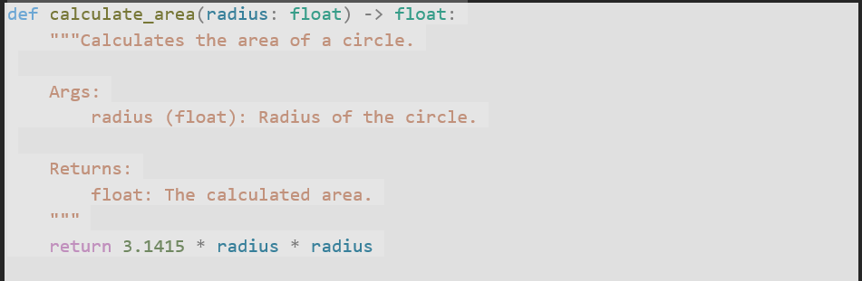
Task #5: Documentation – Review and Correct Docstrings
Prompt:
Review all docstrings in this Python file.
Fix inaccuracies so they match current code behavior.
Ensure Google-style format with description, parameters, return type, and example.
Code:
Before:
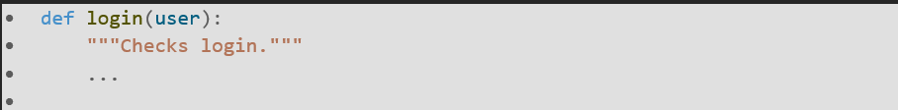
After:
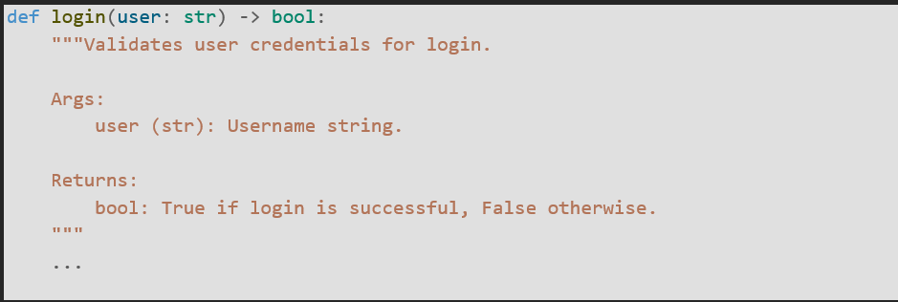
Task #6: Documentation – Prompt Comparison Experiment
Prompt:
Compare AI documentation for one Python function using two prompts:
1) "Add comments to this function"
2) "Add Google-style docstring with description, parameters, return type, and example"
Create a table showing prompt type, output, and observations.
Code:
