Assignment-10.3
Name: N. Shiva
Htno:2403A51298
Batch:24BTCAICSB12
Task Description #1 – Refactor Nested Conditionals
PROMPT:
Please simplify and refactor the following Python function. The current nested if/else structure is hard to read. Could you make the logic cleaner and more direct
CODE:
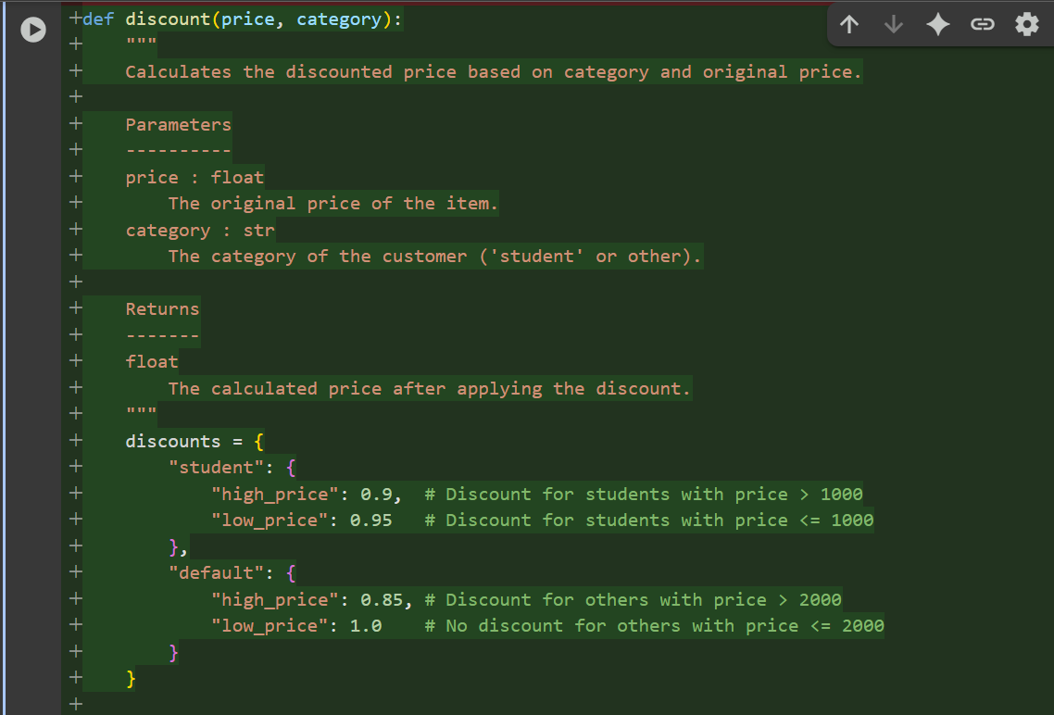
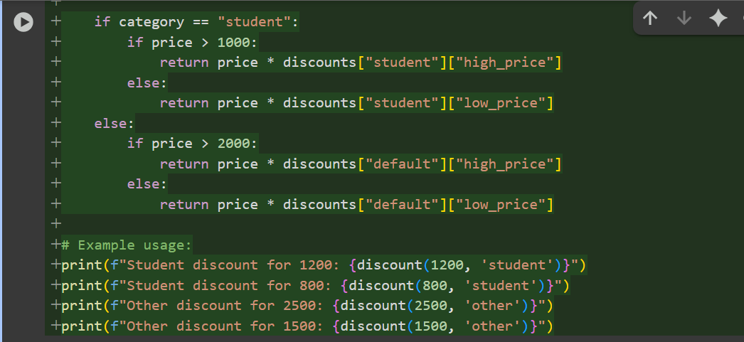
OUTPUT:
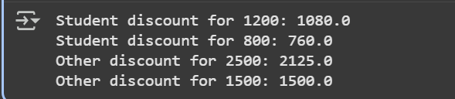

Task Description #2 – Optimize Redundant Loops
PROMPT:
Can you refactor and optimize this Python function? The nested loop is very inefficient for finding common elements between two lists. I'm looking for a more performant and Pythonic solution
CODE:
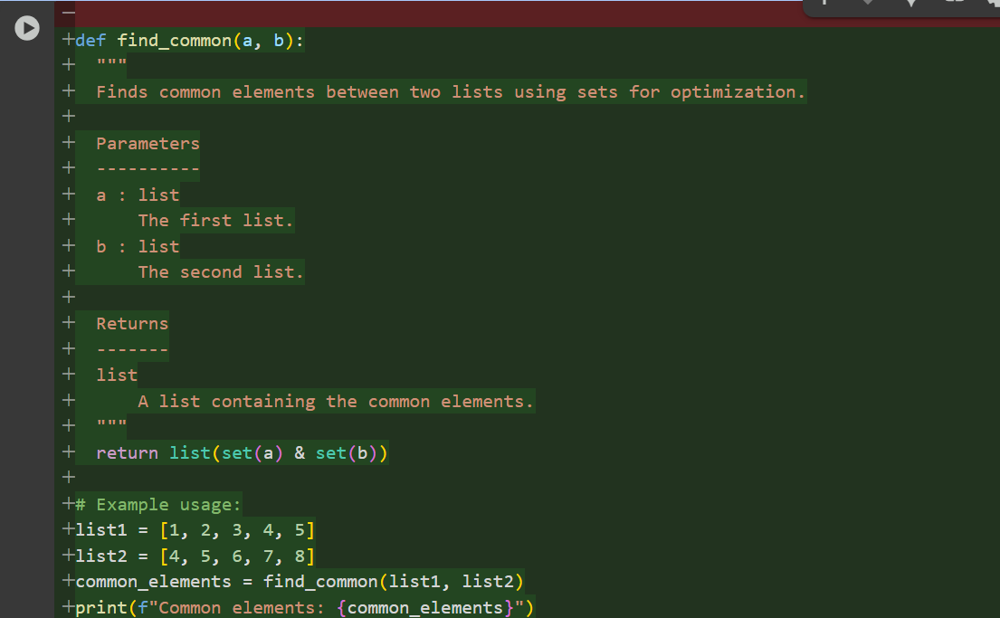
OUTPUT:

Task Description #3 – Improve Class Design
PROMPT:
Please improve the design of this Python class. Focus on better naming conventions for the class and its methods (e.g., emp, n, s, inc, pr), proper encapsulation of its attributes, and overall readability. Please add docstrings to explain what the class and its methods do
CODE:
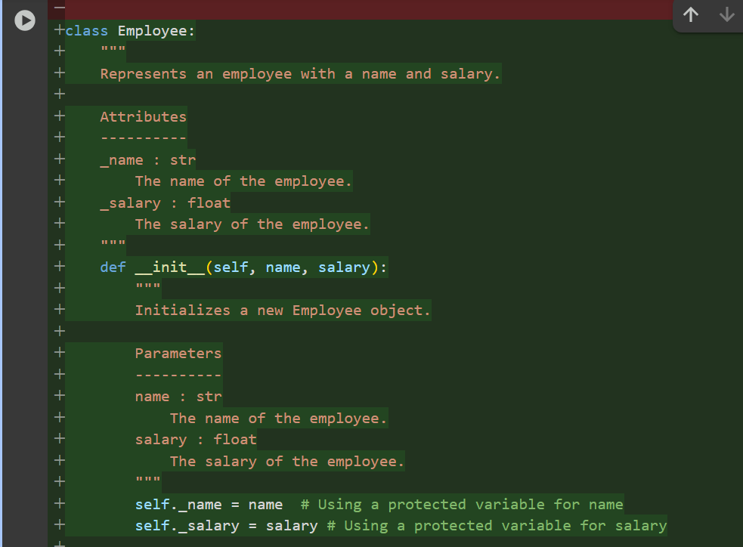
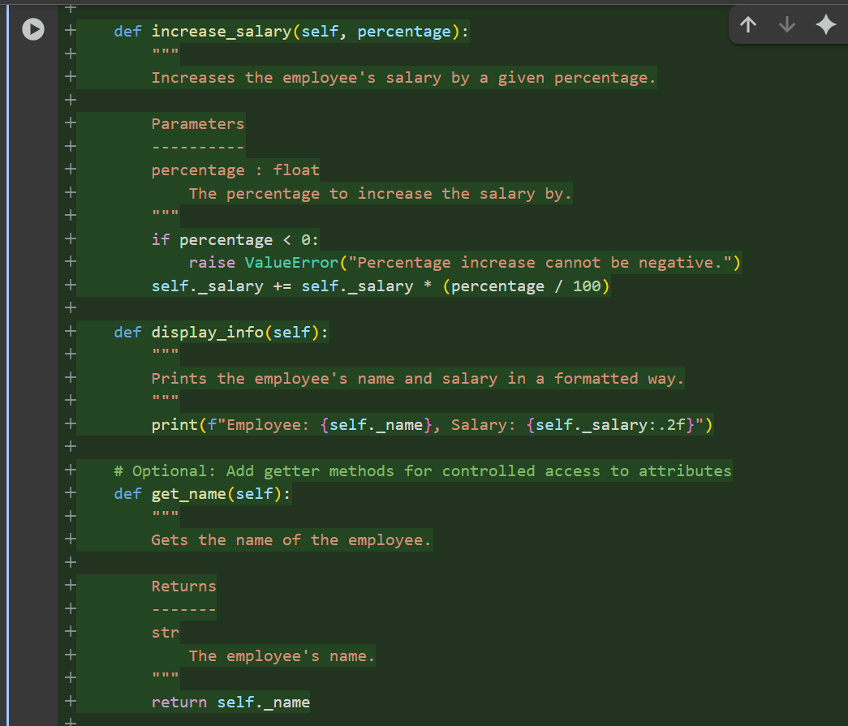
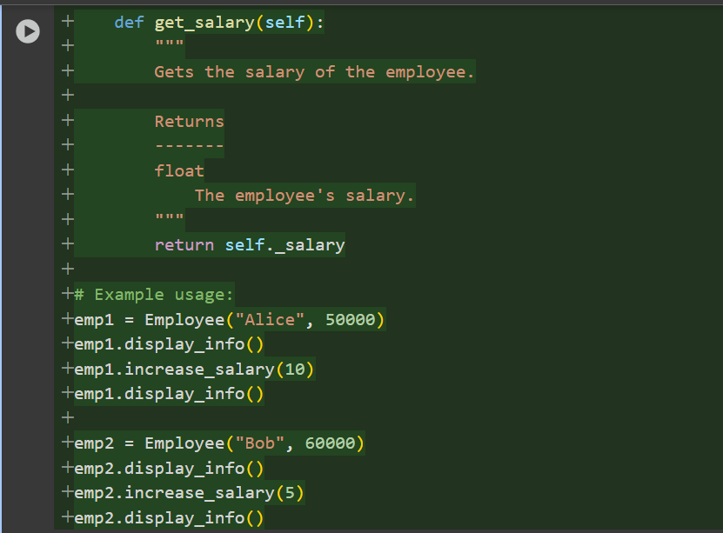
OUTPUT:
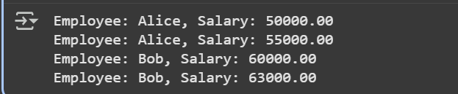
Task Description #4 – Modularize Long Function
PROMPT:
This Python function is too long and handles multiple tasks in one block of code. Could you please modularize it by breaking it down into smaller, single-purpose helper functions? The main function should then call these helpers to produce the same result, but with a much cleaner structure
CODE:
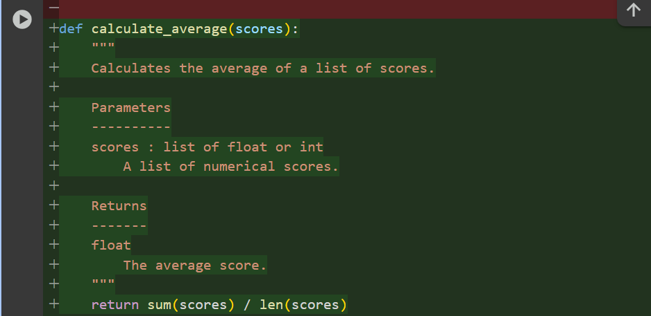
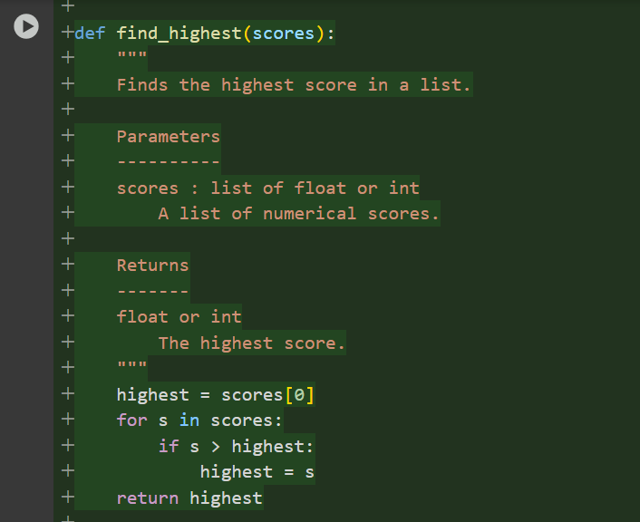
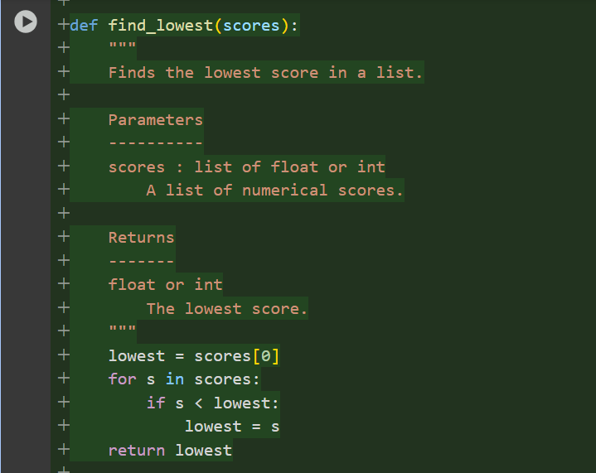
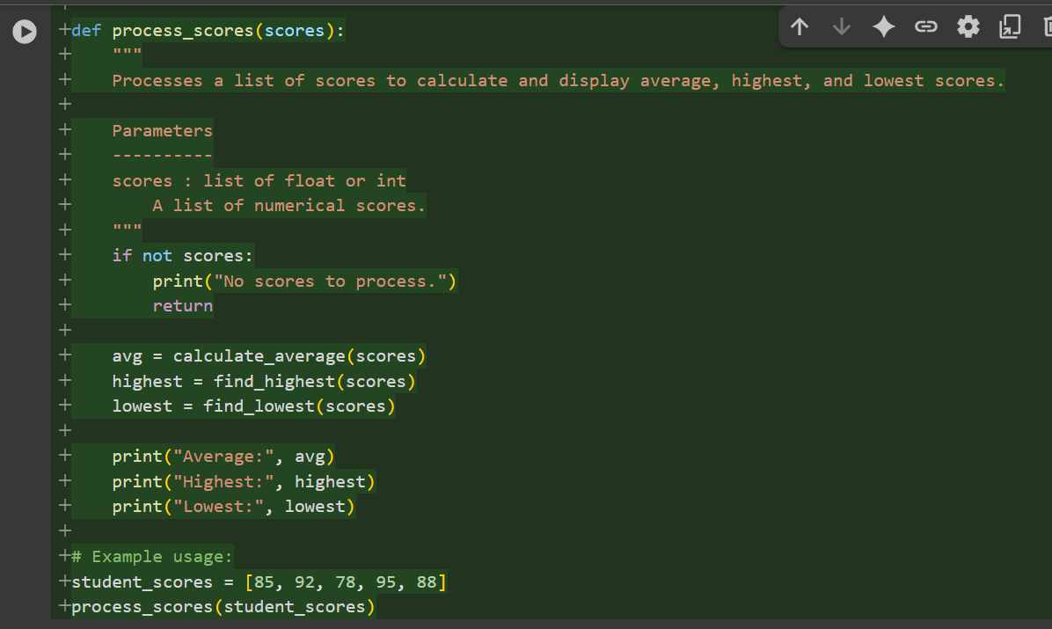
OUTPUT:
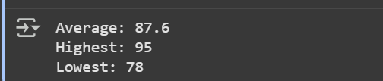
Task Description #5 – Code Review on Error Handling
PROMPT:
Please review and fix this Python code. It crashes when dividing by zero. I need you to add proper error handling using a try-except block, improve the function name to be more descriptive, and add a docstring explaining how it works and how it handles errors
CODE:
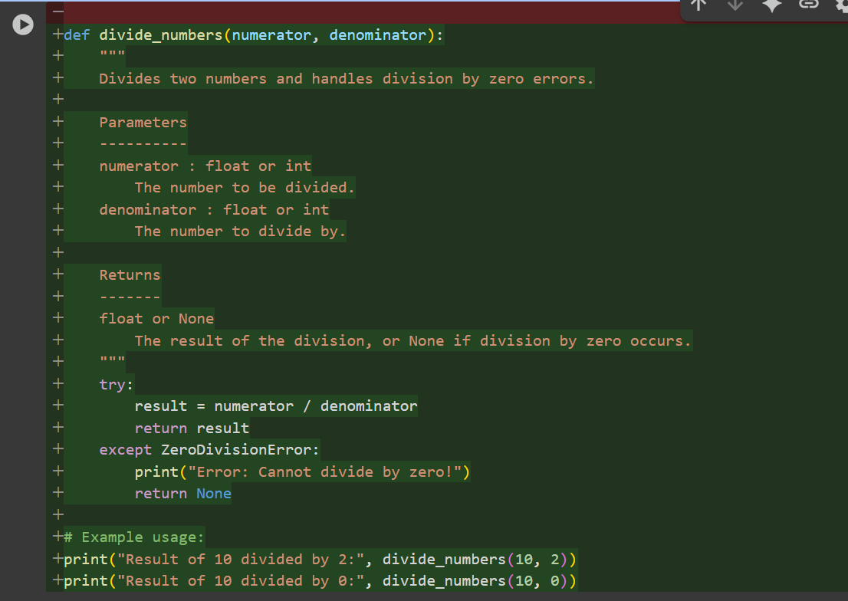
OUTPUT:
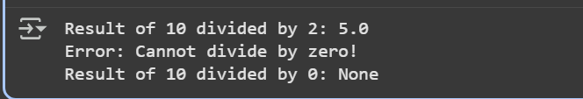
Task Description #6 – Complexity Reduction
PROMPT:
Can you simplify the logic in this Python function? The deeply nested if/else statements are overly complex and hard to follow. Please refactor it into a cleaner, more readable structure using elif statements
CODE:
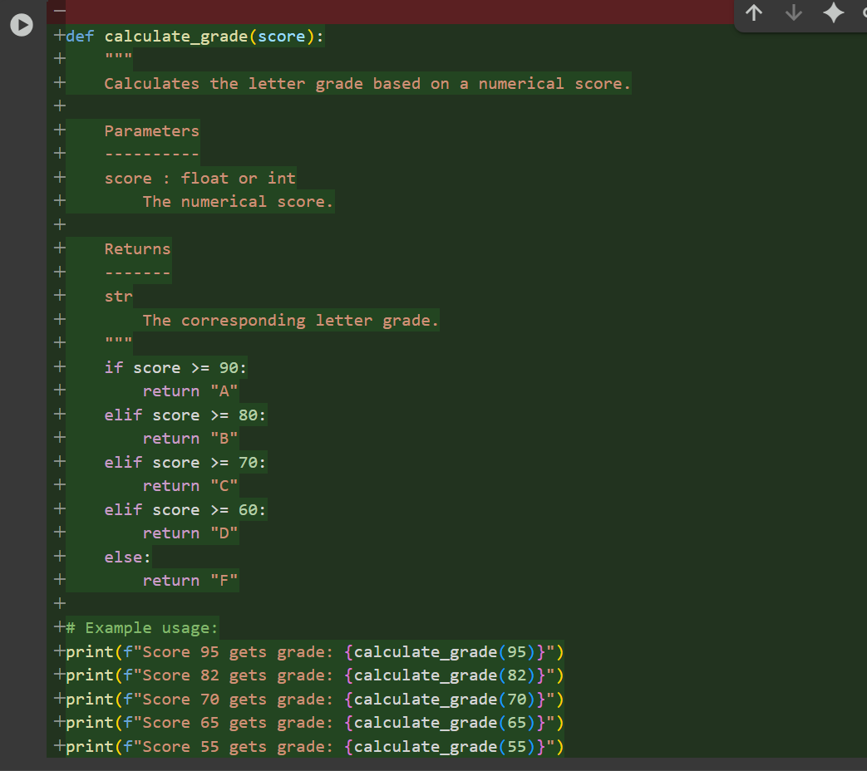
OUTPUT:
