Assignment-10.2
Name: N. Shiva
Htno:2403A51298 Batch:24BTCAICSB12

Task Description#1 AI-Assisted Code Review (Basic Errors)
• Write Python program as shown below.
• Use an AI assistant to review and suggest corrections
def calcFact(n):
result=1
x=0
for i in range(1,n):
result=result i
return result
def main():
num = 5
FACT = calcFact (num)
print("the factorial of", num, "is", FACT)
t=10
if FACT>10:
print("BIG Number")
else:
print("small number")
main()
CODE:
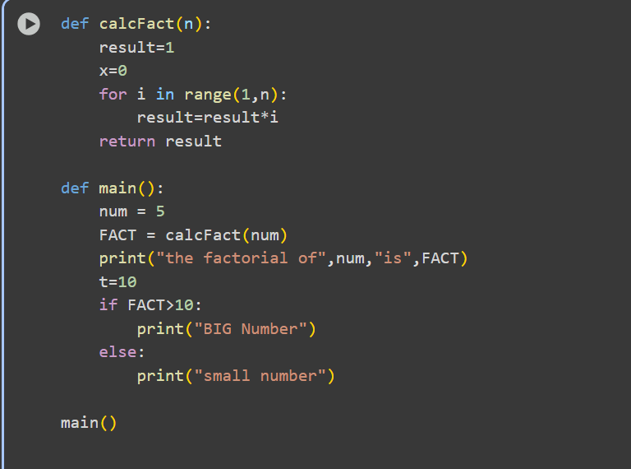

OUTPUT:
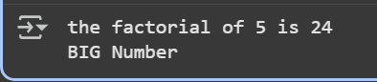
Task Description#2 Automatic Inline Comments
• Write the Python code for Fibonacci as shown below and execute.
• Ask AI to improve variable names, add comments, and apply PEP8 formatting
(cleaned up).
• Students evaluate which suggestions improve readability most. one.
def f1(xx):
b-1
c=2
Zz-[a,b]
while c<-XX:
death
Zz.append(d)
b-d
return zz
def m():
NN-10
ans-f1(NN)
print("fib series till", NN, ":", ans)
m()
code:
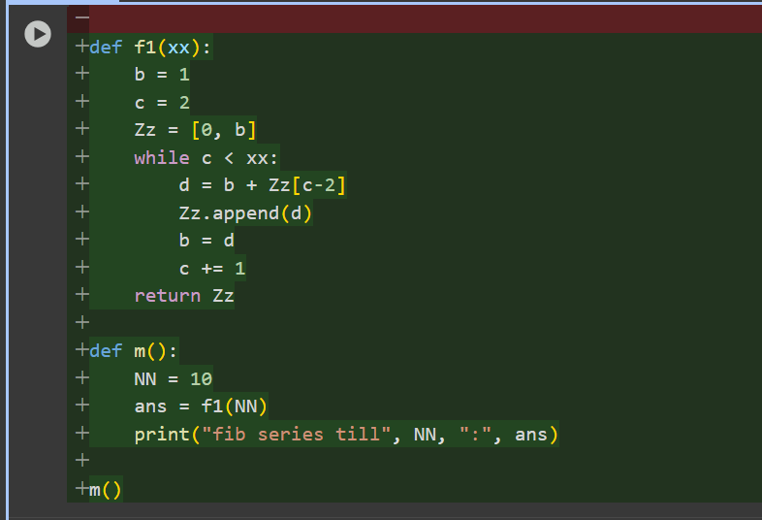
Output:

Task Description#3
Prompt: Create a Python script (add, subtract, multiply, divide) with NumPy-style docstrings, compare with AI docstrings, and explain code smells.
Code:
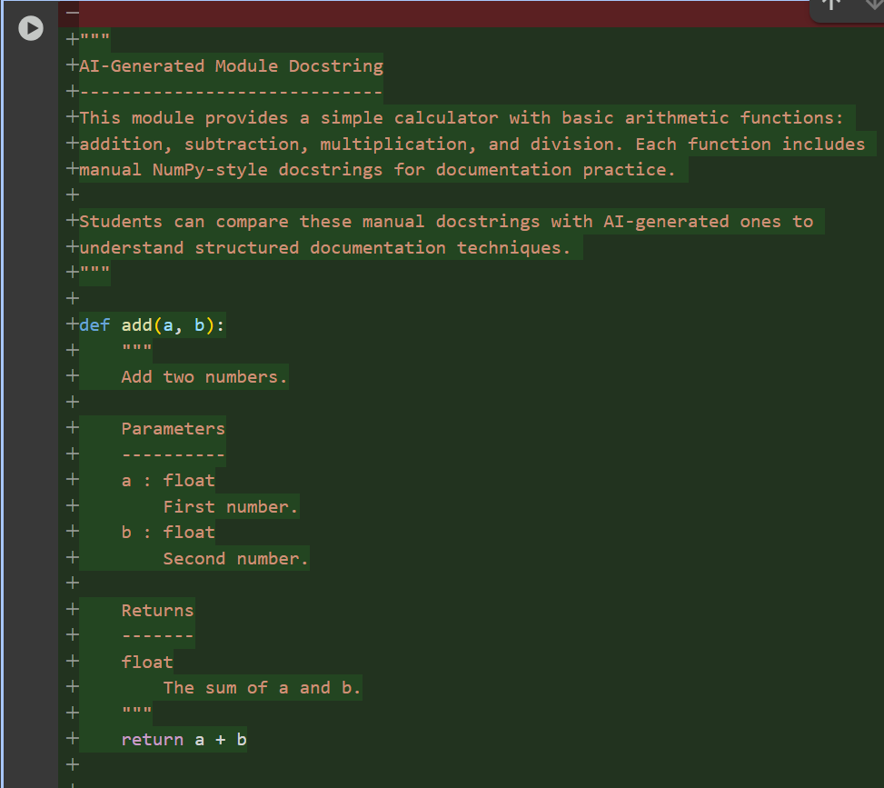
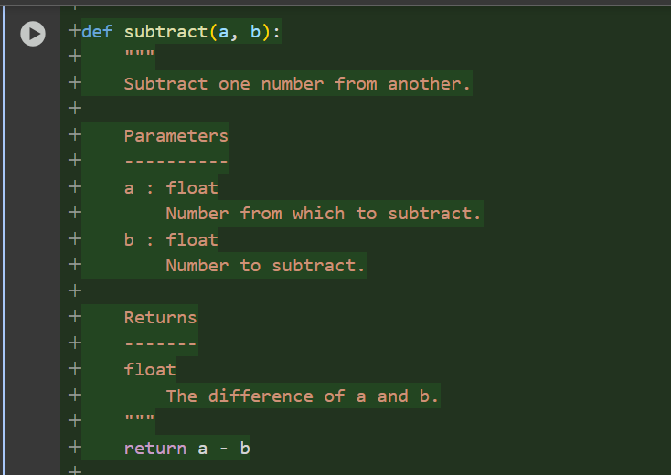
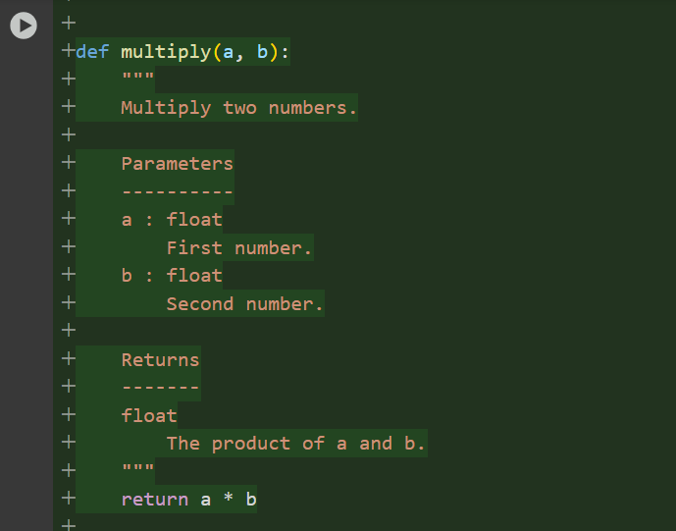
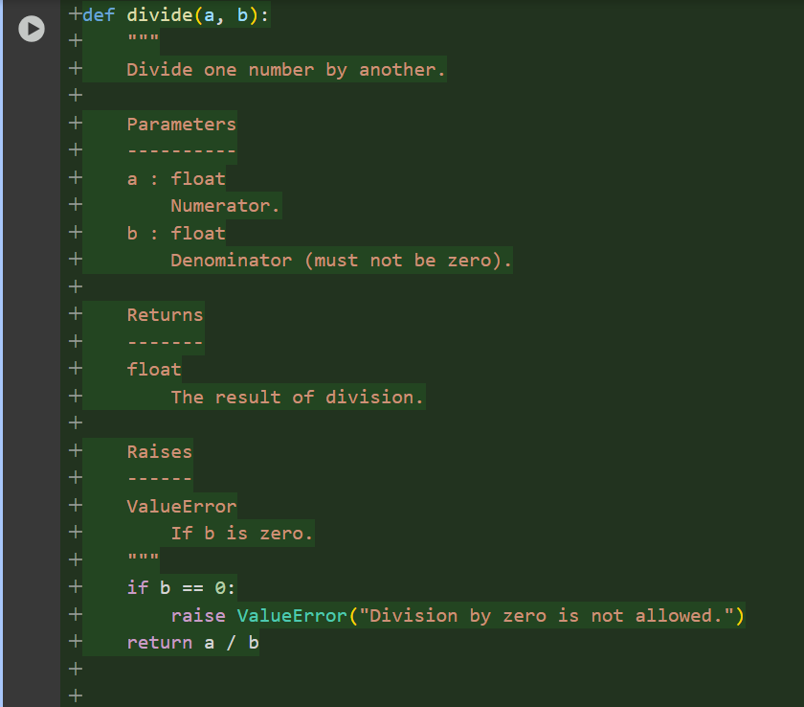
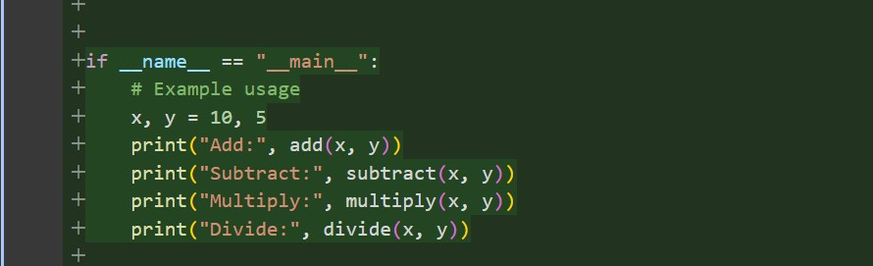
Output:
