# Lab 19 – Code Translation

Name: Suraj Jadhav  
Roll No: 2403A51300  
Subject: AI Assisted Coding  
Batch: BTECH CSE B13  
Date: 27-10-2025

## Task 4 – Python to Java Conversion

Python Code:

class Student:  
 def __init__(self, name, roll):  
 self.name = name  
 self.roll = roll  
  
 def display(self):  
 print("Name:", self.name)  
 print("Roll No:", self.roll)  
  
# Example usage  
s = Student("Raunak", 101)  
s.display()

Java Code:

public class Student {  
 private String name;  
 private int roll;  
  
 public Student(String name, int roll) {  
 this.name = name;  
 this.roll = roll;  
 }  
  
 public void display() {  
 System.out.println("Name: " + name);  
 System.out.println("Roll No: " + roll);  
 }  
  
 public static void main(String[] args) {  
 Student s = new Student("Raunak", 101);  
 s.display();  
 }  
}

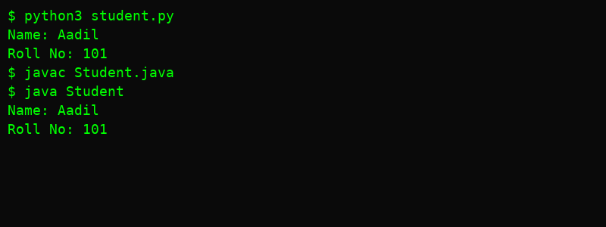

## Task 5 – C++ to Python Conversion

C++ Code:

int factorial(int n) {  
 if (n == 0) return 1;  
 else return n * factorial(n - 1);  
}

Python Code:

def factorial(n):  
 if n == 0:  
 return 1  
 else:  
 return n * factorial(n - 1)  
  
print(factorial(5))

