**Name : Suraj Jadhav**

**Roll No : 2403a51300**

**Batch no : 13**

**Task Description #1:**

**•** Start a Python class named Student with attributes name, roll_number, and marks. Prompt GitHub Copilot to complete methods for displaying details and checking if marks are above average.

Prompt:

**create a python class named Student with attributes name, roll_number, and marks and complete methods for displaying details and checking if marks are above average**

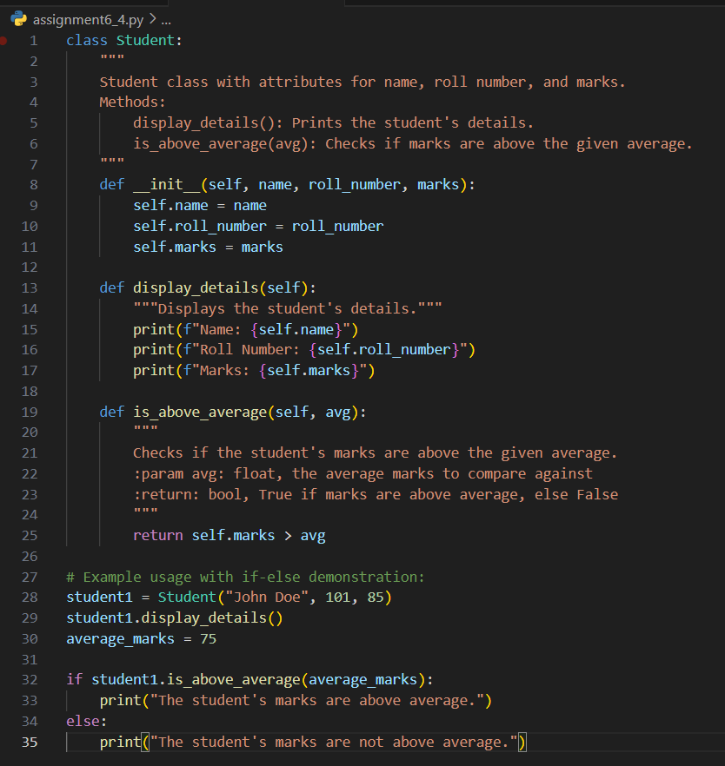

**Task Description #2:**

**• Write the first two lines of a for loop to iterate through a list of numbers. Use a comment prompt to let Copilot suggest how to calculate and print the square of even numbers only.**

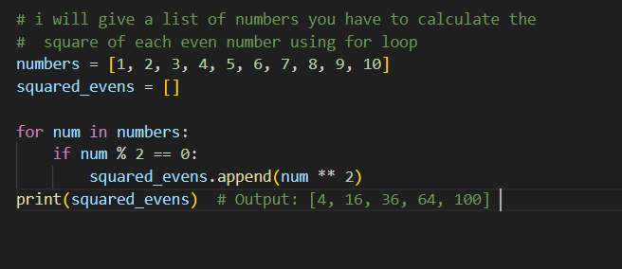

**Task Description #3:**

**• Create a class called BankAccount with attributes account_holder and balance. Use Copilot to complete methods for deposit(), withdraw(), and check for insufficient balance.**

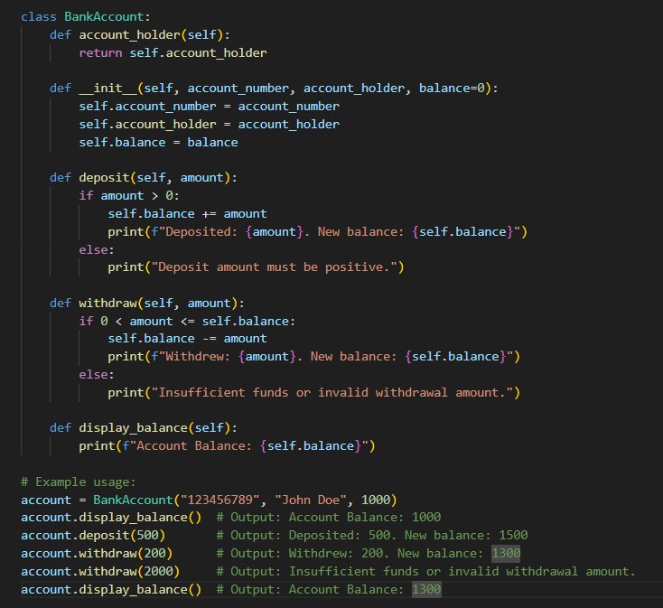

**Task Description #4:**

**• Define a list of student dictionaries with keys name and score. Ask Copilot to write a while loop to print the names of students who scored more than 75.**

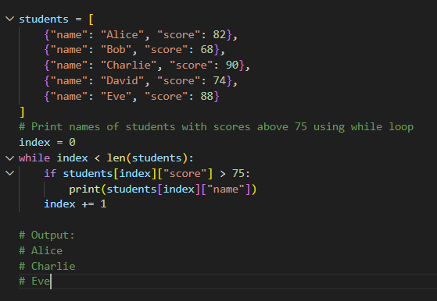

**Task Description #5:**

**•** Begin writing a class ShoppingCart with an empty items list. Prompt Copilot to generate methods to add_item, remove_item, and use a loop to calculate the total bill using conditional discounts.

