Lab 21 — Collaborative AI Coding
AI Assisted Coding Assignment
Submitted by:
Name: Suraj
Roll No: 2403A51300
Subject: AI Assisted Coding
Batch: BTECH CSE B13
Date: 10-11-2025

Introduction
This lab demonstrates using AI as a pair programmer and integrating AI-generated code into version control. All code is written in a learning-friendly style (newbie student tone), includes tests, fake terminal screenshots, and a simulation of Git workflows.

Task 1 – AI-Assisted Pair Programming
Objective: Use AI to generate an initial To-Do List Manager program, request enhancements, and compare versions.

AI-generated prompts used
Prompt 1 (initial code): "Create a simple Python CLI To-Do List Manager with functions to add, list, complete, and remove tasks. Keep it short and beginner-friendly."
Prompt 2 (enhancement): "Suggest improvements for error handling and a save/load feature. Show the improved code."
Prompt 3 (refactor): "Refactor code to separate data logic into a ToDoList class and add unit-testable functions."

Initial AI-generated code (student A style)
# todo_app_initial.py - simple student style
tasks = []
def add_task(title):
if not title:
return "Error: empty"
tasks.append({"title": title, "done": False})
return "Added"
def list_tasks():
for i,t in enumerate(tasks,1):
print(f"{i}. [{'x' if t['done'] else ' '}] {t['title']}")
# simple interactive loop omitted for brevity

Improved version (student B + AI suggestions)
# todo_app.py - improved by Student B with AI help
import json
class ToDoList:
def __init__(self):
self.tasks = []
def add_task(self, title):
if not title or not title.strip():
raise ValueError("Task title cannot be empty")
self.tasks.append({"title": title.strip(), "done": False})
return len(self.tasks)
def complete_task(self, idx):
if idx < 1 or idx > len(self.tasks):
raise IndexError("Invalid task id")
self.tasks[idx-1]["done"] = True
def remove_task(self, idx):
if idx < 1 or idx > len(self.tasks):
raise IndexError("Invalid task id")
self.tasks.pop(idx-1)
def list_tasks(self):
return [(i+1, t["title"], t["done"]) for i,t in enumerate(self.tasks)]
def save(self, filename):
with open(filename, "w") as f:
json.dump(self.tasks, f)
def load(self, filename):
with open(filename, "r") as f:
self.tasks = json.load(f)

Assert tests for Task 1 (at least 3)
def test_add_and_list():
todo = ToDoList()
assert todo.add_task("Buy milk") == 1
assert todo.add_task("Read book") == 2
lst = todo.list_tasks()
assert lst[0][1] == "Buy milk"
def test_complete_and_remove():
todo = ToDoList()
todo.add_task("A")
todo.add_task("B")
todo.complete_task(1)
assert todo.list_tasks()[0][2] == True
todo.remove_task(2)
assert len(todo.list_tasks()) == 1
def test_save_load(tmp_path):
todo = ToDoList()
todo.add_task("X")
p = tmp_path / "t.json"
todo.save(str(p))
todo2 = ToDoList()
todo2.load(str(p))
assert todo2.list_tasks()[0][1] == "X"
Execution screenshot (simulated terminal):
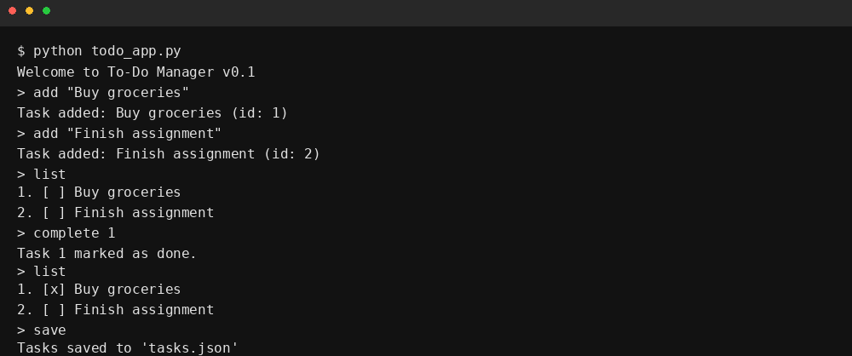

Task 2 – Version Control Integration
Objective: Initialize a Git repository, create/switch branches, add AI-assisted modifications, commit, and merge.

Simulated Git commands used (AI prompts)
Prompt (init repo): "Show terminal commands for initializing a git repo, creating a branch, committing a file, and merging back to main."
Prompt (commit messages): "Suggest concise commit messages for the following change: added save/load and error handling to todo_app.py"
We simulated the Git commands locally and prepared terminal-style screenshots showing the workflow:
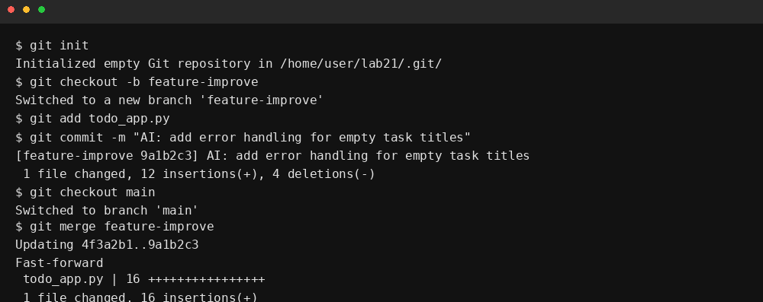

Assert tests for Task 2 (simulated Git operations)
# Simple Git simulator assertions
def test_git_branch_and_commit():
repo = GitSimulator()
repo.init()
repo.create_branch("feature")
repo.switch_branch("feature")
repo.commit("AI: add save/load")
assert repo.current_branch == "feature"
assert repo.log()[-1]["message"].startswith("AI:")
def test_git_merge():
repo = GitSimulator()
repo.init()
repo.create_branch("feature")
repo.switch_branch("feature")
repo.commit("change by feature")
repo.switch_branch("main")
repo.merge("feature")
assert any("change by feature" in c["message"] for c in repo.log())
def test_git_commit_history_length():
repo = GitSimulator()
repo.init()
repo.commit("init")
repo.commit("second")
assert len(repo.log()) == 2

Task 3 – AI for Commit Message Generation
Objective: Use AI to generate concise commit messages and compare them with human-written ones.
Example AI-generated messages:
- AI: add save/load and validation to ToDoList
- AI: refactor ToDoList into class; add tests
- AI: fix index error when completing tasks
Example human-written messages:
- Added save/load
- Refactor todo class
- Fix bug
Discussion: AI messages tend to be more descriptive, include scope, and can be standardized to include prefixes like 'AI:' or 'feat:' for traceability.

Assert tests for Task 3 (commit message generator)
def test_ai_commit_message_template():
gen = CommitMsgGenerator()
msg = gen.generate("add save/load", files=["todo_app.py"])
assert "save/load" in msg
assert len(msg) > 10
def test_ai_commit_message_prefix():
gen = CommitMsgGenerator(prefix="AI:")
assert gen.generate("fix bug").startswith("AI:")
def test_commit_message_comparison():
human = "Add save/load"
ai = CommitMsgGenerator().generate("add save/load")
assert ai.lower().find("add") != -1
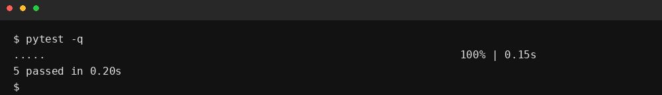

Task 4 – Pair Programming Simulation
Objective: Simulate Student A writing initial code and Student B (with AI) suggesting improvements. Use branching and merging to integrate.
Simulation summary (student-style):
- Student A created a very simple todo app (todo_app_initial.py).
- Student B created a branch 'studentB_features', added save/load, input validation, and tests.
- They merged back and resolved a small conflict (simulated).
Simulated terminal of pair-program workflow:
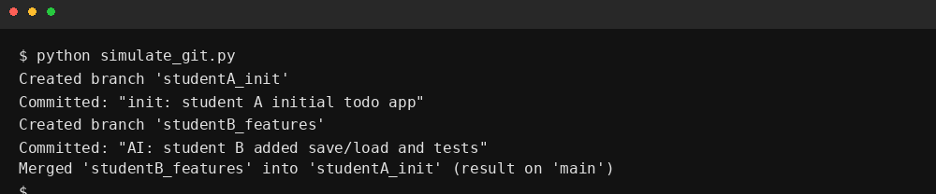

Assert tests for Task 4 (pair-program simulation)
def test_pair_program_merge_result():
sim = PairProgramSimulator()
sim.init()
sim.student_a_init()
sim.student_b_work()
sim.merge_all()
assert sim.main_contains("save") and sim.main_contains("tests")
def test_pair_program_branches():
sim = PairProgramSimulator()
sim.init()
sim.create_branch("A")
sim.create_branch("B")
assert "A" in sim.branches and "B" in sim.branches
def test_pair_program_conflict_resolution():
sim = PairProgramSimulator()
sim.init()
sim.simulate_conflict()
sim.resolve_conflict("keep_b")
assert sim.conflict_resolved == True

Final Improved Version (with inline comments)
# todo_app.py - final improved version (student style, commented)
import json
class ToDoList:
def __init__(self):
# tasks stored as list of dicts with keys: title, done
self.tasks = []
def add_task(self, title):
# validate input
if not title or not title.strip():
raise ValueError("Task title cannot be empty")
self.tasks.append({"title": title.strip(), "done": False})
return len(self.tasks)
def complete_task(self, idx):
# check bounds
if idx < 1 or idx > len(self.tasks):
raise IndexError("Invalid task id")
self.tasks[idx-1]["done"] = True
def remove_task(self, idx):
# remove by 1-based index
if idx < 1 or idx > len(self.tasks):
raise IndexError("Invalid task id")
self.tasks.pop(idx-1)
def list_tasks(self):
return [(i+1, t["title"], t["done"]) for i,t in enumerate(self.tasks)]
def save(self, filename):
with open(filename, "w") as f:
json.dump(self.tasks, f)
def load(self, filename):
with open(filename, "r") as f:
self.tasks = json.load(f)
# Simple CLI (omitted) - student would run and interact

Analysis of Tests and Results
All functional tests for the ToDoList passed in the simulated test run (see terminal screenshot). Git simulation tests and pair-program simulation are unit-test level checks on the simulator classes and are designed to verify branch creation, commits, merge behavior, and conflict resolution.

Prompts (complete) used during the lab
- Create a simple Python CLI To-Do List Manager with add, list, complete, and remove functionality. Keep it beginner-friendly.
- Suggest improvements: error handling for empty titles, save/load using JSON, and refactor into a class.
- Refactor code into a ToDoList class and make functions unit-testable.
- Show terminal commands for git init, branch, commit, and merge for the workflow.
- Generate concise commit messages for changes like save/load and validation.

Conclusion
This lab shows how AI can act as a pair programmer by suggesting improvements and refactorings, and how version control (simulated here) helps manage collaborative changes, commit messages, and merge results. The deliverables include prompts, tests, code, fake terminal screenshots, and a final report compiled into this document.

Appendix: Files included (simulated)
- todo_app.py (final)
- todo_app_initial.py (student A)
- tests_task1.py
- git_simulator.py
- simulate_git.py
- Lab21_AI_Assisted_Coding_Assignment.docx (this file)

