**Name**: R. Shwejan **Roll_no:** 2403A51303

**Batch: 13**

Task Description #1 (Classes – Employee Management)  
• Task: Use AI to create an Employee class with attributes (name,  
id, salary) and a method to calculate yearly salary.  
• Instructions:  
o Prompt AI to generate the Employee class.  
o Analyze the generated code for correctness and structure.  
o Ask AI to add a method to give a bonus and recalculate  
salary.  
Expected Output #1:  
• A class with constructor, display_details(), and calculate_bonus()  
methods

**Prompt:** Create a Python Employee class with name, id, salary, and methods to display details and calculate yearly salary. Add a method for bonus and recalculate the salary.

**Code:**

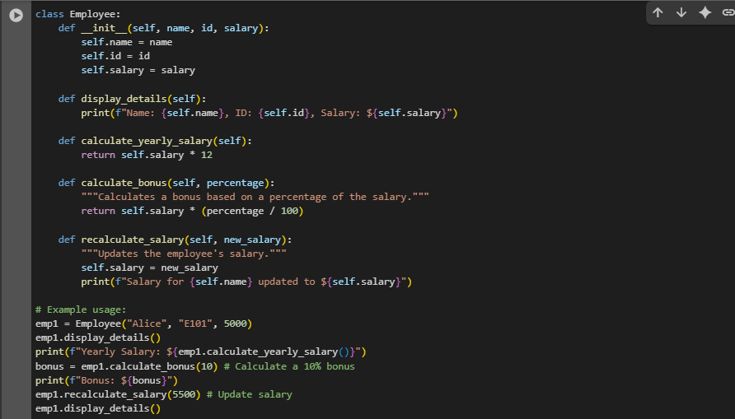

**Output:**

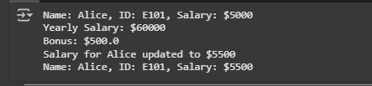

Task Description #2 (Loops – Automorphic Numbers in a Range)  
• Task: Prompt AI to generate a function that displays all  
Automorphic numbers between 1 and 1000 using a for loop.  
• Instructions:  
o Get AI-generated code to list Automorphic numbers using  
a for loop.  
o Analyze the correctness and efficiency of the generated  
logic.  
o Ask AI to regenerate using a while loop and compare both  
implementations.  
Expected Output #2:  
• Correct implementation that lists Automorphic numbers using  
both loop types, with explanation.

**#for loop**

**Prompt:** Generate a python function to list automorphic numbers using for loop. (range(0,1000)).

**Code and output:**

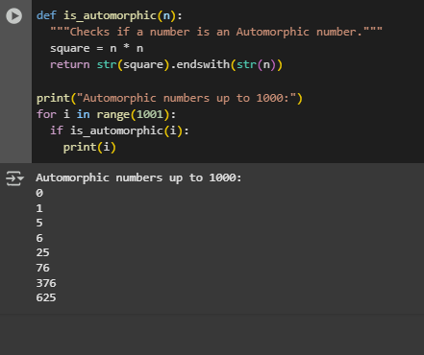

**#while loop:**

**Prompt:** Generate a python function to list automorphic numbers using while loop. (range (0,1000)).

**Code and output:**

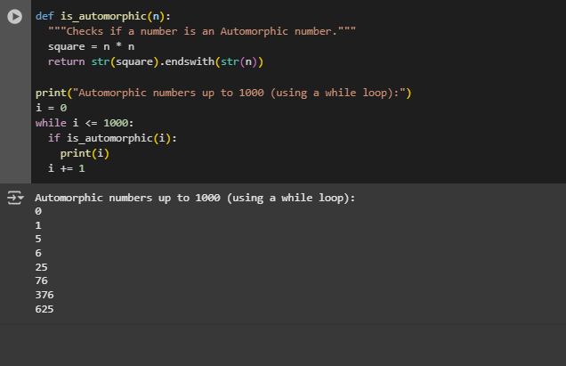

Task Description #3 (Conditional Statements – Online Shopping  
Feedback Classification)  
• Task: Ask AI to write nested if-elif-else conditions to classify  
online shopping feedback as Positive, Neutral, or Negative based  
on a numerical rating (1–5).  
• Instructions:  
o Generate initial code using nested if-elif-else.  
o Analyze correctness and readability.  
o Ask AI to rewrite using dictionary-based or match-case  
structure.  
Expected Output #3:  
• Feedback classification function with explanation and an  
alternative approach.

**Prompt:** Write a Python function that classifies online shopping feedback as Positive, Neutral, or Negative based on a numerical rating (1–5) using nested if-elif-else statements.

**Code:**

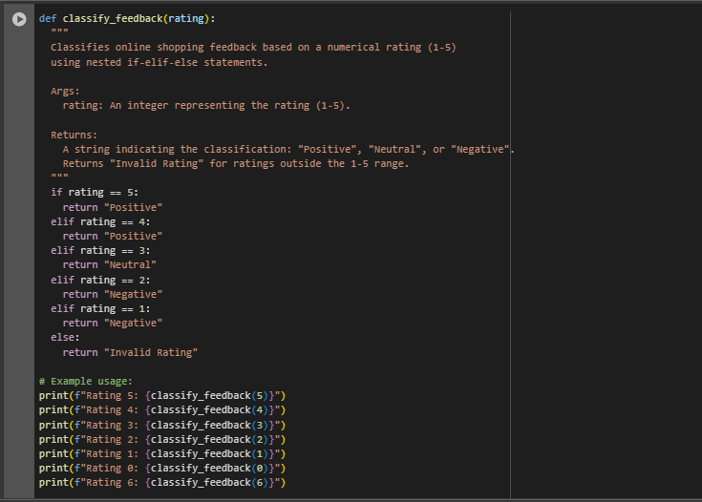

**Output:**

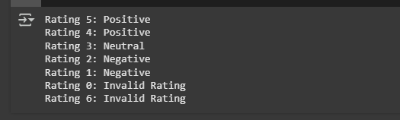

**# based on dictionary**

**Prompt:** Write a Python function that classifies online shopping feedback as Positive, Neutral, or Negative based on a numerical rating (1–5) using dictionary.

**Code:**

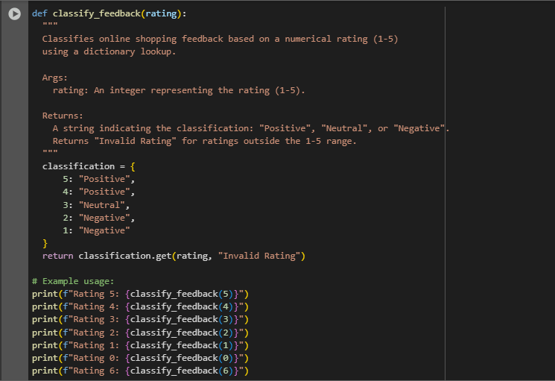

**Output:**

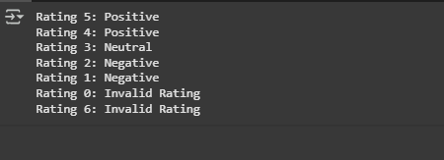

Task Description #4 (Loops – Prime Numbers in a Range)  
• Task: Generate a function using AI that displays all prime  
numbers within a user-specified range (e.g., 1 to 500).  
• Instructions:  
o Get AI-generated code to list all primes using a for loop.  
o Analyze the correctness and efficiency of the prime-  
checking logic.  
o Ask AI to regenerate an optimized version (e.g., using the  
square root method).  
Expected Output #4:  
• Python program that lists all prime numbers within a given range,  
with an optimized version and explanation.

**Prompt:** generate a python function that list all the prime numbers with in a range (100).

**Code and output :**

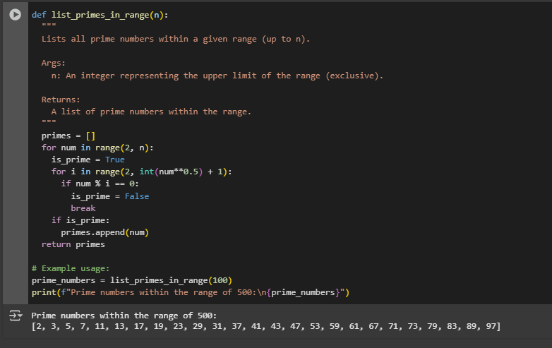

**# square root method**

**Prompt:** generate a python function that list all the prime numbers with in a range (100) using square root method.

**Code with output:**

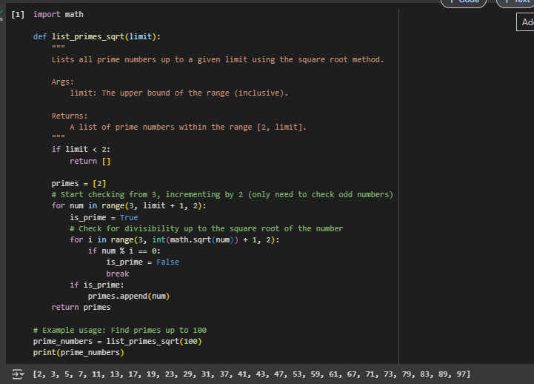

Task Description #5 (Classes – Library System)  
• Task: Use AI to build a Library class with methods to  
add_book(), issue_book(), and display_books().  
• Instructions:  
o Generate Library class code using AI.  
o Analyze if methods handle edge cases (e.g., issuing  
unavailable books).  
o Ask AI to add comments and documentation.  
Expected Output #5:  
• Library class with all methods, inline comments, and explanation.

**Prompt:** Build a Library class with methods to add_book(), issue_book(), and display_books().add comments and documentation.

**Code with output:**

