CHINTHALA PAVAN KUMAR

2403A51318

BATCH : 13

DATE : 13 AUGUST 2025

TASK - 1 :

Zero-Shot Prompting with Conditional Validation

Objective. Use zero-shot prompting to instruct an AI tool to generate a function that validates an Indian mobile number.

Requirements :

The function must ensure the mobile number:

Starts with 6, 7, 8, or 9

Contains exactly 10 digits

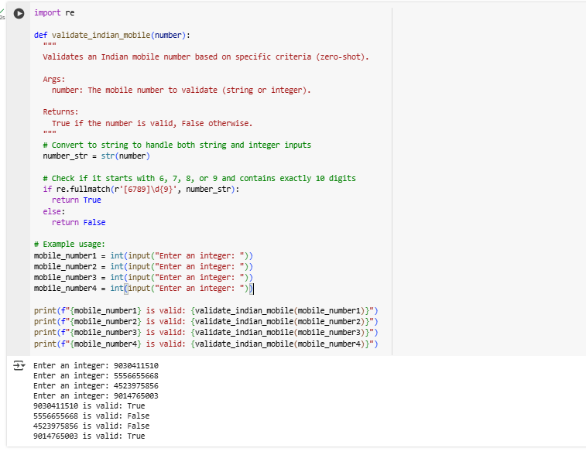

TASK -2 :

Use one-shot prompting to generate a Python function that calculates the factorial of a number.

Requirements :

Provide one sample input-output pair in the prompt to guide the AI.

The function should handle:

0! correctly

Negative input by returning an appropriate message

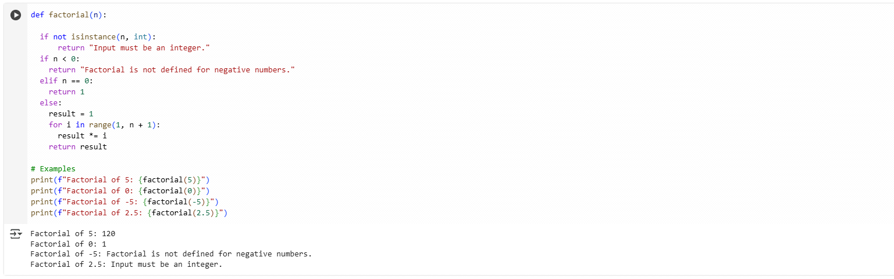

TASK - 3 :

Use few-shot prompting (2–3 examples) to instruct the AI to create a function that parses a nested dictionary representing student information.

Requirements :The function should extract and return:

~ Full Name

~ Branch

~ SGPA

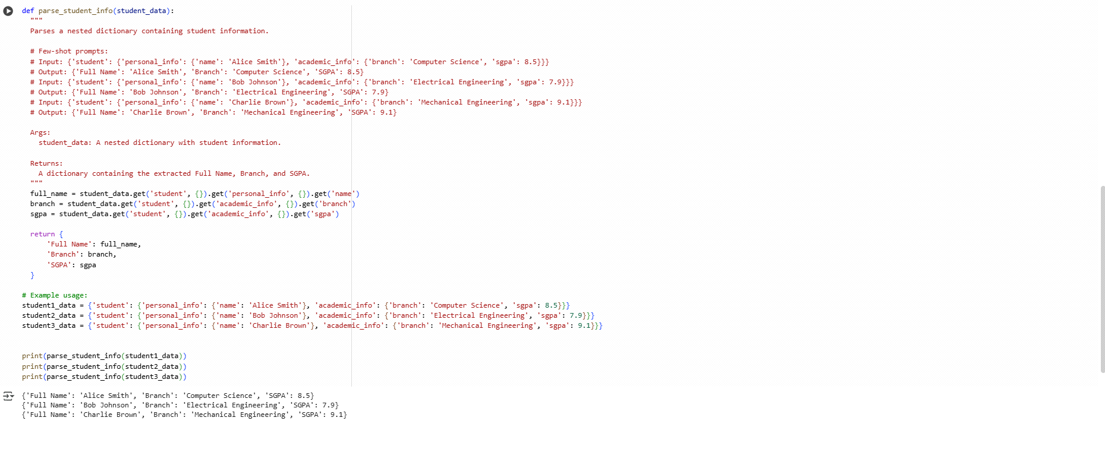

TASK - 4 :

Experiment with zero-shot, one-shot, and few-shot prompting to generate functions for CSV file analysis.

Requirements :

Each generated function should:

Read a .csv file

Return the total number of rows

Count the number of empty rows

Count the number of words across the file

Zero-Shot Prompting

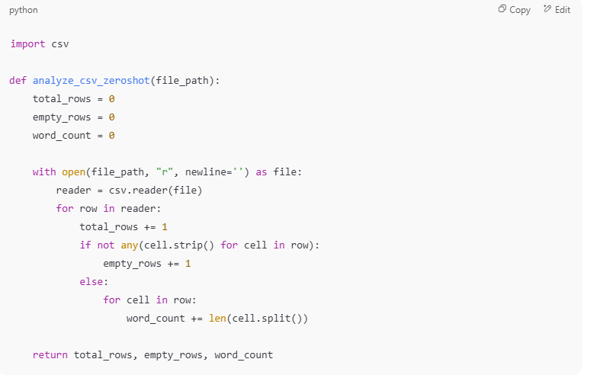

One-Shot Prompting:

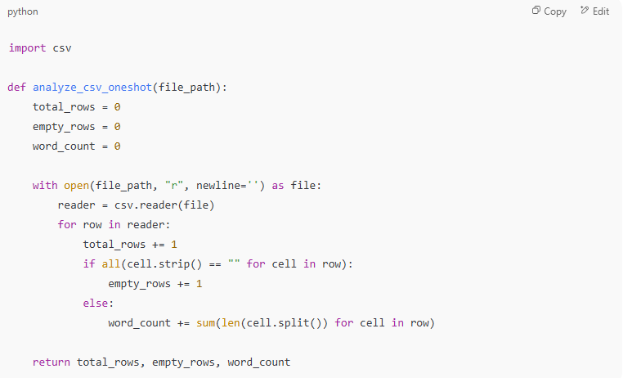

Few-Shot Prompting:

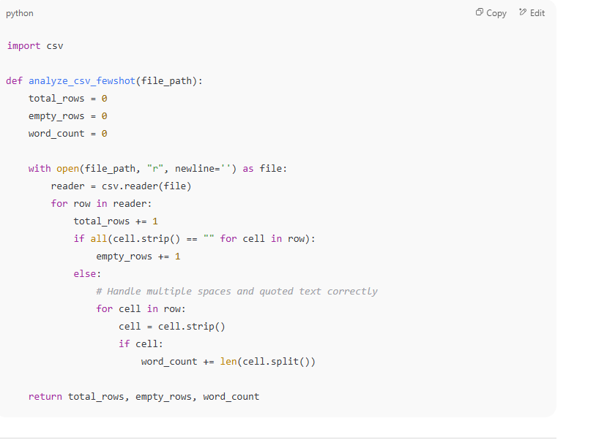

output:

