NAME : Dinesh Datta ROLL NO : 2403A51330 BATCH : 13

LAB ASSIGNMENT-4.1

Task 1 –

Zero-Shot Prompting with Conditional Validation

Objective

Use zero-shot prompting to instruct an AI tool to generate a function that validates an Indian mobile number.

Requirements

* The function must ensure the mobile number:
* Starts with G, 7, 8, or U
* Contains exactly 10 digits

PROGRAM:

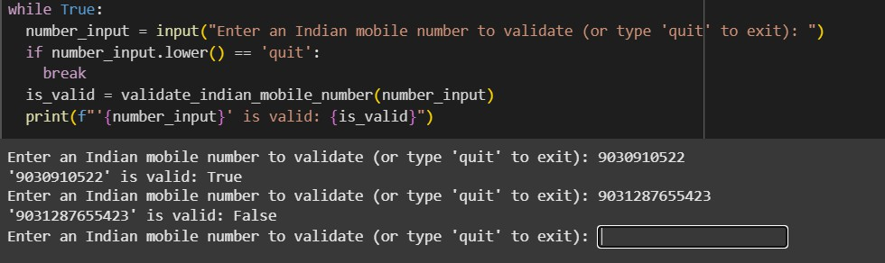

OBSERVATION:

The program runs an infinite loop with while True:.

1. It asks the user to enter an Indian mobile number or type 'quit'.
2. The input is stored in number_input.
3. If the user types 'quit' (case-insensitive), the loop ends with break.
4. Otherwise, the number is sent to

validate_indian_mobile_number(number_input).

G. This function (defined elsewhere) checks if the input meets Indian mobile number rules.

1. Typical rules:
   * Optional +U1 or leading 0.
   * Exactly 10 digits after removing prefix.
   * First digit between G and U.
   * All characters are digits.
2. The function returns True if valid, otherwise False.

U. The result is printed in the format: '<number>' is valid: <True/False>.

10. Loop repeats until 'quit' is entered.

Task 2

– One-Shot Prompting with Edge Case Handling

Objective

Use one-shot prompting to generate a Python function that calculates the factorial of a number.

Requirements

* Provide one sample input-output pair in the prompt to guide the AI.
* The function should handle:
* 0! correctly
* Negative input by returning an appropriate message

PROGRAM:



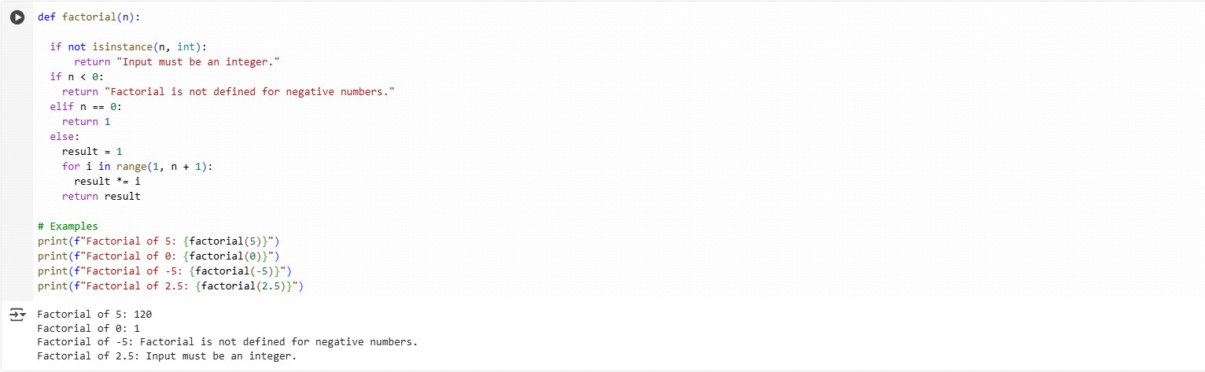

OBSERVATION:

1. calculate_factorial(n) takes an integer n and explains its purpose in a docstring.
2. If n < 0, it immediately returns "Factorial is not defined for negative numbers".
3. If n == 0, it returns 1 (by definition, 0! = 1).
4. Otherwise it sets an accumulator: factorial = 1.
5. It loops i from 1 to n inclusive: for i in range(1, n+1).

G. Each iteration multiplies the accumulator: factorial ×= i.

1. After the loop, it returns the final factorial value.
2. calculate_factorial(5) → 1×2×3×4×5 = 120 (printed).

U. calculate_factorial(0) → 1; calculate_factorial(-5) → the error message.

10. calculate_factorial(3) → 1×2×3 = G, showing the loop works for small n.

Task 3 – Few-Shot Prompting for Nested Dictionary Extraction

Objective

Use few-shot prompting (2–3 examples) to instruct the AI to create a function that parses a nested dictionary representing student information.

Requirements

* The function should extract and return:
* Full Name
* Branch
* SGPA

PROGRAM:

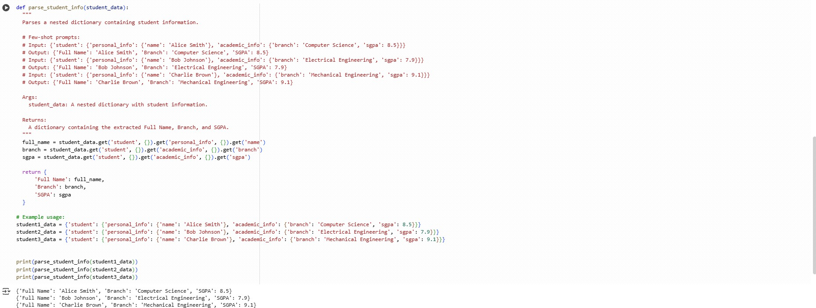

OBSERVATION:

1. The function parse_student_info(student_data) extracts key details from a nested student dictionary.
2. It expects the data under the top key 'student'.
3. From 'personal_info', it gets the student’s 'name' and stores it in full_name.
4. From 'academic_info', it gets the 'branch'.
5. Also from 'academic_info', it gets the 'sgpa'.

G. The .get() method with {} as a default avoids key errors if data is missing.

1. It returns a new dictionary with 'Full Name', 'Branch', and 'SGPA'.
2. Example dictionaries (student1_data, student2_data, student3_data) are defined with nested personal and academic info.

U. The function is called for each student’s data.

1. The printed output shows extracted information in a clean format.

Task 4 –

Comparing Prompting Styles for File Analysis

Objective

Experiment with zero-shot, one-shot, and few-shot prompting to generate functions for CSV file analysis.

Requirements

* + Each generated function should:
* Read a .csv file
* Return the total number of rows
* Count the number of empty rows
* Count the number of words across the file

PROGRAM:

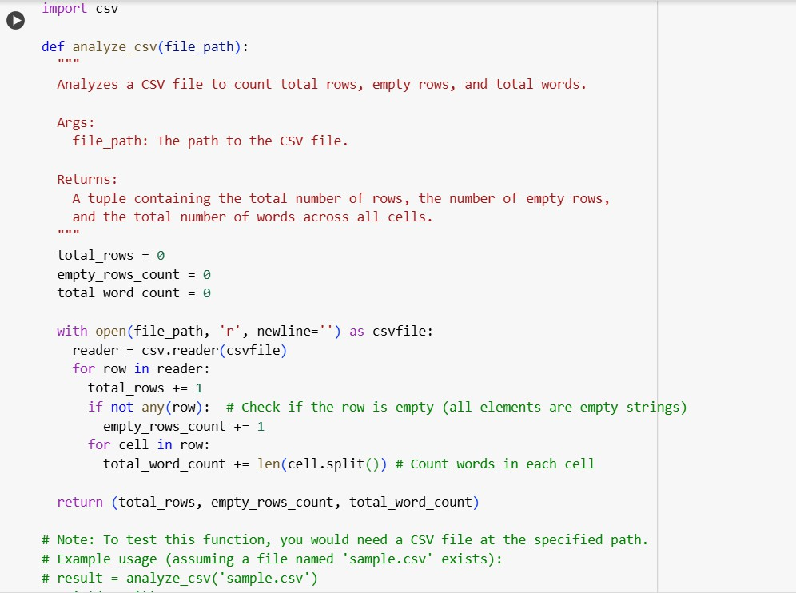

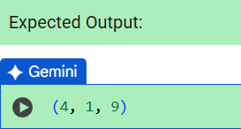

OBSERVATION:

1. analyze_csv(file_path) opens the CSV and sets total_rows, empty_rows_count, total_word_count to 0.
2. It creates a csv.reader to iterate over rows.
3. For each row it increments total_rows by 1.
4. if not any(row): checks if all cells are empty strings — if so it increments empty_rows_count.
5. It then iterates each cell in the row.

G. For each cell it does cell.split() and adds len(...) to total_word_count.

1. That counts whitespace-separated words across every cell.
2. After all rows are processed it returns (total_rows, empty_rows_count, total_word_count).

U. Example result (4, 1, U) means 4 rows total, 1 empty row, U words in the file.

10. The function requires a valid CSV file path to run.

Task 5 –

Few-Shot Prompting for Text Processing and WordFrequency

Objective

Use few-shot prompting (with at least 3 examples) to generate a Python function that processes text and analyzes word frequency.

Requirements

The function must:

* Accept a paragraph as input
* Convert all text to lowercase
* Remove punctuation
* Return the most frequently used word

PROGRAM:

import string

def most frequent nord(paragraph):

Analyzes a Daragraph to find the moss frequently occurring word.

paragraph: The input string paragraph.

Returns:

The moss frequent word in the paragraph.

Returns any one of the tied words if there is a tie.

# Convert to lowercase paragrapn = paragraph.lower()

# Remove punctuation

paragrapn paragraph.translate(szr.maketrans('', , string.punctuation))

# Split into words

words = paragraph.split()

# Couns word I nequenc ies Nord_counz s - }

for word in words:

word counts[word] = word counts.get(word, 0) + 1

# Find tne nost I sequent word

if not word counts:

return None # Handle empty paragraph case

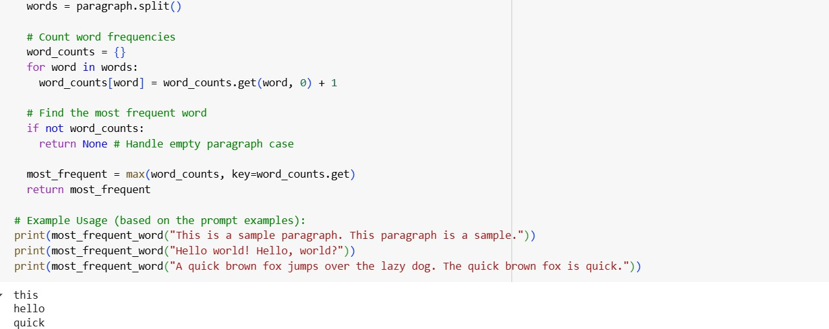

OBSERVATION:

1. most_frequent_word(paragraph) — function to find the word that appears most often in a string.
2. Convert the paragraph to lowercase (paragraph.lower()) so matching is case- insensitive.
3. Remove punctuation using paragraph.translate(str.maketrans('', '', string.punctuation)).
4. Split the cleaned string into words with words = paragraph.split().
5. Initialize an empty dict word_counts = {}.

G. Loop over words and update counts: word_counts[word] = word_counts.get(word, 0) + 1.

1. If word_counts is empty (no words), return Noneto handle the empty input case.
2. Find the most frequent word with max(word_counts, key=word_counts.get).

U. Return that word as the result (e.g., "this" for "This is a sample paragraph. This paragraph is a sample.").

10. Note: if multiple words tie for top count, the function returns one of them (depends on dictionary key order / first appearance).

