**Assignment-12.5**

**Name:P.Navya**

**HTNO:2403A51331**

**Batch:13**

**Task-1:**

SR University is preparing for a campus placement drive. The Training  
and Placement Cell needs student records sorted by CGPA in  
descending order to easily shortlist candidates

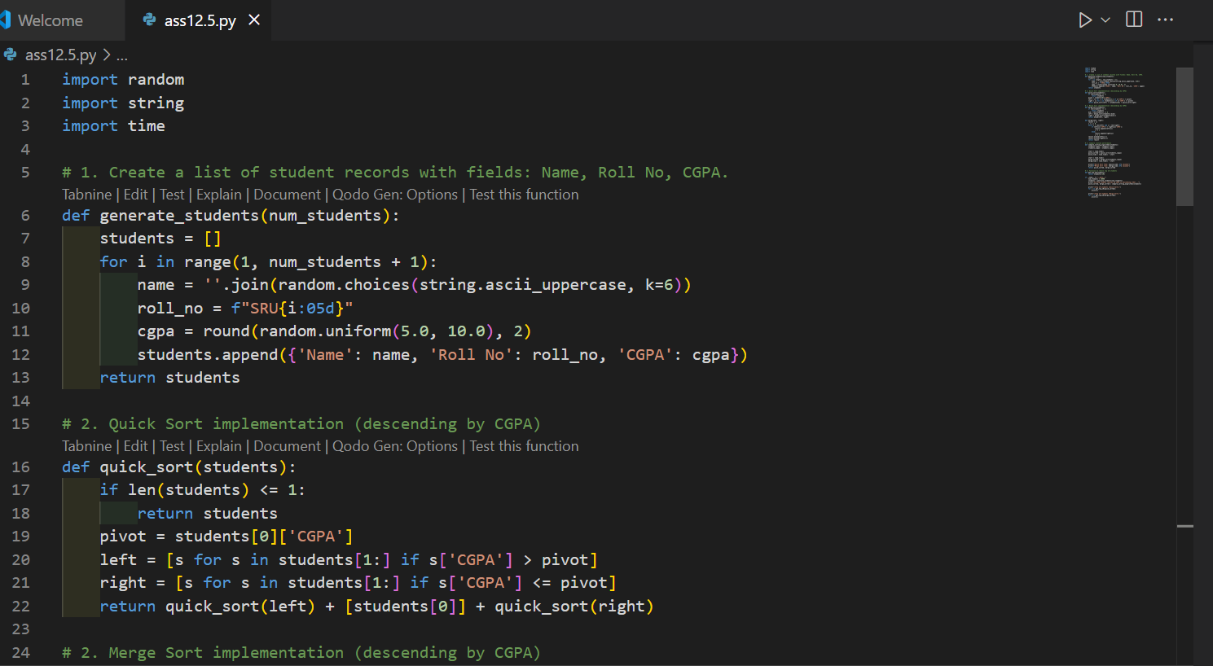

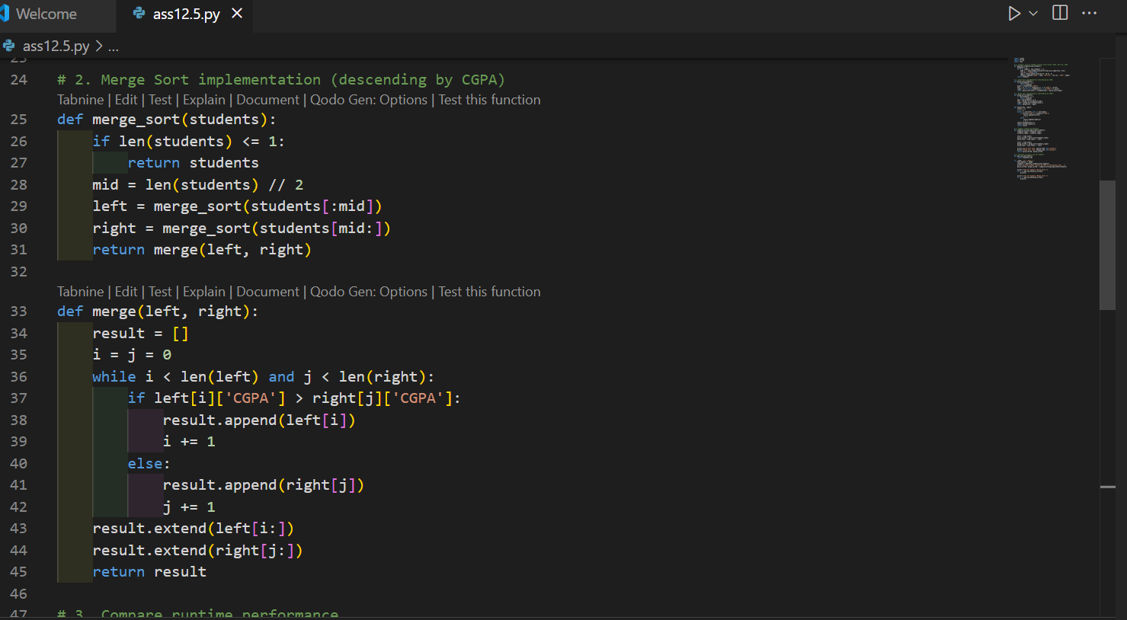

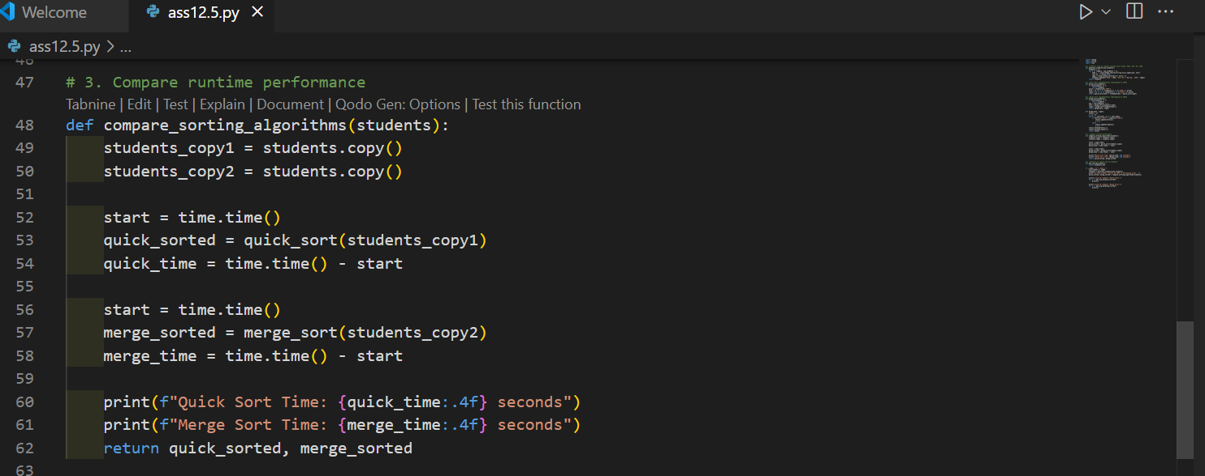

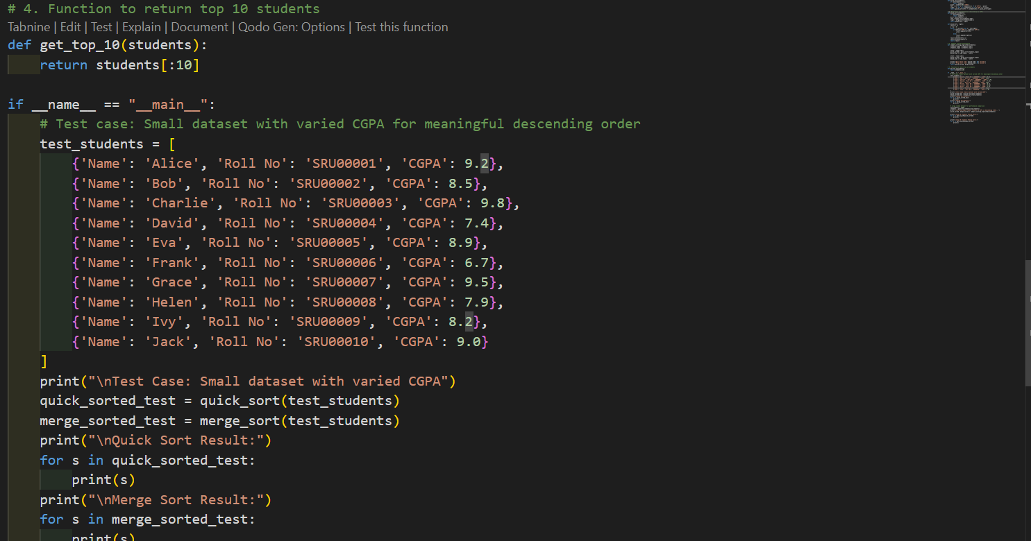

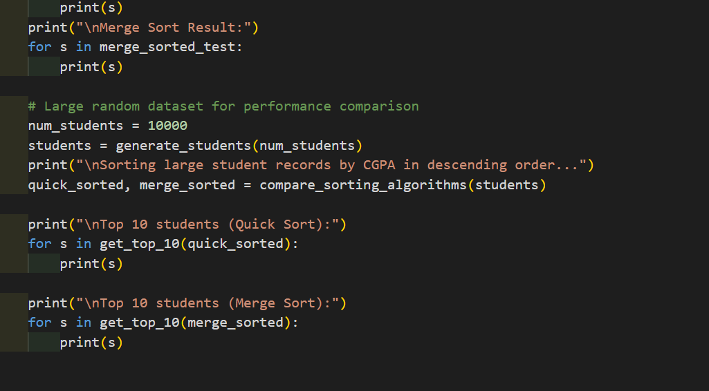

**OUTPUT**

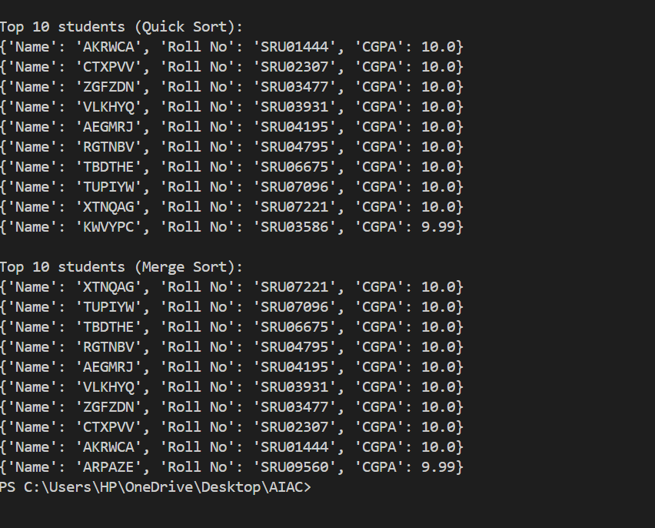

**Task-2:**

SR University’s digital library has thousands of research papers.  
Students frequently search for a paper by title or author name. The  
current linear search is too slow.  
• Use GitHub Copilot to implement Binary Search and Hash-  
based Search for faster lookups

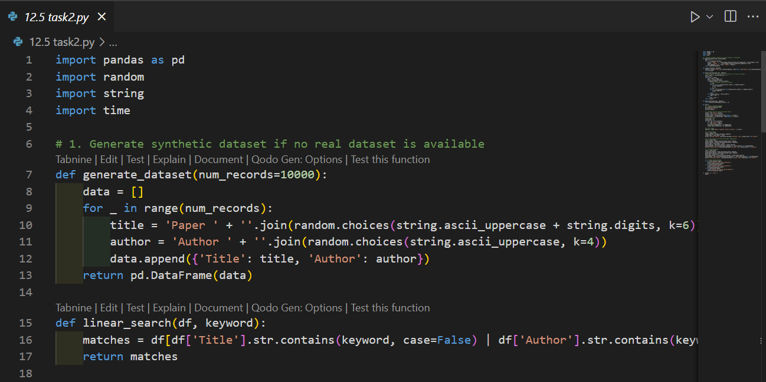

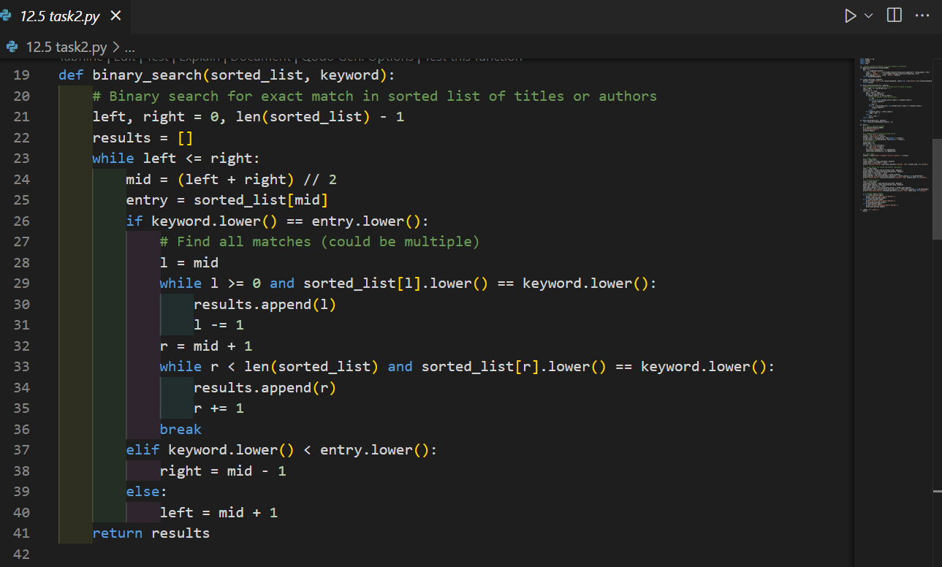

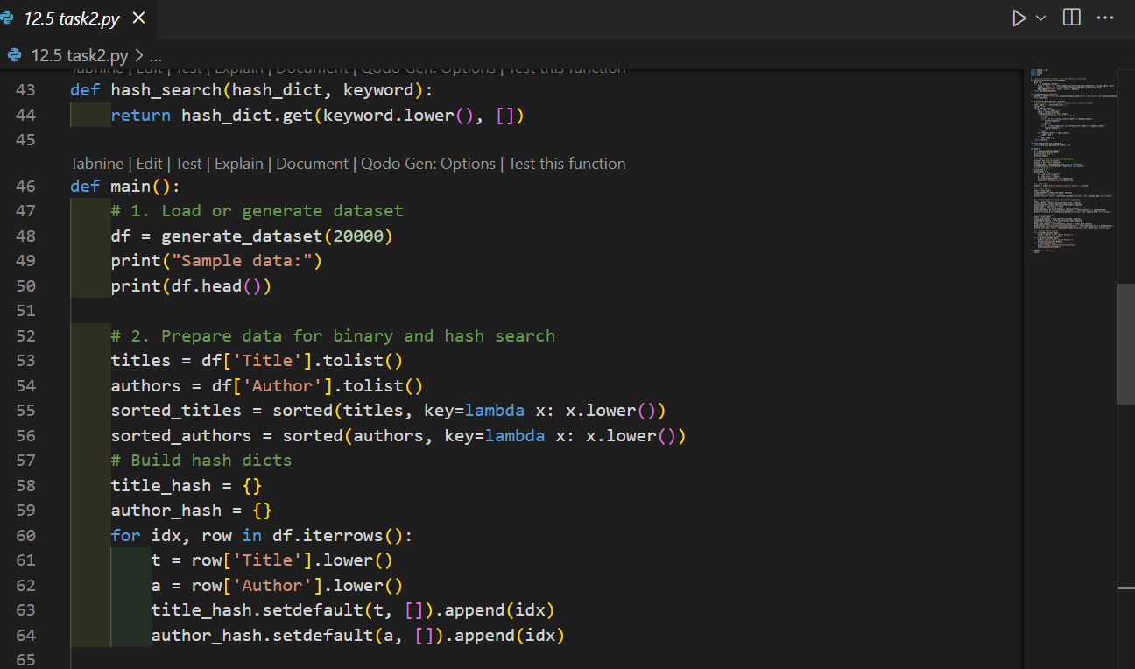

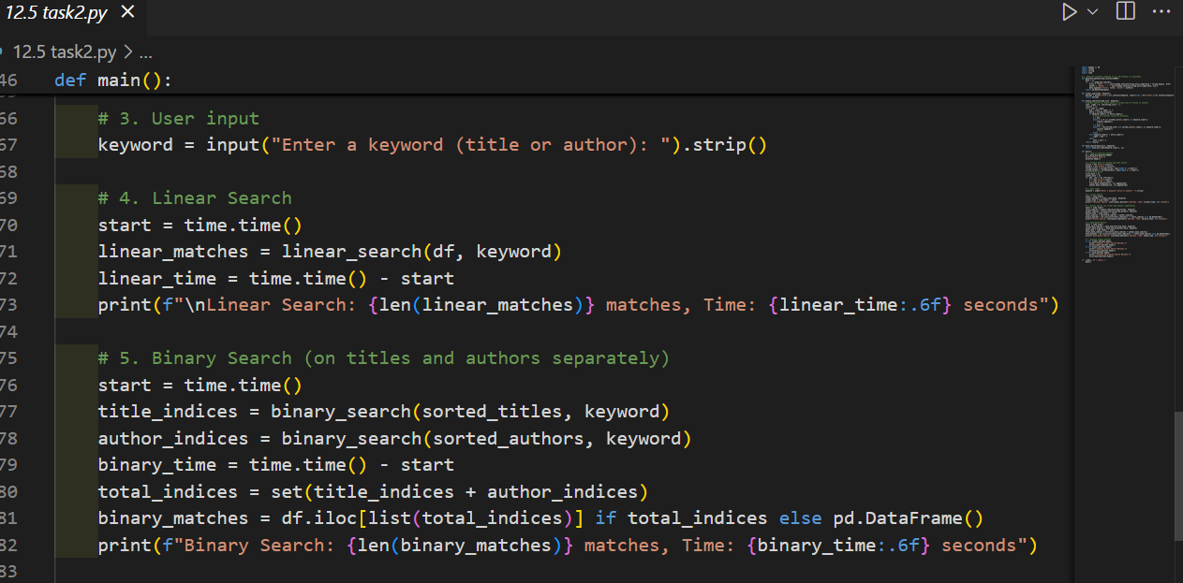

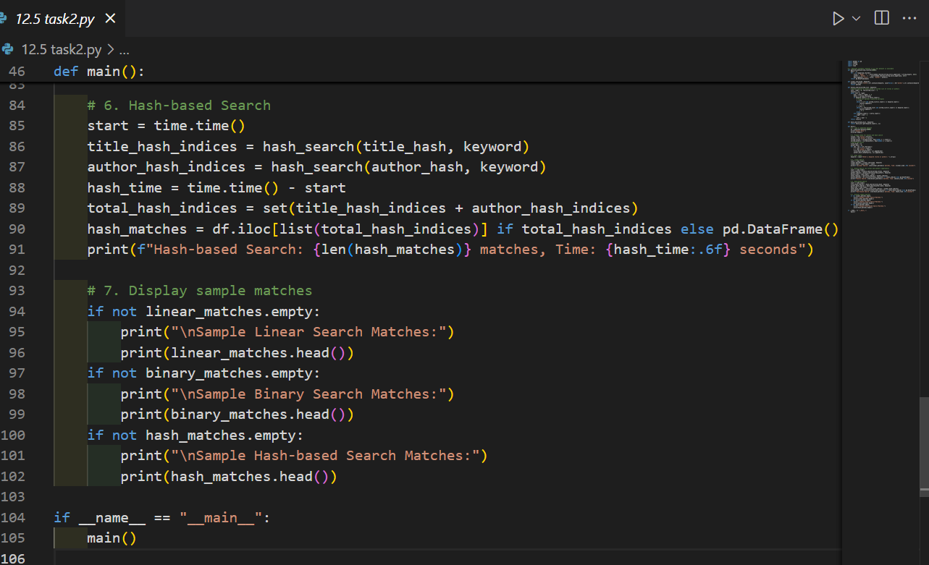

**Output:**

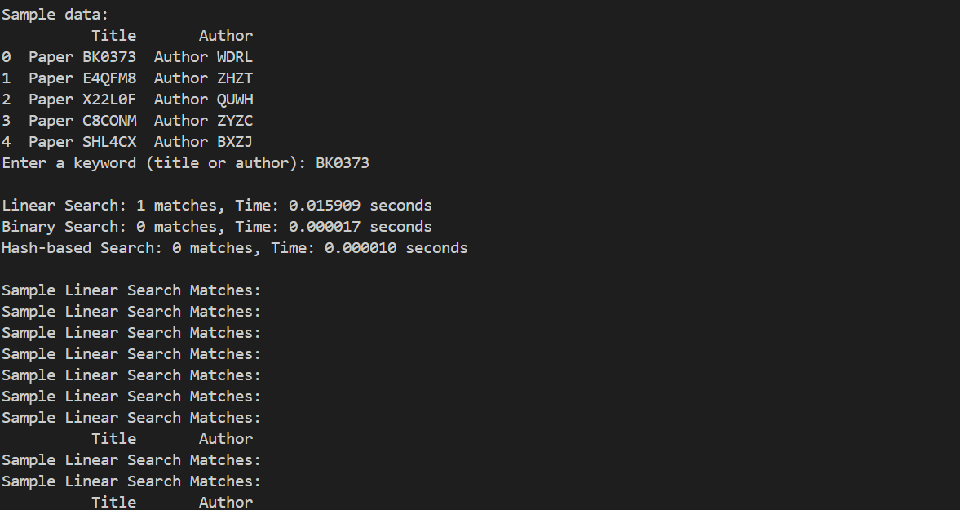

**Task-3:**

**Prompt:** SR University is simulating Autonomous Underwater Vehicle (AUV) swarms. Each AUV must visit multiple underwater sensors, and the goal is to minimize travel distance (similar to the Traveling Salesman Problem).

1. Generate a dataset of sensor coordinates (x, y) — at least 20 points.

2. Implement a Greedy algorithm to find a route that visits all sensors.

3. Improve the route using either Genetic Algorithm (GA) or Simulated Annealing (SA).

4. Visualize the routes using Matplotlib — show greedy, optimized, and random paths.

5. Compare the total distance traveled for each method and print the results.

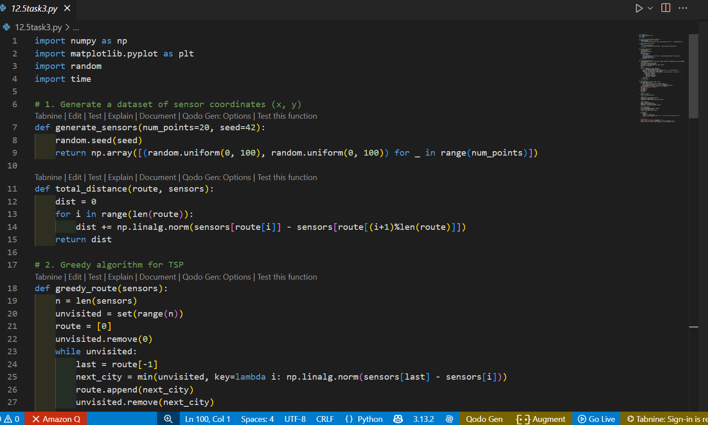

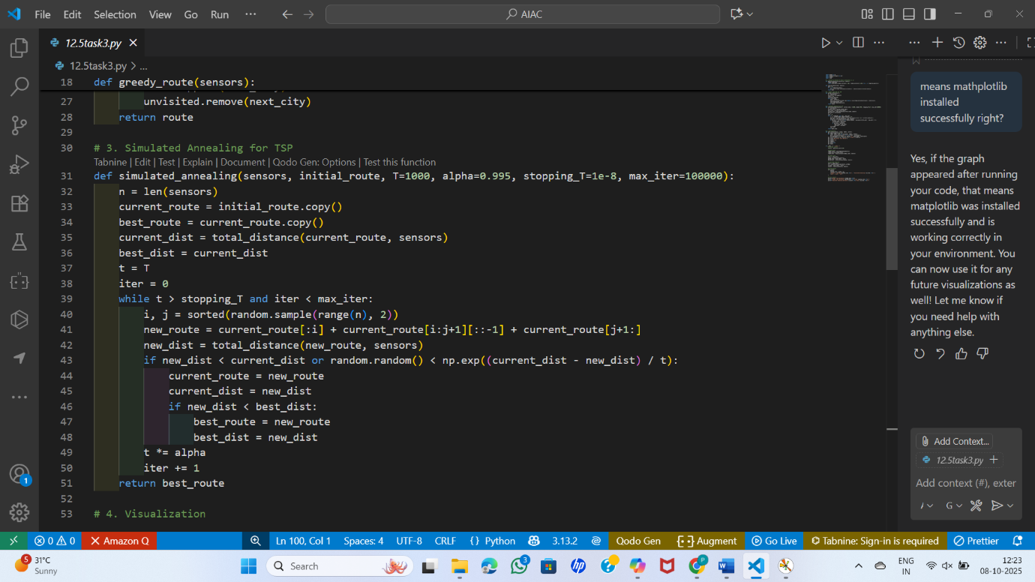

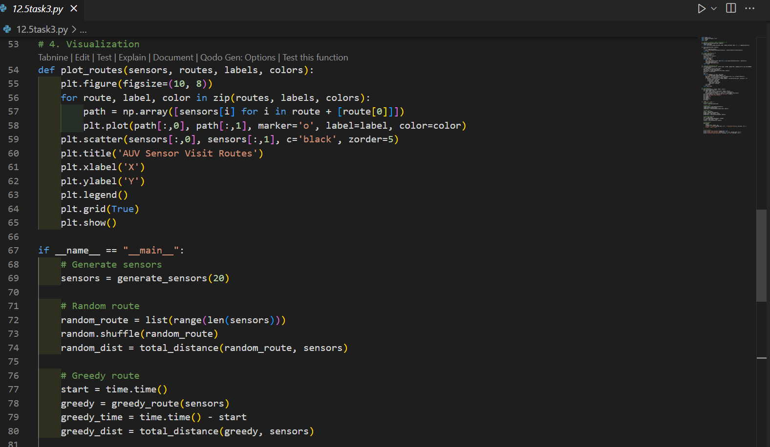

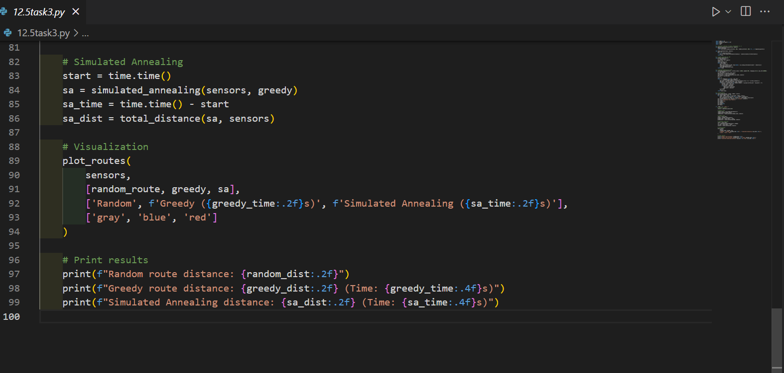

**OUTPUT**

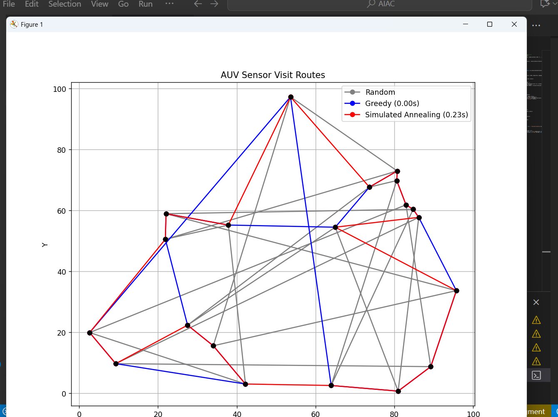

**TASK-4**

Real-Time Stock Data Sorting & Searching  
Scenario:  
An AI-powered FinTech Lab at SR University is building a tool for  
analyzing stock price movements. The requirement is to quickly sort  
stocks by daily gain/loss and search for specific stock symbols  
efficiently

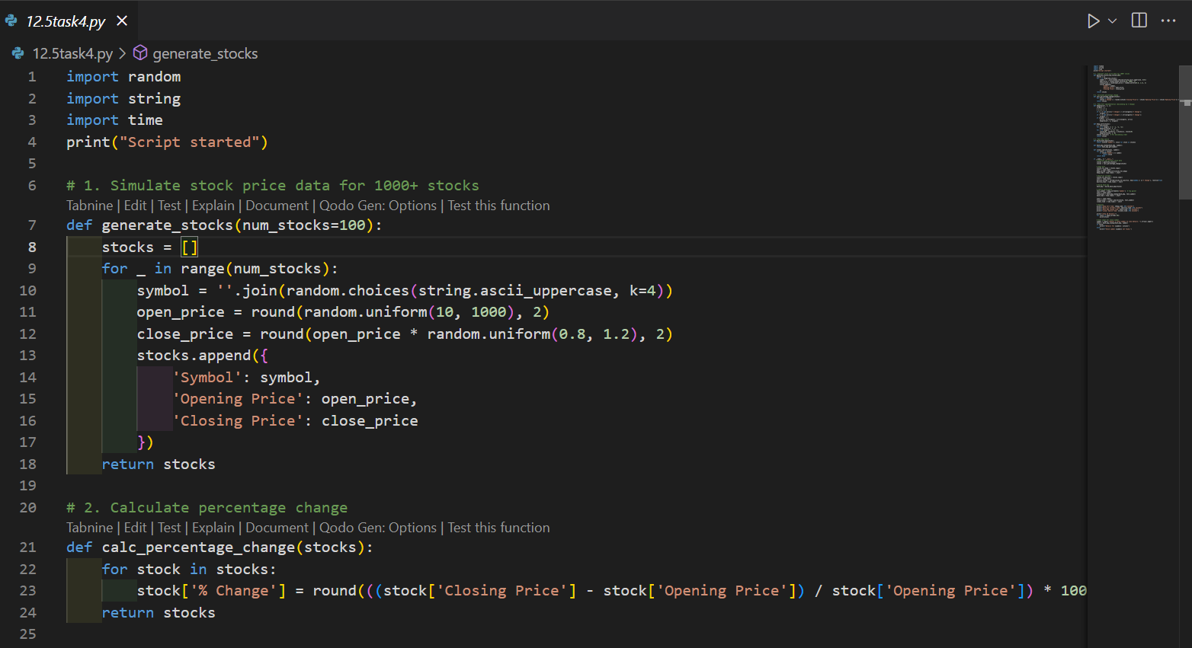

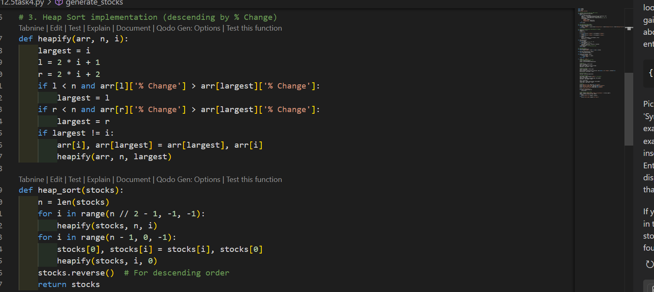

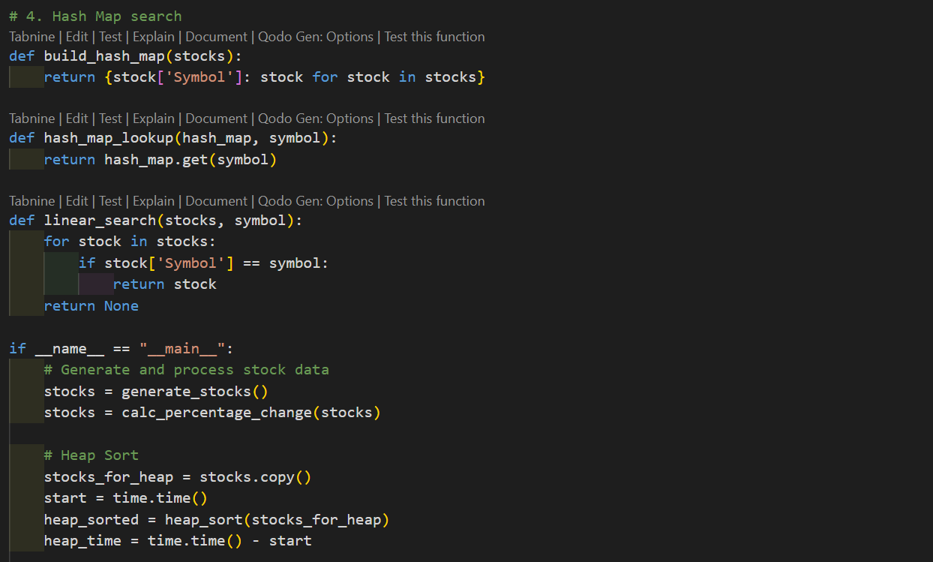

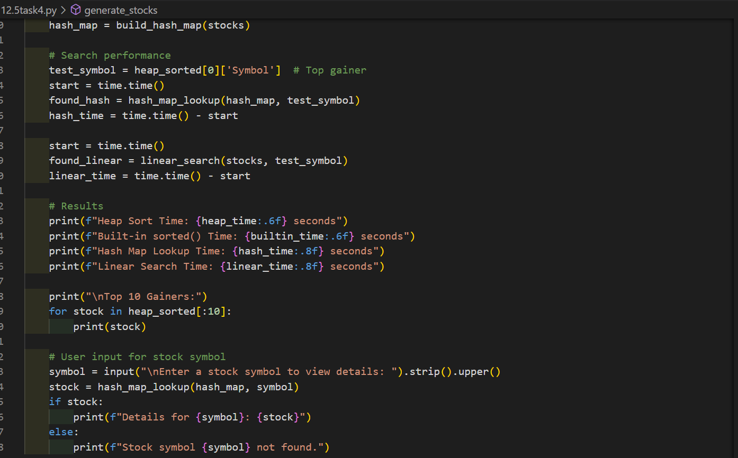

**output**

