**ASSIGNMENT-4.3**

**Name:**P.Navya

**HTNO:**2403a51331

**Batch:**13

**Prompt:**

**Task-1**

Zero-shot: Prompt AI to write a function that checks whether a given year is a leap year

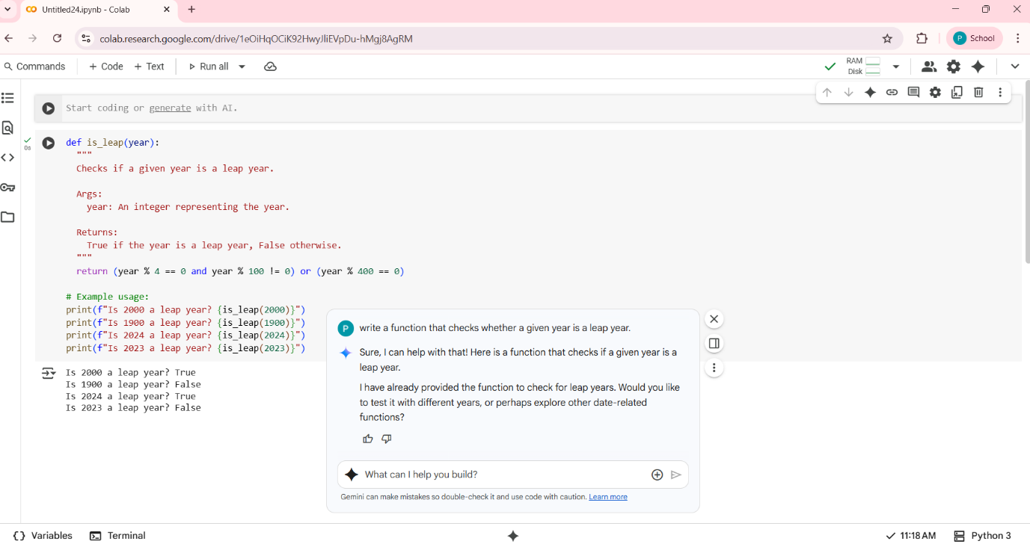

**Observation:**

Years divisible by 4 and not by 100 are leap years.Years divisible by 400 are also leap years.

The docstring adds clarity. It uses a single return statement with a logical condition.Takes its own examples.

**Task-2**

One-shot: Give one input-output example to guide AI in writing a function that converts centimeters to inches

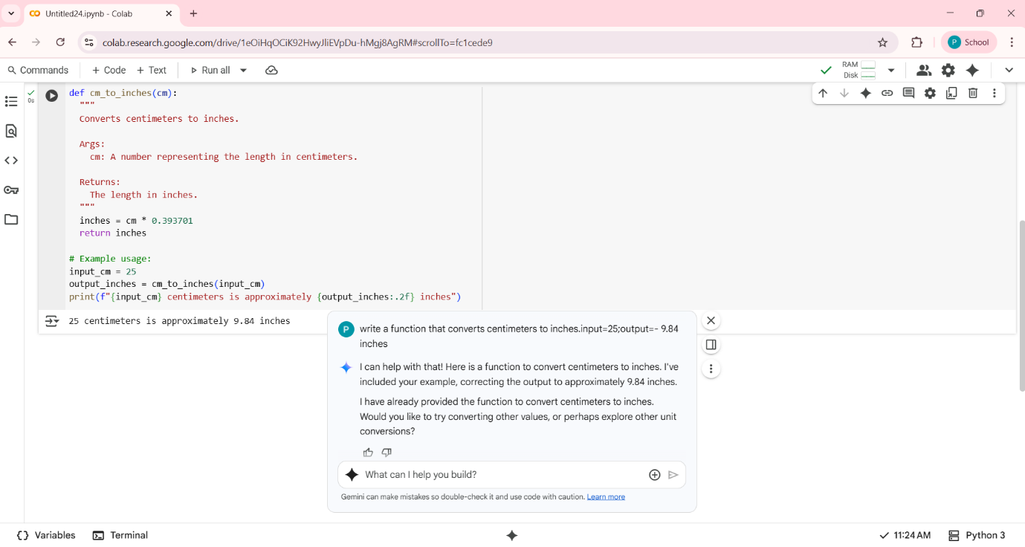

**Observation:**

The function cm_to_inches(cm) converts centimeters to inches.Eamples are used that what the user had given. The output is formatted to 2 decimal places for readability.

**Task-3**

Few-shot: Provide 2–3 examples to generate a function that formats full names as “Last, First”.

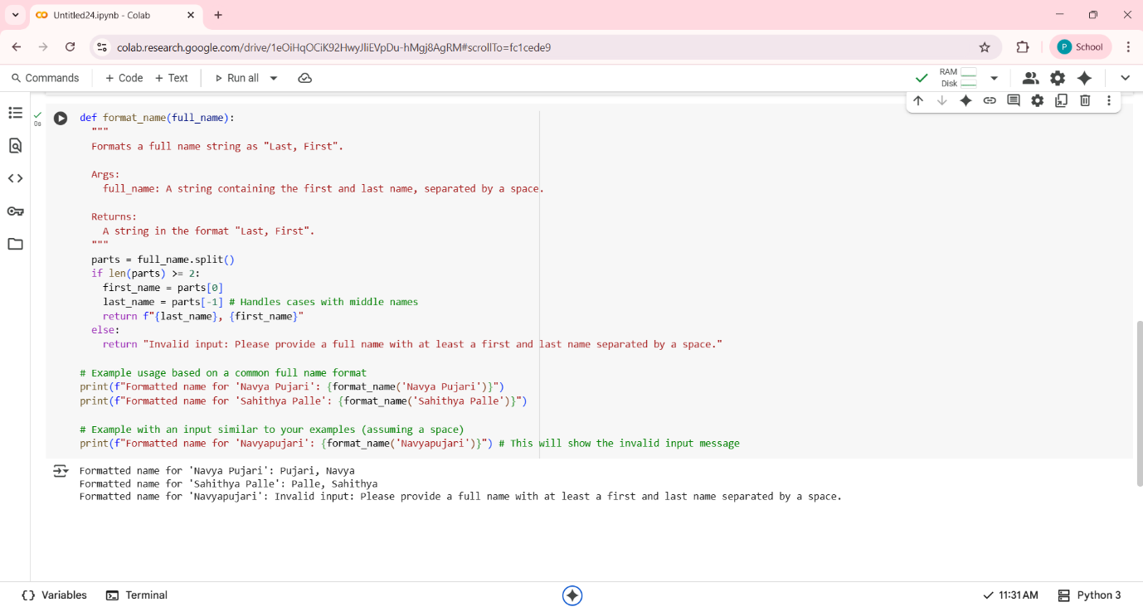

**Observation:**

The function reformats a full name string into the format "Last, First".It uses split() to divide the input string into parts based on spaces.The first word is treated as the first name, and the last word as the last name.If the input doesn't contain a space, it returns a helpful error message.The docstring is well-written and clearly explains the function’s purpose and behavior.The example usage demonstrates both valid and invalid inputs effectively.Output is formatted cleanly and is easy to understand.Overall, it’s a practical and user-friendly function for name formatting.

**Task-4:**

Compare zero-shot and few-shot prompts for writing a function that counts the number of vowels in a string.

**zero-shot:**

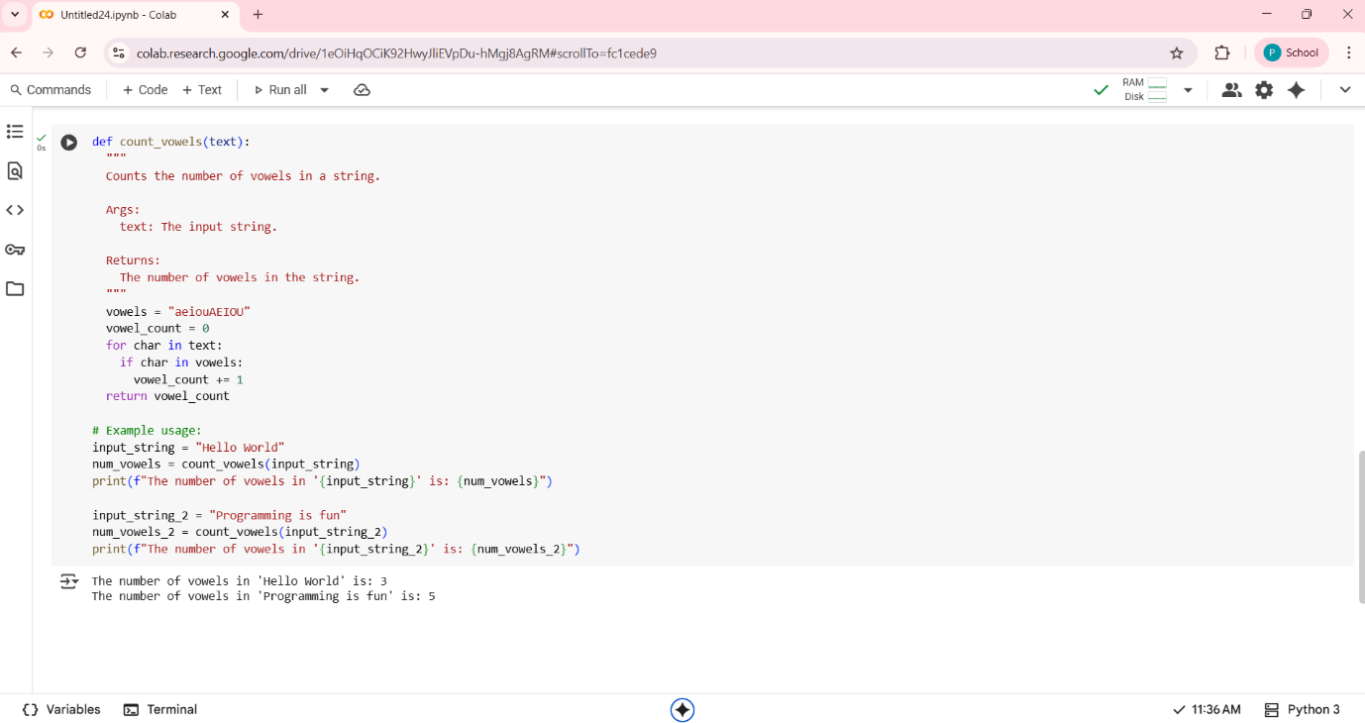

**Observation:**.

It includes both uppercase and lowercase vowels for case-insensitive matching.The loop iterates through each character in the input string.A simple if condition checks for vowel presence.The counter vowel_count is incremented only when a vowel is found.The function returns the total number of vowels found.The docstring clearly explains the function’s purpose and usage.Example inputs like "Hello World" and "Programming is fun" show varied results**.**

**Few-shot:**

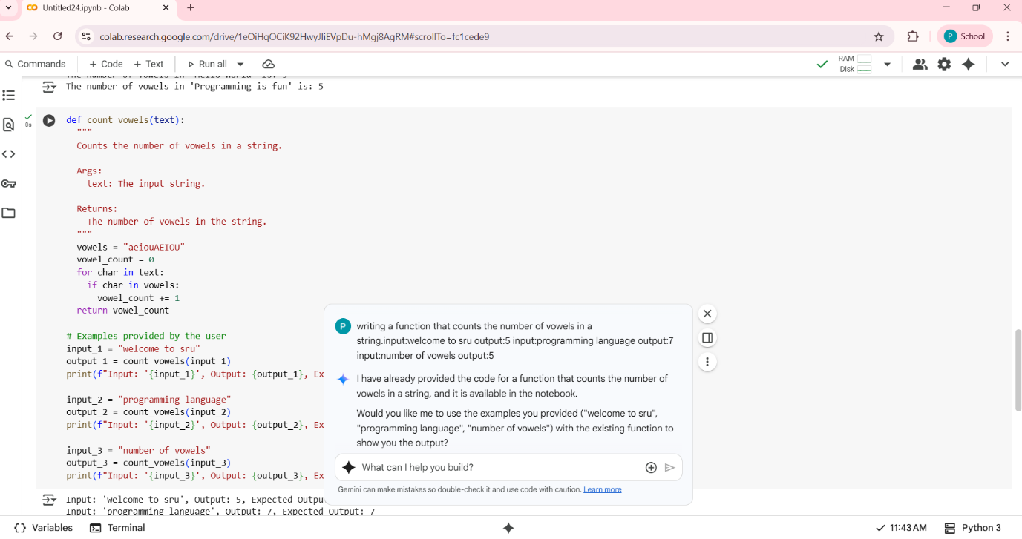

**Observation:**

The count_vowels function you've written is a clear and effective way to determine the number of vowels in a given string. It checks each character against a set of both uppercase and lowercase vowels, ensuring accurate results regardless of case. The test cases you've provided are well-chosen and demonstrate the function's correctness. For example, in the string "programming language", the function correctly identifies and counts seven vowels.

**Comparison zero-shot and few-shot prompts:**

| Feature | First code | Second code |
| --- | --- | --- |
| Function Used | count_vowels | count_vowels |
| Input Example 1 | "Hello World" | "welcome to sru" |
| Output Example 1 | 3 | 5 |
| Input Example 2 | "Programming is fun" | "programming language" |
| Output Example 2 | 5 | 7 |
| Input Example 3 | Not present | "number of vowels" |
| Output Example 3 | Not present | 5 |
| Purpose of Examples | Demonstrate basic usage  Includes two general examples: "Hello World" and "Programming is fun". | Verify with specific user cases  Includes the three specific examples I provided: "welcome to sru", "programming language", and "number of vowels". |

**Task-5**

Use few-shot prompting to generate a function that reads a .txt file and returns the number of lines.

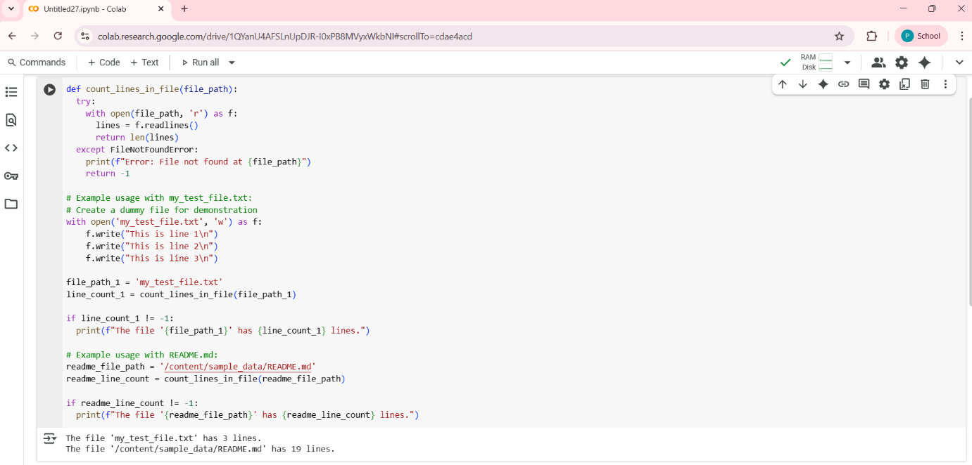

**Observation:**

The count_lines_in_file function is a clean and efficient way to determine the number of lines in a text file. It uses a generator expression within a sum() call, which is both memory-friendly and concise. The use of a try-except block ensures graceful error handling, returning -1 and printing a helpful message if the file is not found. The example usage demonstrates practical scenarios, checking two different file paths and comparing the actual output with expected line counts. This setup is useful for validating the function’s accuracy. To further improve robustness, you might consider handling other exceptions like PermissionErroror adding support for different file encodings**.**