**AI ASSITED CODING**

**Hallno:2403A51331**

**Name: Pujari Navya**

**Batch:24BTCAICSB13**

**Assignment -2.1**

**Task-1:**

* **Prompt:** Use Google Gemini in Colab to write a Python function that reads a list of numbers and calculates the mean, minimum, and maximum values.

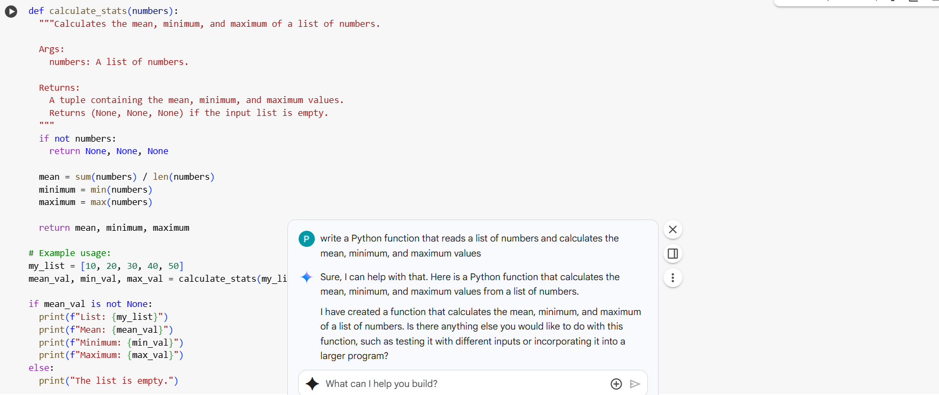

**Output:**

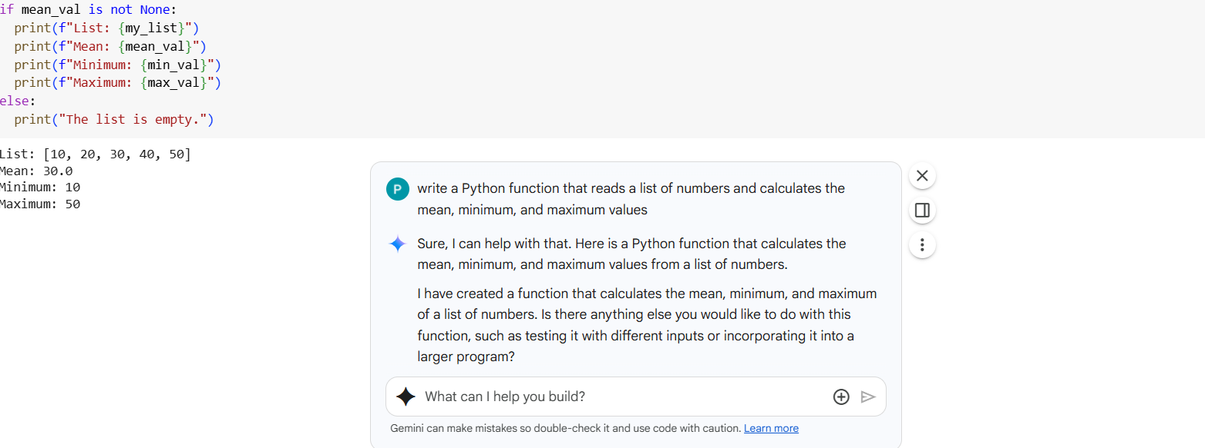

**Task-2:**

* **Prompt:** Compare Gemini and Copilot outputs for a Python function that checks whether a number is an Armstrong number. Document the steps, prompts, and outputs.
* Gemini

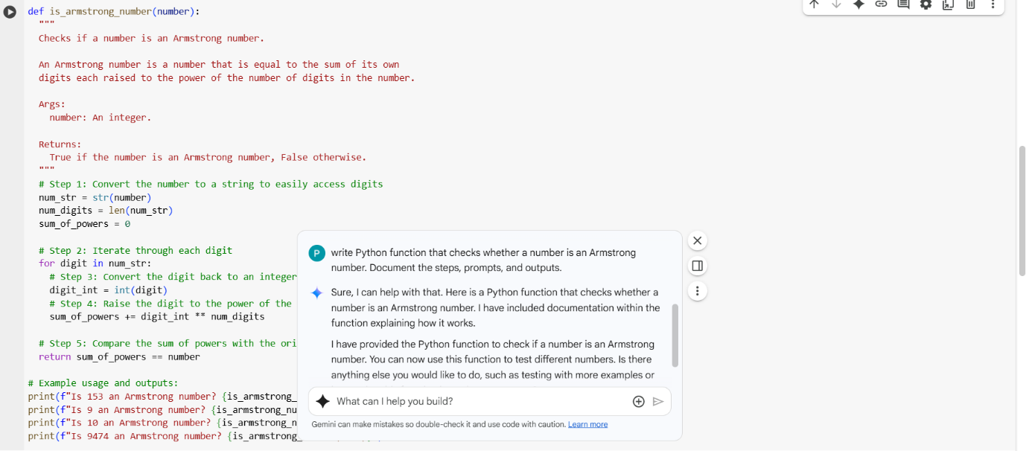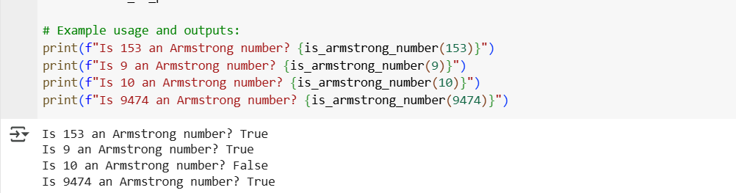

**Copilot:**

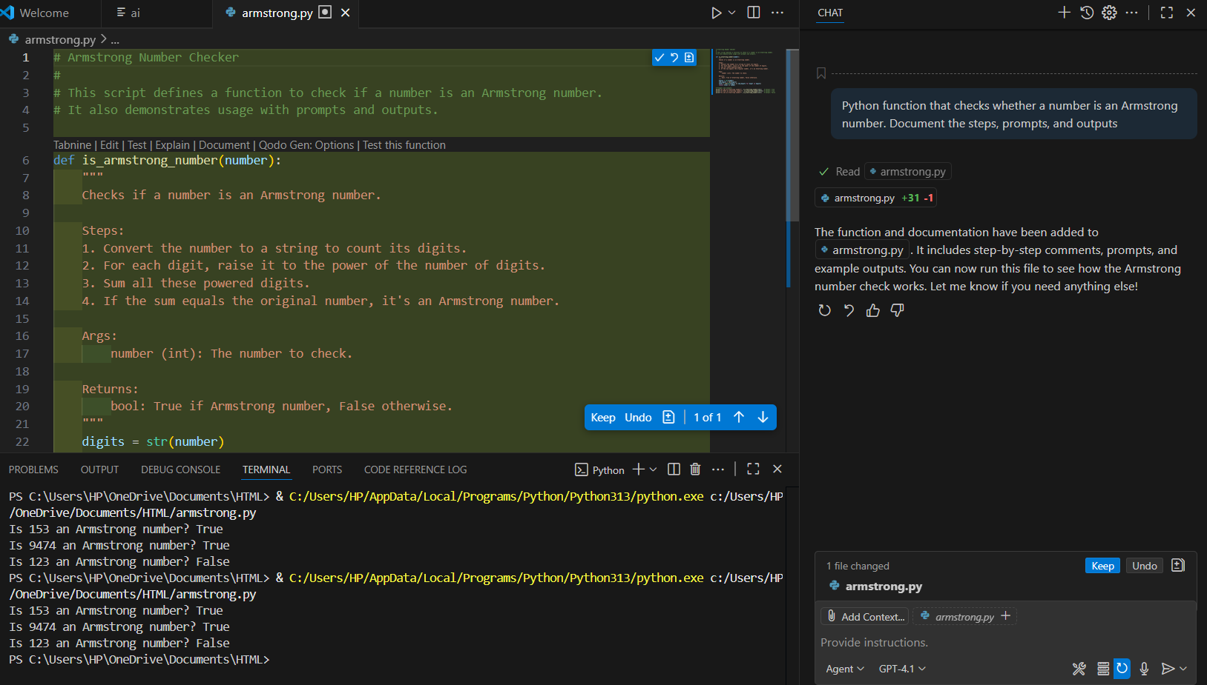

**Observations of Task 2:**

|  |  |
| --- | --- |
| Gemini | Copilot |
| Given code is Big in gemini | **Given lines of code is small compared to Gemini** |
| The respond is very fast | **The respond is slow** |
| Output matches expected results | **Output matches expected results** |
| Gives explanation in understandable way | **Explanation is different compare to gemini but understandable** |

**Task 3:**

1. **Prompt:** Ask Gemini to explain a Python function (e.g., is_prime(n) or is_palindrome(s)) line by line.

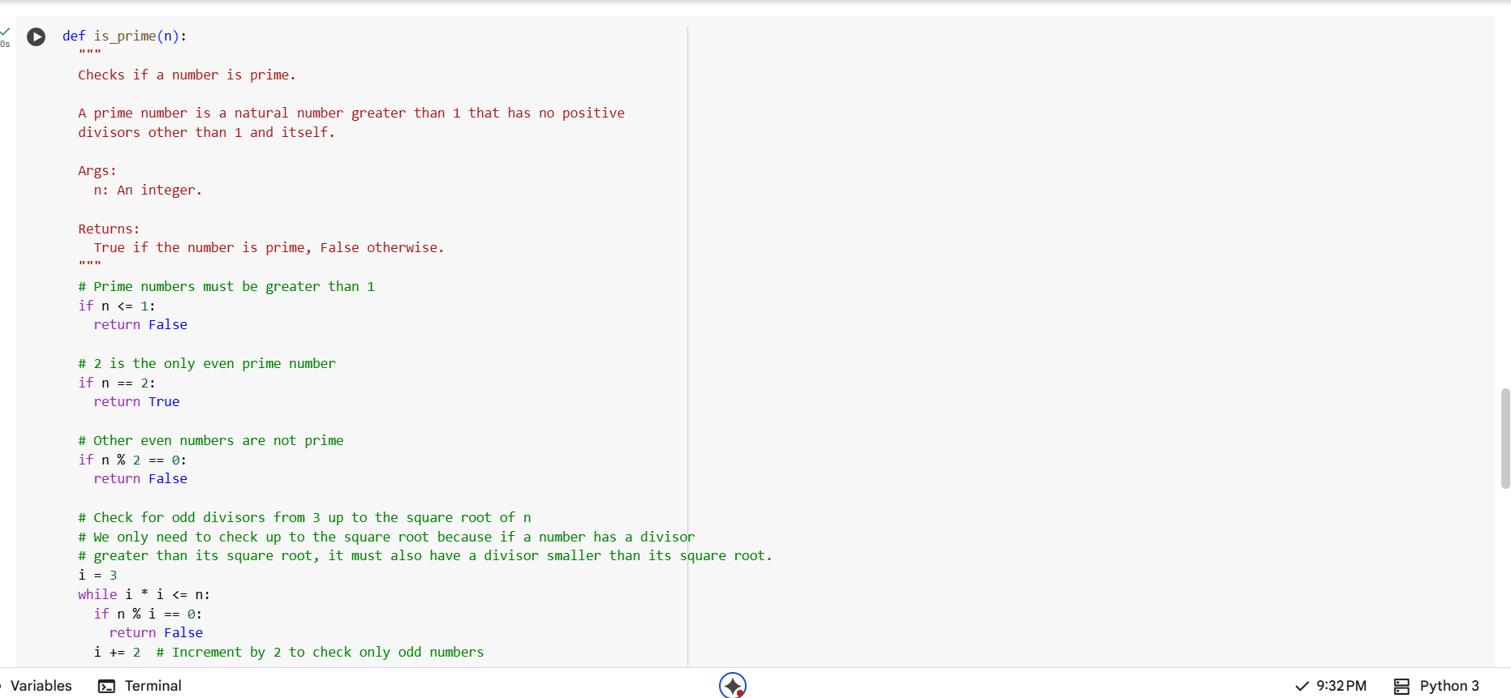

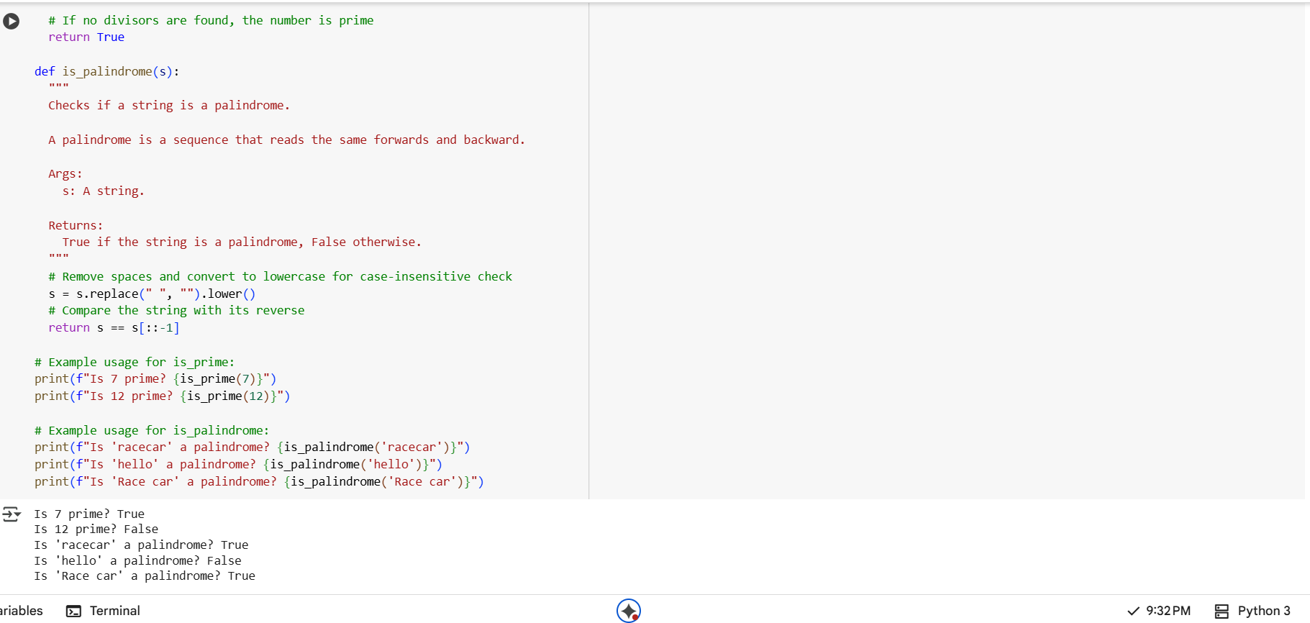

**Prompt:** Choose either a prime-checking or palindrome-checking function and document the explanation provided by Gemini.

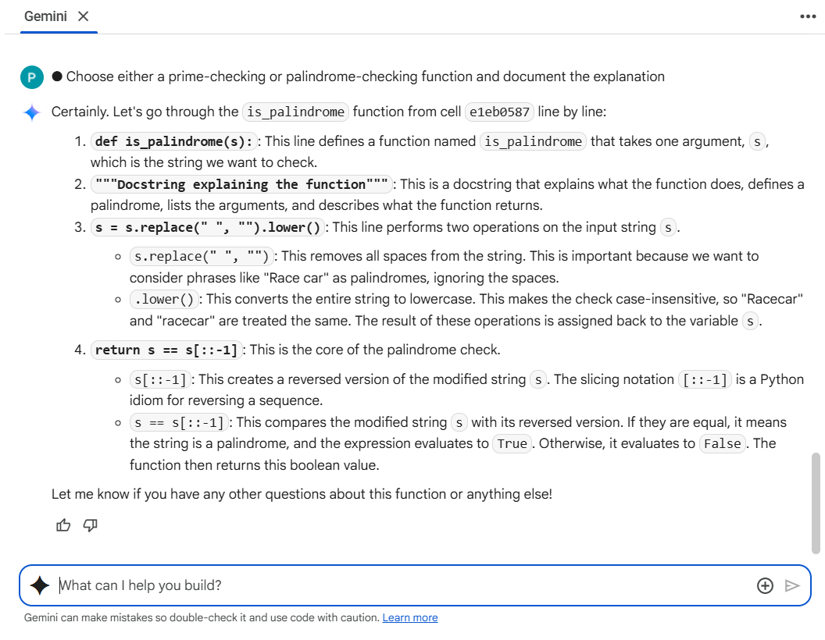

**TASK 4:**

* **Prompt:** function (e.g., sum of the first N natural numbers) and test its output.
* 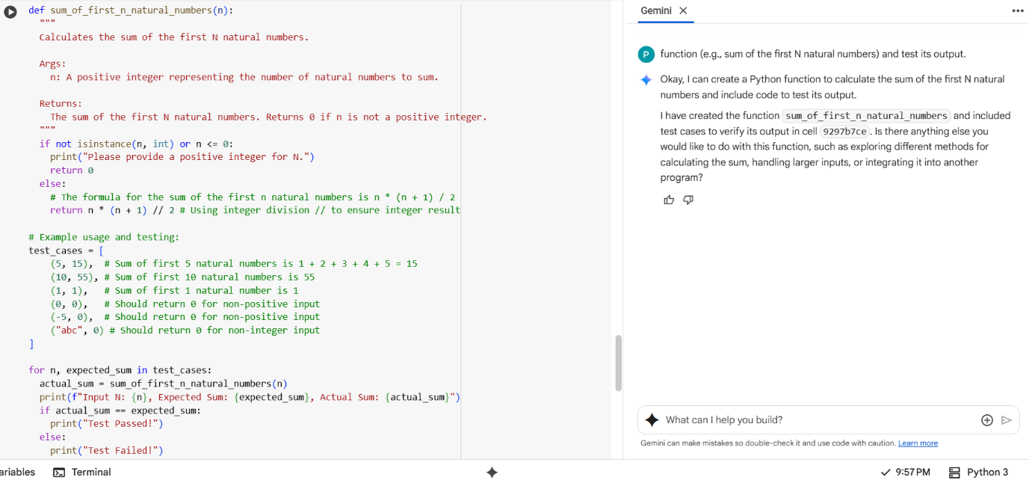

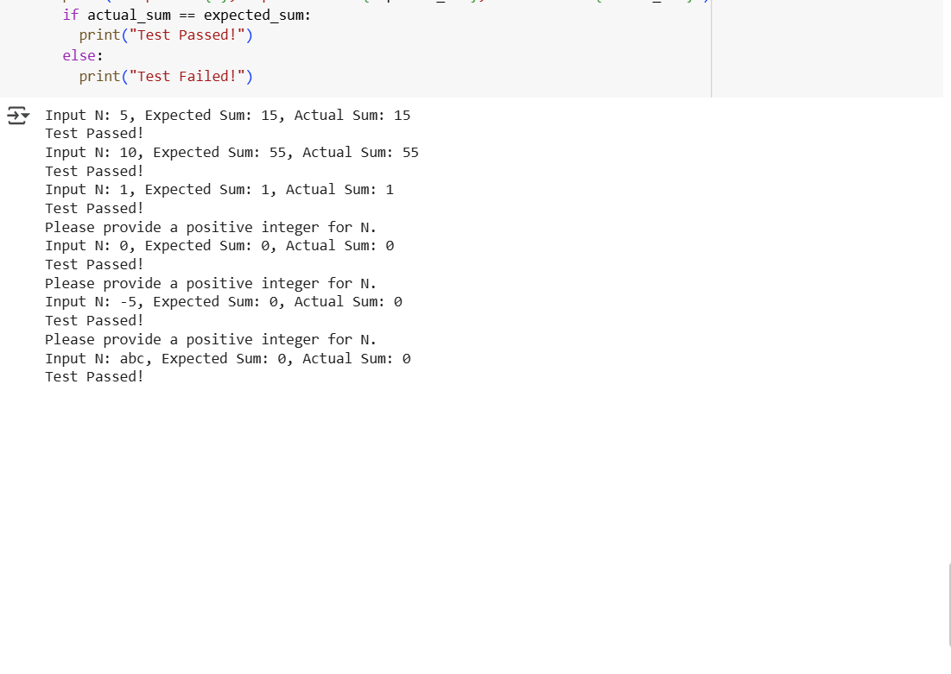**Cursor ai:**

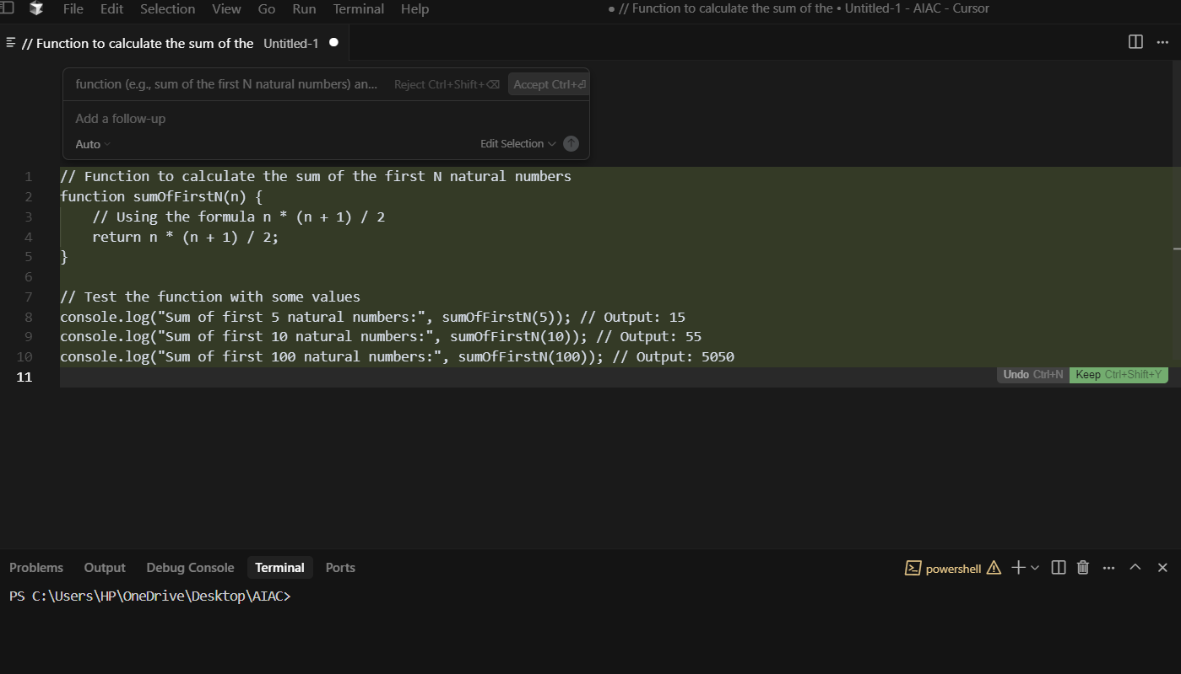

**Task 5:**

* **Prompt:** Students need to write a Python program to calculate the sum of odd numbers and even numbers in a given tuple**.**

**Student Code:**

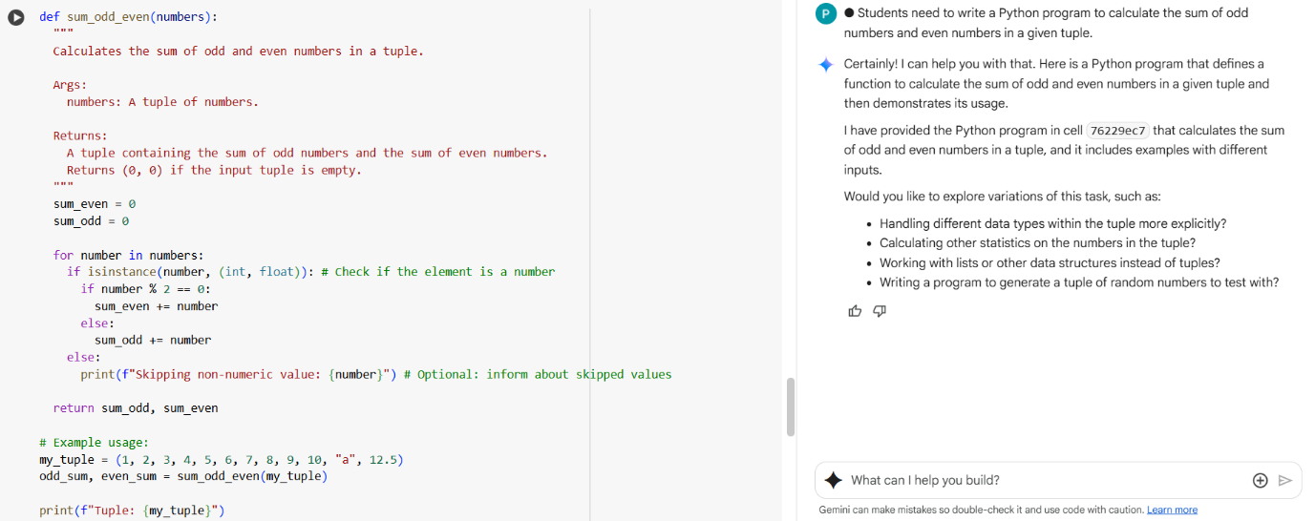

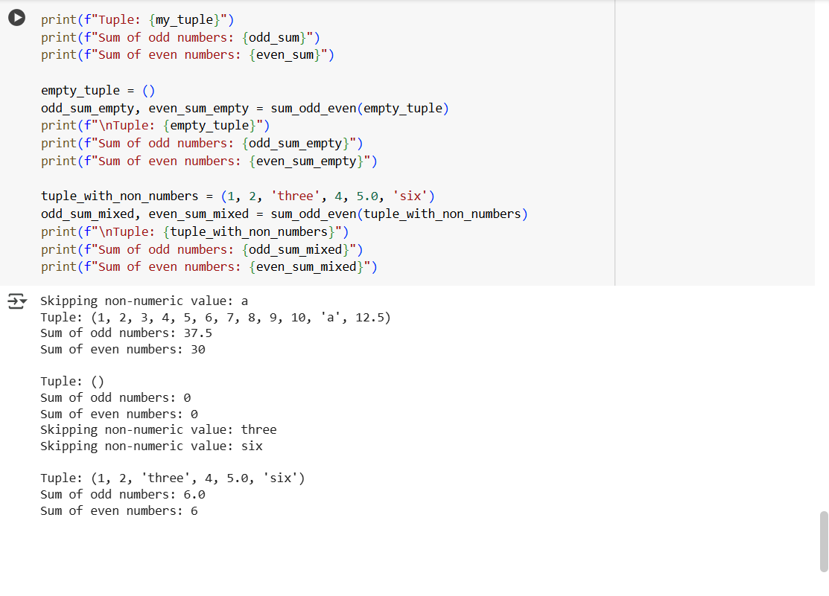

**Refactored Code:**

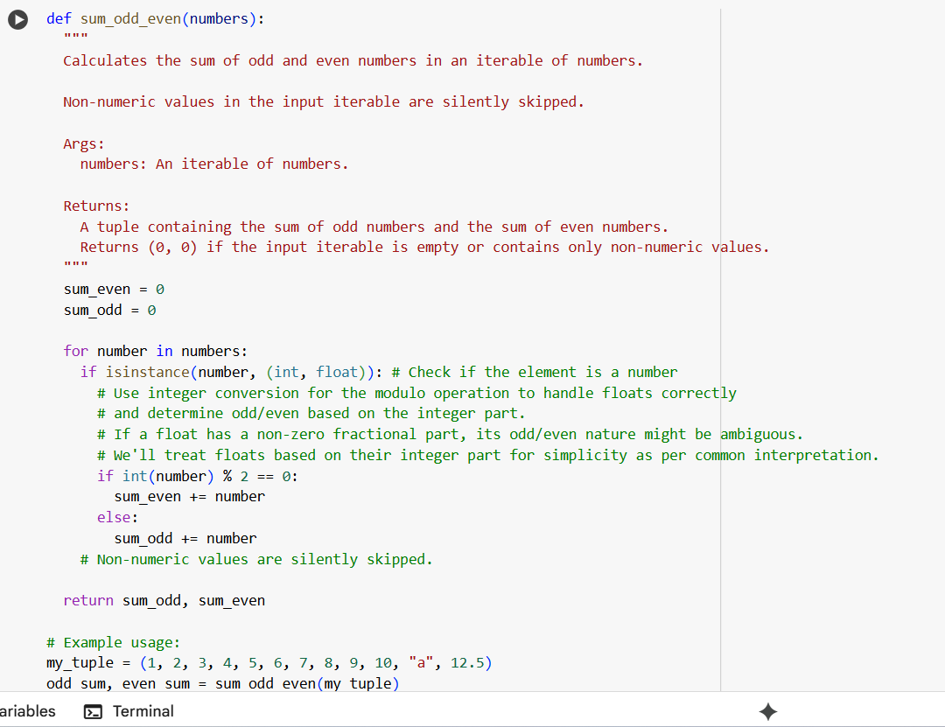

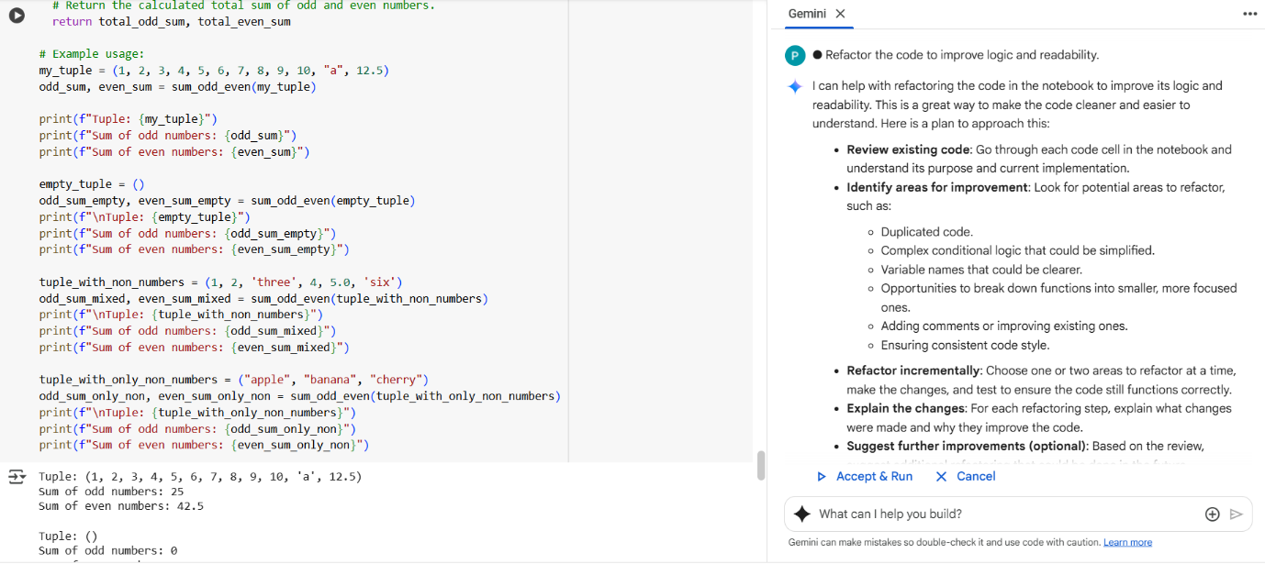

**Explanation:**

Improvements Made

* **List Comprehensions:** Replaced manual loops with concise sum() and generator expressions.
* **Type Hints:** Added Tuple[int, ...] and Dict[str, int] for clarity and IDE support.
* **Docstring:** Clear explanation of function purpose, arguments, and return values.
* **Formatted Output:** Used f-strings for cleaner printing.