NAME:saketh

HOLLNUM:2403A51337

BATCH:30

10.2

Task Description.1

Write python program as shown below.  
• Use an AI assistant to review and suggest corrections

**code**

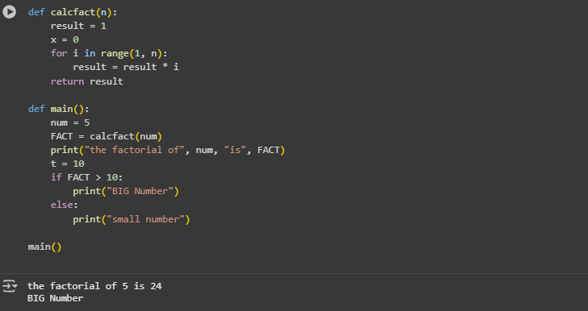

Output



prompt

1. Identify any **logical errors** or **inefficiencies** in the code.
2. Suggest **improvements** to variable naming, formatting, or style.
3. Rewrite the calcfact(n) function using a correct factorial logic.
4. Add a **docstring** (NumPy style) for the function calcfact(n) and the main() function.
5. Reflect: How does adding docstrings and improving names affect readability and understanding?

Task Description.2

**Automatic Inline Comments  
• Write the Python code for Fibonacci as shown below and execute.  
• Ask AI to improve variable names, add comments, and apply PEP8 formatting  
(cleaned up).  
• Students evaluate which suggestions improve readability most. one.**.

**code**

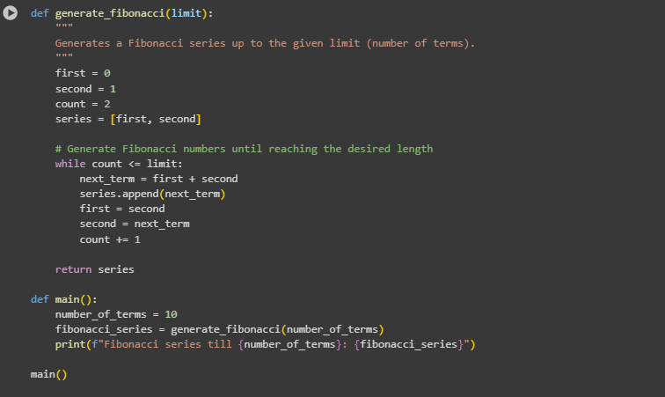

Output



prompt

• Identify and explain what the function f1(xX) is doing.

• Suggest improvements to **variable names** to make the code easier to understand.

• Add a **NumPy-style docstring** to the f1() function describing its purpose, parameters, and return value.

• Is there any unnecessary or confusing part of the code? If so, how would you simplify it?

• Modify the m() function to accept user input instead of using a fixed value (NN = 10).

• Reflect: How does better naming and documentation affect the readability of the code?

Task Description.3

**Write a Python script with 3–4 functions (e.g., calculator: add, subtract, multiply,  
divide).  
• Incorporate manual docstring in code with NumPy Style  
• Use AI assistance to generate a module-level docstring + individual function  
docstrings.  
• Compare the AI-generated docstring with your manually written one.**

CODE

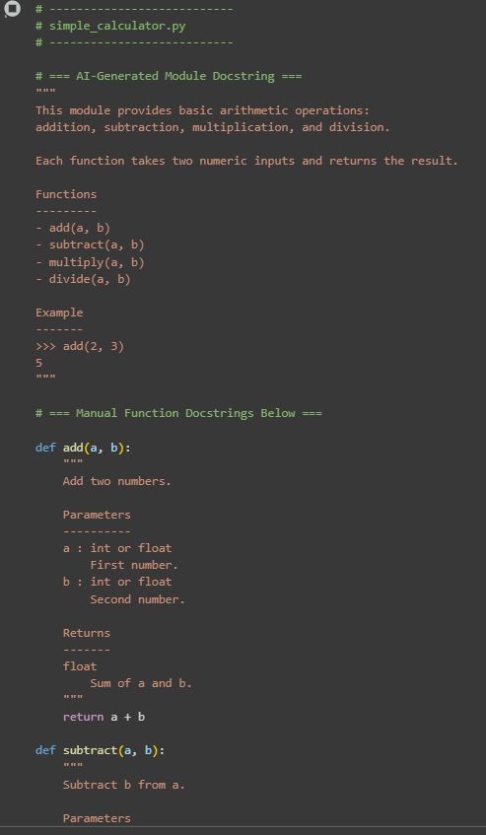

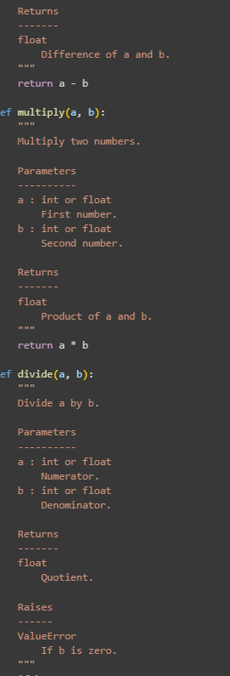

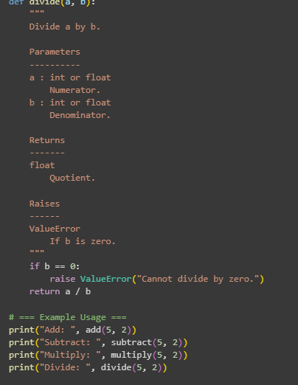

OUTPUT

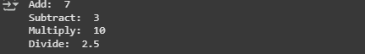

PROMPT

• Carefully read the module-level docstring and the function-level docstrings.

• What are the differences in tone, structure, or detail between the AI-generated docstring and the manual ones?

• Do you think the AI-generated module-level docstring accurately describes the purpose and use of the module? Why or why not?

• Suggest one improvement for each of the following:  
• The variable names  
• The comments or docstrings  
• The code structure or formatting

• Rewrite one of the function docstrings using your own words, still following the **NumPy docstring style**.

• Reflect: How does the use of structured docstrings (like NumPy-style) help in understanding and maintaining code?