Task Description #1 (Password Strength Validator – Apply AI in  
Security Context)  
• Task: Apply AI to generate at least 3 assert test cases for  
is_strong_password(password) and implement the validator  
function.  
• Requirements:  
o Password must have at least 8 characters.  
o Must include uppercase, lowercase, digit, and special  
character.  
o Must not contain spaces. 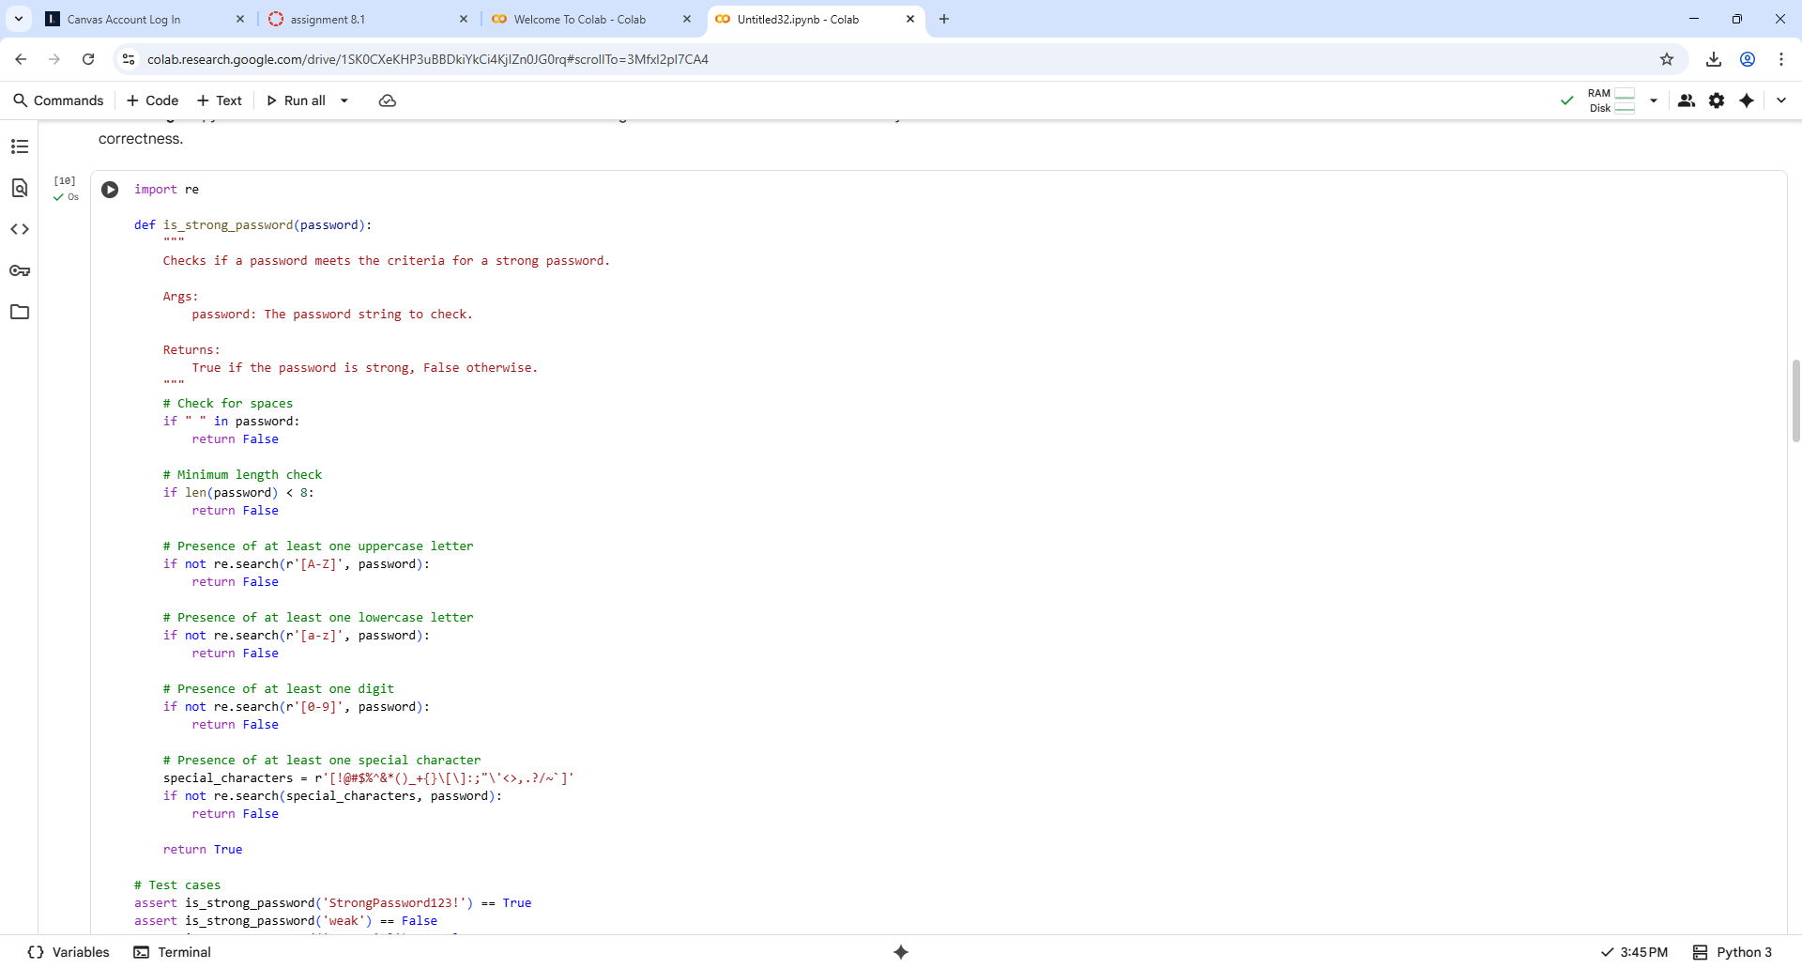

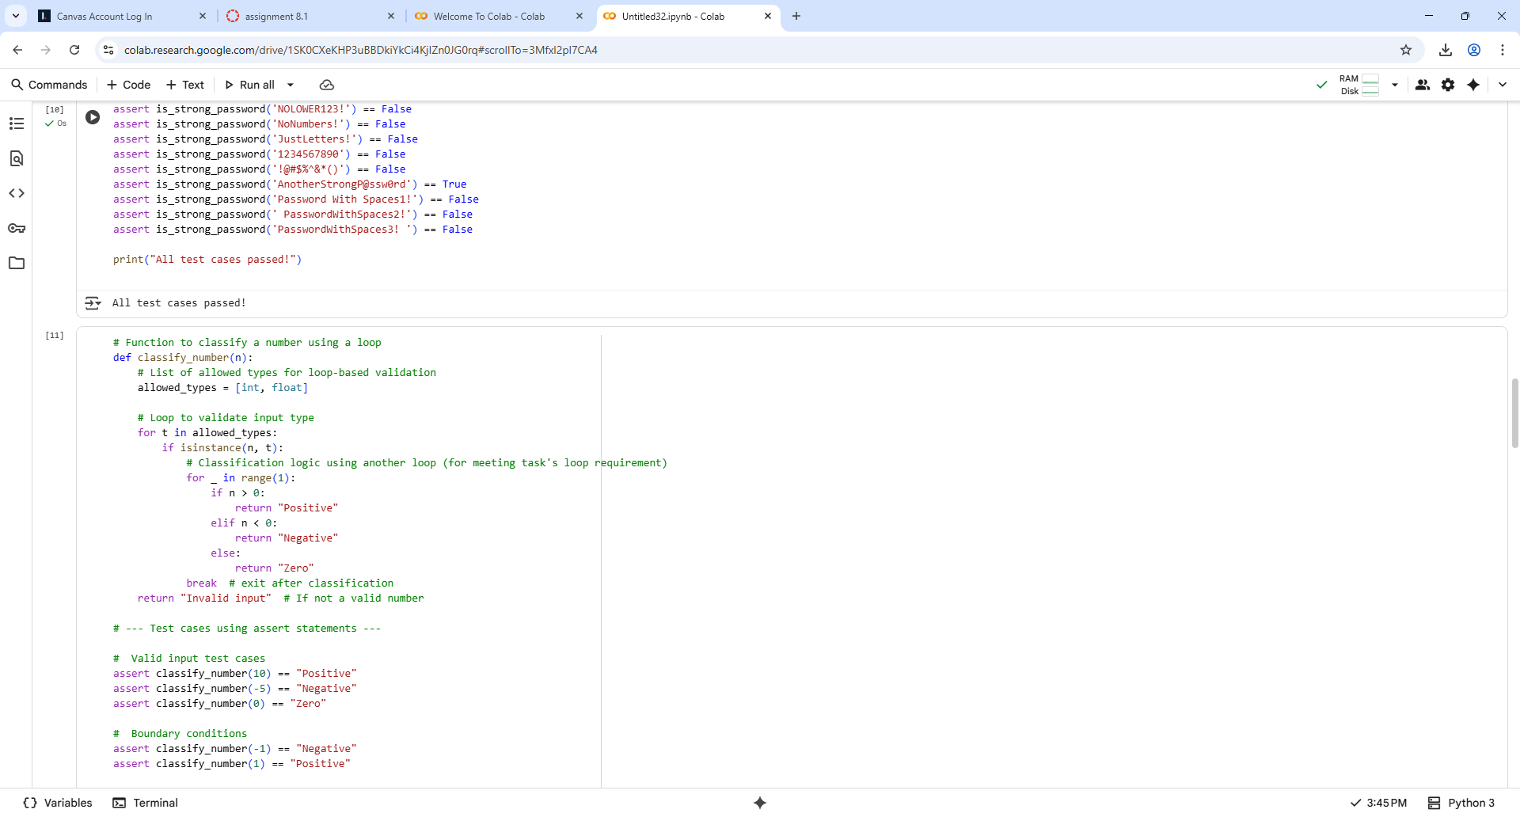

## Task Description #2

(Number Classification with Loops – Apply AI for  
Edge Case Handling)  
• Task: Use AI to generate at least 3 assert test cases for a  
classify_number(n) function. Implement using loops.  
• Requirements:  
o Classify numbers as Positive, Negative, or Zero.  
o Handle invalid inputs like strings and None.

o Include boundary conditions (-1, 0, 1).  
Example Assert Test Cases:  
assert classify_number(10) == "Positive"  
assert classify_number(-5) == "Negative"  
assert classify_number(0) == "Zero"  
Expected Output #2:  
• Classification logic passing all assert tests

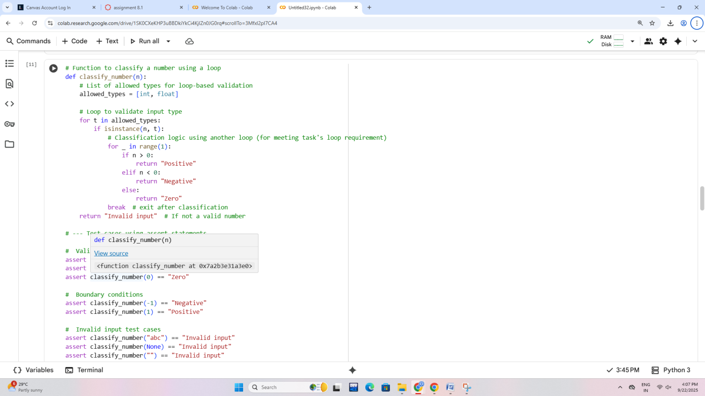

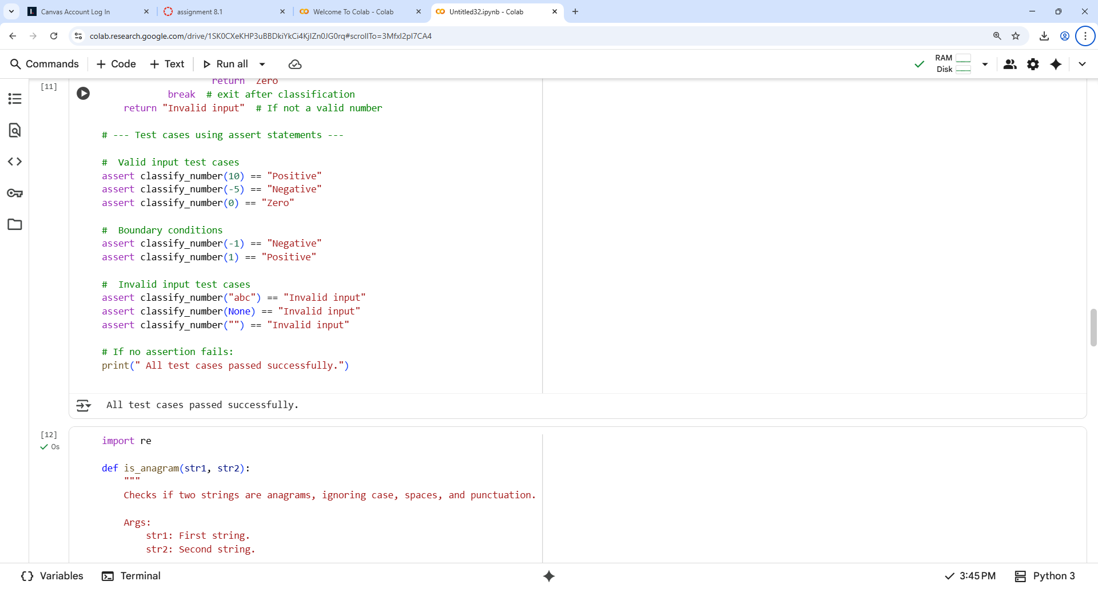

Task Description #3

(Anagram Checker – Apply AI for String Analysis)  
• Task: Use AI to generate at least 3 assert test cases for  
is_anagram(str1, str2) and implement the function.  
• Requirements:  
o Ignore case, spaces, and punctuation.  
o Handle edge cases (empty strings, identical words).  
Example Assert Test Cases:  
assert is_anagram("listen", "silent") == True  
assert is_anagram("hello", "world") == False  
assert is_anagram("Dormitory", "Dirty Room") == True

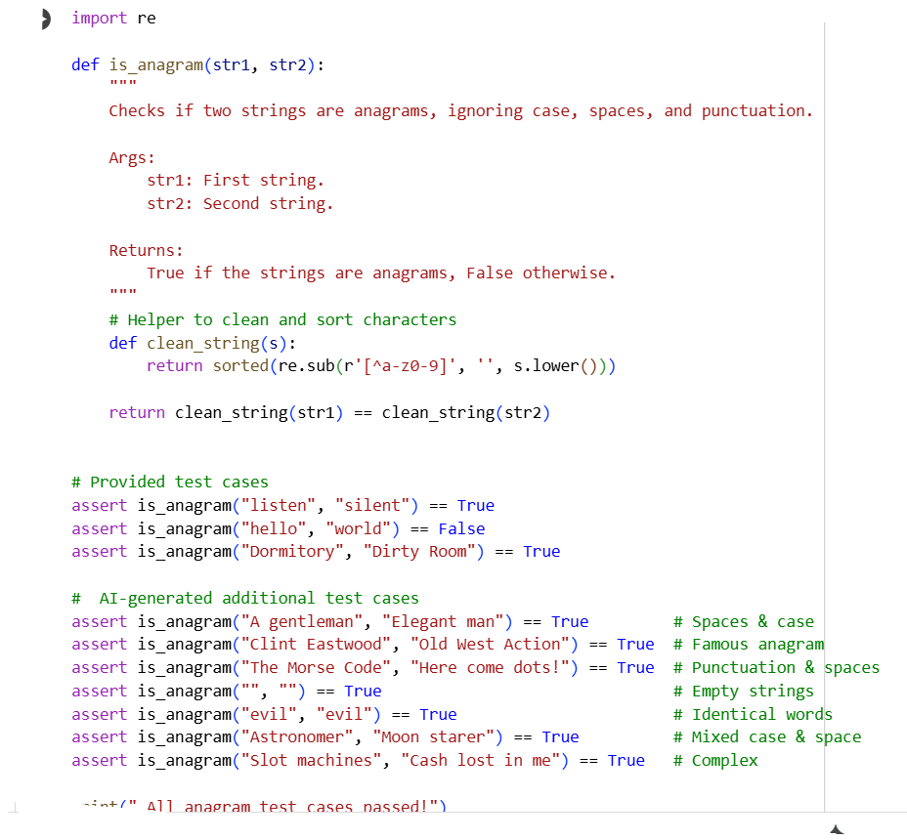

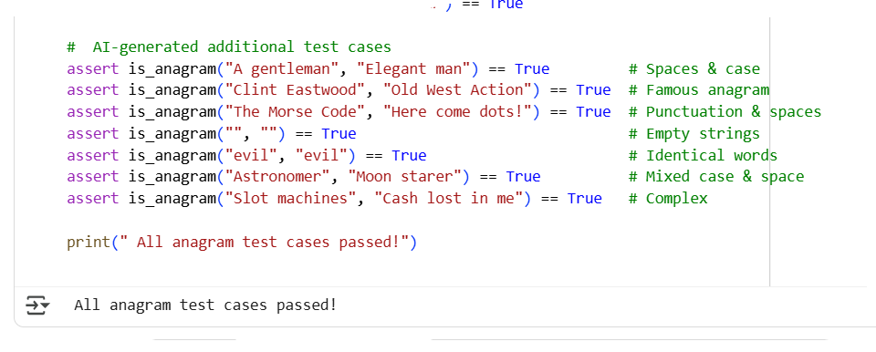

Task Description #4

(Inventory Class – Apply AI to Simulate Real-  
World Inventory System)  
• Task: Ask AI to generate at least 3 assert-based tests for an  
Inventory class with stock management.  
• Methods:  
o add_item(name, quantity)  
o remove_item(name, quantity)  
o get_stock(name)  
Example Assert Test Cases:  
inv = Inventory()  
inv.add_item("Pen", 10)  
assert inv.get_stock("Pen") == 10  
inv.remove_item("Pen", 5)  
assert inv.get_stock("Pen") == 5  
inv.add_item("Book", 3)  
assert inv.get_stock("Book") == 3  
Expected Output #4:  
• Fully functional class passing all assertions.

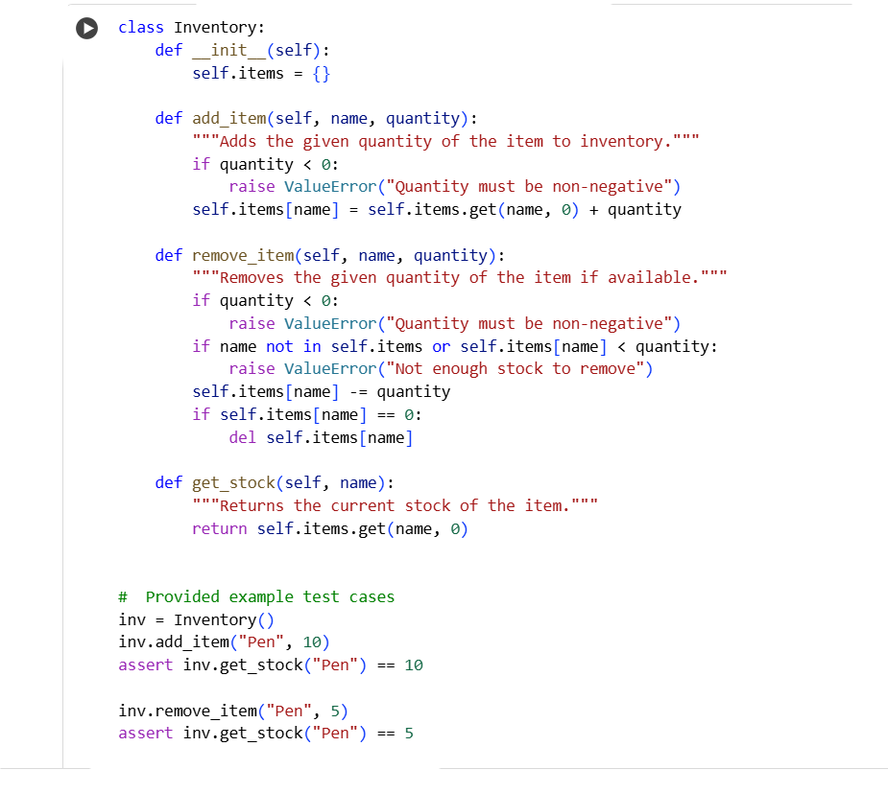

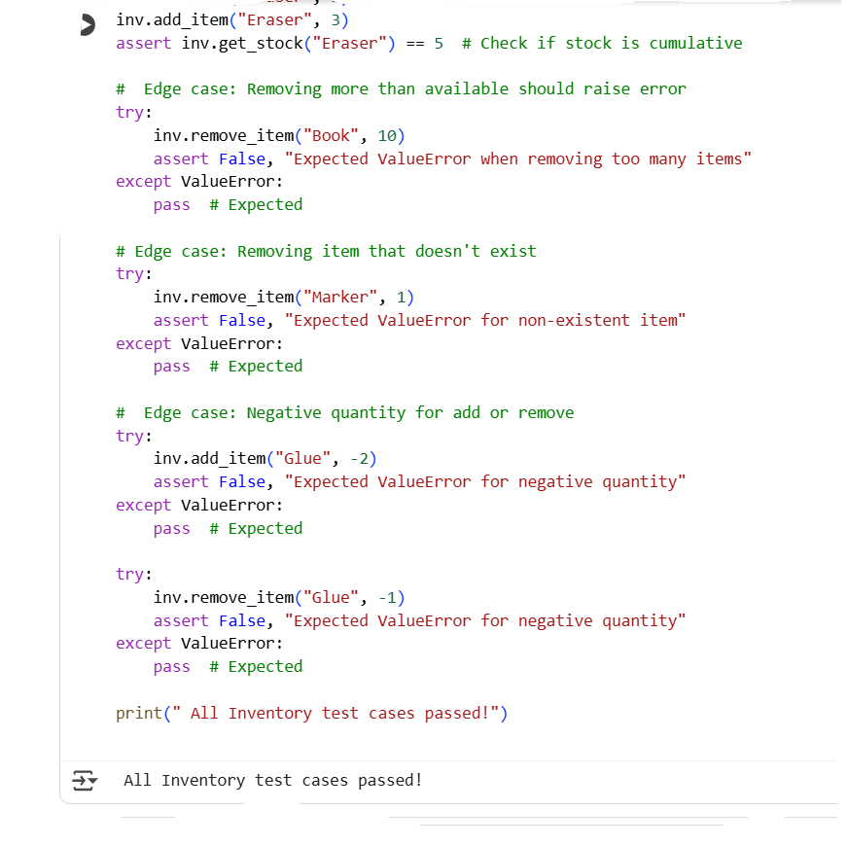

Task Description #5

(Date Validation & Formatting – Apply AI for  
Data Validation)  
• Task: Use AI to generate at least 3 assert test cases for  
validate_and_format_date(date_str) to check and convert dates.  
• Requirements:  
o Validate "MM/DD/YYYY" format.  
o Handle invalid dates.  
o Convert valid dates to "YYYY-MM-DD".  
Example Assert Test Cases:  
assert validate_and_format_date("10/15/2023") == "2023-10-15"  
assert validate_and_format_date("02/30/2023") == "Invalid Date"  
assert validate_and_format_date("01/01/2024") == "2024-01-01

