**AI ASSISTED CODING ASSIGNMENT 4.3**

**NAME:J.ABHIRAM**

**ROLL.NO:2403A51342**

**BATCH:06**

**TASK-1:**

PROMPT:



CODE:

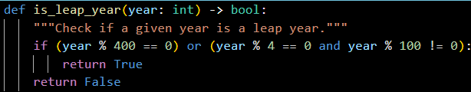

**TASK-2:**

CODE:

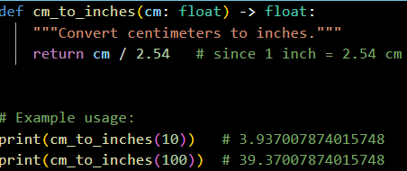

OUTPUT:



**TASK-3**:

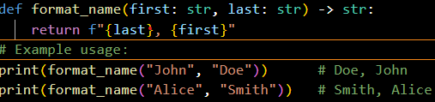



EXAMPLE:2

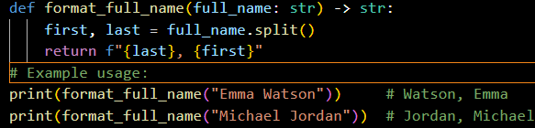



EXAMPLE:3

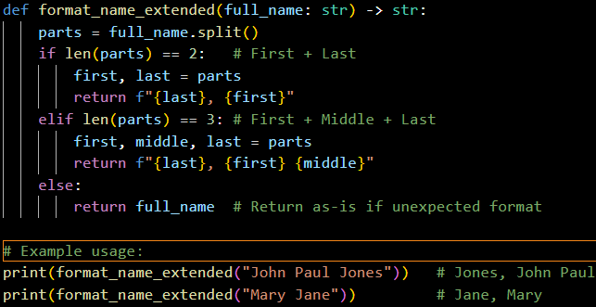



**TASK-4:**

PROMPTS:

ZERO SHOT:



FEW SHOT:



Outputs:

  
 



**TASK-5:**

PROMPT:

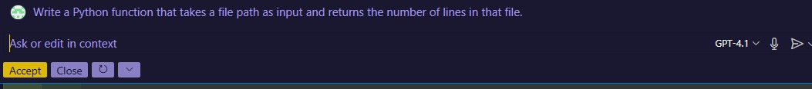

CODE:

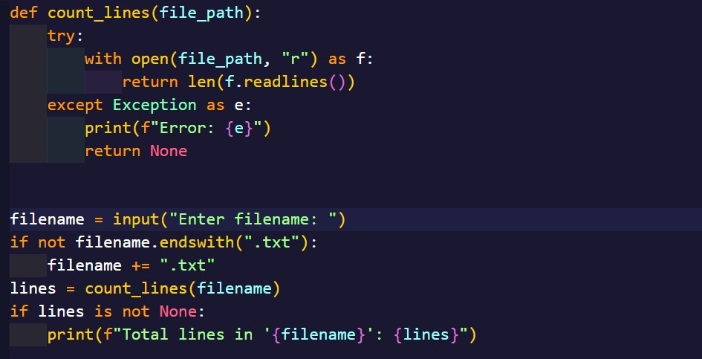

OUTPUT:

