# Assignment 16.3

# NAME:J.ABHIRAM 2403A51342 BATCH:06

## Prompts:

### Task Description #1 – Schema Generation

Ask AI to design a schema for an Online Course Management System (Tables: Courses, Students, Enrollments).

### Task Description #2 – Insert Data

Ask AI to generate INSERT INTO statements for the above schema (at least 3 sample records per table).

### Task Description #3 – Basic Queries

Use AI to create SQL queries to list all courses a particular student is enrolled in.

### Task Description #4 – Update and Delete Queries

Use AI to generate queries for:  
- Updating a course’s availability to ‘Closed’ when seats are full.  
- Deleting an enrollment record safely when a student withdraws.

## Code:

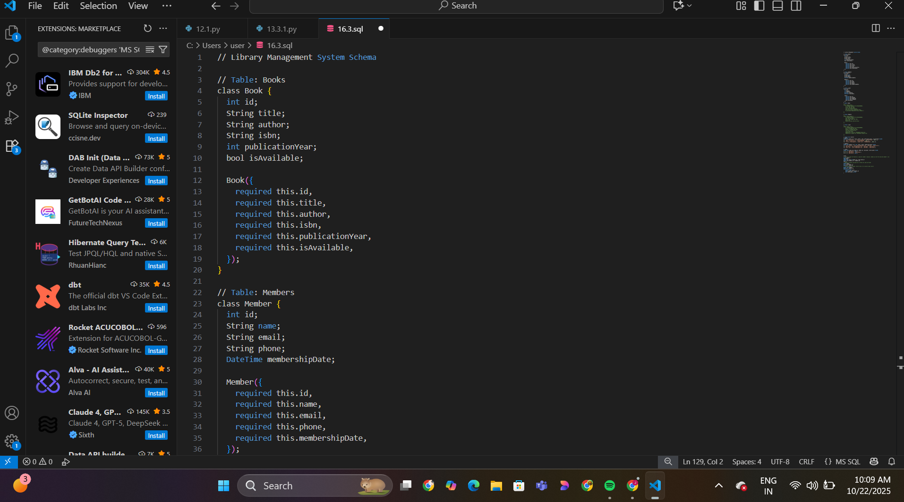

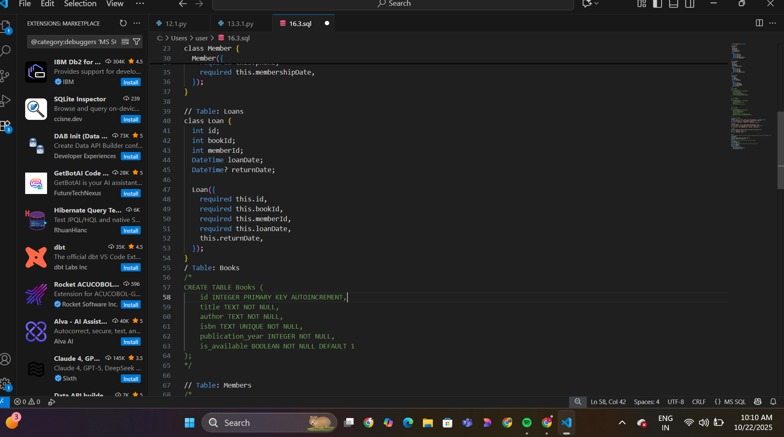

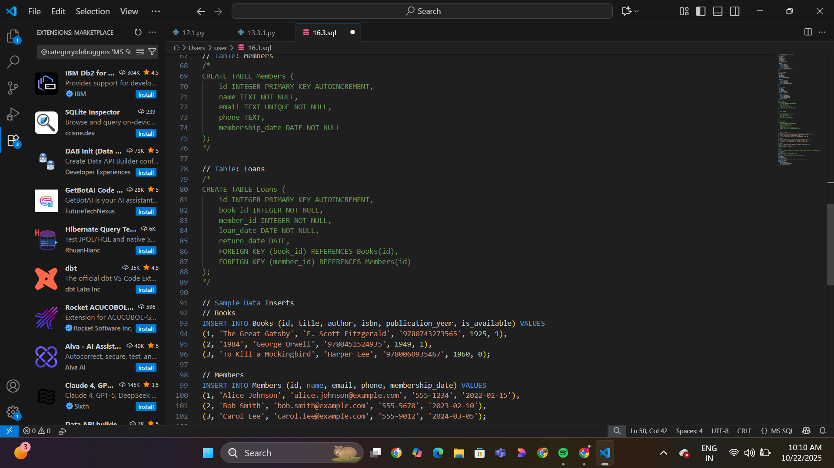

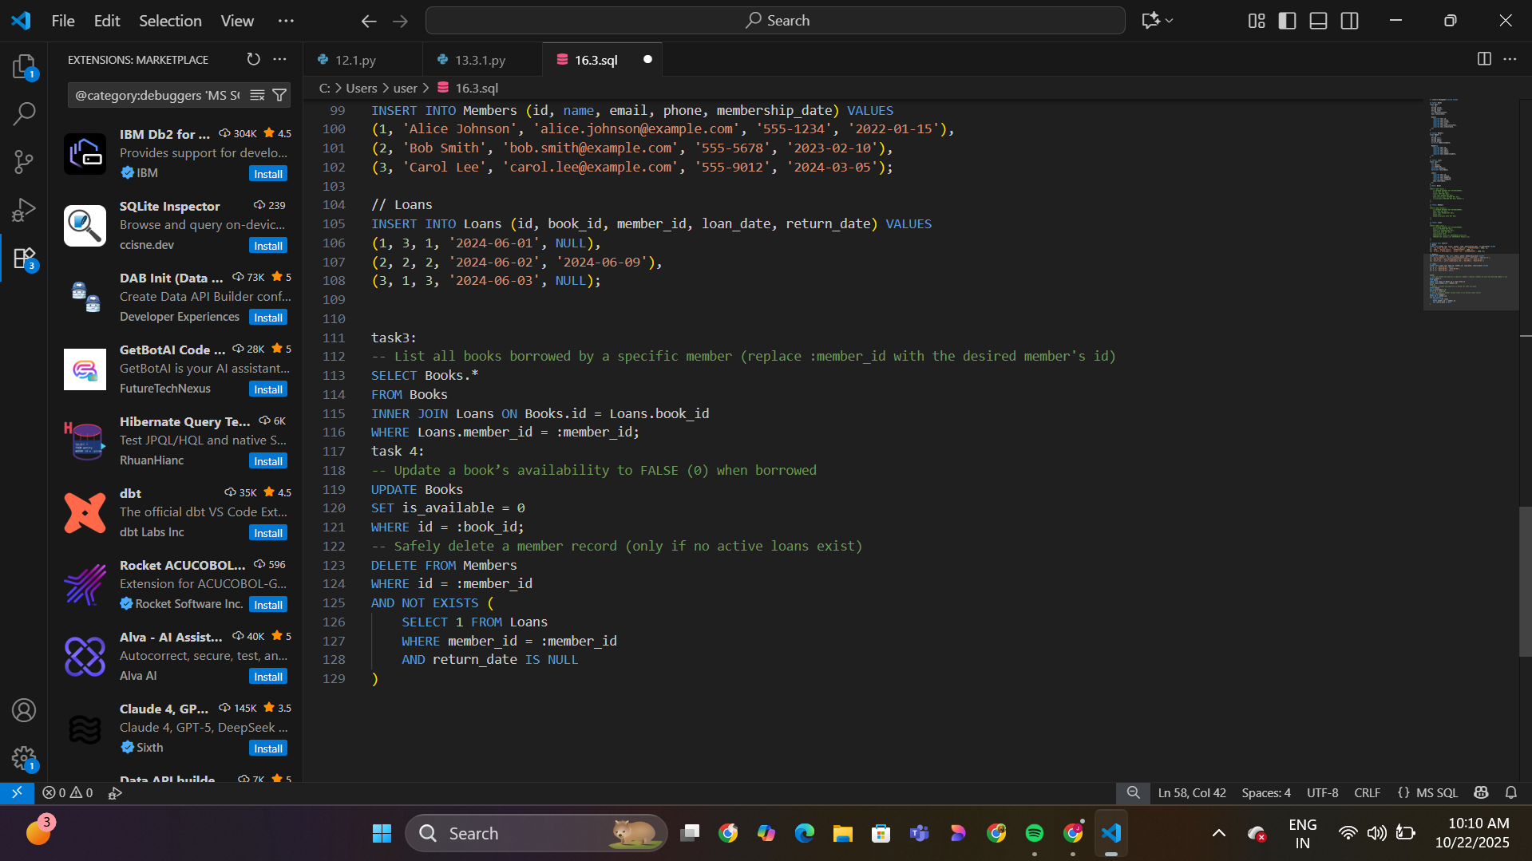

## Observations

1. The schema design using AI reduces manual effort and ensures structural consistency.

2. AI-generated INSERT queries help quickly populate test data for validation.

3. Using AI for query formulation ensures correct syntax and improves learning of SQL patterns.

4. The update and delete queries highlight how AI assists in automating database maintenance tasks.