**Task 1**: Task Description #1

* Use Google Gemini in Colab to write a Python function that reads a list of numbers and calculates the mean, minimum, and maximum values.

Expected Output #1

* Functional code with correct output and screenshot.

Prompt: write a Python function that reads a list of numbers and calculates the mean, minimum, and maximum values

Code: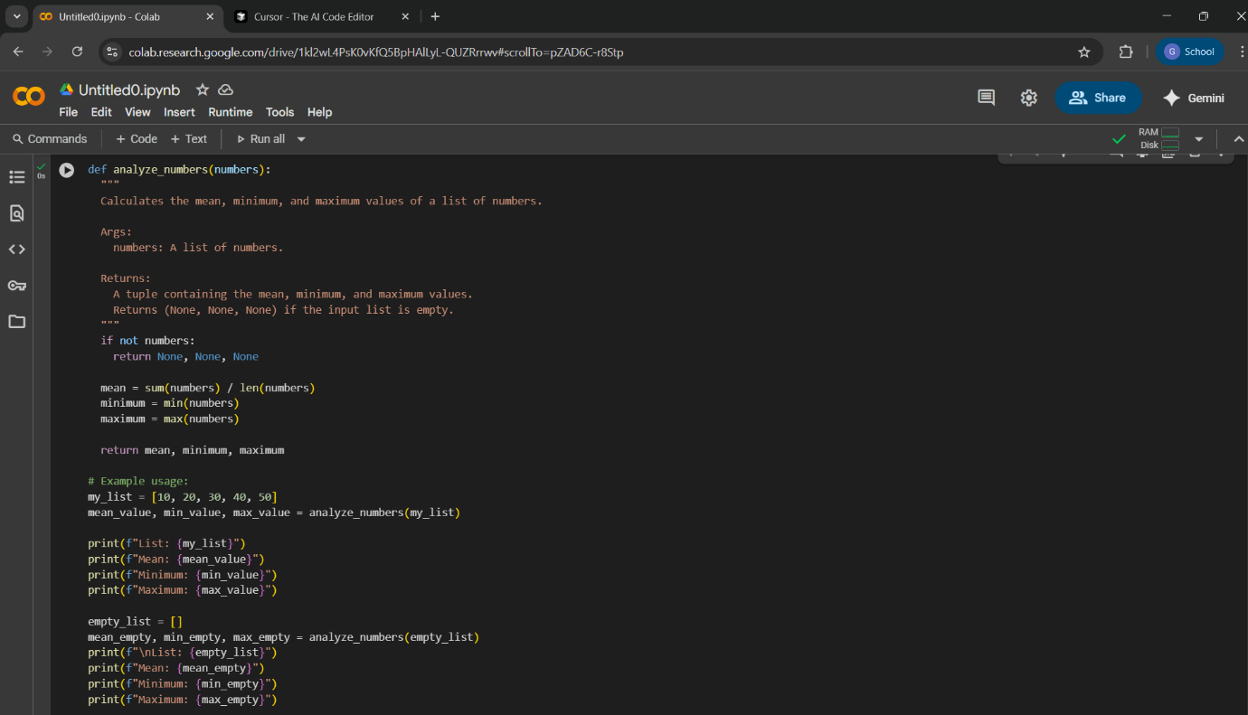

Output:

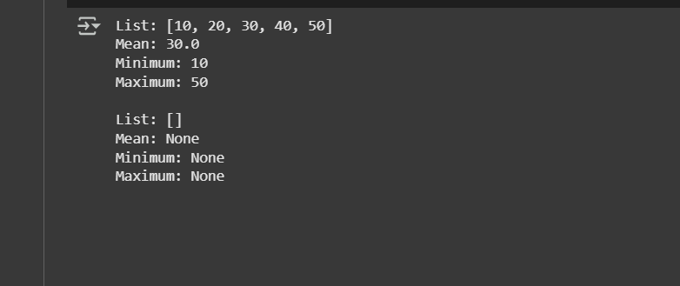

**Task 2:**

Task Description #2

* Compare Gemini and Copilot outputs for a Python function that checks whether a number is an Armstrong number. Document the steps, prompts, and outputs.

Expected Output #2

* Side-by-side comparison table with observations and screenshots.

Prompt :Write Python function that checks whether a number is an Armstrong number

|  |  |  |  |
| --- | --- | --- | --- |
|  |  | Gemini (Google collab) | Copilot(VS Code copilot) |
|  | CODE | Code: | Code: |
|  | Output: | Output: | Output: |
|  | Observation: | In Gemini I gave Prompt :Write Python function that checks whether a number is an Armstrong number  It give total code with example for the prompt | In Copilot in vscode I gave Prompt :Write Python function that checks whether a number is an Armstrong number  it gave only function for the prompt  it doesnot gave any example for the prompt |

Task 3:

Task Description #3

* Ask Gemini to explain a Python function (e.g., is_prime(n) or is_palindrome(s)) line by line.
* Choose either a prime-checking or palindrome-checking function and document the explanation provided by Gemini.

Expected Output #3

* Detailed explanation with the code snippet and Gemini’s response.

Prompt: explain a Python function (e.g., is_prime (n) or is_palindrome(s)) line by line and give code

Code and output:

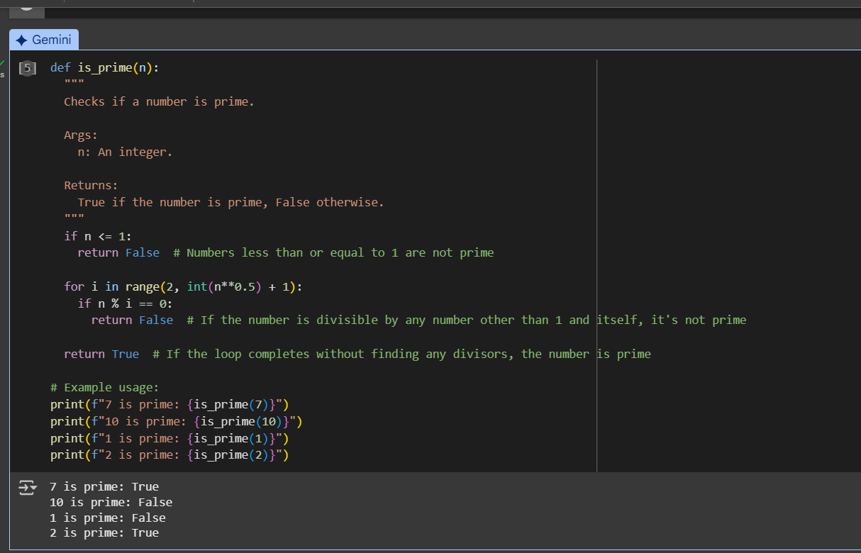

Explanation by gemini in google collab:

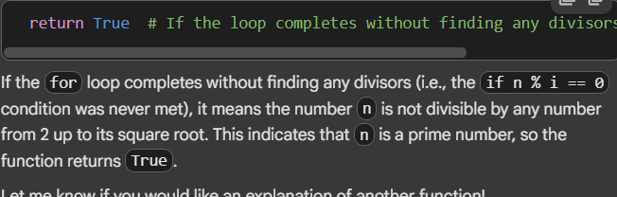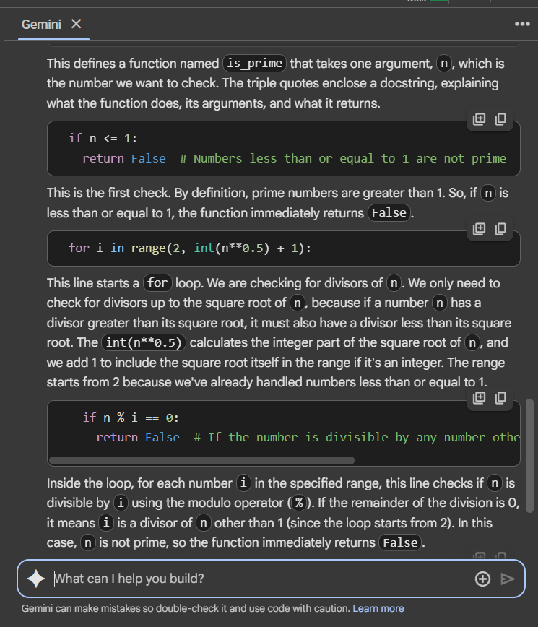

Observation : it gave the information about prime number line by line

Task 4:

Task Description #4

* Install and configure Cursor AI. Use it to generate a Python function (e.g., sum of the first N natural numbers) and test its output.
* Optionally, compare Cursor AI’s generated code with Gemini’s output.

Expected Output #4

Screenshots of Cursor AI setup, prompts used, and generated code with output.

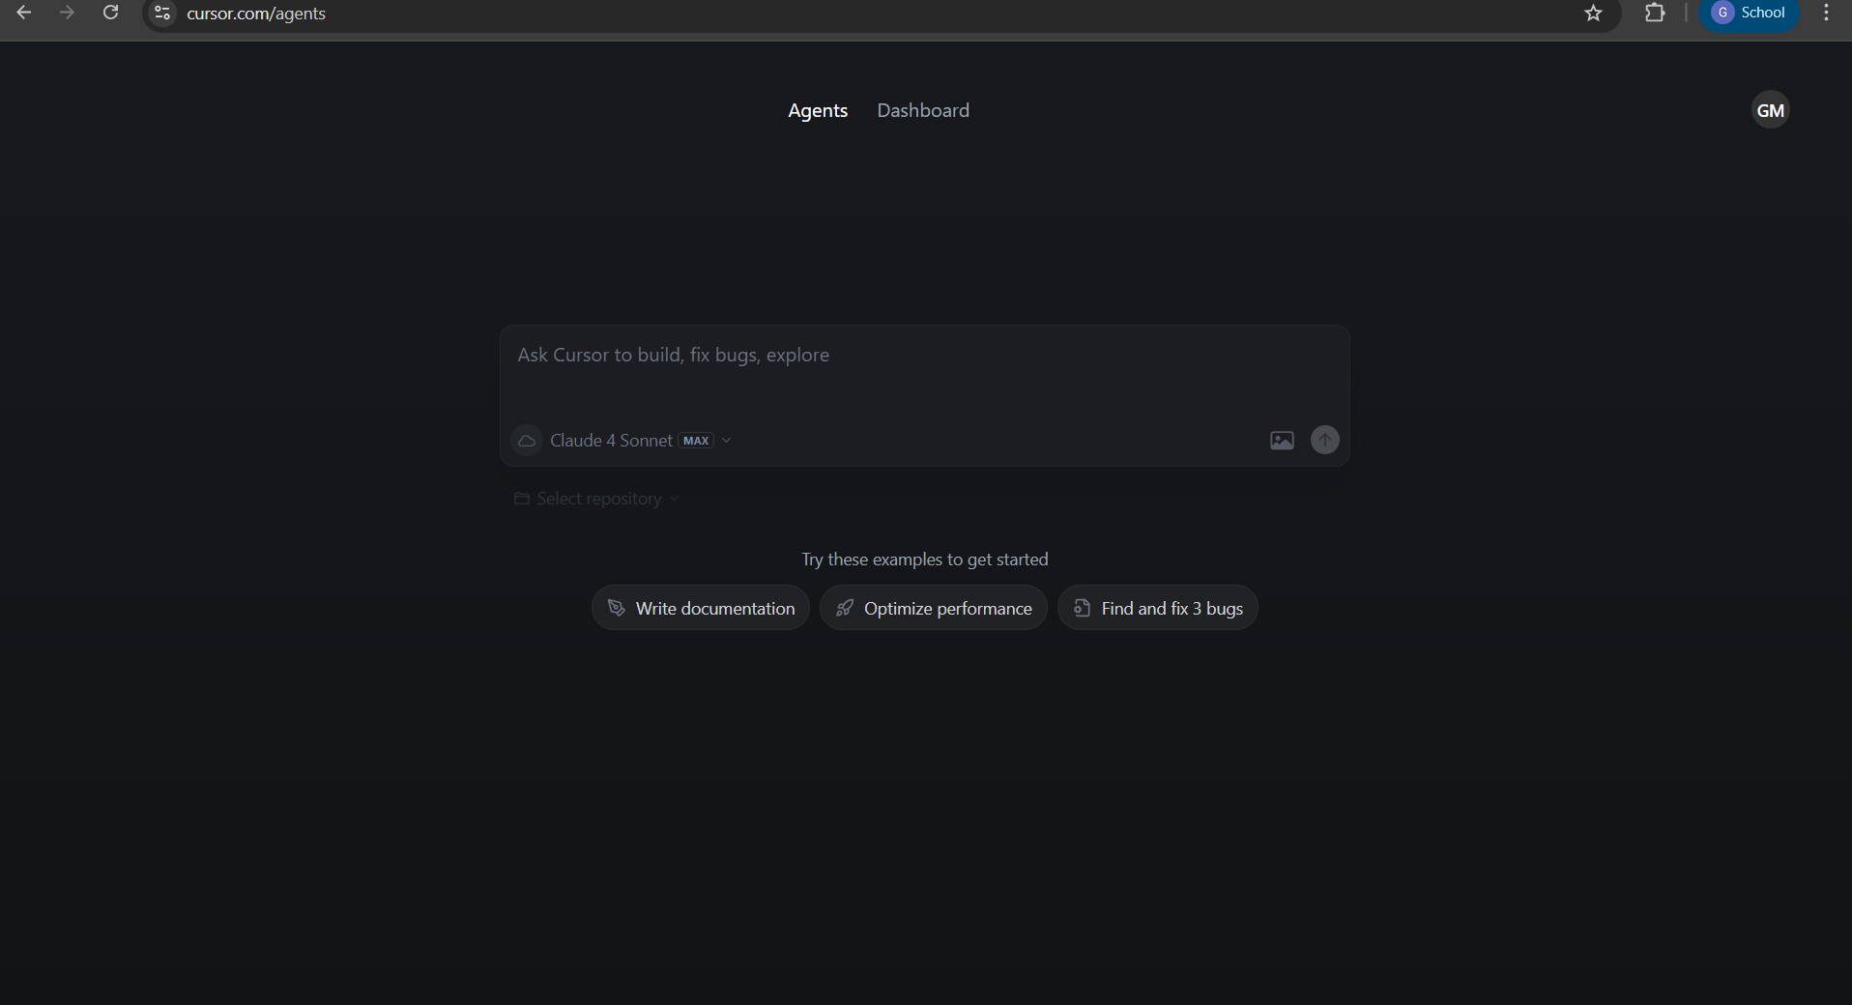

Prompt: write python function for sum of first n natural number with example

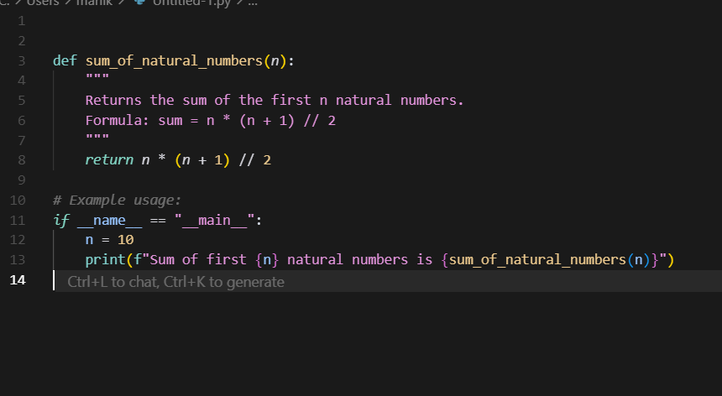



Task Description #5

* Students need to write a Python program to calculate the sum of odd numbers and even numbers in a given tuple.
* Refactor the code to improve logic and readability.

Expected Output #5

* Student-written refactored code with explanations and output screenshots.

