Task Description #1 (Documentation – Google-Style Docstrings for  
Python Functions)  
• Task: Use AI to add Google-style docstrings to all functions in a  
given Python script.  
• Instructions:  
o Prompt AI to generate docstrings without providing any  
input-output examples.  
o Ensure each docstring includes:  
▪ Function description  
▪ Parameters with type hints  
▪ Return values with type hints  
▪ Example usage  
o Review the generated docstrings for accuracy and  
formatting.  
• Expected Output #1:  
o A Python script with all functions documented using  
correctly formatted Google-style docstrings  
  
Prompt: generate docstrings Ensure each docstring includes:Function description,Parameters with type hints,Return values with type hints,Example usage

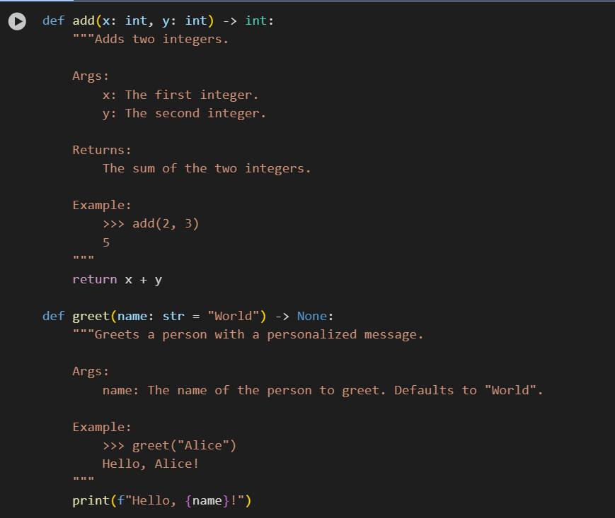

Obervation:It Generates docstrings for the code to for simple explanation of the code

Task Description #2 (Documentation – Inline Comments for Complex  
Logic)  
• Task: Use AI to add meaningful inline comments to a Python  
program explaining only complex logic parts.  
• Instructions:  
o Provide a Python script without comments to the AI.  
o Instruct AI to skip obvious syntax explanations and focus  
only on tricky or non-intuitive code sections.  
o Verify that comments improve code readability and  
maintainability.  
• Expected Output #2:  
o Python code with concise, context-aware inline comments  
for complex logic blocks.  
  
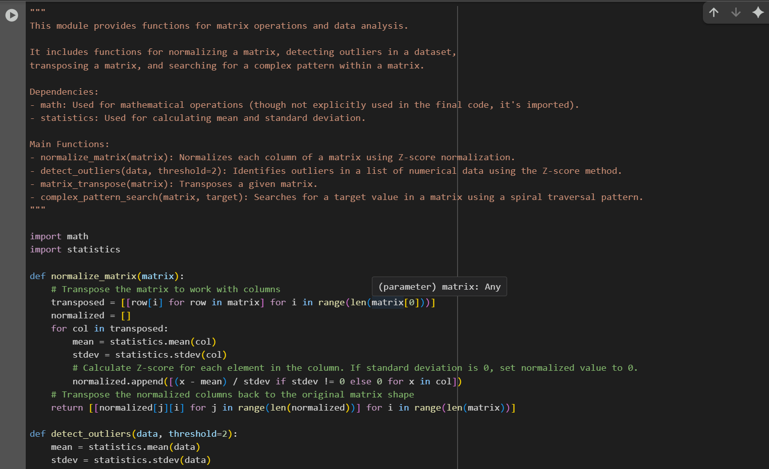

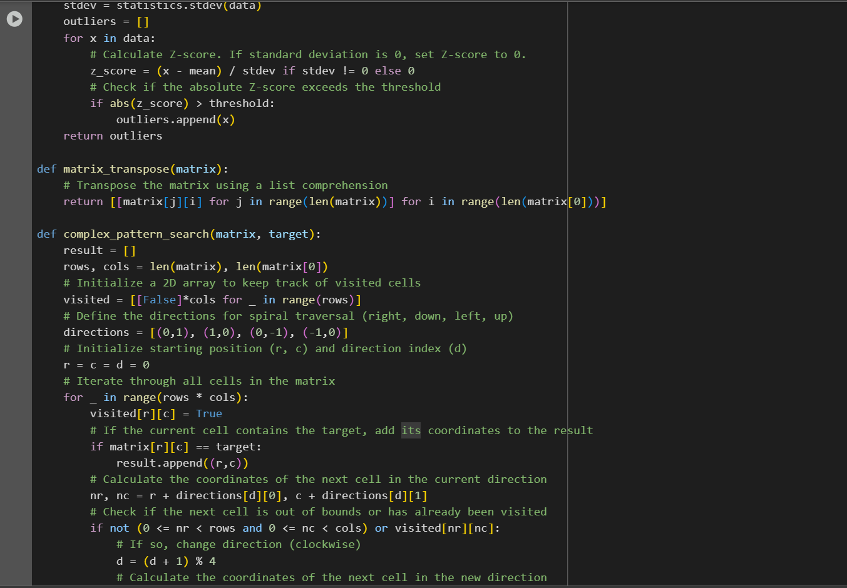

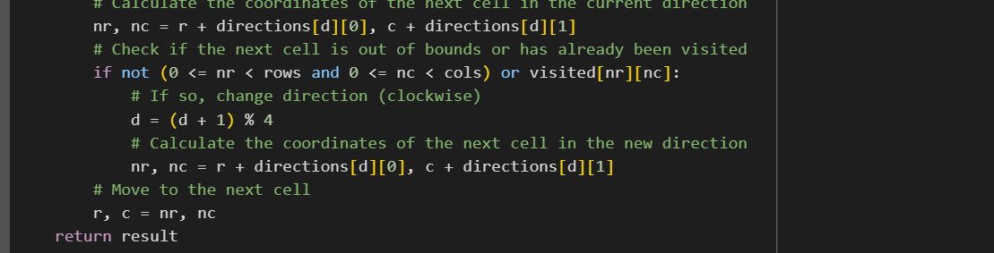

Obervation: AI correctly added comments only to complex parts of the code, skipping basic syntax.  
This made the code easier to understand without hard words.

Task Description #3 (Documentation – Module-Level Documentation)  
• Task: Use AI to create a module-level docstring summarizing the  
purpose, dependencies, and main functions/classes of a Python  
file.

• Instructions:  
o Supply the entire Python file to AI.  
o Instruct AI to write a single multi-line docstring at the top  
of the file.  
o Ensure the docstring clearly describes functionality and  
usage without rewriting the entire code.  
• Expected Output #3:  
o A complete, clear, and concise module-level docstring at  
the beginning of the file.

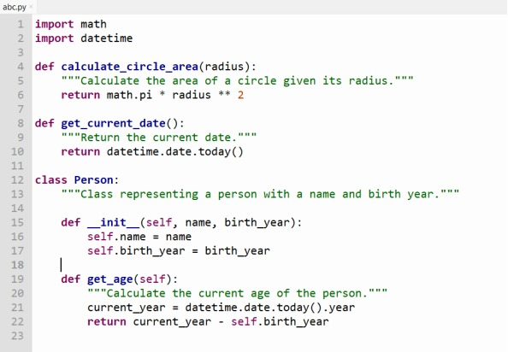

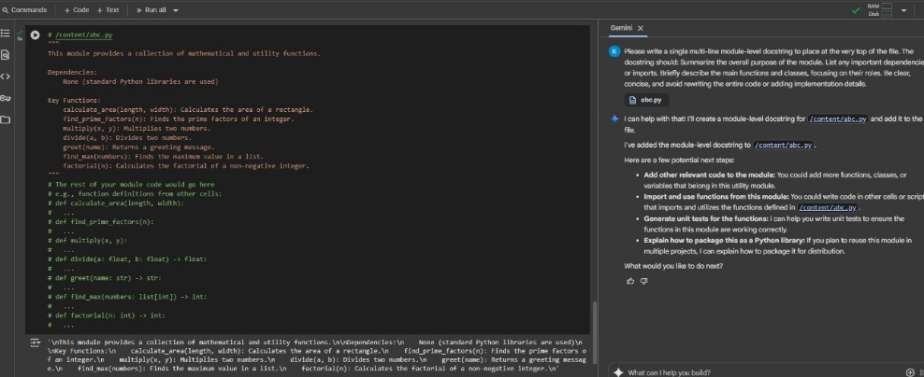

Observation: AI generated a clear module-level docstring that summarized the file’s purpose, dependencies, and main components without altering the code.

Task Description #4 (Documentation – Convert Comments to  
Structured Docstrings)  
• Task: Use AI to transform existing inline comments into  
structured function docstrings following Google style.  
• Instructions:  
o Provide AI with Python code containing inline comments.  
o Ask AI to move relevant details from comments into  
function docstrings.  
o Verify that the new docstrings keep the meaning intact  
while improving structure.  
• Expected Output #4:  
o Python code with comments replaced by clear,  
standardized docstrings

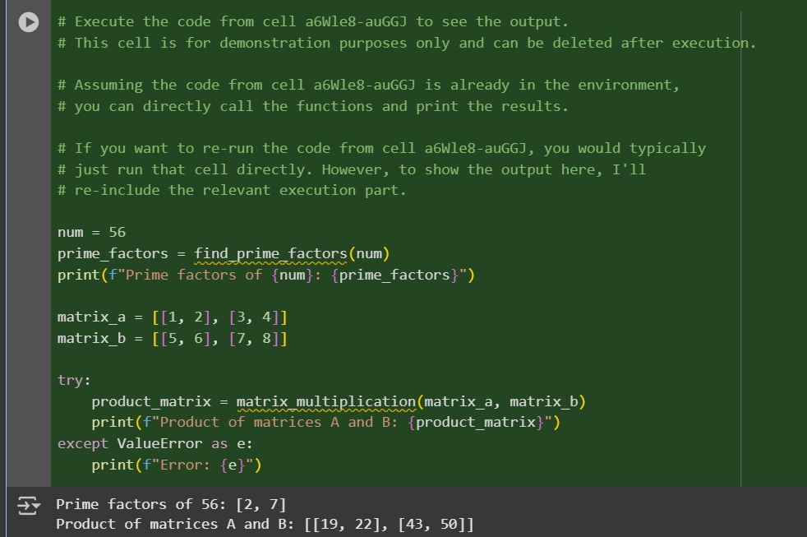

Obervations: AI successfully converted inline comments into clear Google-style docstrings, improving structure and readability without changing the code logic.

Task Description #5 (Documentation – Review and Correct  
Docstrings)  
• Task: Use AI to identify and correct inaccuracies in existing  
docstrings.  
• Instructions:  
o Provide Python code with outdated or incorrect  
docstrings.  
o Instruct AI to rewrite each docstring to match the current  
code behavior.  
o Ensure corrections follow Google-style formatting.  
• Expected Output #5:  
o Python file with updated, accurate, and standardized  
docstrings.

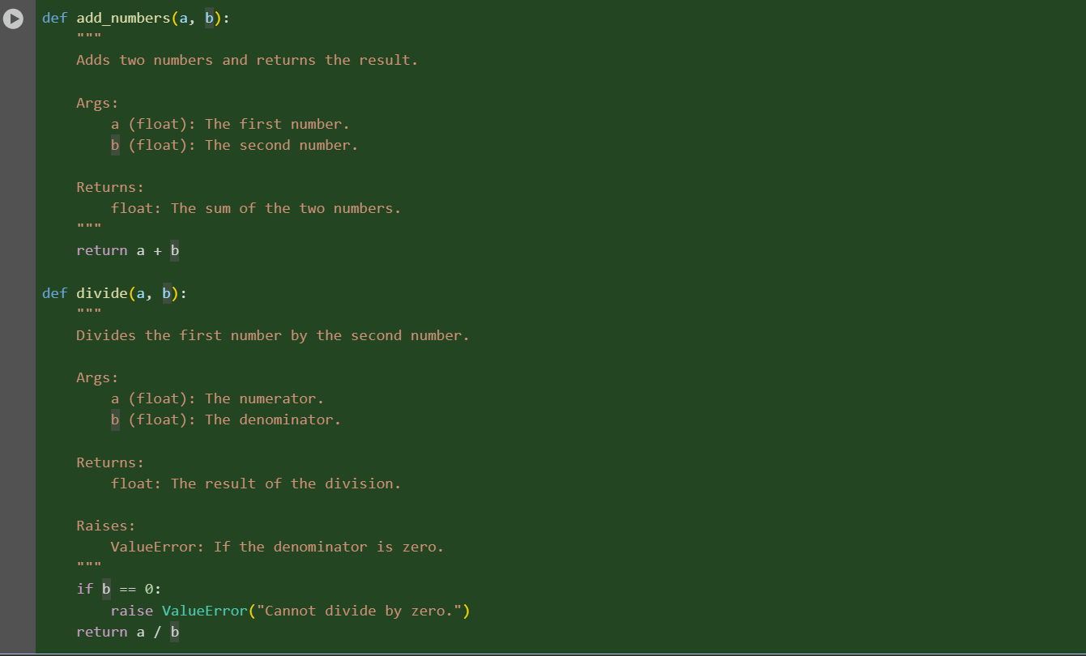

Obervation: AI identified outdated docstrings and corrected them to accurately reflect the current code using proper Google-style formatting.

Task Description #6 (Documentation – Prompt Comparison  
Experiment)

• Task: Compare documentation output from a vague prompt and a  
detailed prompt for the same Python function.  
• Instructions:  
o Create two prompts: one simple (“Add comments to this  
function”) and one detailed (“Add Google-style docstrings  
with parameters, return types, and examples”).  
o Use AI to process the same Python function with both  
prompts.  
o Analyze and record differences in quality, accuracy, and  
completeness.  
• Expected Output #6:  
o A comparison table showing the results from both  
prompts with observations

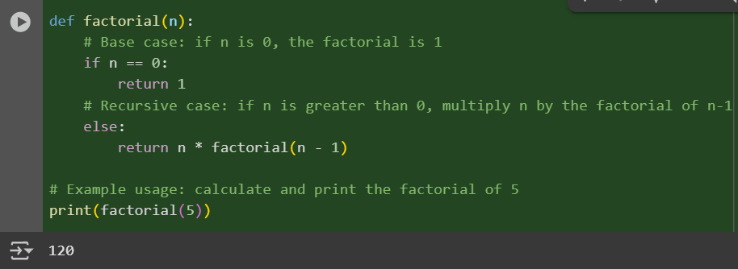

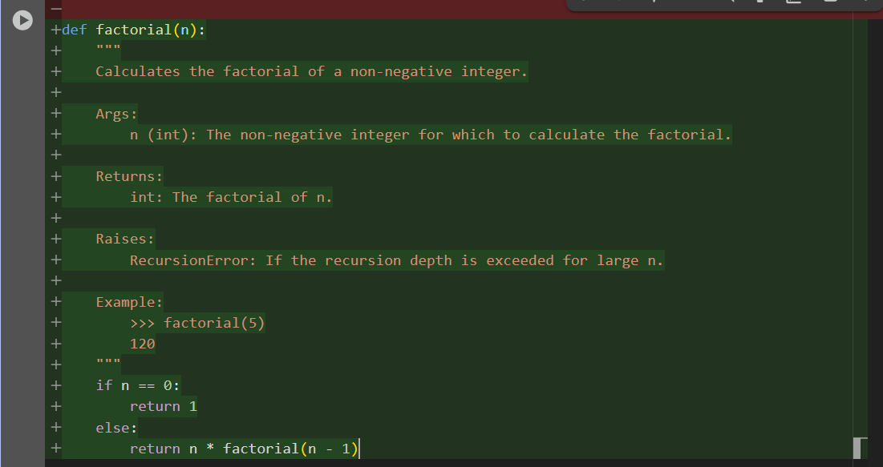

Observation: Comments only give Explain specific lines or logic in code and for Google-style Docstrings Describe the purpose, parameters, and output of a function or class