**Task Description#1**

* Use Google Gemini in Colab to write a function that reads a CSV file and calculates mean, min, max.

**Expected Output#1**

* Functional code with output and screenshot

Prompt: write a function that reads a CSV file and calculates mean, min, max

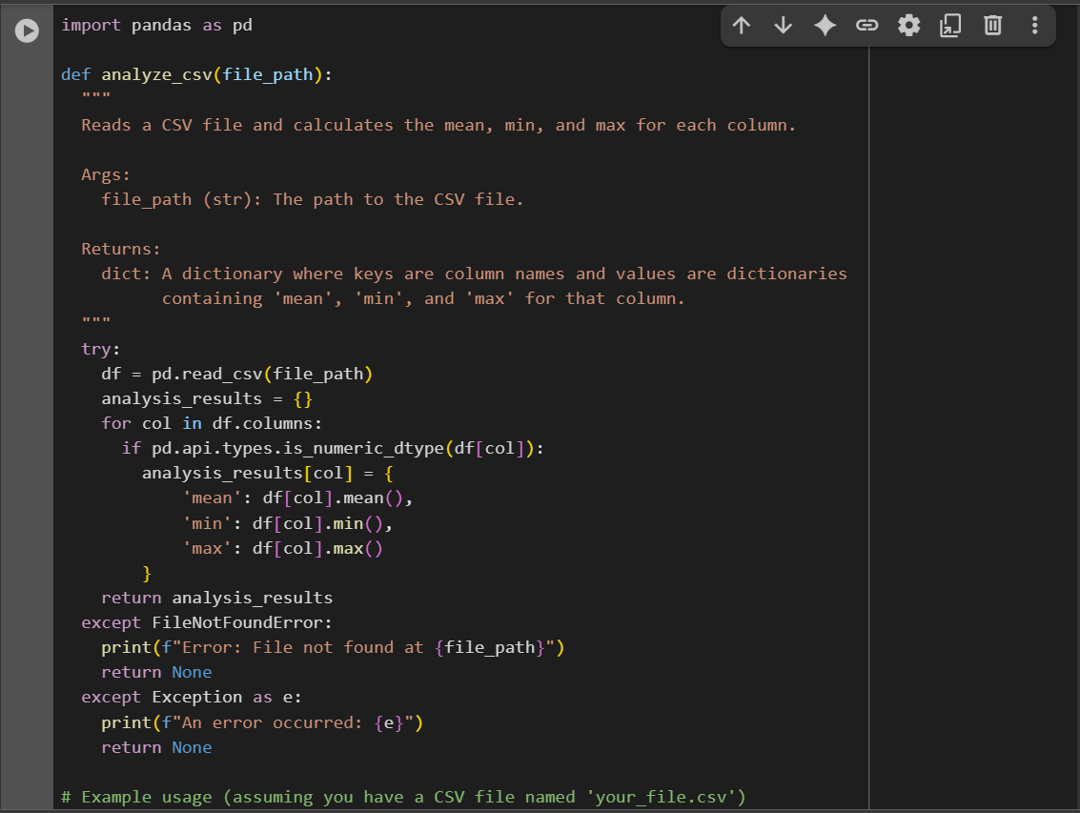

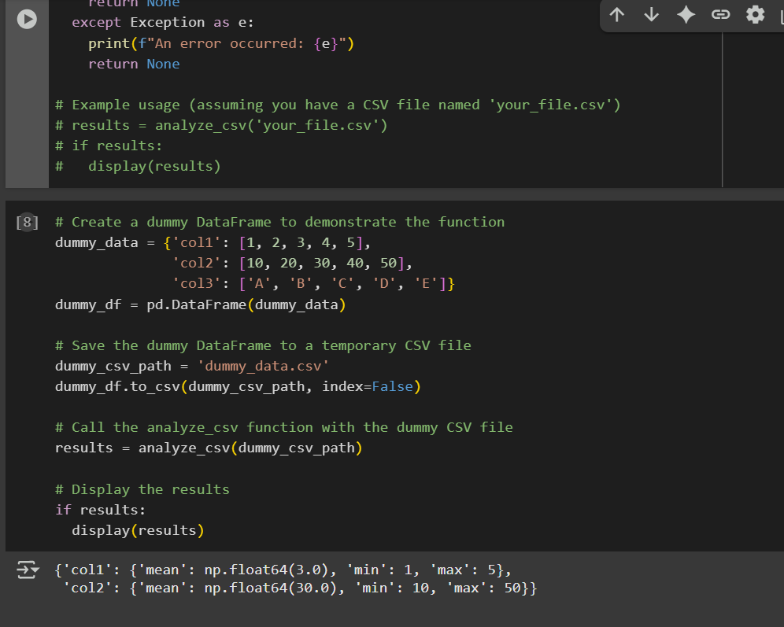

**Task Description#2**

* Compare Gemini and Copilot outputs for a palindrome check function.

**Expected Output#2**

* Side-by-side comparison and observations

Prompt:Write a check function for palindrome with output

|  |  |
| --- | --- |
| Gemini | Copilot(VS CODE) |
|  |  |
| Obsevation | Obseravtion |
| Cleans and normalizes input.Returns a value instead of forcing print statements.  Uses clear documentation. | Shorter code.Prints the result directly.Easier for beginners to understand the logic without extra steps. |

**Task Description#3**

* Ask Gemini to explain a Python function (to calculate area of various shapes) line by line..

**Expected Output#3**

* Detailed explanation with code snippet

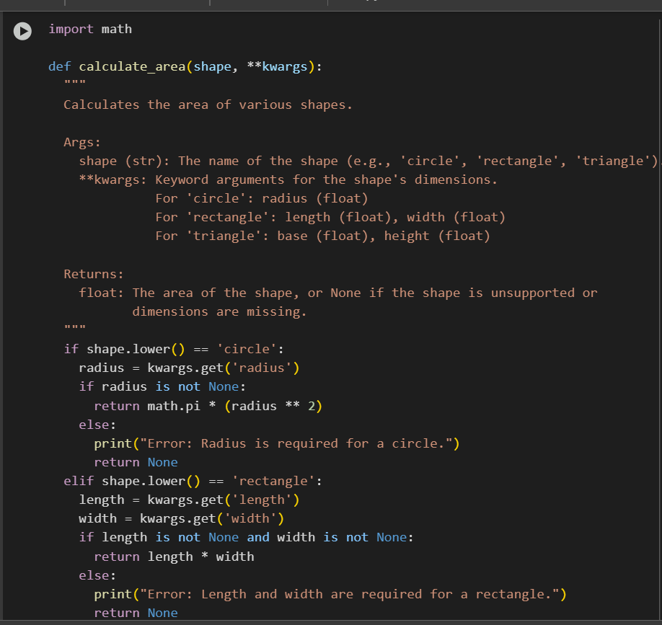

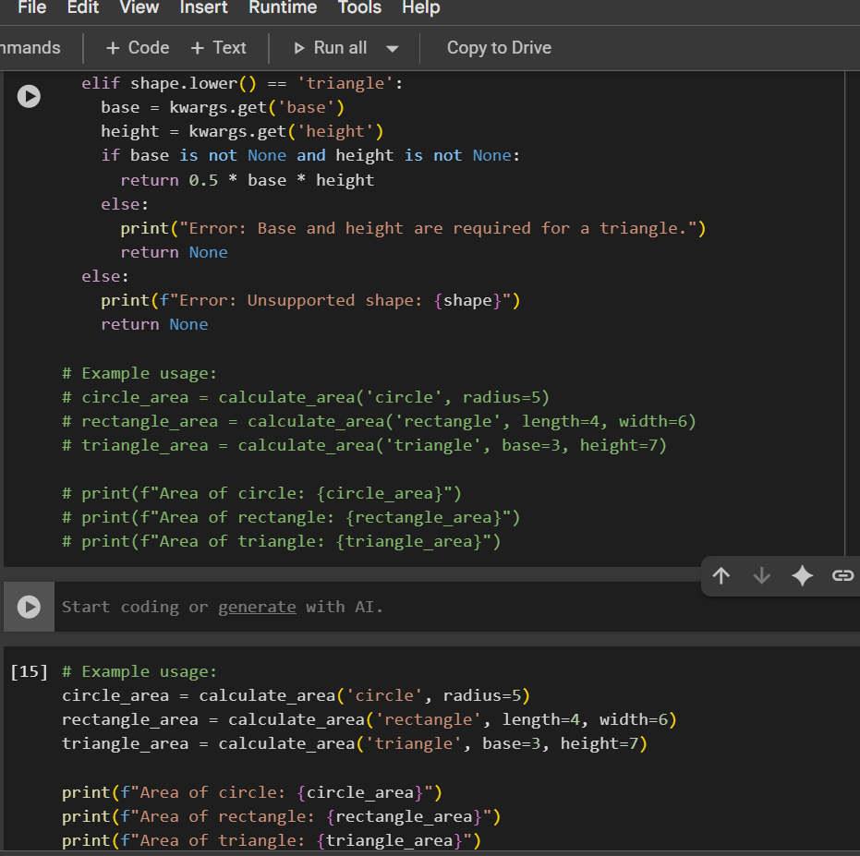

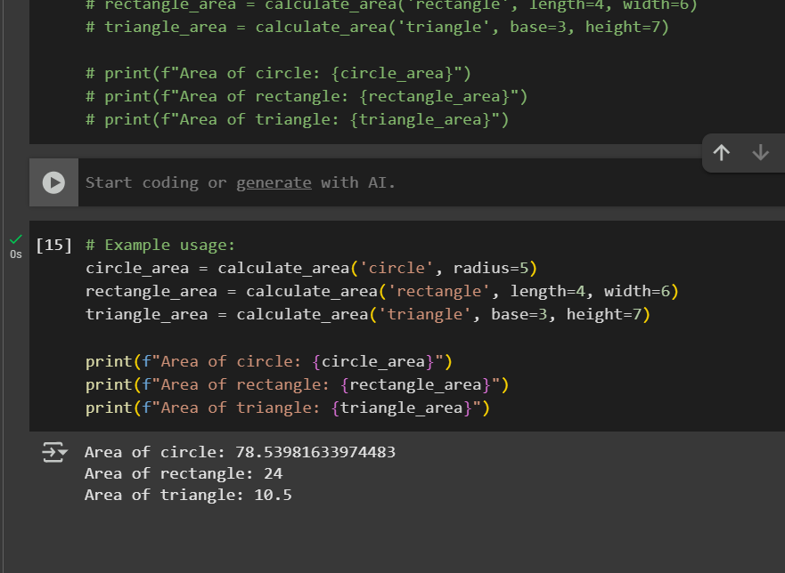

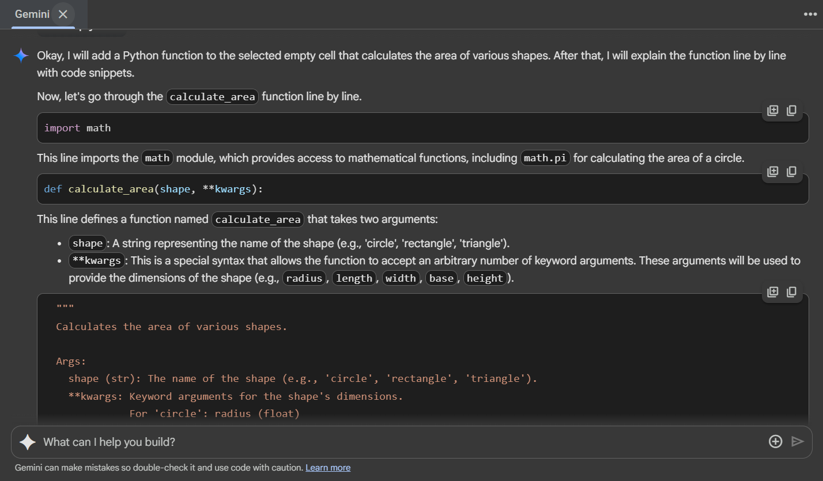

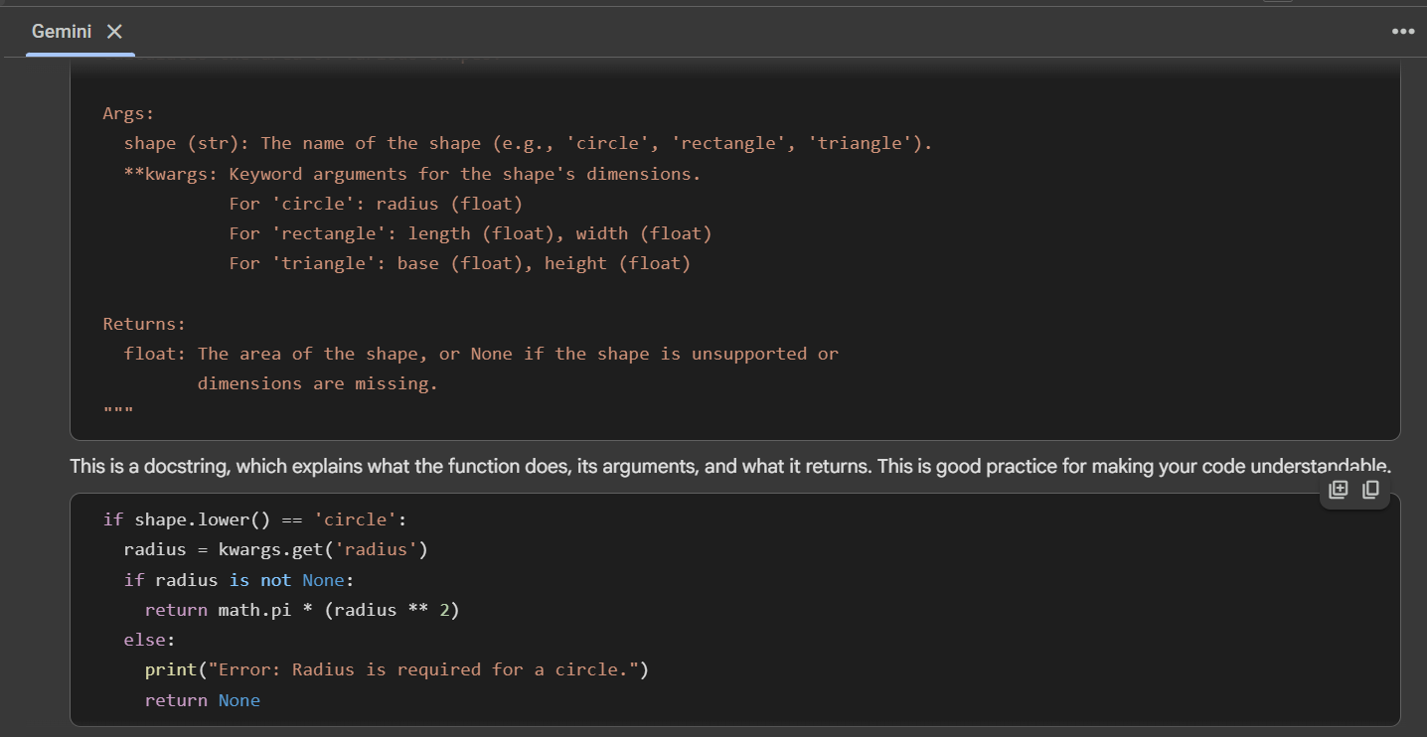

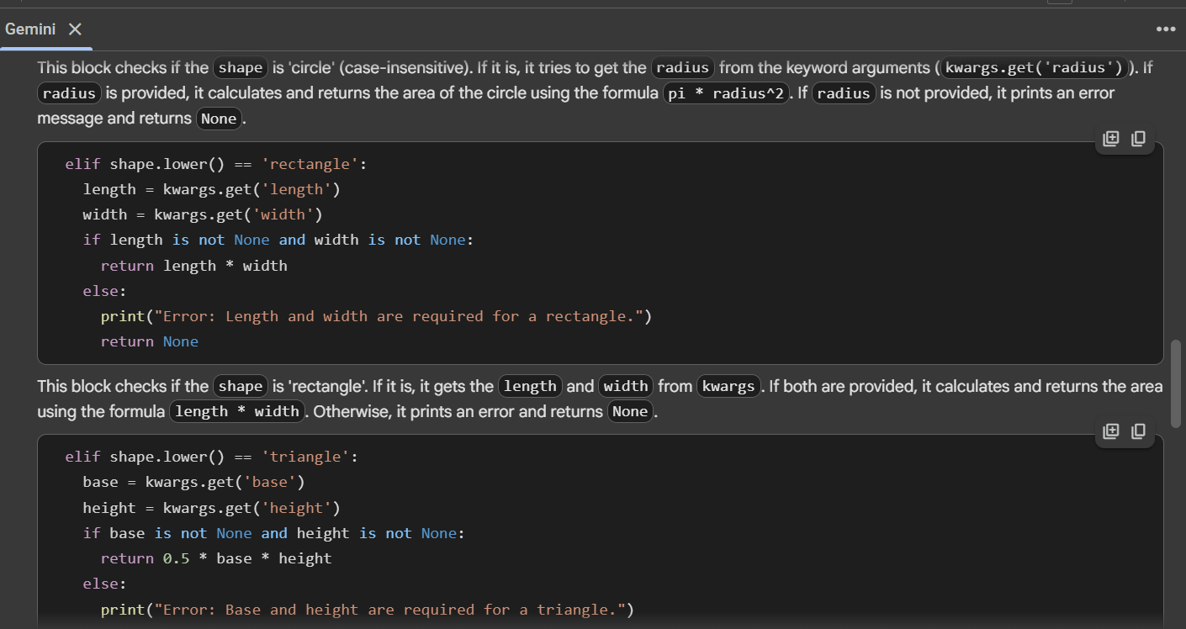

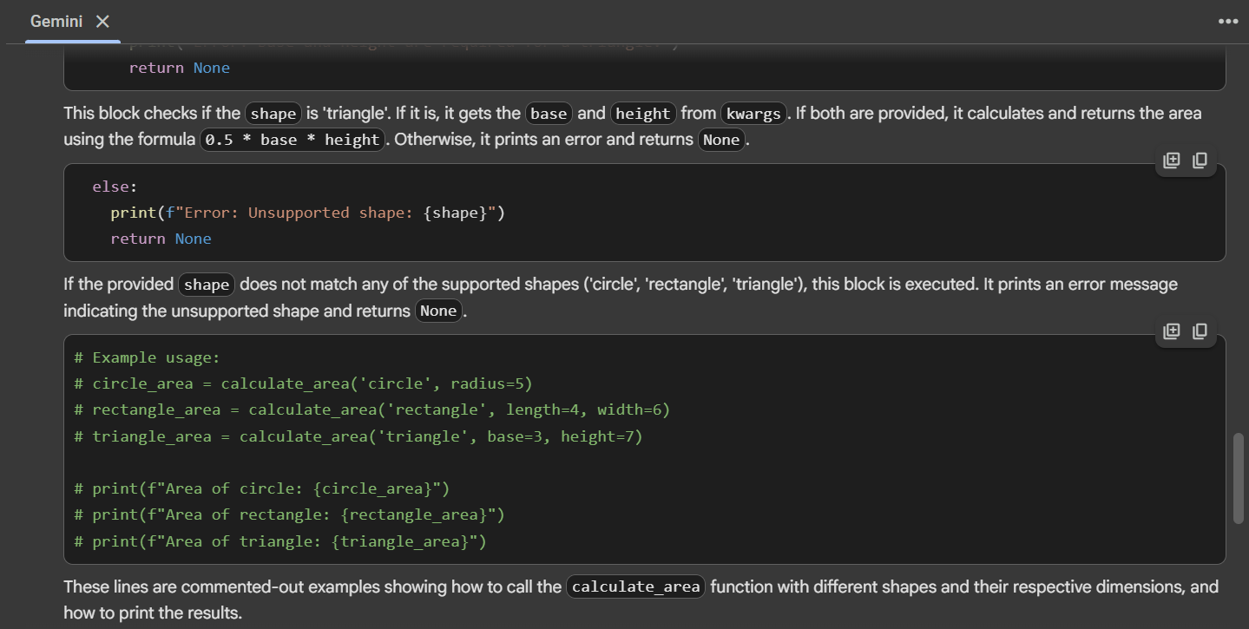

**Task Description#4**

* Install and configure Cursor AI. Use it to generate a Python function (e.g., sum of squares).

**Expected Output#4**

* Screenshots of working environments with few prompts to generate python code

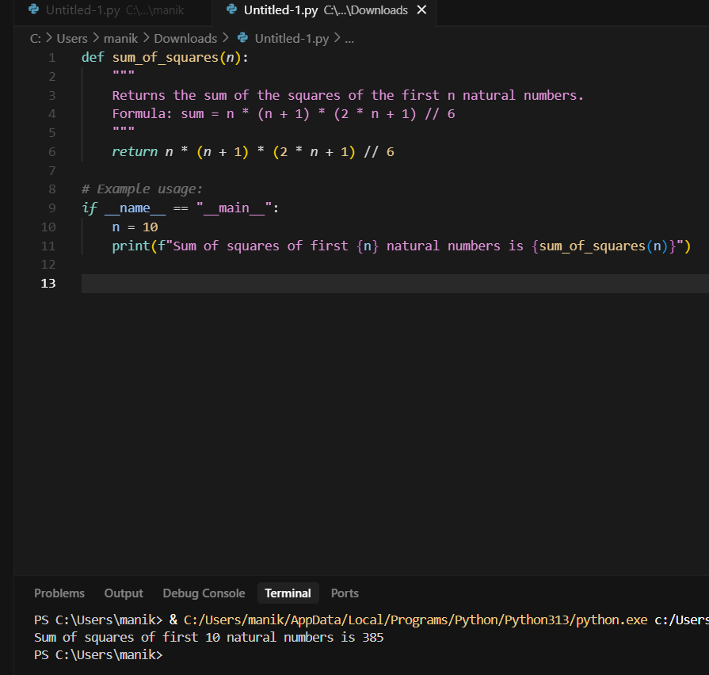

**Task Description#5**

* Student need to write code to calculate sum of add number and even numbers in the list

**Expected Output#5**

Refactored code written by student with improved logic

