**Task Description#1 AI-Assisted Code Review (Basic Errors)**

* Write python program as shown below.
* Use an AI assistant to review and suggest corrections.

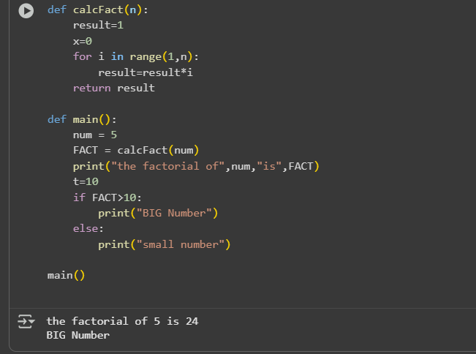

Prompt :Correct the Given code without errors,review and suggest corrections

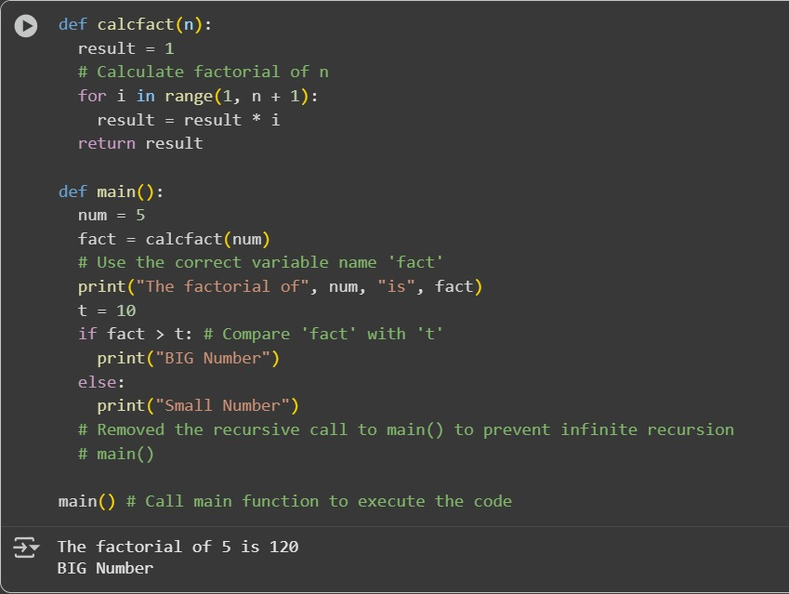

Observation :I have Obsereved that Given code has error.After asking Google Ai it gives corrected code

**Task Description#2 Automatic Inline Comments**

* Write the Python code for Fibonacci as shown below and execute.
* Ask AI to improve variable names, add comments, and apply PEP8 formatting (cleaned up).
* Students evaluate which suggestions improve readability most. one.

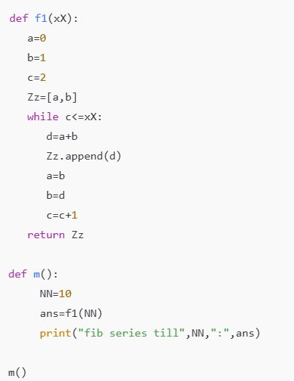

**Expected Output#2:** Prompt: improve variable names, add comments, and apply PEP8 formatting.improve readability

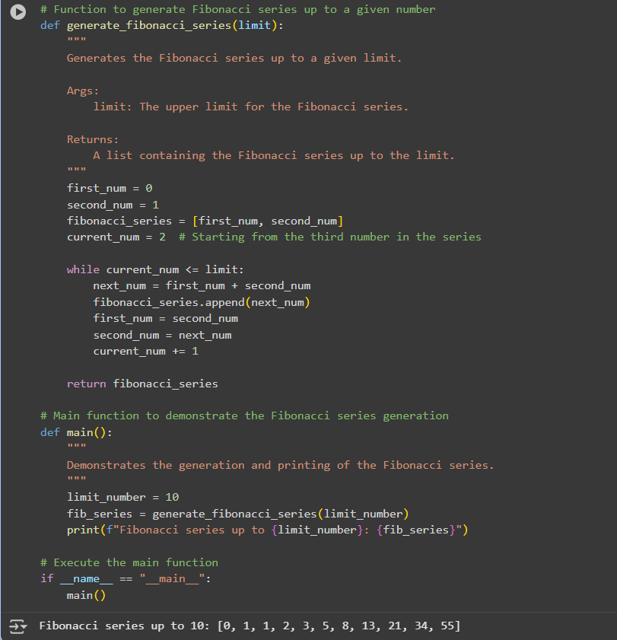

**Observation : I have Observed that ai improves the code by improving variable names,and comments and easy to Understand**

**Task Description#3**

* **Write a Python script with 3–4 functions (e.g., calculator: add, subtract, multiply, divide).**
* **Incorporate manual docstring in code with NumPy Style**
* **Use AI assistance to generate a module-level docstring + individual function docstrings.**
* **Compare the AI-generated docstring with your manually written one.**

**Manual Docstrings:** 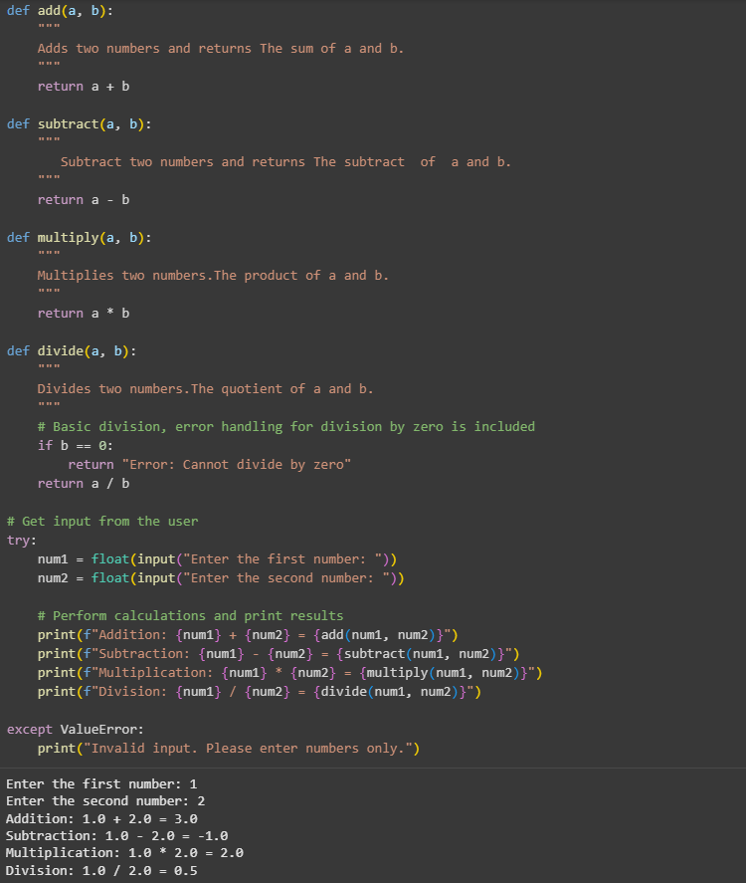

AI Genrated DocStrings:

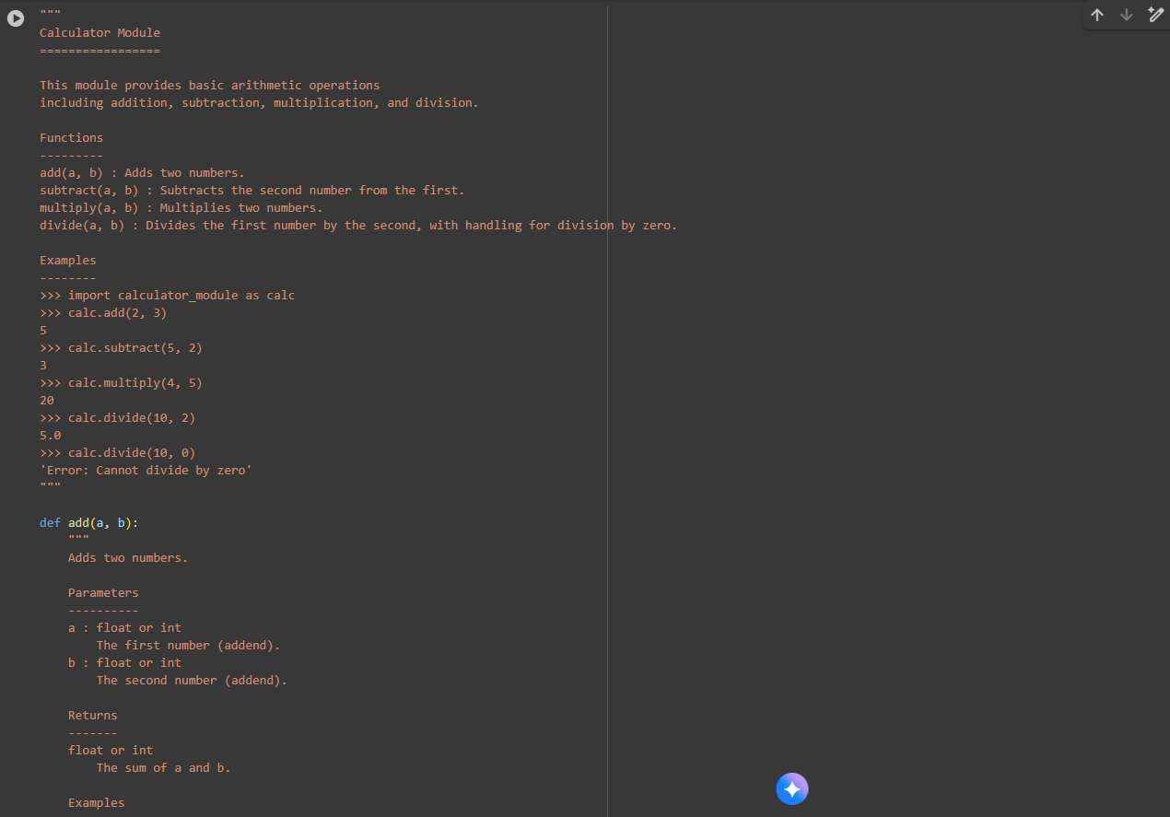

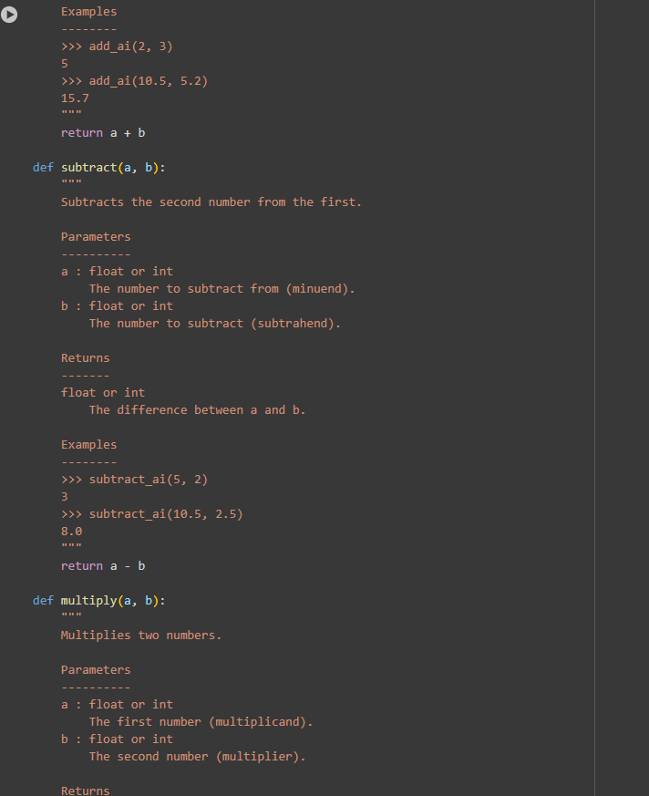

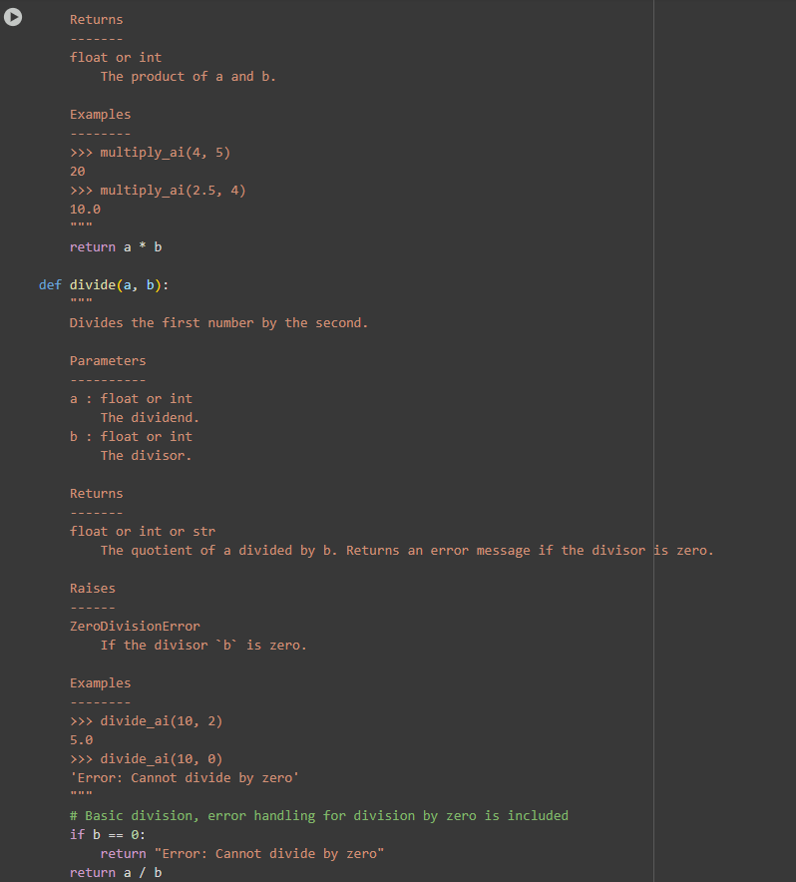

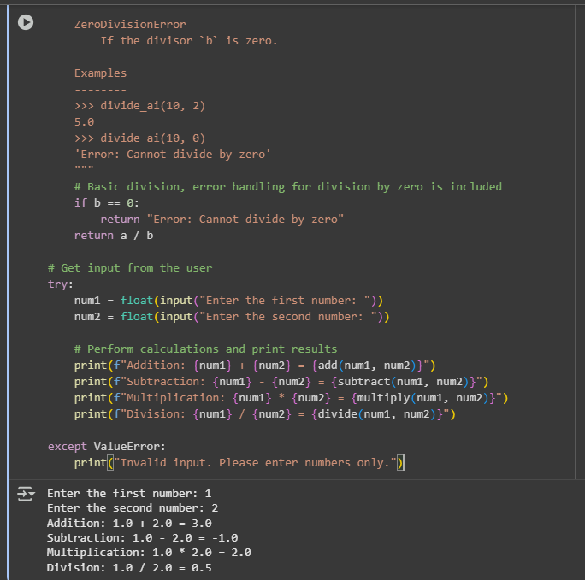

Observation : I have Observed that Manual Docstrings are Short and Easy to understand.Where as Ai Generated Docstrings is Long and Explains clear about function and return value