Task Description #1:  
• Start a Python class named Student with attributes name, roll_number, and marks. Prompt  
GitHub Copilot to complete methods for displaying details and checking if marks are above  
average.  
Expected Outcome #1:  
• Completed class with Copilot-generated methods like display_details() and is_passed(),  
demonstrating use of if-else conditions

Prompt:

Write Python class named Student with attributes name, roll_number, and marks.add methods:display_details is_passed().by use of if-else conditions.should check if marks are above average (assume average = 40).

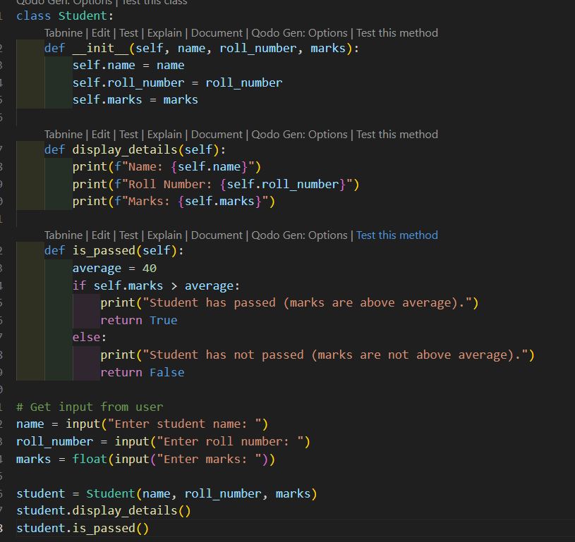

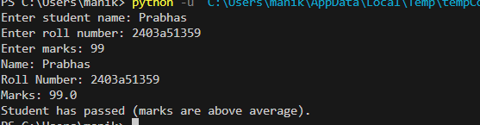

Observation: I have Observed that It asks for input and gives output whether. Person has average marks or no

Task Description #2:  
• Write the first two lines of a for loop to iterate through a list of numbers. Use a comment  
prompt to let Copilot suggest how to calculate and print the square of even numbers only.  
Expected Outcome #2:  
• A complete loop generated by Copilot with conditional logic (if number % 2 == 0) and  
appropriate output

Prompt: Write a program to calculate and print the square of even numbers only. with conditional logic (if number % 2 == 0) and appropriate output

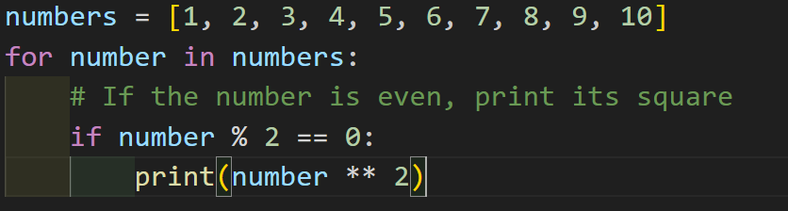

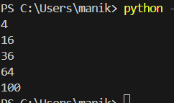

Observation : I Observed that It prints the square of even number from the list

Task Description #3:  
• Create a class called BankAccount with attributes account_holder and balance. Use Copilot to  
complete methods for deposit(), withdraw(), and check for insufficient balance.  
Expected Outcome #3:  
• Functional class with complete method definitions using if conditions and self attributes. Code  
should prevent overdrawing

Prompt: Create a Python class BankAccount with attributes account_holder and balance, and methods deposit(), withdraw() (with insufficient balance check), and get_balance() with output

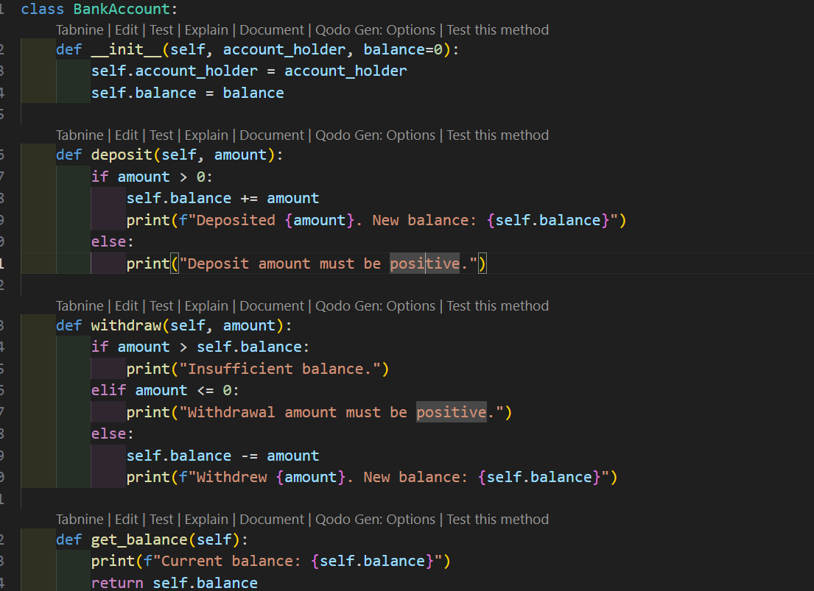

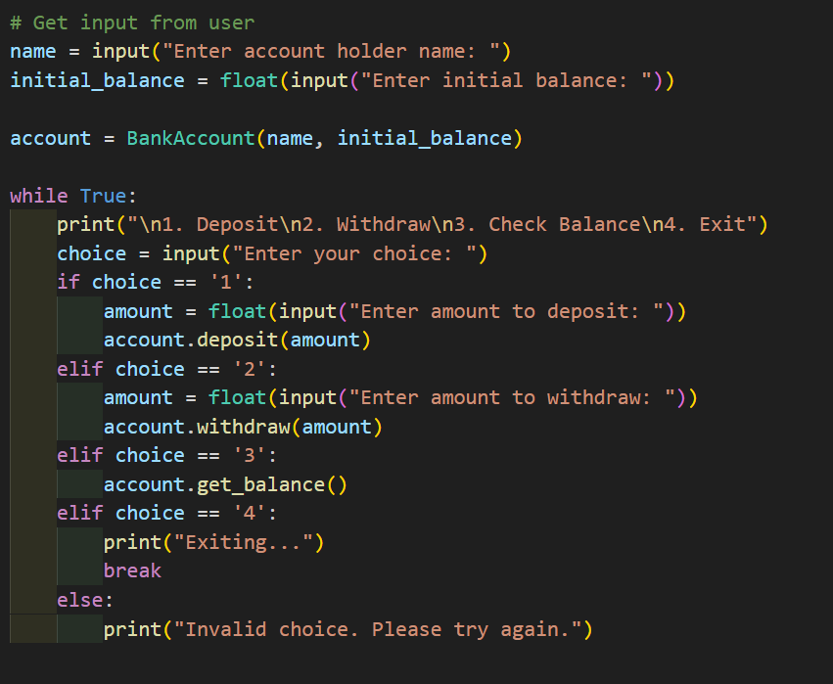

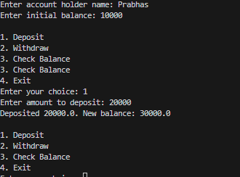

Observation: I observed that it asks for initial balance and then deposit withdraw money by using choices and gives the output

Task Description #4:  
• Define a list of student dictionaries with keys name and score. Ask Copilot to write a while  
loop to print the names of students who scored more than 75.  
Expected Outcome #4:  
• A complete while loop generated by Copilot with proper condition checks and formatted  
output.  
prompt: Write a list of student dictionaries with keys name and score, then write a while loop to print names of students who scored more than 75

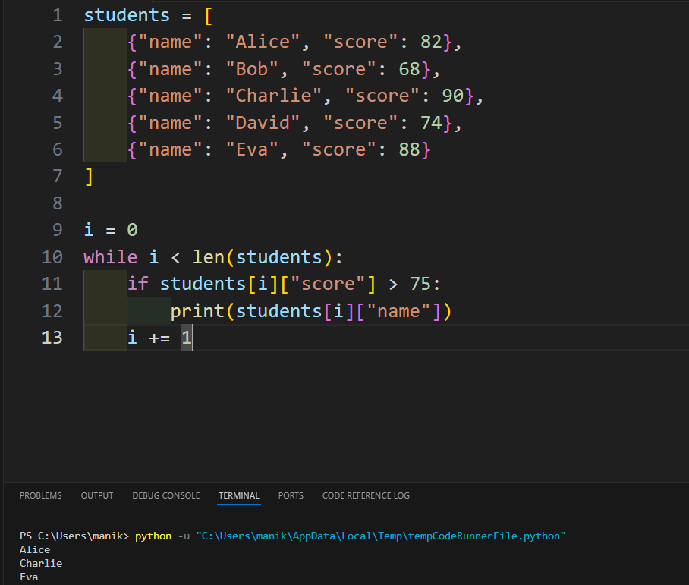

Observation: I have observed that I uses while to check the score and prints the name

Task Description #5:  
• Begin writing a class ShoppingCart with an empty items list. Prompt Copilot to generate  
methods to add_item, remove_item, and use a loop to calculate the total bill using conditional  
discounts.  
Expected Outcome #5:  
• A fully implemented ShoppingCart class with Copilot-generated loops and if-else statements  
handling item management and discount logic

Prompt: Write a Python class ShoppingCart with an empty items list, and generate methods using Copilot to add_item, remove_item, and calculate the total bill with conditional discounts using loops and if-else statements handling item management and discount logic with output

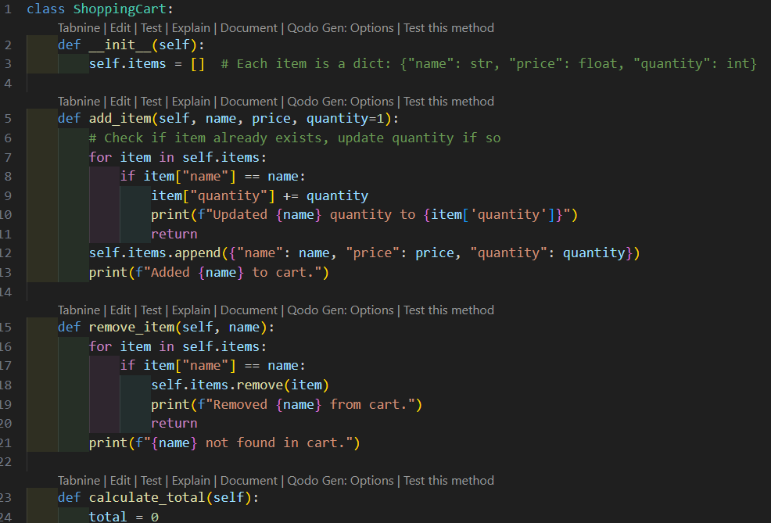

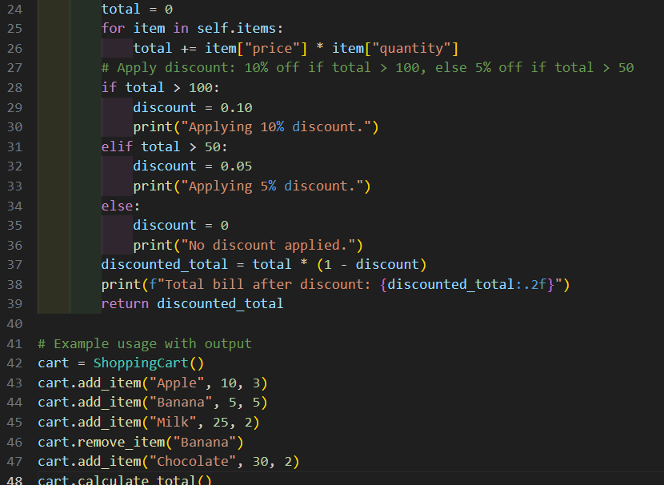

Output:

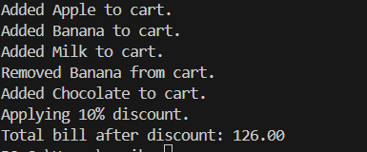

Observation: I have oberserved that the ShoppingCart class manages items and applies conditional discounts using loops and if-else statements providing easy output