ASSIGNMENT-9.3
Course: AI Assisted coding
Name: Ch.Shreevidya
HT NO: 2403A51419
Batch- 16
Task 1:
Prompt:
write a program in python that finds the addition of odd and even numbers from the list 1 to 10 without doc strings and inline comments.
Code:
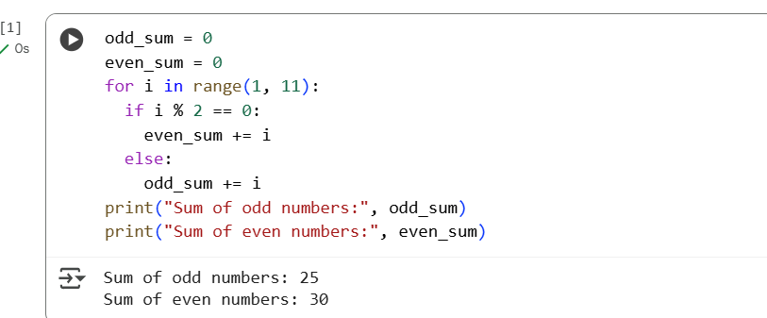
Adding doc strings:
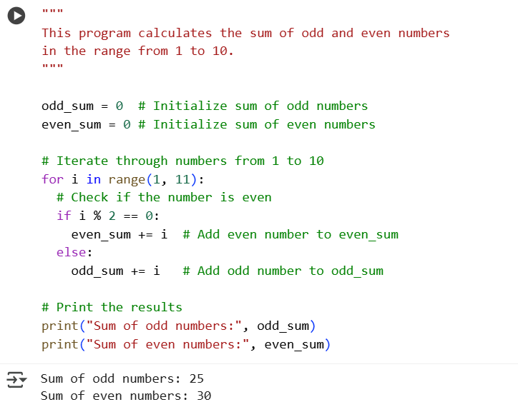
Task 2:
Prompt:
write a program in python to create a class name sru_student with attributes like name,roll_no,hostel_fee without doc string and inline comments
please add fee_updates method and display_details method. please add sample names and attributes details and display it.

Code:
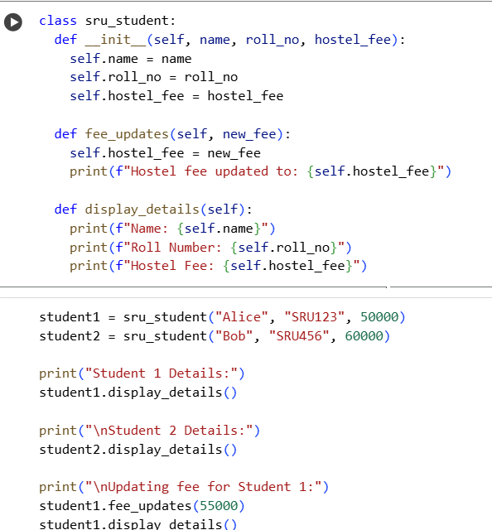

Adding doc strings:
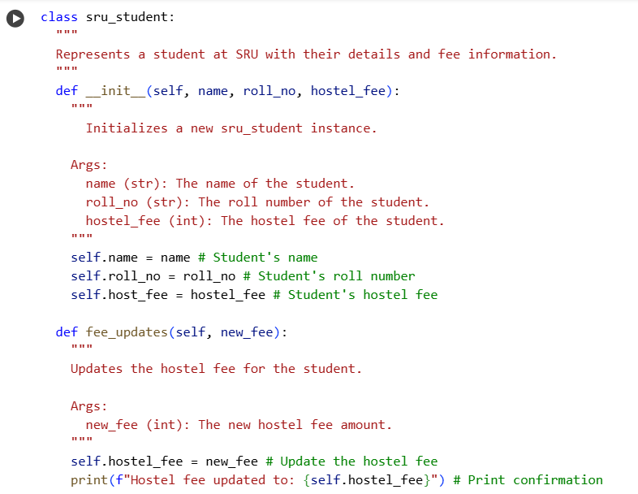
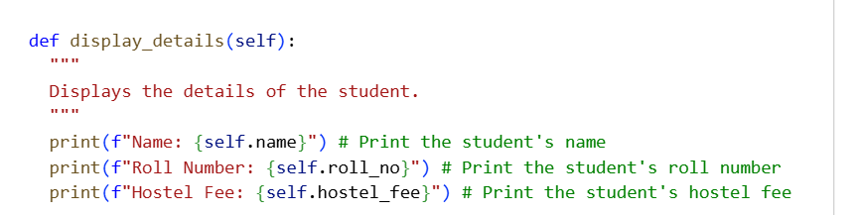
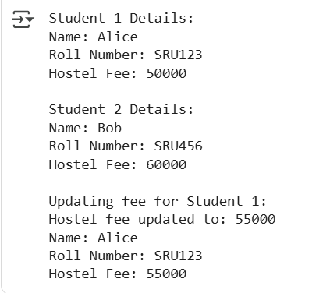
Task 3:
Prompt:
write a program in python with 3-4 functions like add,subtract,multiply ,divide based on user input without doc strings and inline comments.
Code:
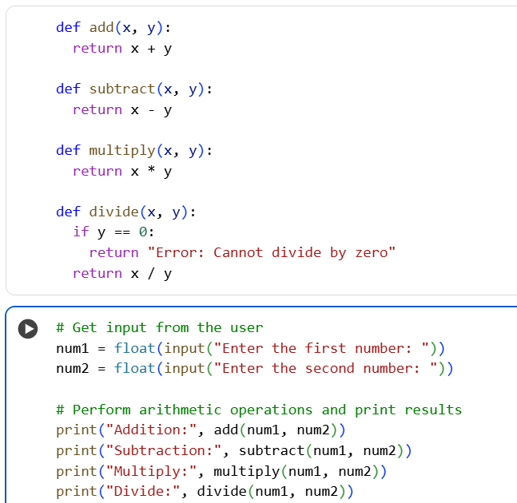
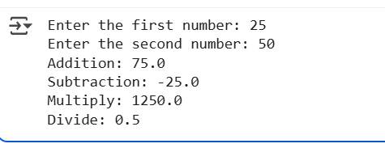

Adding doc strings:
