# Lab – 5.4

TASK-1

Prompt: Write a Python script that collects user data (name, age, email). Add comments explaining how to anonymize or protect this data (e.g., hashing emails, not storing raw values).

Code:

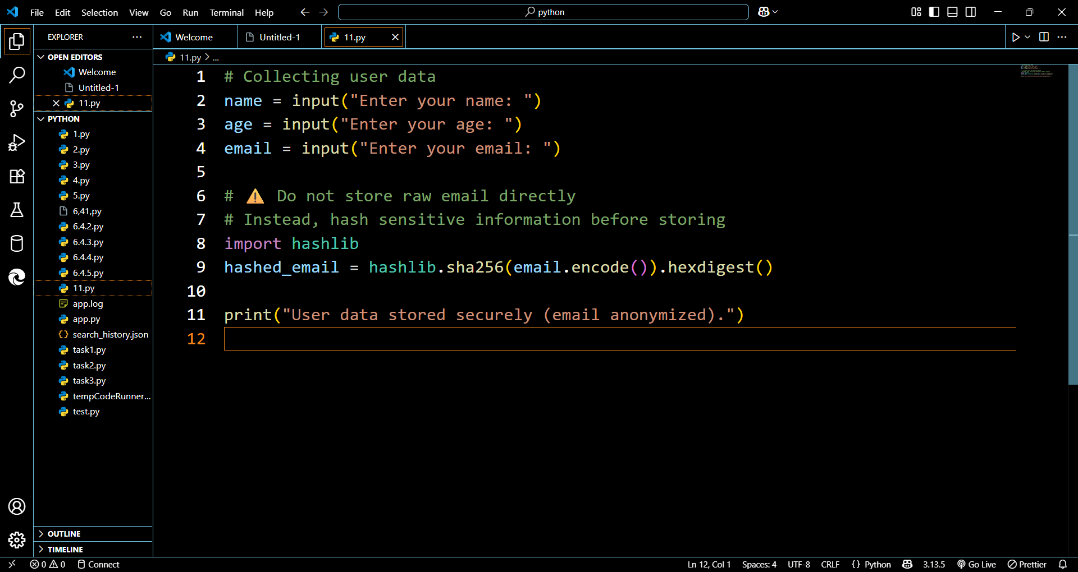

Output:

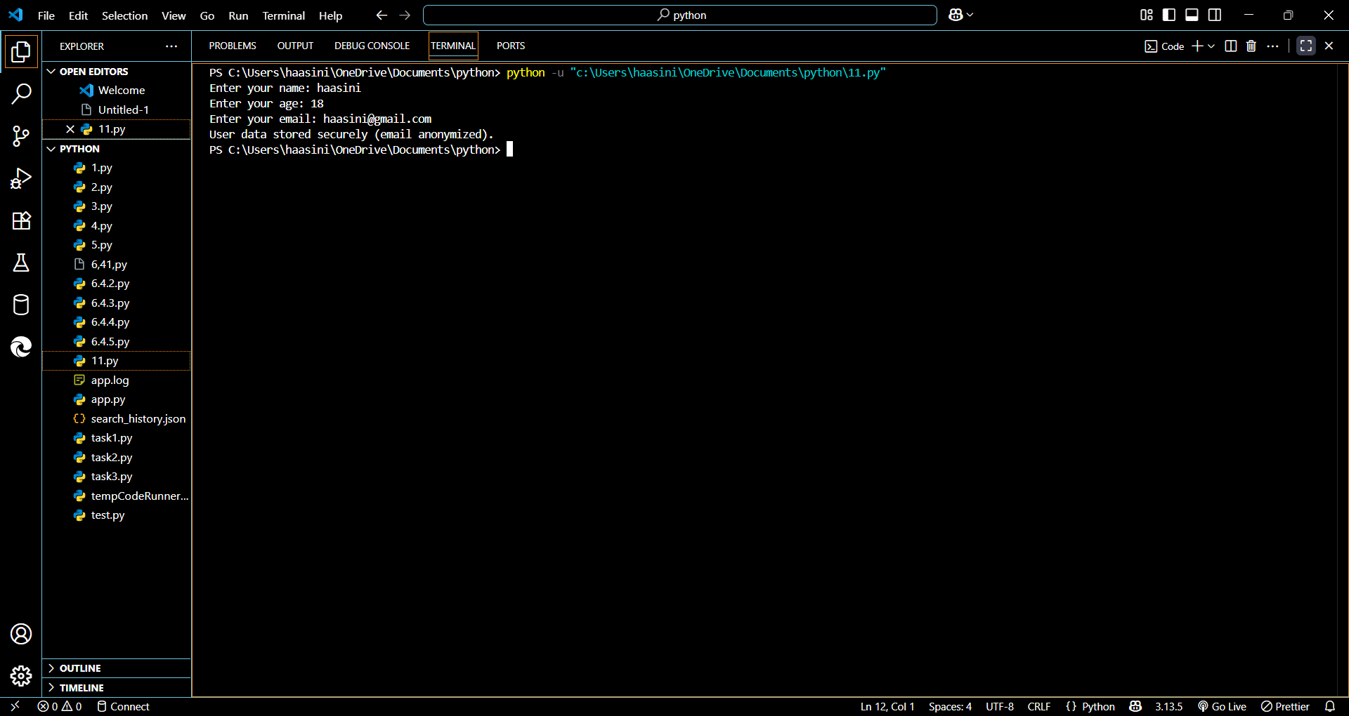

TASK:2

Prompt: Write a Python function for sentiment analysis. Add comments explaining possible biases and strategies like balancing datasets or removing offensive words.

Code: 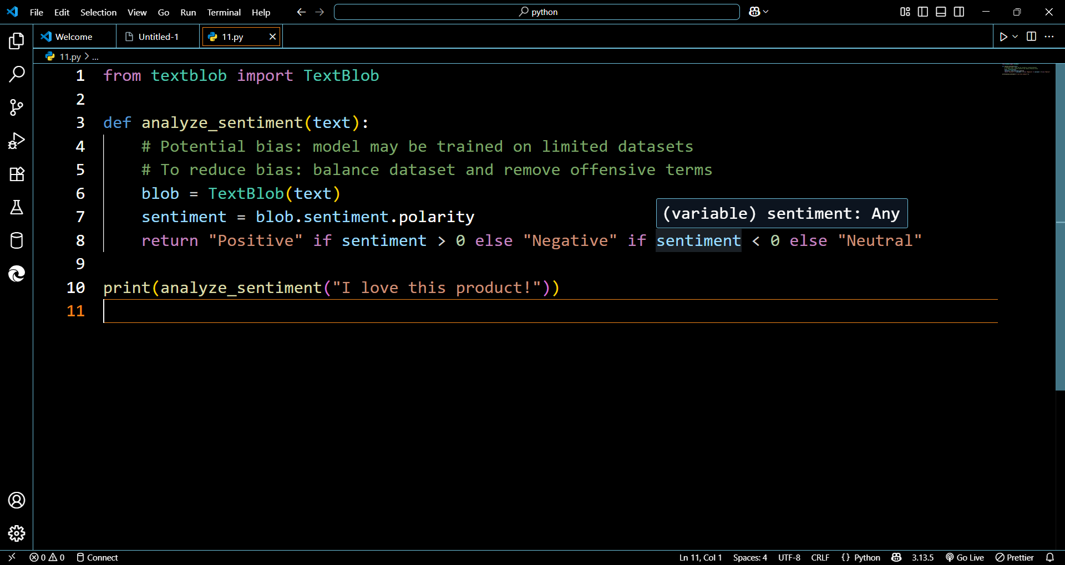

Output: 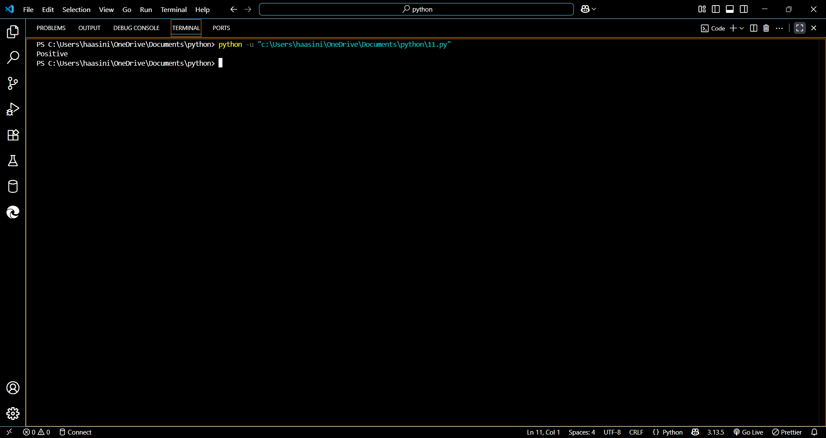

TASK:3

Prompt: Write a Python program that recommends products based on user history. Add fairness checks and user feedback options.

Code: 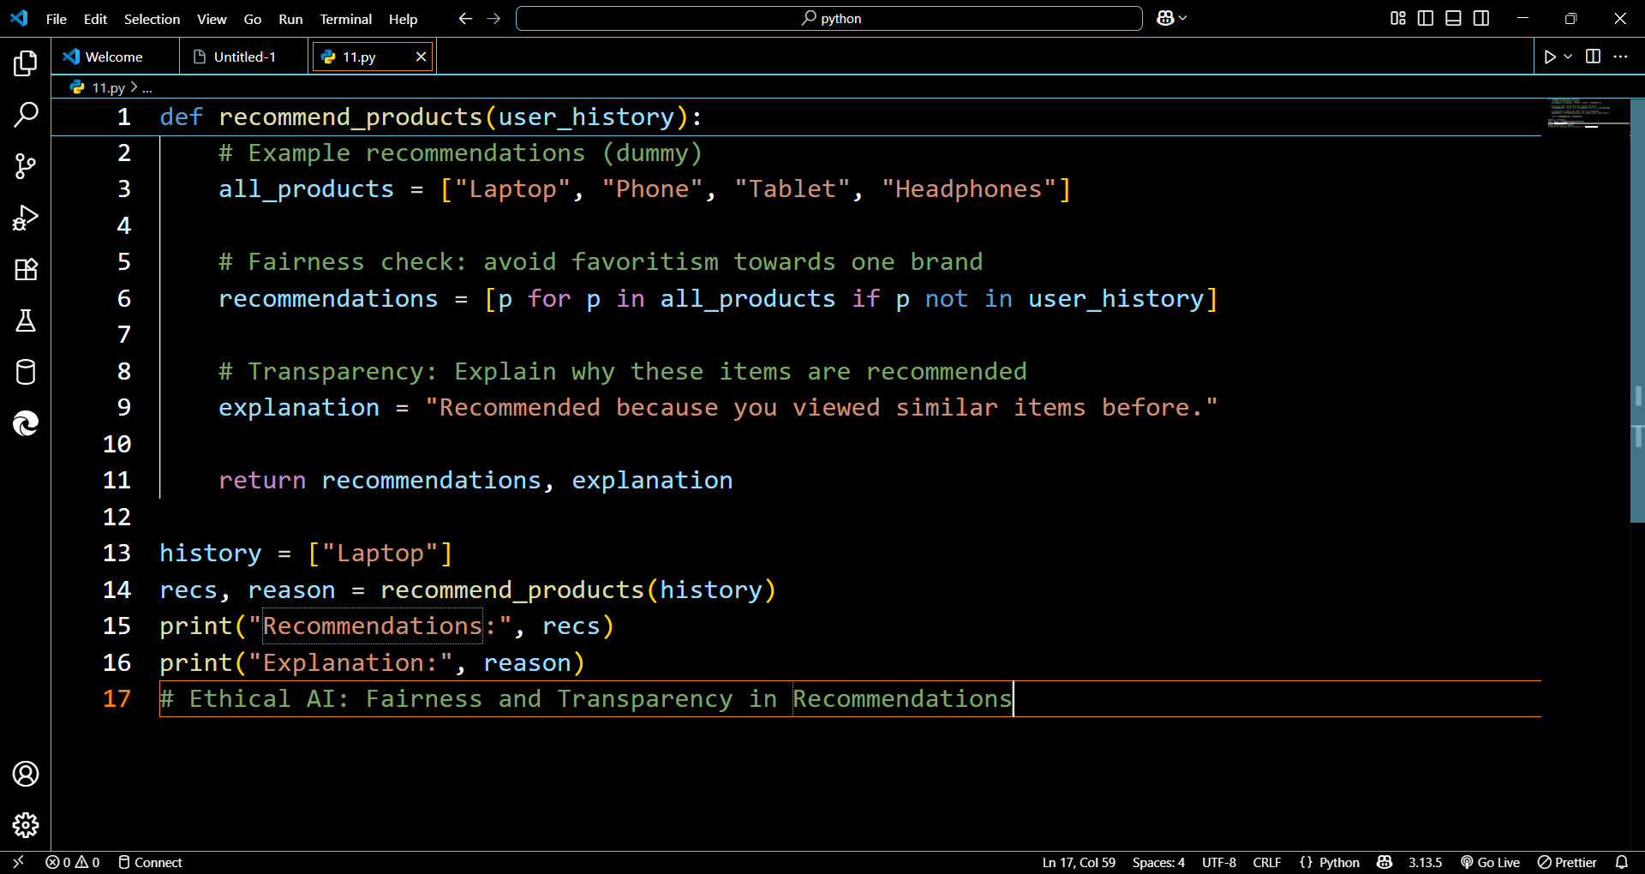

Output: 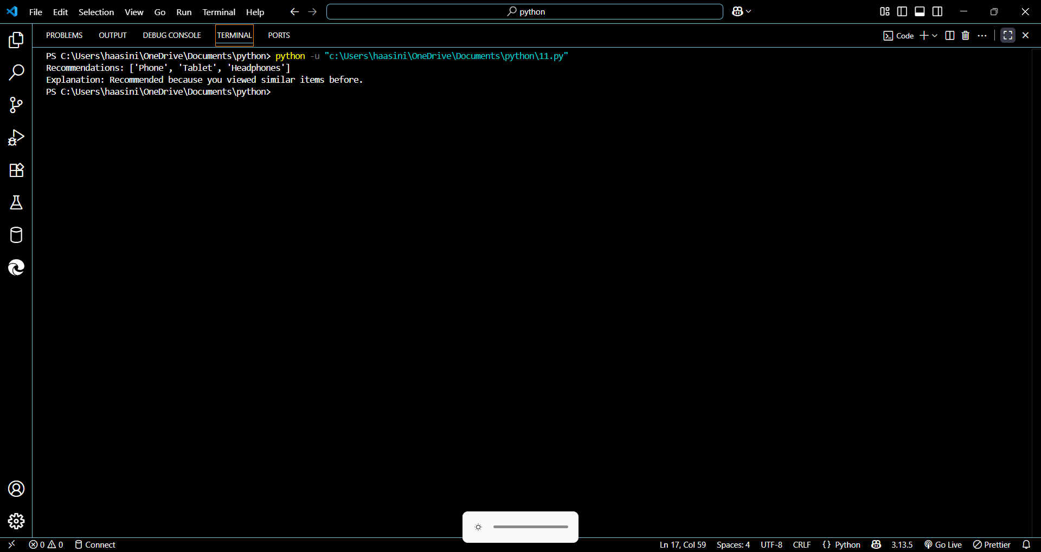

TASK:4

Prompt: Write Python logging code for a web app that avoids storing sensitive information like passwords or emails. Add comments about safe logging practices.

Code: 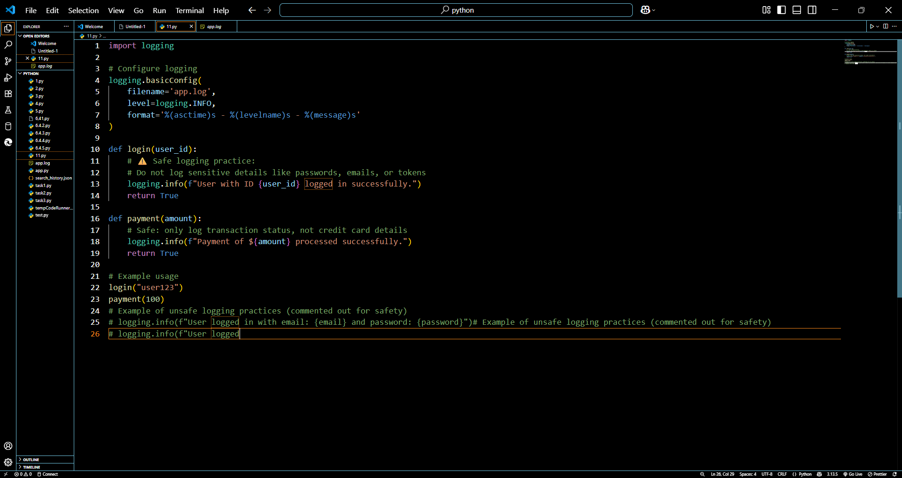

Output: 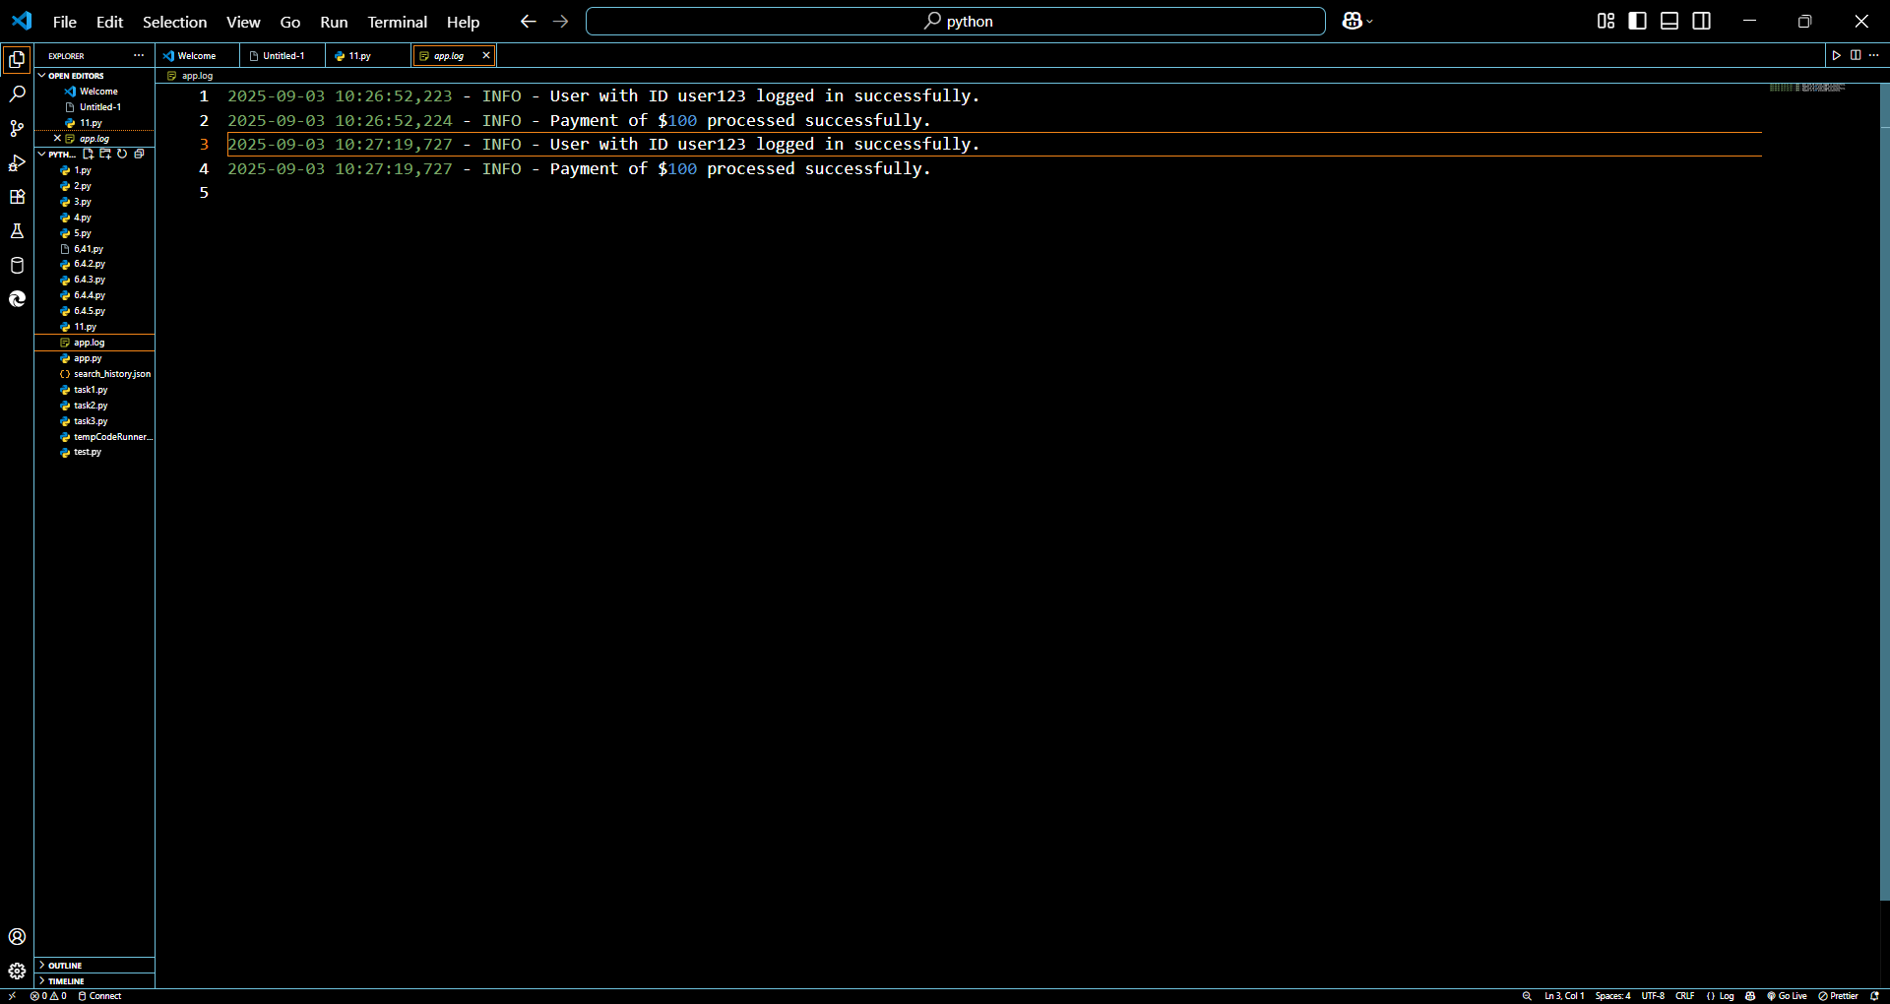

TASK:5

Prompt: Write Python code to train a simple ML model on sample data. Add a README-style comment about responsible usage, fairness, and limitations.

Code: 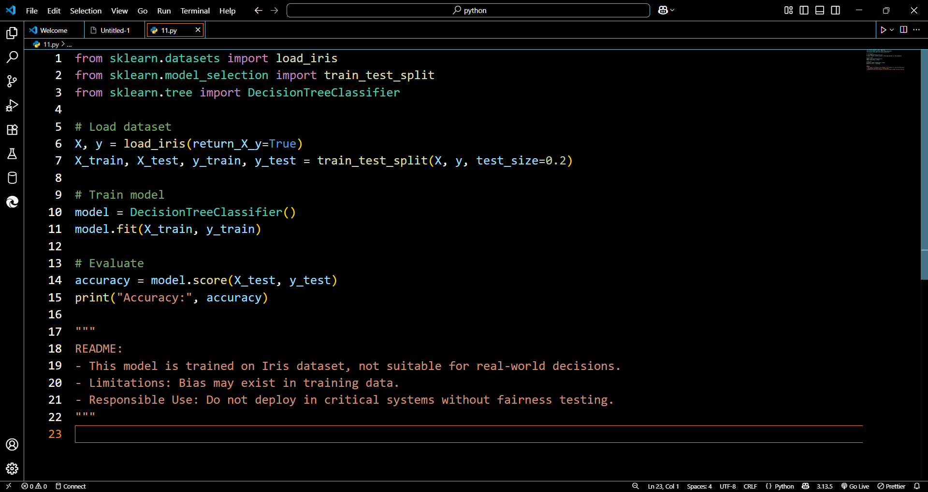

Output: 