TASK 1:

Prompt: Write a python program with attributes name, roll_number and marks using methods display_details() and is_passed() for demonstrating the marks and check whether the marks are greater than average.

Code: 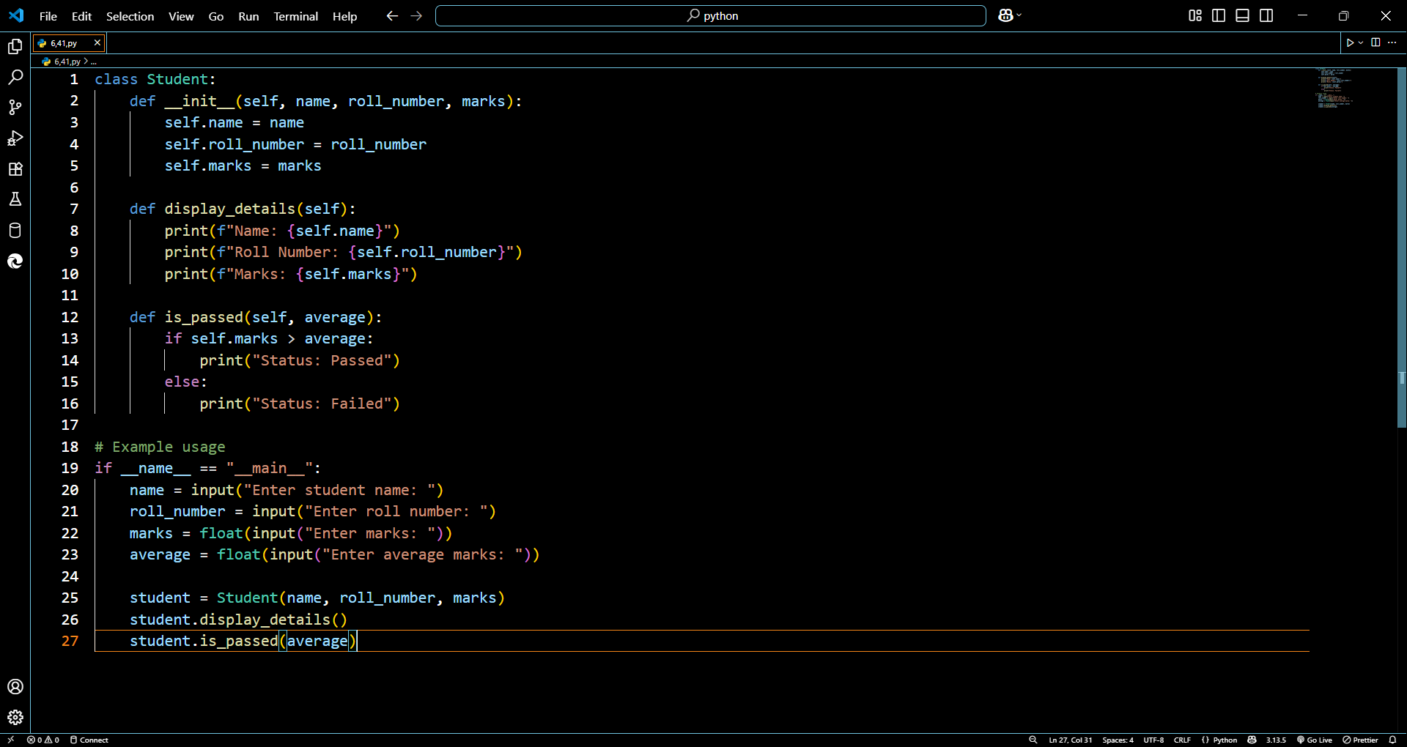

Output:

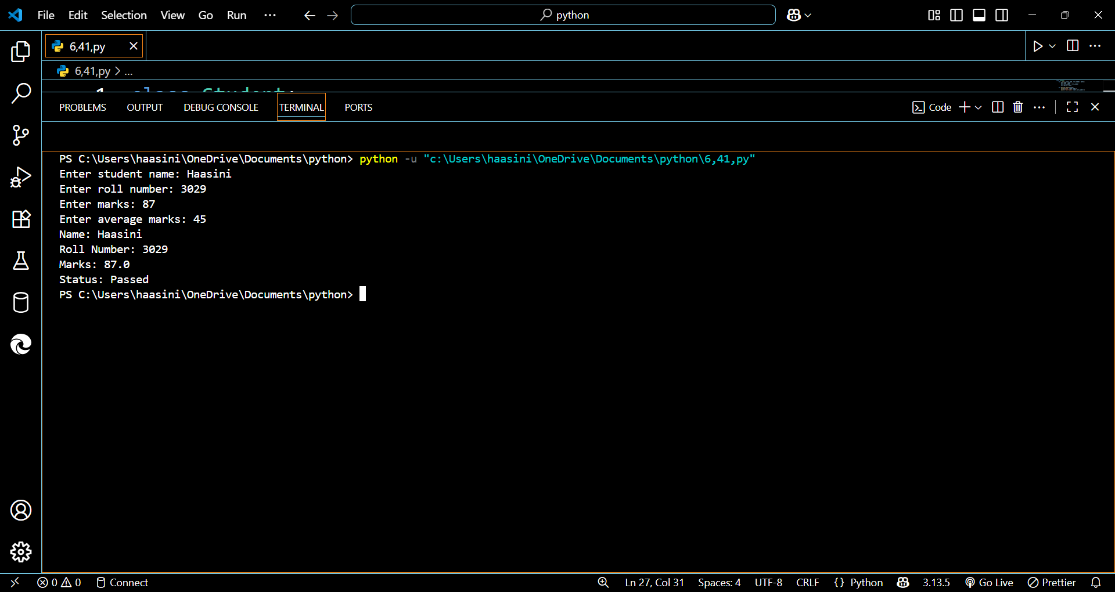

* .

TASK 2:

Prompt: n=[4,5,6,7,10,14,3,2,44] for(i=0;i<n;i++) calculate and print only squares of even numbers only using conditional logic if (n%2==0)

Code:

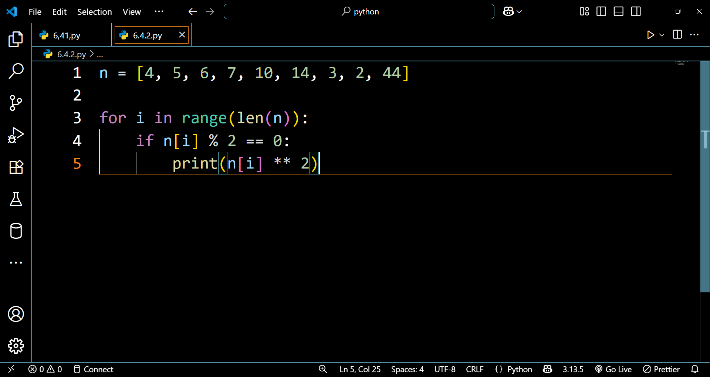

Output:

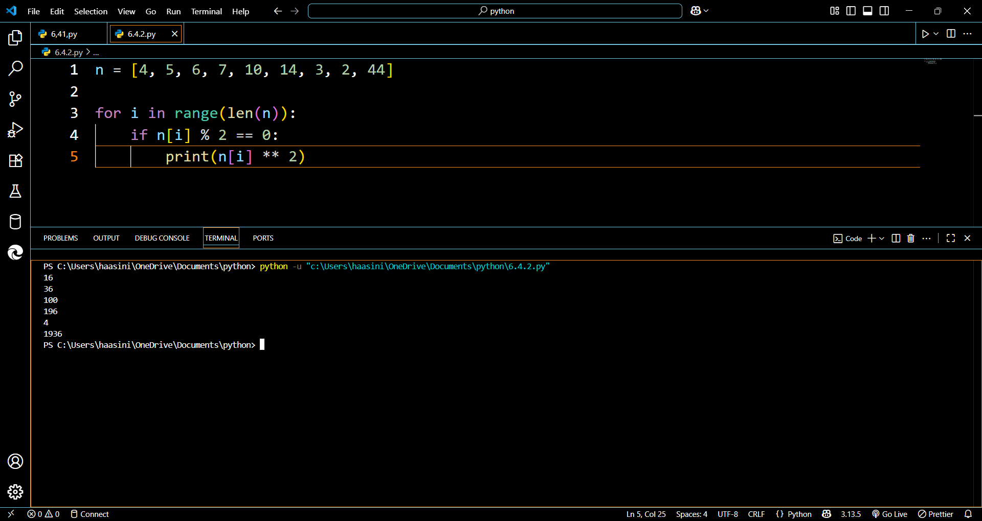

TASK 3:

Prompt:

write a python program with class called bank account having attributes account_holder and balance with methods for deposit(), withdraw(), and check for insufficient balance prevent from overdrawing.

Code:

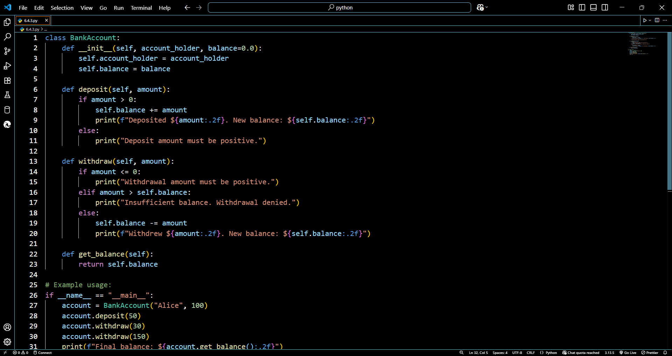

Output:

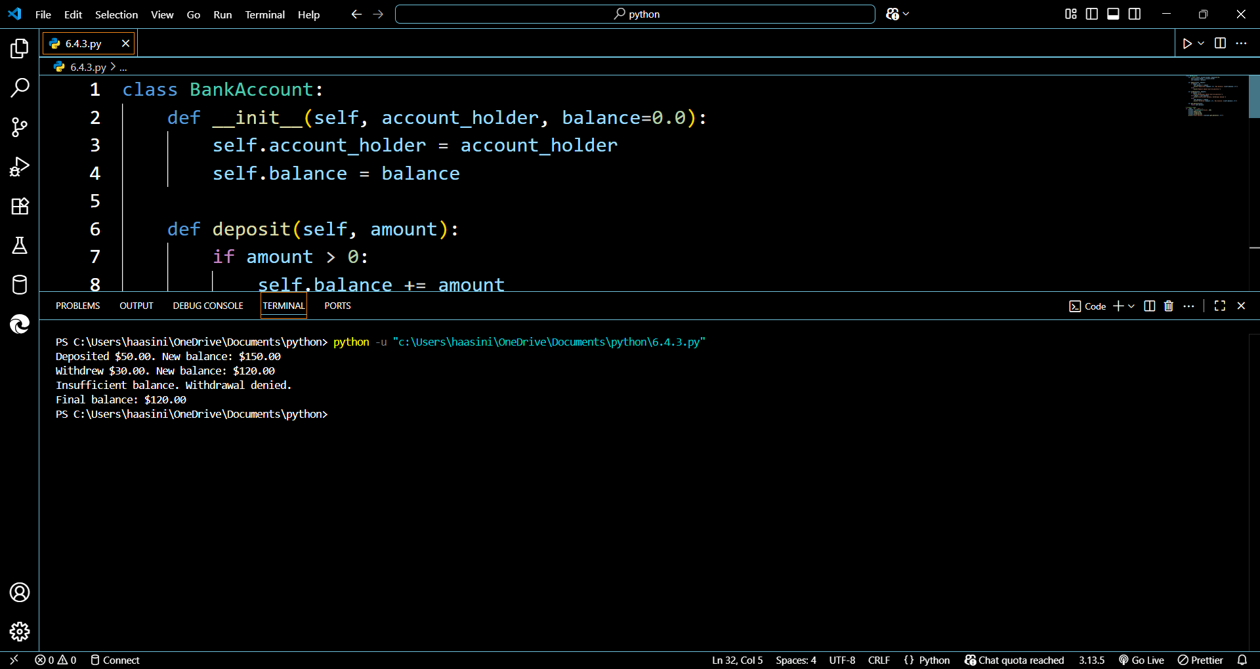

TASK 4:

Prompt:

students = [

{"name": "Haasini", "score": 92},

{"name": "Rahul", "score": 85},

{"name": "Priya", "score": 78},

{"name": "Arjun", "score": 88},

{"name": "Meena", "score": 65},

{"name": "Vikram", "score": 55},

{"name": "Sita", "score": 72},

{"name": "Ravi", "score": 60}

]

Print the students who scored more than 75 using while loop

Code: 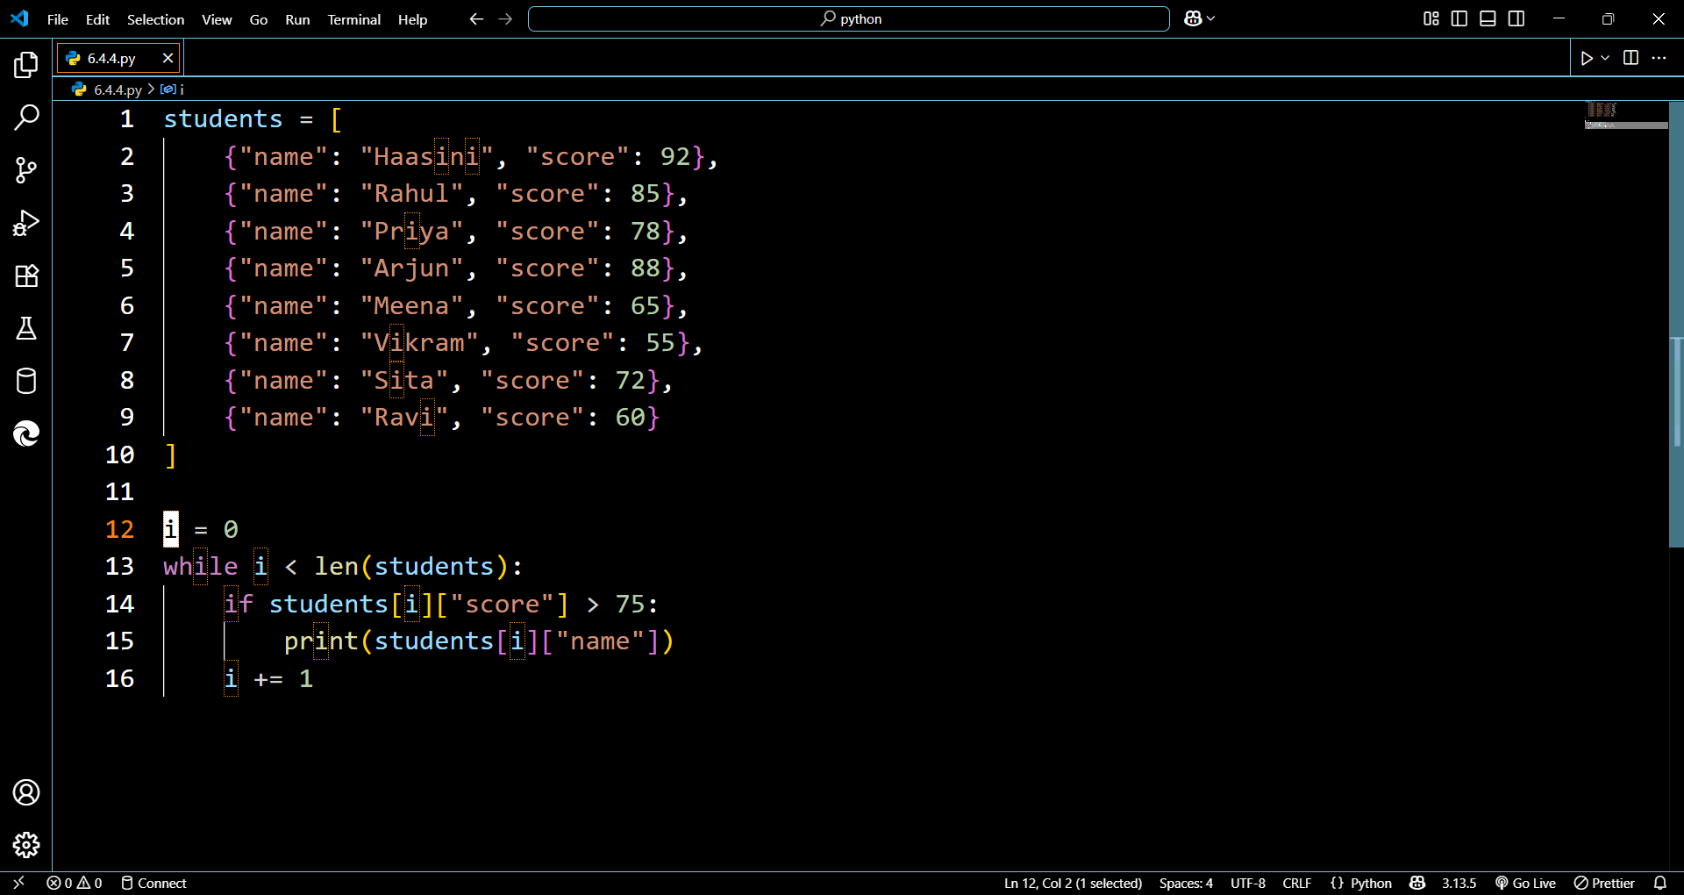

Output: 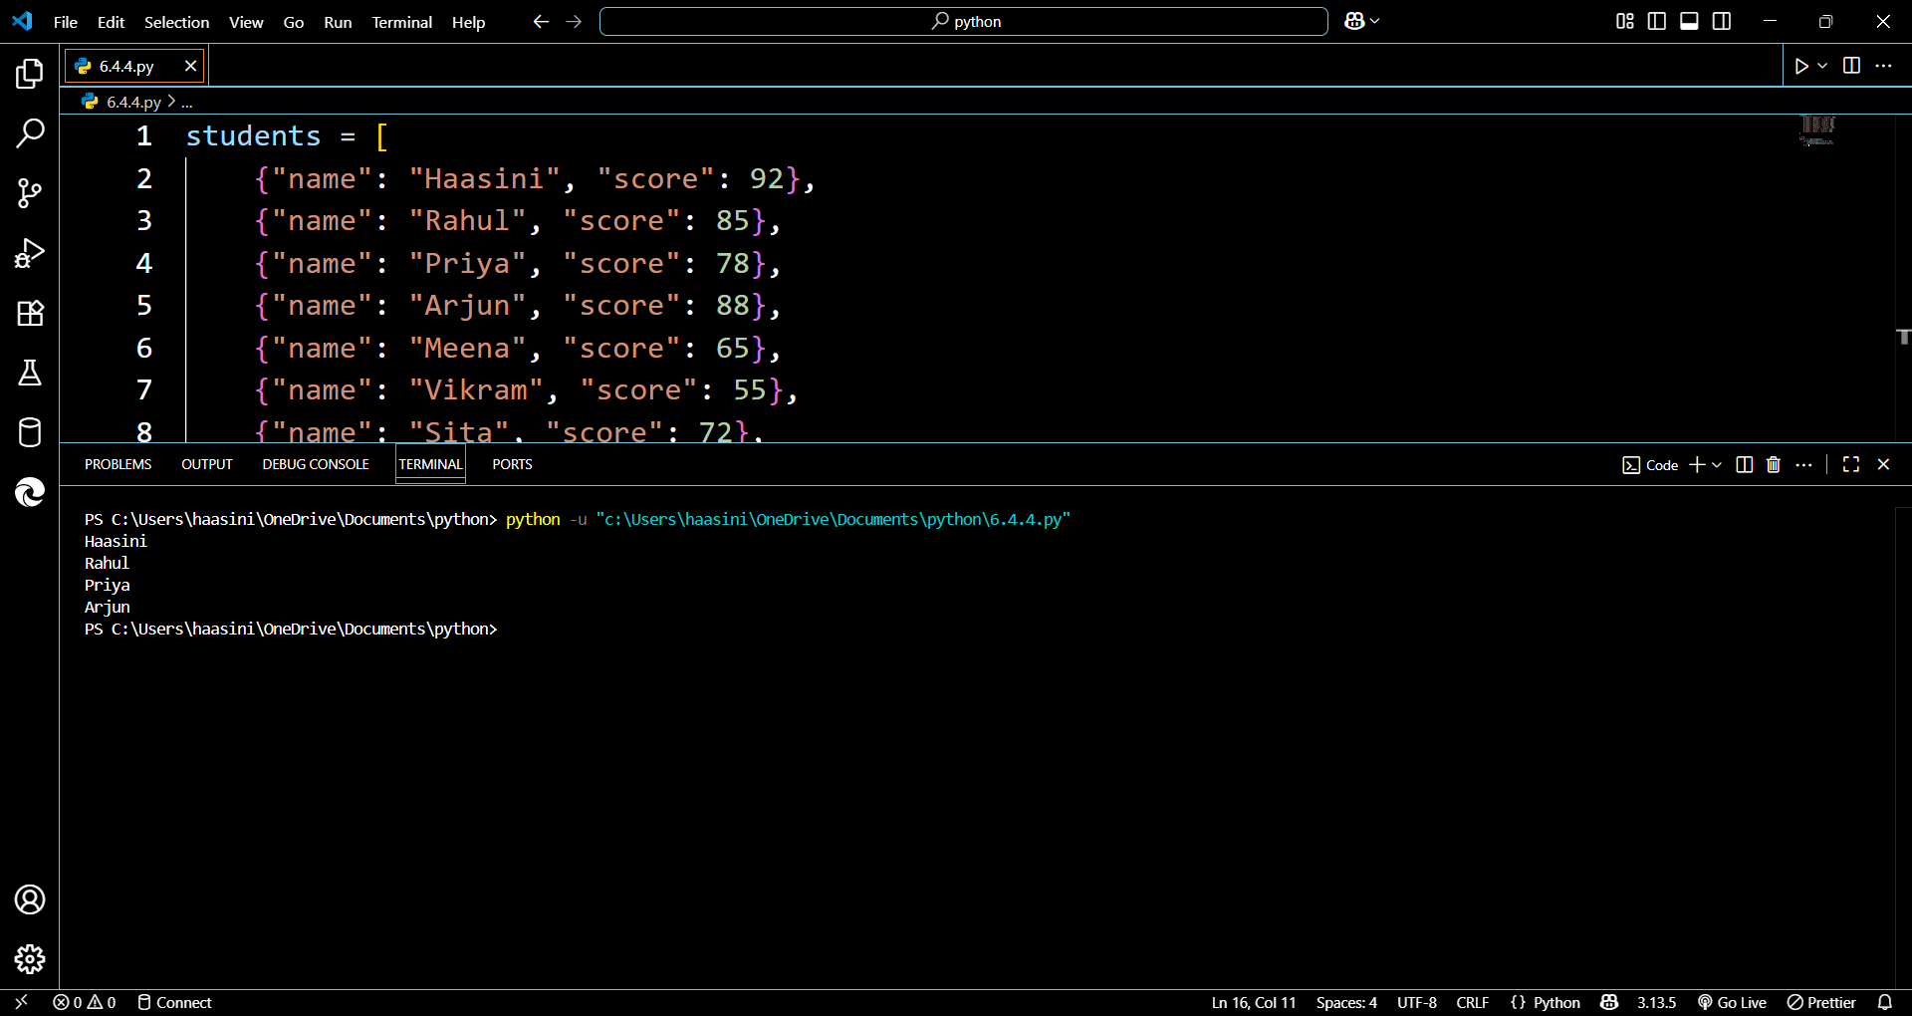

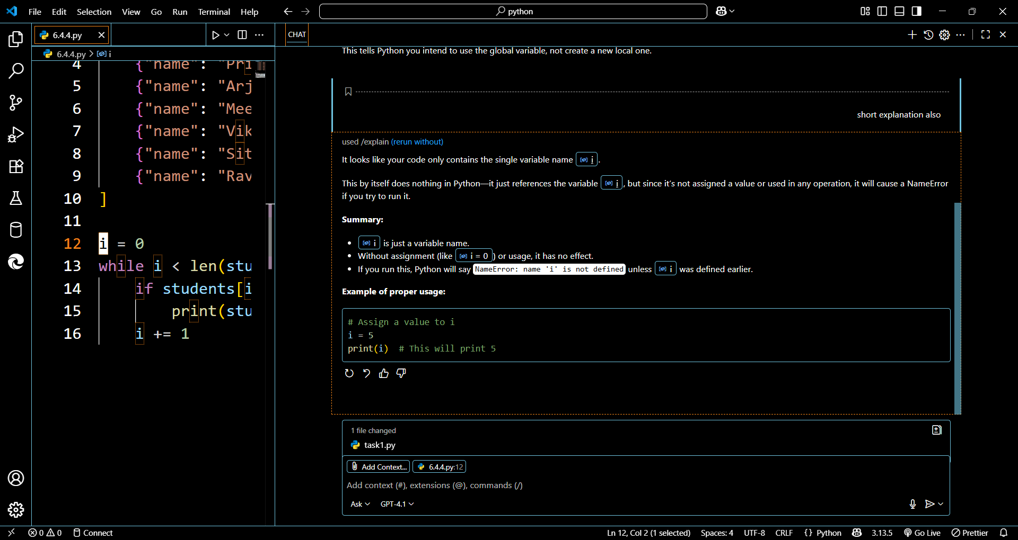

TASK 5:

Prompt: Begin writing a class ShoppingCart with an empty items list. Add methods to add_item, remove_item, and use a loop to calculate the total bill with conditional discounts.

Code:

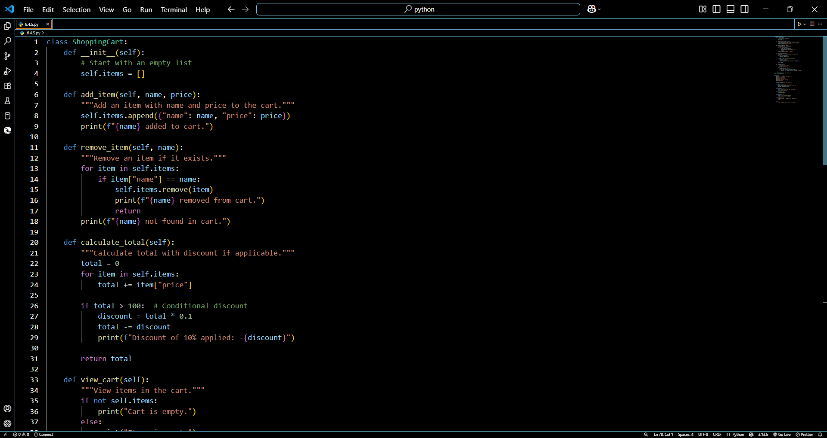

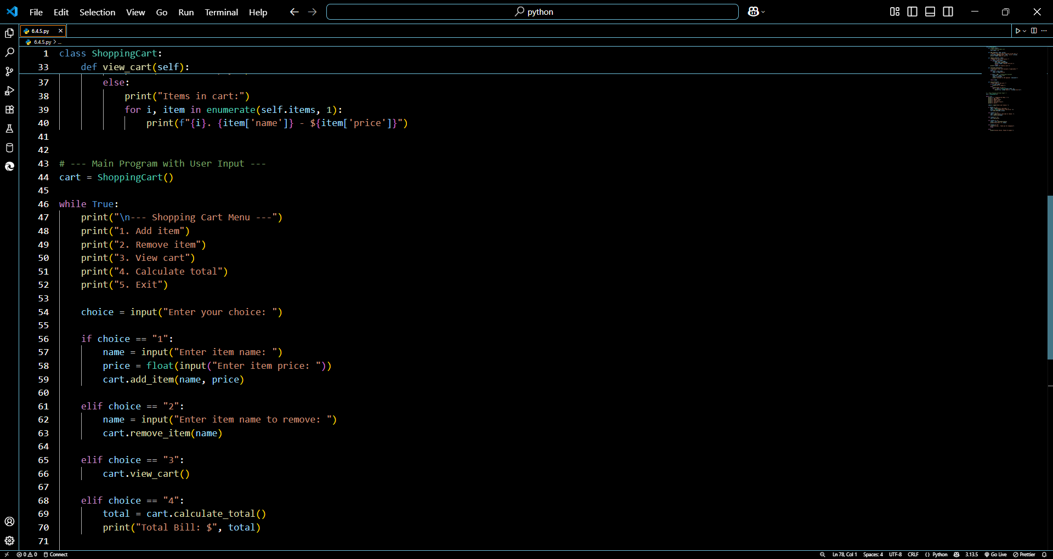

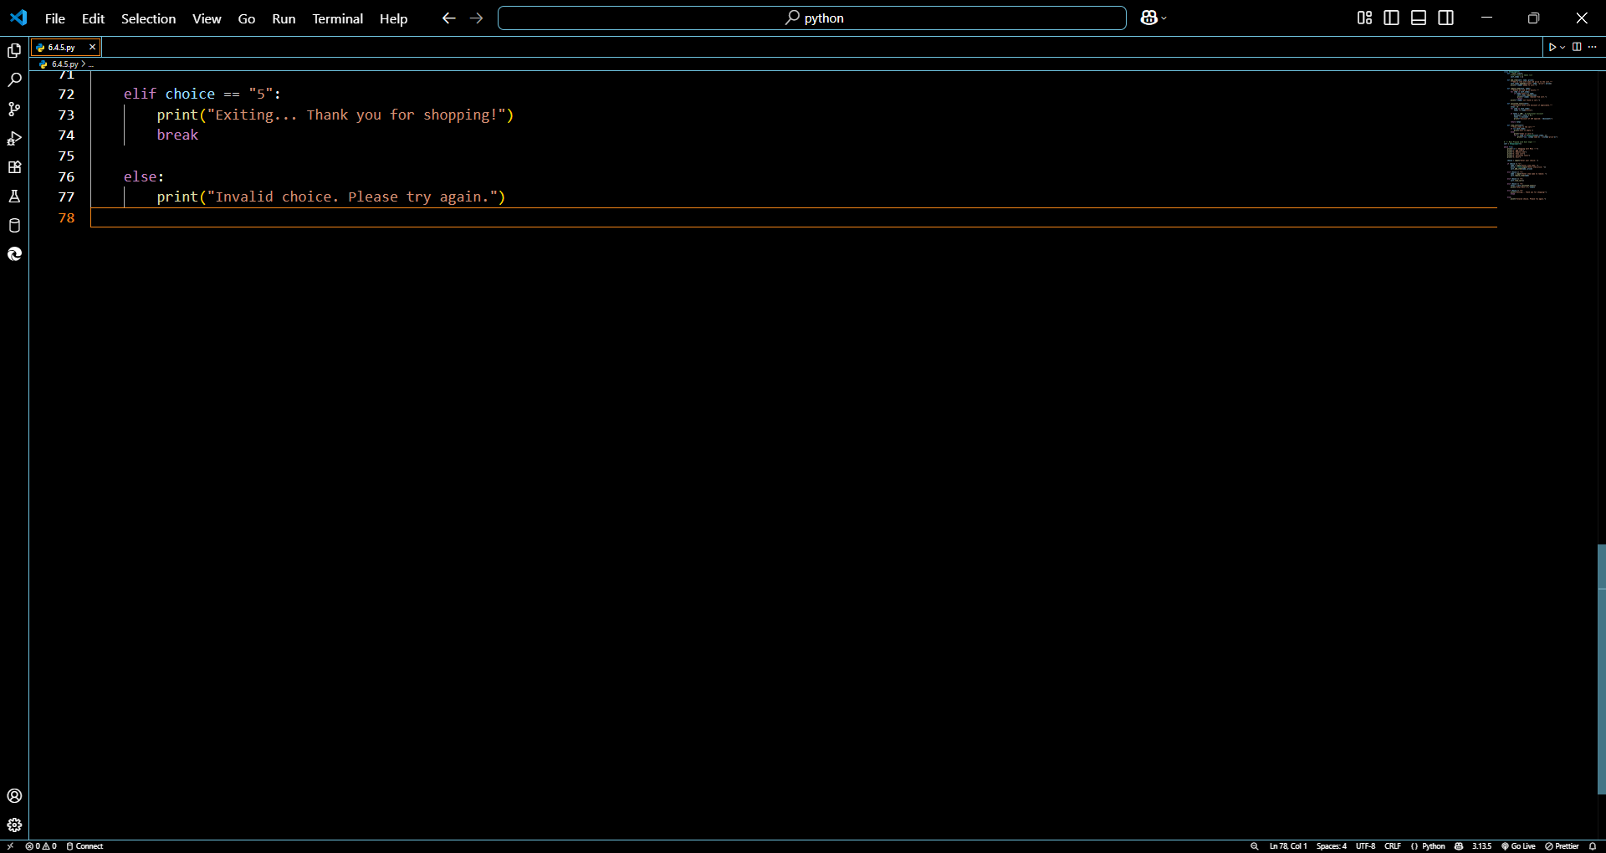

Output:

