AI-ASSISTED CODING

SET-3

QUESTION -3

3. (2 Marks) Write a Python program that generates all prime numbers between start and end (both inclusive) entered by the user. Use GitHub Copilot along with VS Code. Use few shot prompting

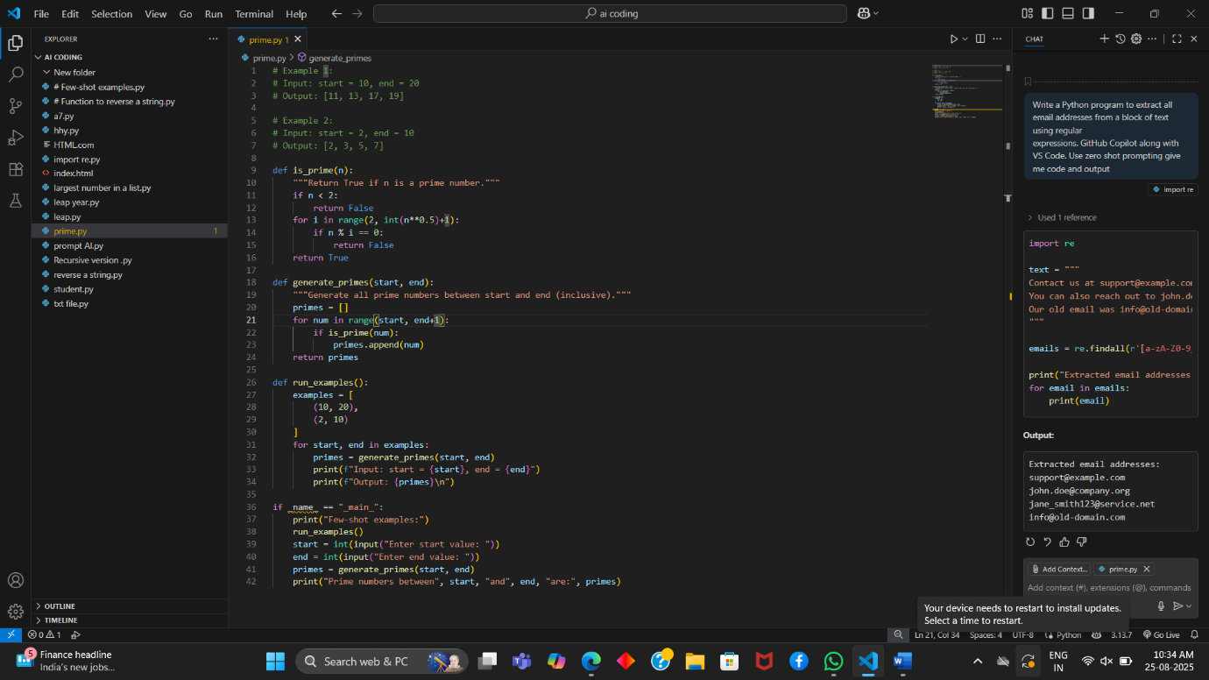

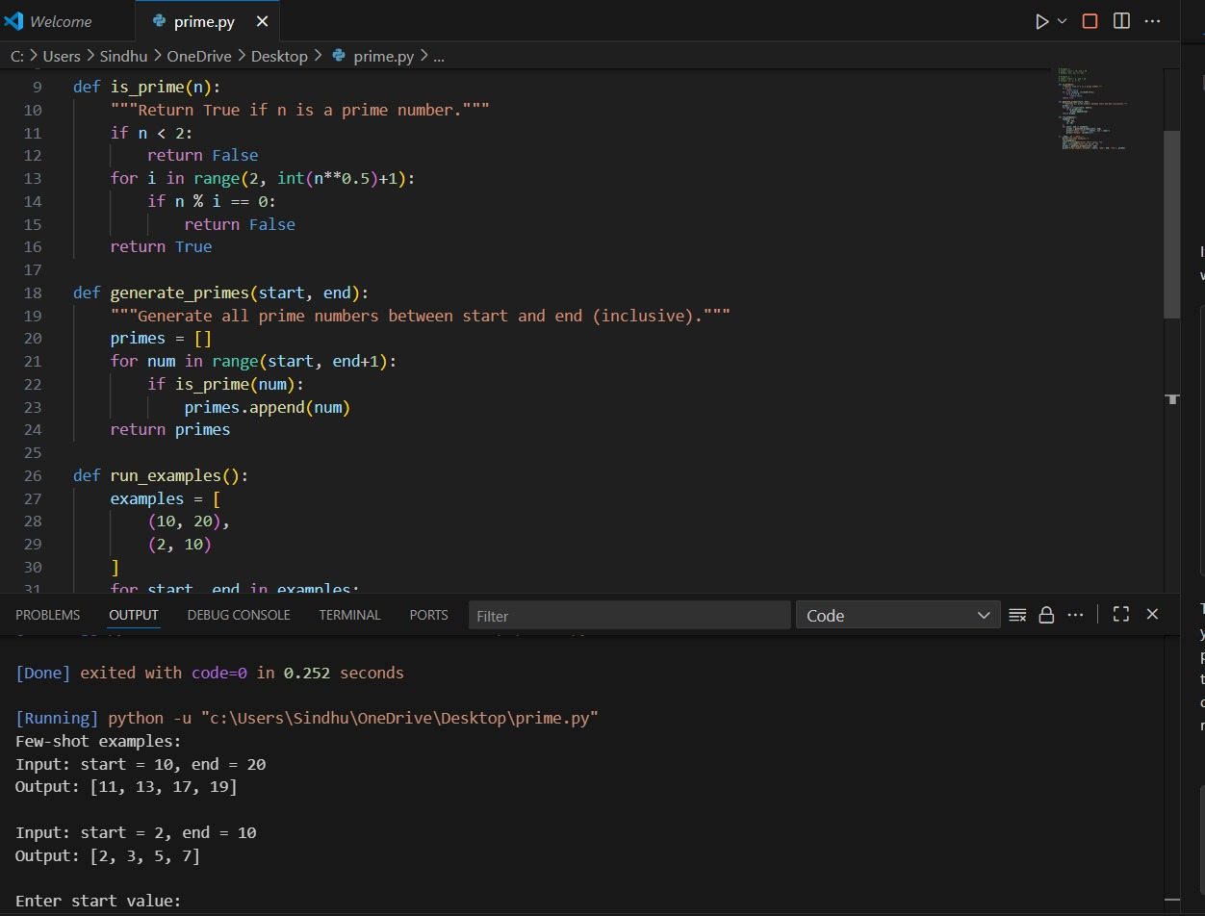

4.(2 Marks) Write Python code that takes a list of student names and generates institutional email IDs in the format: @sru.edu.in Example: "Anita Sharma"→ asharma@sru.edu.in. Use GitHub Copilot along with VS Code. Use few shot prompting

